w w w . s o h a i I v f x . c o m

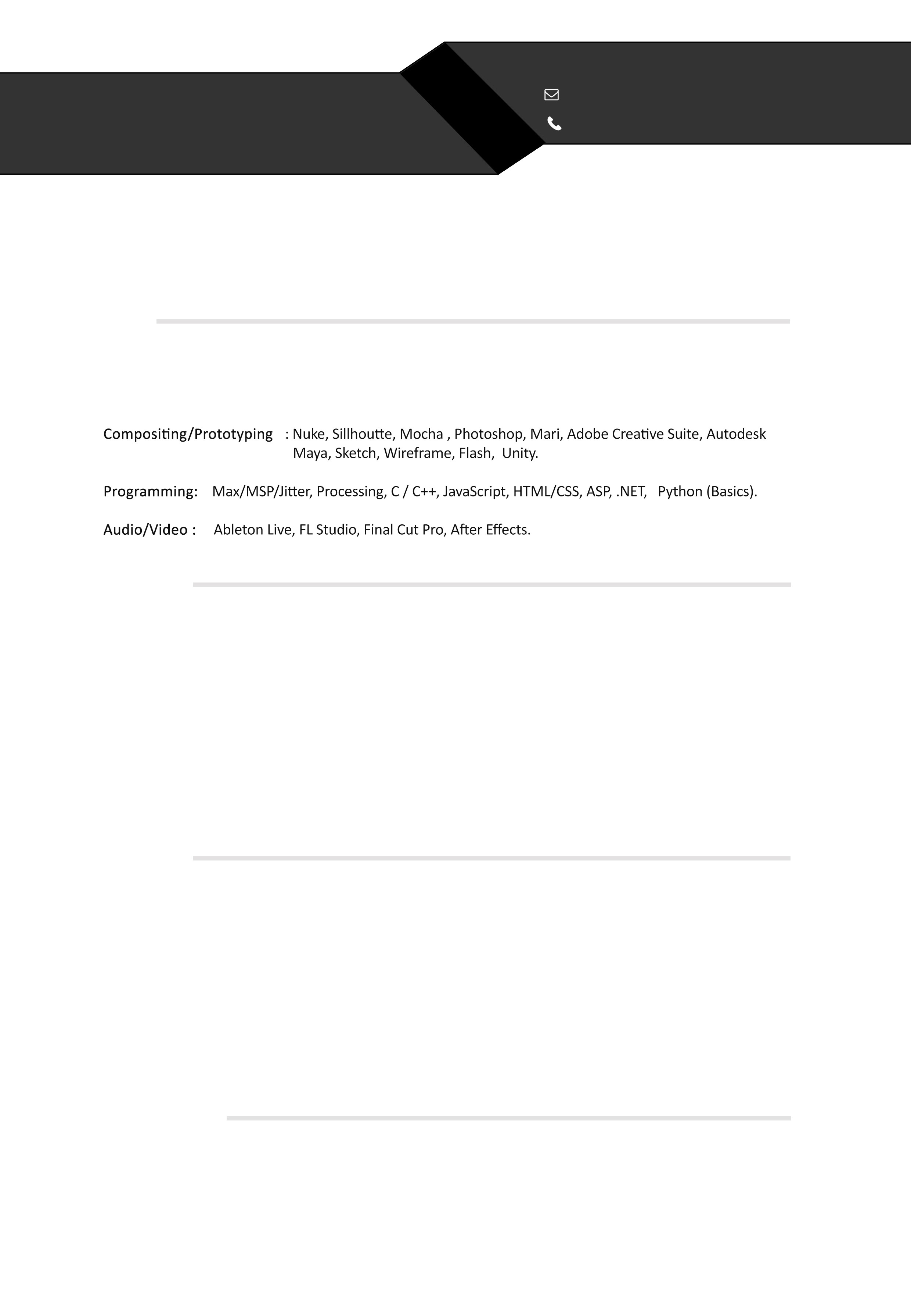

MOHAMMED SOHAIL

COMPOSITOR / ROTO-BG PREP ARTIST

[mail@sohailvfx.com](mailto:mail@sohailvfx.com)

+ 1 604 754 9354

# Objective

To obtain a challenging position in the visual effect industry to where I can apply my knowledge and skills to the organizational growth and making a significant contribution to the success of my career and employer.

# Skills

Rotoscoping, keying, 2D & 3D tracking, color grading, BG prep, paint outs, 2D, 3D & multi−pass compositing, set extension, 3D projections, matchmoving, CG intregration, basic python scripting, digital painting, modeling, texturing, UV unwrapping, shading, animation, multi−pass & multi−layer rendering, video editing.

# Experience

lnteractive Designer Nucreus Design Labs, lndia

2012 - 2013

I used to design user interfaces for the futuristic user centered design application with highly analytical ideation to make effective user interaction experiences .

Graphic Designer Freelance Works Cleverhats Photoplay , India

2011 - 2012

Designing graphic elements for web interfaces and motion graphics for clients by following latest design trends without losing original intent.

# Education

Advance Diploma

Lost Boys Studios− School Of Visual Effects

2014 - 2015

The advance visual effect compositing program with skills focused on Roto, paint, keying, combining CG elements and also 3D basic skills.

Bachelors Degree in Computing Science & Engineering VIT University , Tamil Nadu , India.

2006 - 2011

The ability to identify, formulate and solve (CS) engineering problems by apply design and development principles in the construction of software systems.

# Personal Details

**Language Skills : Activities & lnterests :**

English, Hindi, Urdu, German−Basic level.

Movies, Abstract Drawing , Sketching, Digital design, Travelling, Cooking.