jQuery Exercises

Q1:-

<a href='<http://www.google.com/policy.pdf>'>Policy</a>

<a href='www.yahoo.com/logo.png' title='yahoo logo'>View Logo</a>

<a href='http://www.facebook.com' title='Facebook'>Facebook</a>

Select all anchor tags that link to a pdf document.

Select all anchor tags that start with http

Select all anchor tags that have title attribute

Sol:-

<html>

<head>

<script src="jquery.js">

</script>

</head>

<body>

<a href='http://www.google.com/policy.pdf'>Policy</a>

<a href='www.yahoo.com/logo.png' title='yahoo logo'>View Logo</a>

<a href='http://www.facebook.com' title='Facebook'>Facebook</a>

</body>

</html>

1.1 $('a[href $=pdf]')

1.2 $('a[href^=http]')

1.3 $('a[title]')

Output:-

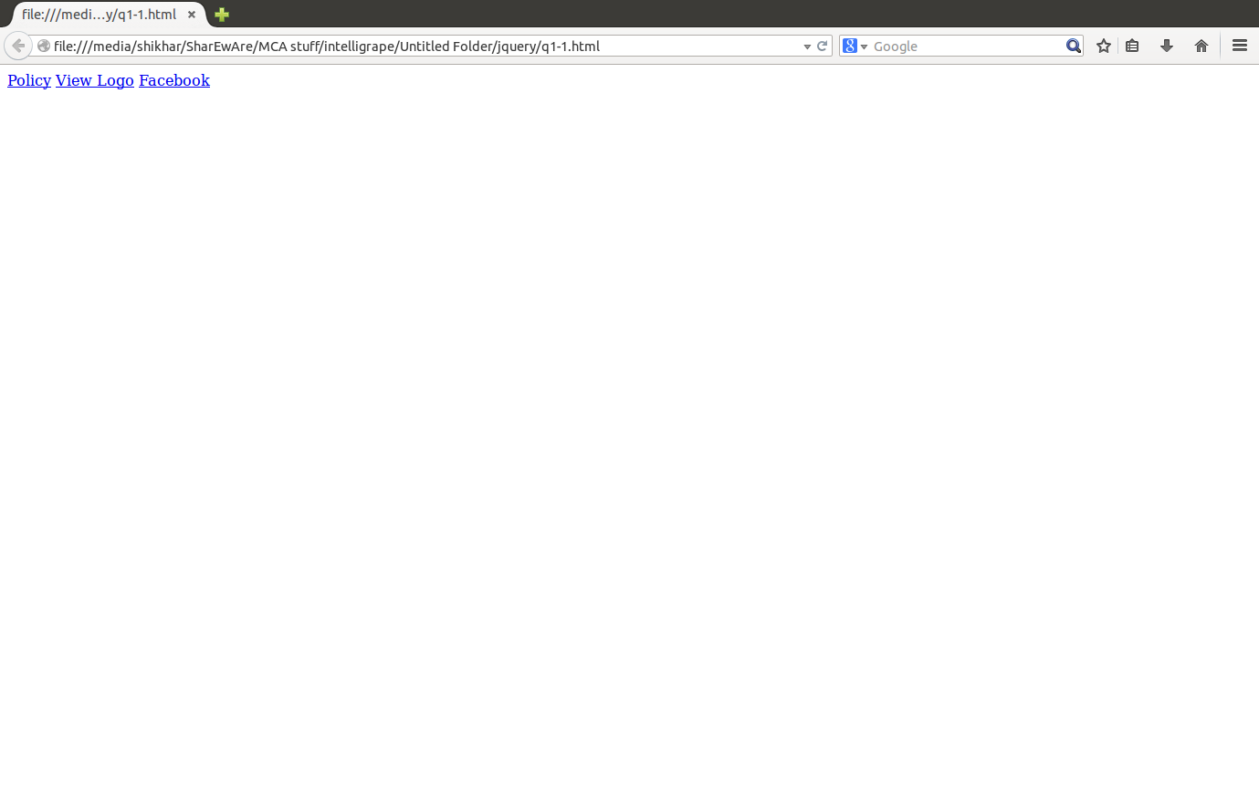

Q2:-Create an anchor tag using jQuery and add href attribute and assign it a value [http://www.google.com](http://www.google.com/)

Sol:- $('body').append{'<a href=www.google.com>Google</a>')

Q3:-Create a simple button and one(or two?) paragraph with text “Hi”. Once the button is clicked, the paragraph text should change to “Hello”. If button is clicked once again, the paragraph text should again change to “Hi”. This process must repeat on subsequent clicks.

Sol:-

<html>

<head>

<script src="jquery.js">

</script>

</head>

<body>

<input type="button" id="button1" value="Click" height="50" width="20"/>

<p id="change">hi</p>

<script>

$(document).ready(function(){

$('#button1').click(function(){

if($('#change').text()=="hello")

$('#change').text("hi")

else if($('#change').text()=="hi")

$('#change').text("hello")

})

})

</script>

</body>

</html>

Output:-

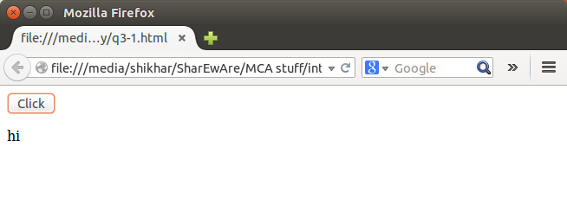

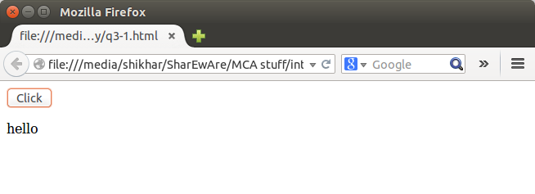

Q4:-Create toggle buttons, i.e there should be div's which has a class of "toggle-button", bind a click event on it and whenever the button is clicked, classes "on" and "off" should toggle(if class is 'on' change it to 'off' and vice-versa) changing the background-color of that clicked DIV.

SoL:-

<html>

<head>

<script src="jquery.js">

</script>

</head>

<body>

<div class="on" style="background-color:blue"/>

<input type="button" id="button1" value="click" top=/>

<script>

$(document).ready(function(){

$('#button1').click(function(){

if($('div').attr('class')=="on")

{

$('div').removeClass('on')

$('div').addClass('off')

$('div').css('background','purple')

}

else if($('div').attr('class')=="off")

{

$('div').removeClass('off')

$('div').addClass('on')

$('div').css("background","blue")

}

})

})

</script>

</body>

</html>

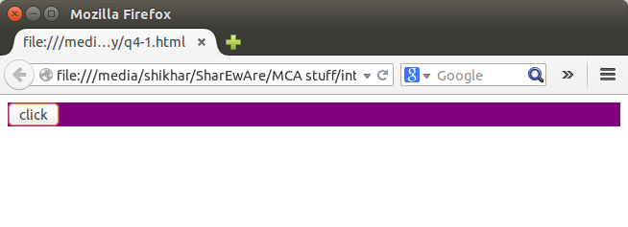

Q5:-Create a simple animation of a DIV (update left property) which starts on click event of a button, the button also resets the animation when clicked again.

Sol:-

<html>

<head>

<script src="jquery.js">

</script>

</head>

<body>

<input type="button" id="button1" value="Click" height="50" width="20"/>

<div style="background:green;height:100px;width:100px;position:absolute;left:0"/>

<script>

$(document).ready(function(){

$("#button1").click(function(){

if($('div').offset().left=="250")

$("div").animate({left:'0px'})

else

$("div").animate({left:'250px'})

});

});

</script>

</body>

</html>

Output:-

