ANDROID APPLICATION DEVELOPMENT

REQUIREMENTS:

1. ANDROID STUDIO 2.1V
2. SQLITE DATABASE
3. SDK MANAGER
4. SDK COMPONENTS.
5. JDK

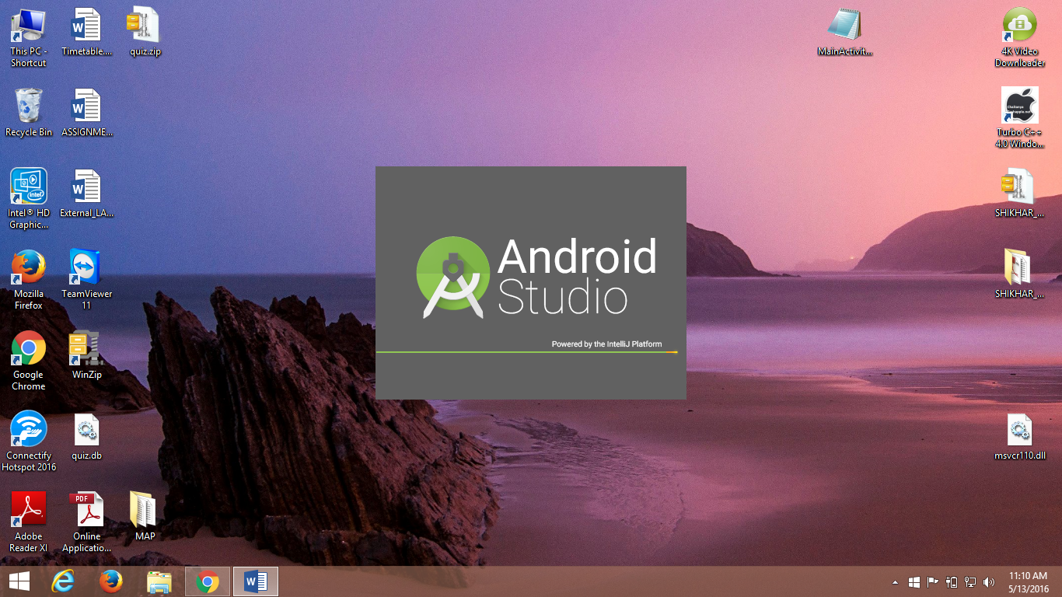

INTERFACE OF ANDROID STUDIO:

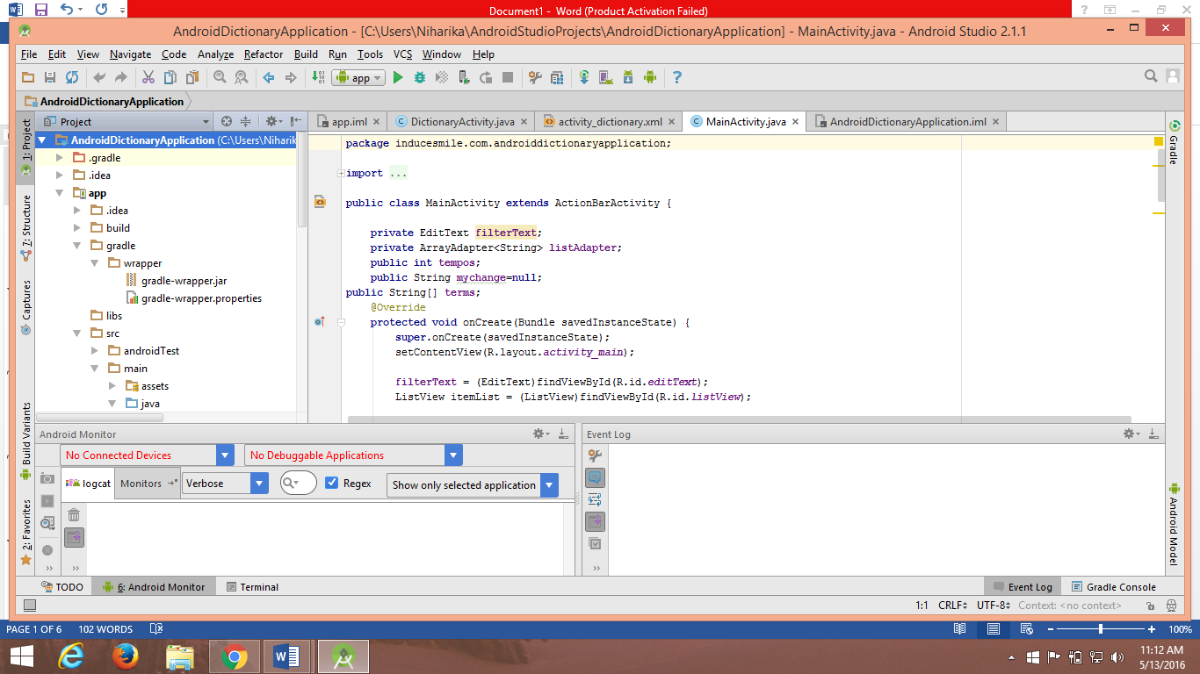

First Look of APPLICATION in MOBILE UI

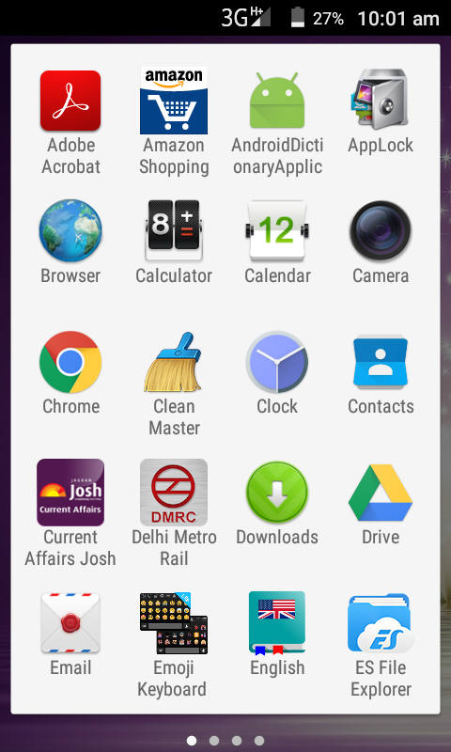

ACTIVITY 1:

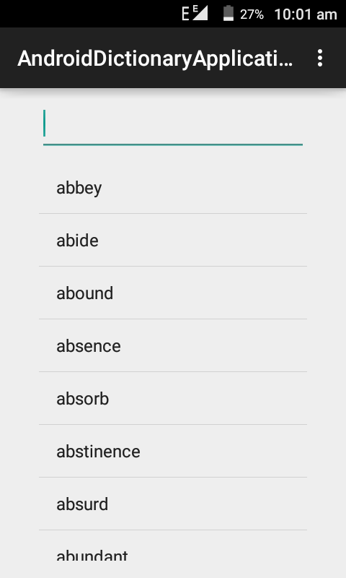

***We can select the word from the list and get the meaning in another activity*** ( Intent activity ).

INTENT ACTIVITY:

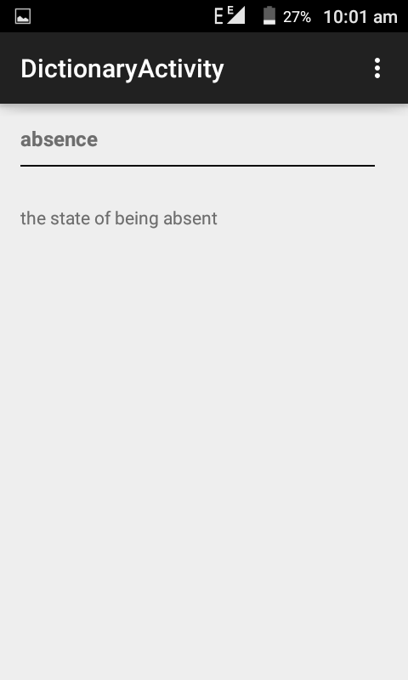

***When we type the particular word in the search bar for its meaning.***

INTENT ACTIVITY:

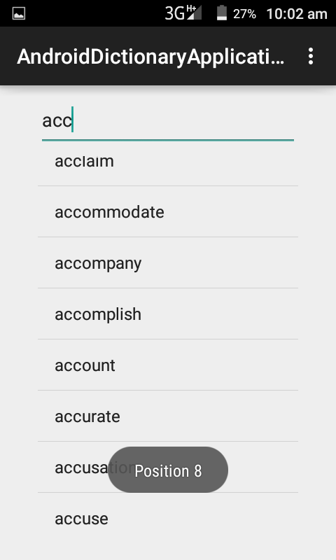

***The word list appears on typing the initials and then word can be selected from list without typing the whole word.***

INTENT ACTIVITY:

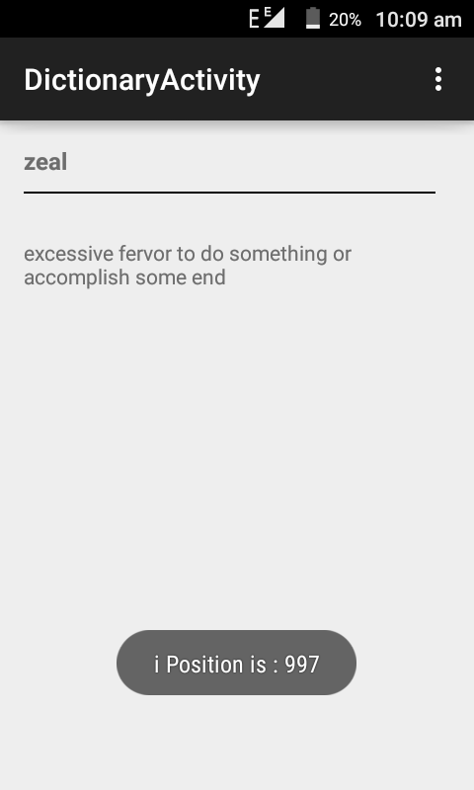

***The last letter(z) words in the application, from the database (showing the position).***