**LAMDA DOCUMENTATION**

**Step 1: Access the AWS Lambda console**

1. Log in to the [**AWS Management Console**](https://aws.amazon.com/console/).
2. Navigate to the Lambda service.

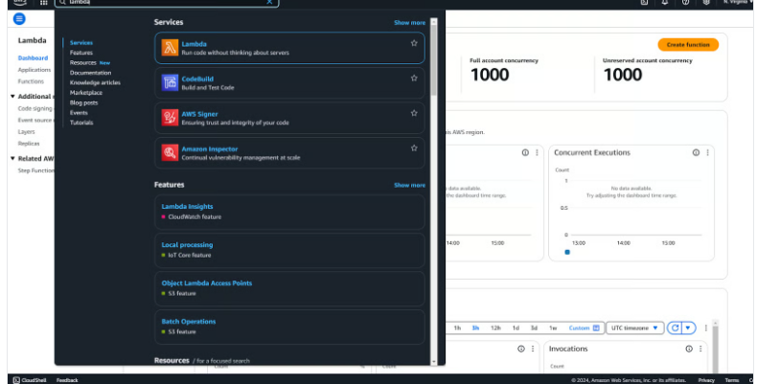

*Navigation dashboard in AWS console.*

Click on ***Lambda*** in the navigation menuto see the dashboard:

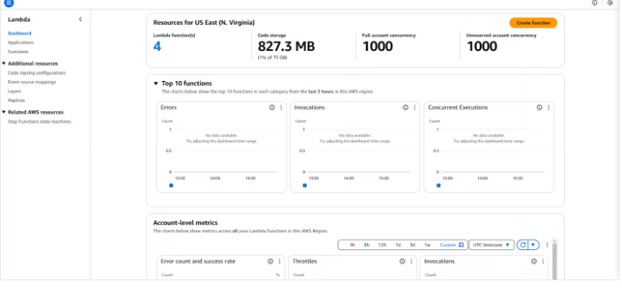 *AWS Lambda Dashboard in AWS Console.*

**Step 2: Create a new function**

1 . Click ***Create Function***.

2. Choose “Author from Scratch.”

3. Provide a name for your function.

4.Select a runtime (e.g., Python 3.11).

5. Click on the ***Create Function*** button.

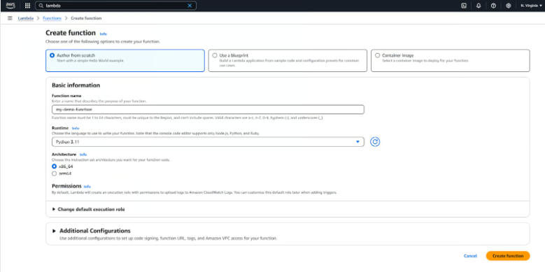

*Create a new AWS Lambda function.*

It will take a few seconds. Once the function is created, you will see a successful message on the top.

**Step 3: Write your function code**

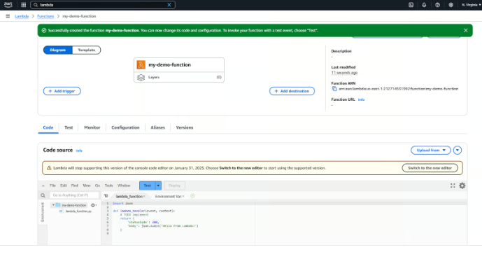  
 *AWS Lambda browser IDE for simple code editing.*

**Step 4: Test your Lambda function**

At this point, this function just returns the string *“Hello from Lambda!”*.

There is no logic, no dependencies, nothing.

We have a Python script called lambda_function.py that contains the function named lambda_handler() that returns a string.

We can now test it by simply clicking the Test button.

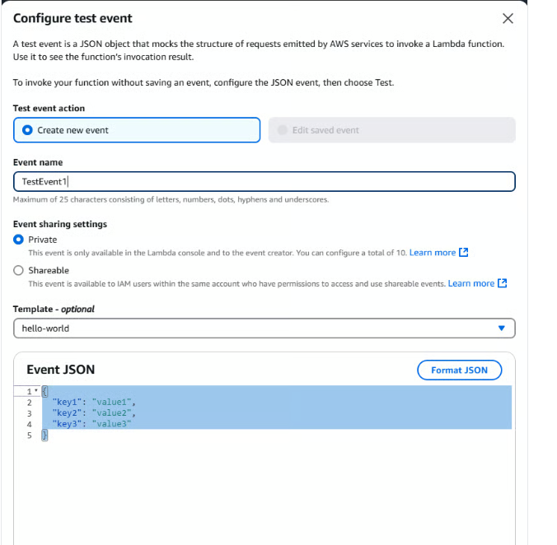

Test your AWS lambda function in browser.

You can remove the “Event JSON” as our function takes no input. Give an event name and click on the Invoke button.

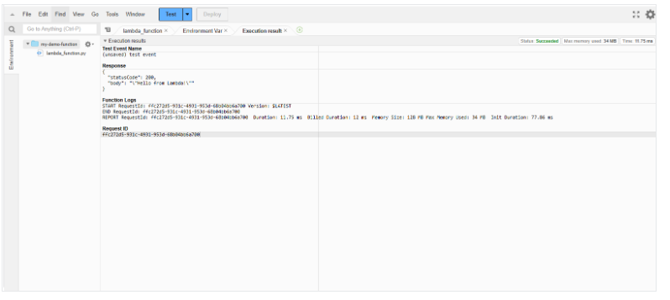

Successful test of AWS Lambda function.

The function was successfully executed, and the message was returned.

Yayy! We just deployed a serverless function using AWS Lambda. It doesn’t do much at the moment, but it is up and running. Every time this function is invoked, it returns a simple string.

Triggering Lambda with Events

**1. Setting up an S3 trigger**

1.Go to the S3 console.

2.Select S3 bucket.

3.Under Properties, add an event notification to trigger your Lambda function when creating an object.

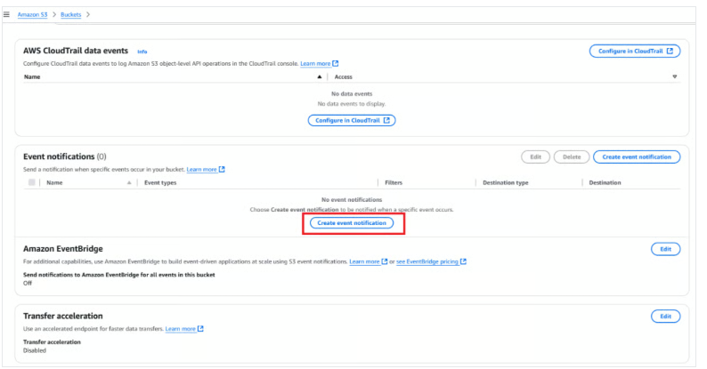

*Create event notification in the AWS S3 bucket.*

*Select the Lambda function to trigger in S3*