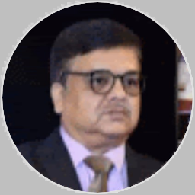 |  |  | Dr. Brij behari dave  Retired Civil Servant
Profile  39 years’ experience in administration in the State and the Center.  Proficiency in International Finance.  Contact  PHONE:  9414060441  WEBSITE: bb4dave.wordpress.com  The World Today – Analysis without Noise. (wordpress.com)  EMAIL:  bbdave100@outlook.com  Hobbies  Gardening  Travelling  Writing  Listening Music |  |  | EDUCATION  University of Jodhpur, Jodhpur  1979-1980  Master of Science (Organic Chemistry)  Forest Research Institute, Dehradun  1981 - 1983  PG Diploma in Forestry (Silver Medal in Silviculture)  Indian Institute of Management, Bangalore  2004-06 (PG Diploma in Management and Public Policy)  Sardar Patel University, Anand  Doctor of Philosophy (2018)  WORK EXPERIENCE  Belong to Indian Postal Service (1986)  Retired as a Member Postal Services Board  33 years of experience in Central Service Group ‘A’  6 years of State Forest Service  SKILLS  Working as Microsoft Insider for Windows and Microsoft Office since 2014.  Presented research papers in IIM, Indore, and Management Colleges in Guwahati and Sardar Patel University, Anand.  28 research papers published in National and International Journals.  Affiliation: NIL  Receipt of Research Grant: NIL

