**Smart EV Charging Optimization with Geo-Analytics**

**BY- Team INNOVATORS**

**1.Team Members :-**

1. Shikhar Verma (7355354823)
2. Sanket Raj Chauhan (7766063202)
3. Pooja (6376262176)

**2.College Name:- University of Engineering and Management, Jaipur**

**3.Problem Statement**

Electric Vehicle (EV) Infrastructure Planning

This project addresses the challenge of inefficient EV charging station placement in cities. Poor infrastructure hampers EV adoption, slows sustainable urban development, and limits efforts to reduce emissions and promote clean transportation. Optimizing the network is key to supporting greener, smarter cities.

**4.Solution Description**

Our AI-driven solution optimizes EV charging station placement using machine learning and geospatial data analysis. By clustering current EV station locations and predicting high-demand areas, we ensure stations are placed where they are most needed.

**Problem Solved:**

The solution addresses the problem of inefficient EV station placement by using data-driven insights to optimize locations, improving accessibility, reducing congestion, and accelerating EV adoption.

**Core Innovation & AI Use:**

The core innovation lies in leveraging K-Means clustering for station placement and linear regression models to predict future demand based on population density. This AI-driven approach ensures precise, scalable infrastructure planning for urban sustainability.

**5.Technical Architecture**

**AI Algorithms/Models Used:** K-Means Clustering: For identifying optimal locations for new EV charging stations by grouping high-demand areas.

**Linear Regression:** To predict future EV charging demand based on population density and other factors. **EV Charging Station Data-sets:** Contains the geographical locations (latitude, longitude) of existing EV charging stations.

**Population Density Data:** Used to estimate potential demand in different urban areas.

**Programming Languages:**Python: Core programming language used for model development and backend logic (Flask framework).

HTML/CSS: For building the front-end user interface.

**Software/Tools:**

* **Flask**: Web framework for building and hosting the application.
* **OSMnx**: For fetching urban road networks and geospatial analysis.
* **Folium**: For map visualization of EV station locations.
* **Pandas & NumPy**: For data handling and manipulation.
* **scikit-learn**: For machine learning algorithms like K-Means and Linear Regression.

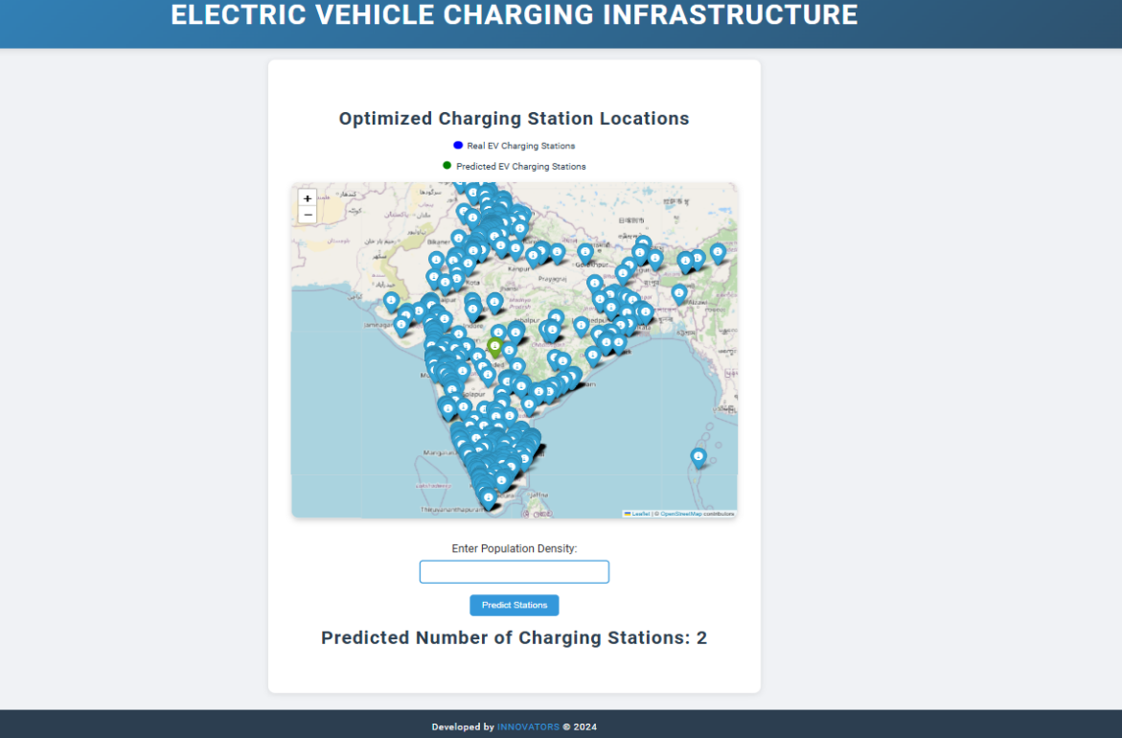

**6.** **Social, Ecological and Economic Impact**

Promoting Sustainability: Our solution promotes sustainability by optimizing the placement of EV charging stations, which encourages EV adoption. This leads to reduced greenhouse gas emissions, improved air quality, and a shift toward cleaner, electric transportation in urban areas.

Estimated Impact at Scale:

* Environmental Impact: A well-planned network could reduce carbon emissions by up to 20% in high-density urban areas by promoting widespread EV usage.
* Economic Impact: Increased EV adoption can reduce fuel costs for consumers and decrease dependence on fossil fuels, potentially saving millions annually in urban transportation expenses.
* Social Impact: Improved air quality and reduced traffic congestion can enhance public health and quality of life, while creating new jobs in the EV infrastructure sector.

**7.** **Integration with Existing Ecosystems**

Our innovation seamlessly integrates with existing city infrastructure and government planning systems by using publicly available data like population density, road networks (via OpenStreetMap), and existing EV station locations. It complements city development plans by offering data-driven insights to local governments and corporations for strategic EV infrastructure expansion.

This solution can be adopted by municipalities to enhance urban mobility plans, by energy companies to optimize charging networks, and by corporations aiming to meet sustainability goals. It aligns with smart city initiatives, reducing emissions and supporting eco-friendly transportation systems.

**8.Future Potential and Scalability**

**Scalability and Deployment:** Our solution is scalable and adaptable to any city with geospatial and population data. It can easily expand as EV demand grows and integrates seamlessly with smart city projects, making it suitable for cities of all sizes.

**Market and Social Opportunity:** With rising EV demand and government support for green transport, this solution offers a cost-effective way for cities and corporations to build efficient charging networks, reduce emissions, create jobs, and enhance urban mobility.