Retail Sales Performance Analysis
A Descriptive Analytics Project using Python

Course: BBA - IBM (2025 – 2028)
Year: 3rd semester 2nd year

Subject: Business Intelligence Analyst

Submitted By: Shikhar Agrawal
University Id : UU250510103

Submitted To: Mr. Farhan

Table of Contents
1. Abstract
2. Introduction and Objectives
3. Dataset Description
4. Tools and Methodology
5. Data Cleaning
6. Key Performance Indicators (KPIs)
7. Regional Analysis
8. Category and Sub-Category Analysis
9. Monthly Sales Trend
10. Discount Analysis
11. Customer Analysis
12. Key Findings
13. Recommendations
14. Limitations
15. Conclusion
Appendix: Python Code

1. Abstract
This project studies the sales performance of a retail business over two years (January 2024 to December 2025) using descriptive analytics. The dataset has 1,500 unique orders after cleaning. Python (pandas and matplotlib) is used to clean the data, calculate key performance indicators and draw six charts that answer simple business questions.
The business earned total sales of Rs 341.2 Lakh and a profit of Rs 46.8 Lakh, which is an overall profit margin of 13.7%. Technology contributes 64.3% of sales and is the most profitable category. Tables is the only loss-making sub-category. The most important finding is that profit margin falls from 19.9% when no discount is given to -2.4% at a 40% discount, which means heavy discounting destroys profit.
The report ends with practical recommendations on discount control, product mix and seasonal planning.

2. Introduction and Objectives
Business Intelligence (BI) is the process of turning raw data into information that helps managers take better decisions. Descriptive analytics is the first and most common type of BI. It answers the question "What happened?" by summarising past data using totals, averages, percentages and charts.
A retail company records every order it receives, but a long list of orders is not useful by itself. This project converts the order records into a short set of numbers and charts that a manager can read in a few minutes.

Business Questions
- How much did the business sell and earn, and what is the profit margin?
- Which region and category perform best?
- Which products are making a loss?
- How do sales change month by month?
- What is the effect of discounts on profit?
- Who are the biggest customers?

Objectives
- To clean and prepare the sales data for analysis.
- To calculate the main KPIs: sales, profit, margin and orders.
- To visualise performance by region, category, time, discount and customer.
- To give simple recommendations based on the findings.

3. Dataset Description
The data is stored in the file retail_sales.csv. It is a sample dataset prepared for this academic project to represent the order records of an Indian retail business. It contains 1,515 rows and 12 columns before cleaning. All amounts are in Indian Rupees (Rs).
Column | Description
Order ID | Unique number of each order
Order Date | Date on which the order was placed
Customer ID | Unique code of the customer
Segment | Consumer, Corporate or Home Office
Region | North, South, East or West
Category | Furniture, Office Supplies or Technology
Sub-Category | Product type, such as Chairs, Copiers, Phones
Quantity | Number of units ordered
Unit Price | Price of one unit before discount
Discount | Discount given (0% to 40%)
Sales | Revenue of the order after discount
Profit | Profit of the order (negative means loss)

The data covers 730 days, 245 different customers, 3 categories and 9 sub-categories.

4. Tools and Methodology

Tools Used
Tool | Purpose
Python 3 | Programming language
pandas | Loading, cleaning and summarising data
matplotlib | Drawing charts
Excel / CSV | Storing and viewing the dataset

Methodology
The project follows six simple steps. The same steps are written as comments in the Python code.
- Step 1 - Load: read retail_sales.csv into a pandas DataFrame.
- Step 2 - Clean: remove duplicate rows and fill missing discounts.
- Step 3 - KPIs: calculate total sales, total profit, profit margin and orders.
- Step 4 - Analyse: group data by region, category, sub-category, discount and customer.
- Step 5 - Visualise: draw six charts and save them as images.
- Step 6 - Findings: print the main insights.
Profit Margin % is calculated as (Profit / Sales) x 100. It shows how many rupees of profit the business keeps from every Rs 100 of sales.

5. Data Cleaning
Real business data is rarely perfect, so it was checked before analysis. Two problems were found and fixed.
Issue | Found | Action Taken
Duplicate rows | 15 | Removed using drop_duplicates()
Missing Discount values | 20 | Filled with 0 (no discount given)
Rows before cleaning | 1,515 | -
Rows after cleaning | 1,500 | Used for all analysis
No other column had missing values. After cleaning, every order appears exactly once, so the totals are not inflated by repeated rows.

6. Key Performance Indicators (KPIs)
KPIs are the headline numbers of the business.
KPI | Value
Total Sales | Rs 341.2 Lakh
Total Profit | Rs 46.8 Lakh
Profit Margin | 13.7%
Total Orders | 1,500
Average Order Value | Rs 22,745
Unique Customers | 245
Sales in 2024 | Rs 170.1 Lakh
Sales in 2025 | Rs 171.1 Lakh

Sales were almost flat between 2024 (Rs 170.1 Lakh) and 2025 (Rs 171.1 Lakh), a growth of under 1%. Profit slightly declined from Rs 23.8 Lakh to Rs 23.0 Lakh, so the business is not growing.

7. Regional Analysis
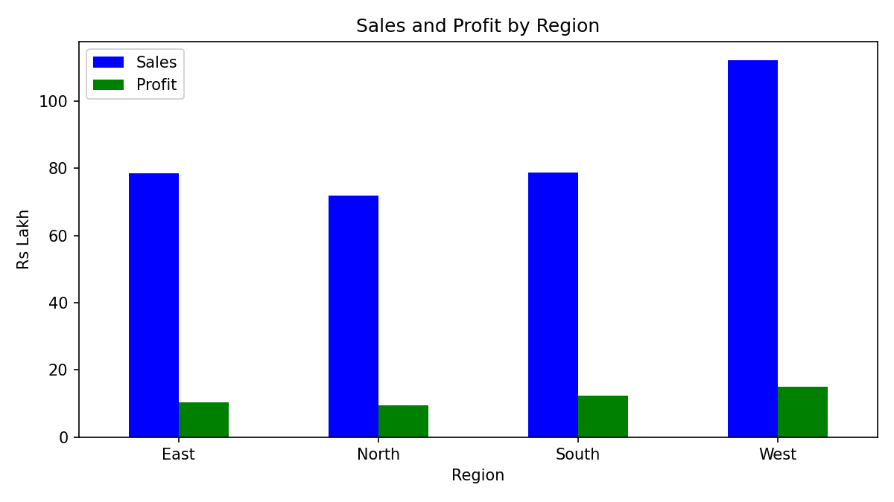
Chart 1: Sales and Profit by Region (Rs Lakh)
Region | Sales (Rs Lakh) | Profit (Rs Lakh) | Margin %
West | 112.1 | 14.9 | 13.3
South | 78.7 | 12.3 | 15.6
East | 78.6 | 10.2 | 13.0
North | 71.8 | 9.4 | 13.2

Interpretation: The West region is the largest and brings about one-third of total sales. The South region sells about the same as the East but has the best margin (15.6%), so it is the most efficient region. East has the lowest margin (13.0%).

8. Category and Sub-Category Analysis
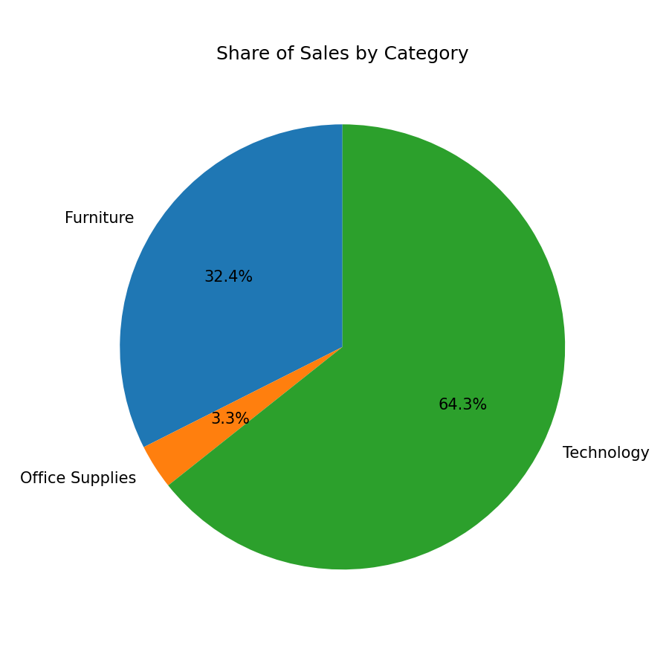
Chart 2: Share of Sales by Category
Category | Sales (Rs Lakh) | Profit (Rs Lakh) | Margin %
Technology | 219.4 | 41.2 | 18.8
Furniture | 110.7 | 4.1 | 3.7
Office Supplies | 11.1 | 1.6 | 14.1

Technology gives 64.3% of sales and 88% of total profit. Furniture gives 32.4% of sales but only 3.7% margin. Office Supplies has a good margin but very small sales.

Sub-Category Profit
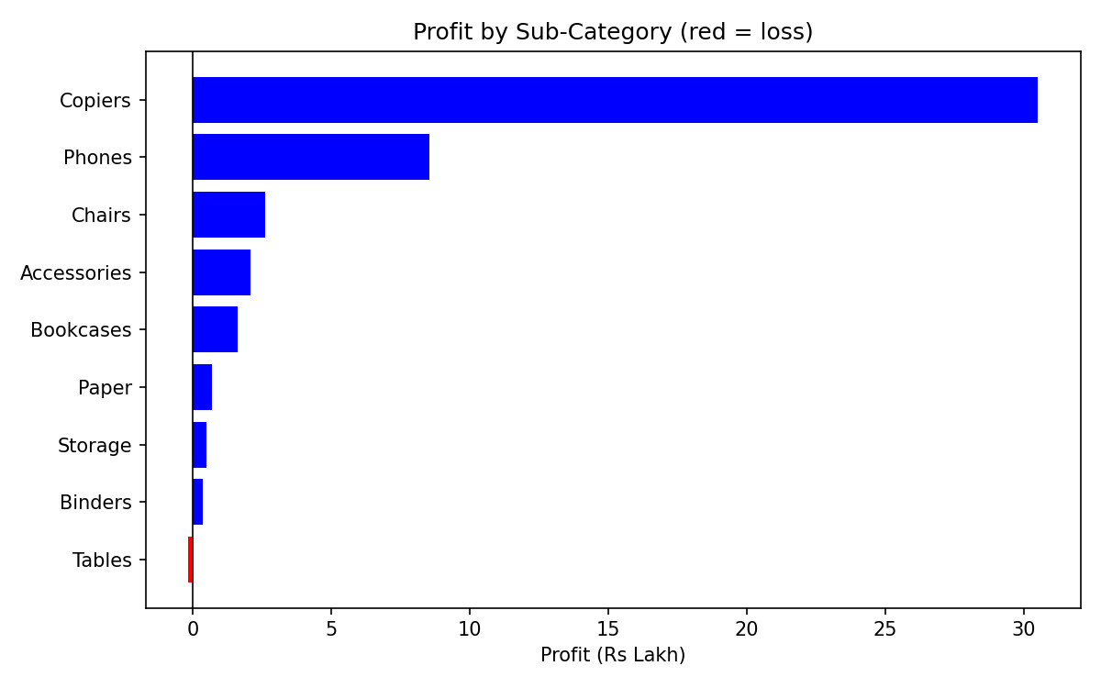
Chart 3: Profit by Sub-Category (red = loss)
Interpretation: Copiers (Rs 30.5 Lakh profit, 23.3% margin) and Phones are the profit drivers. Tables is the only loss-making sub-category, losing about Rs 16,577 on sales of Rs 48.4 Lakh. Bookcases also have a very low margin of 4.5%. The Tables loss comes from discounts: Tables made a profit only on orders with no discount, and lost money at every discount level from 10% upwards.

9. Monthly Sales Trend
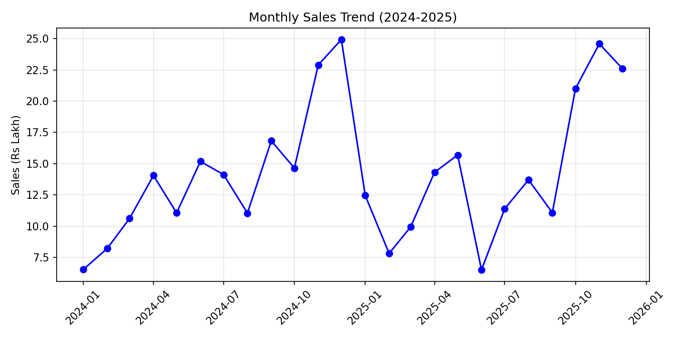
Chart 4: Monthly Sales Trend 2024-2025 (Rs Lakh)
Interpretation: Sales follow a clear seasonal pattern. The three months from October to December are the strongest in both years. December 2024 was the peak month with Rs 24.9 Lakh, and November 2025 was close with Rs 24.6 Lakh. Early-year months such as January and February are weak. This pattern probably reflects festival and year-end buying.
The business should keep more stock and staff ready before October, and plan promotions for the slow months.

10. Discount Analysis
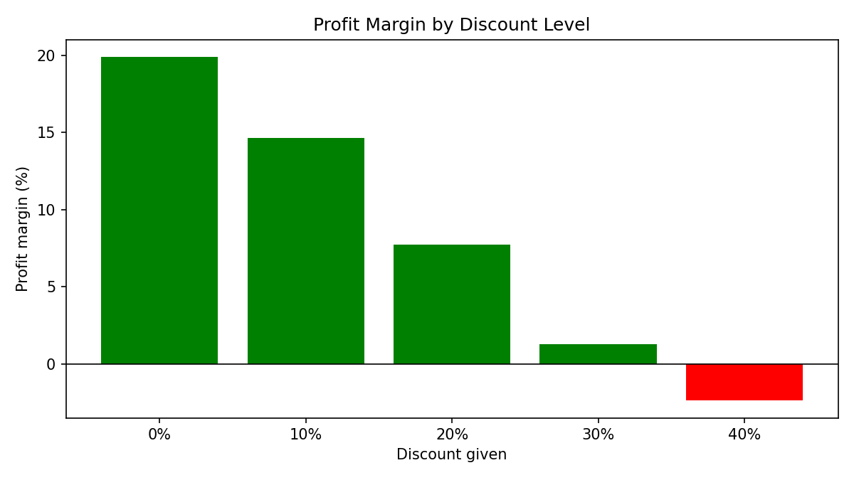
Chart 5: Profit Margin by Discount Level
Discount | Orders | Sales (Rs Lakh) | Profit (Rs Lakh) | Margin %
0% | 667 | 162.1 | 32.3 | 19.9
10% | 303 | 74.1 | 10.9 | 14.7
20% | 235 | 48.3 | 3.7 | 7.7
30% | 184 | 36.1 | 0.5 | 1.3
40% | 111 | 20.6 | -0.5 | -2.4

Interpretation: This is the most important finding. Every extra 10% of discount reduces the margin sharply. At 30% the business almost earns nothing (1.3%), and at 40% it loses money. Orders with 30% or 40% discount make up about 20% of all orders but bring only Rs 0.5 Lakh combined profit on Rs 56.7 Lakh of sales.

11. Customer Analysis
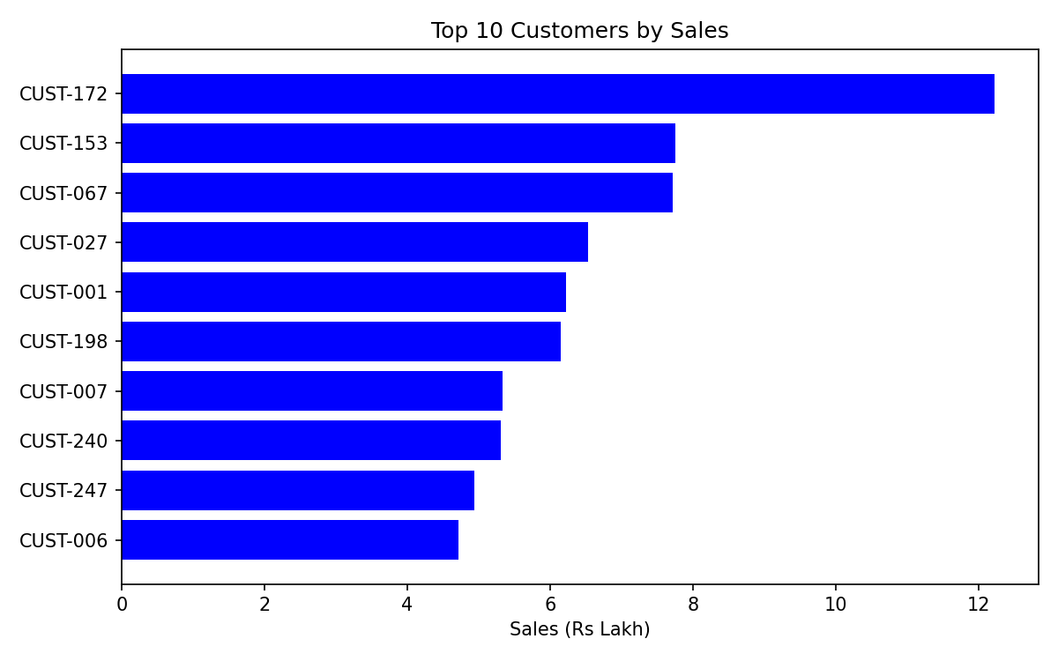
Chart 6: Top 10 Customers by Sales (Rs Lakh)
Interpretation: CUST-172 is the biggest customer with Rs 12.2 Lakh of sales, far ahead of the second customer (Rs 7.7 Lakh). The top 10 customers together give about 19.6% of total sales, so the business is not too dependent on a few buyers, but these customers deserve special care such as loyalty offers and priority service.

Segment View
Segment | Sales (Rs Lakh) | Profit (Rs Lakh) | Margin %
Consumer | 182.9 | 25.3 | 13.8
Corporate | 107.6 | 13.7 | 12.8
Home Office | 50.7 | 7.7 | 15.3

12. Key Findings
- Total sales are Rs 341.2 Lakh with a profit of Rs 46.8 Lakh (13.7% margin).
- Sales and profit were almost flat from 2024 to 2025.
- West is the top region by sales; South has the best margin (15.6%).
- Technology gives 64.3% of sales and about 88% of profit.
- Furniture sells well but earns only 3.7% margin.
- Tables is the only loss-making sub-category.
- Discounts reduce margin from 19.9% (no discount) to -2.4% (40% discount).
- October to December is the peak season; December 2024 was the best month.
- The top 10 customers give about 19.6% of sales.

13. Recommendations
- Limit discounts to 20%. Discounts of 30% and above give almost no profit or a loss.
- Review Tables pricing. Stop discounting this sub-category or raise its price.
- Promote high-margin products such as Copiers, Paper and Binders.
- Prepare for the October-December season with enough stock, and run offers in weak months.
- Reward top customers to retain them, especially CUST-172.
- Learn from the South region and apply its practices in the East and North.

14. Limitations
- The dataset is a sample prepared for academic use and not the records of a real company.
- The analysis is descriptive: it explains what happened but does not predict the future or prove the cause.
- Only two years of data are available, so long-term trends cannot be judged.
- Costs such as rent, salaries and marketing are not included in the profit column.

15. Conclusion
This project showed how simple descriptive analytics in Python can turn 1,500 order records into clear business insights. The business is profitable overall, but its growth is flat and its profit is badly affected by deep discounts and by a few weak products such as Tables. By controlling discounts, focusing on Technology products and preparing for the festive season, the business can improve profit without needing more sales.
As a next step, the same dataset can be used for predictive analytics, for example forecasting monthly sales or predicting which orders will make a loss.

Appendix: Python Code
The complete analysis code (retail_sales_analysis.py) is submitted along with this report. Main parts are shown below.
import os
import pandas as pd
import matplotlib.pyplot as plt

os.makedirs("charts", exist_ok=True)

# STEP 1: LOAD THE DATASET

df = pd.read_csv("retail_sales.csv", parse_dates=["Order Date"])

print("First 5 rows:")
print(df.head())
print("\nRows and columns:", df.shape)

# STEP 2: CLEAN THE DATA

print("\nMissing values in each column:")
print(df.isnull().sum())
print("Duplicate rows:", df.duplicated().sum())

df = df.drop_duplicates() # remove duplicate rows
df["Discount"] = df["Discount"].fillna(0) # missing discount = no discount
print("Rows after cleaning:", len(df))

# STEP 3: KEY NUMBERS (KPIs)

total_sales = df["Sales"].sum()
total_profit = df["Profit"].sum()
total_orders = df["Order ID"].nunique()

print("\n--- KPIs ---")
print("Total Sales : Rs", round(total_sales / 100000, 1), "Lakh")
print("Total Profit : Rs", round(total_profit / 100000, 1), "Lakh")
print("Profit Margin :", round(total_profit / total_sales * 100, 1), "%")
print("Total Orders :", total_orders)

# STEP 4: ANALYSIS

# By region
region = df.groupby("Region")[["Sales", "Profit"]].sum()
region["Margin %"] = region["Profit"] / region["Sales"] * 100
print("\n--- By Region ---")
print(region.round(1))

# By category
category = df.groupby("Category")[["Sales", "Profit"]].sum()
category["Margin %"] = category["Profit"] / category["Sales"] * 100
print("\n--- By Category ---")
print(category.round(1))

# By sub-category
...

