**A PROJECT REPORT ON**

**“SMART ATTENDANCE SYSTEM”**

SUBMITTED TO UNIVERSITY

IN THE PARTIAL FULFILLMENT OF THE REQUIREMENTS

FOR THE AWARD OF THE DEGREE

OF

## BACHELOR OF ENGINEERING (COMPUTER ENGINEERING)

## SUBMITTED BY

**Student Name:**

## DEPARTMENT OF COMPUTER ENGINEERING

## 2021 -2022

**CERTIFICATE**

This is to certify that the project report entitles

**“SMART ATTENDANCE SYSTEM”**

Submitted by

**NAME**

is a bonafide student of this institute and the work has been carried out by him/her under the supervision of **Prof.** and it is approved for the partial fulfillment of the requirement of NAME OF UNIVERSITY, for the award of the degree of **Bachelor of Engineering** (Computer Engineering).

## NAME NAME

Guide, HOD,

Department of Computer Engineering Department of Computer Engineering

**NAME**,

Principal,

**CLG NAME**

Place:

Date :

# ACKNOWLEDGEMENT

It gives us great pleasure in presenting the preliminary project report on Cloud Based Smart Attendance System. I would like to take this opportunity to thank my guide Prof. NAME and Project coordinator Prof. NAME for giving me all the help and guidance we needed. We are really grateful to them for their kind support. Her valuable suggestions were very helpful. We also grateful to NAME, Head of Computer Engineering Department for his indispensable support, suggestions.

# NAME OF THE STUDENTS

**ABSTRACT**

Traditional class attendance registration relies on professor roll-calling, sign-in, and other inefficient methods. Despite the fact that facial recognition has been increasingly popular at home and abroad in recent years, there is no effective application system for this purpose on Chinese university campuses. The paper describes the CBCA System, which is an automatic class attendance registering system based on face detection and identification on cloud computing. Students simply need to stand in front of the camera for a few seconds to sign in, and sign-in data can be recorded in a local or central database. This technique considerably aids teachers in improving class roll-calling efficiency. Furthermore, rather than wasting time, pupils can concentrate on the content of the lesson. We discovered that the programmed is adaptable, trustworthy, and achieves a 100% recognition rate in real-time after a few months of use for various classes. Cloud computing, face recognition, and automatic attendance are all terms that come to mind when thinking about cloud computing.

**Index**- Cloud technology, fingerprint module, pc, microcontroller.

**TABLE OF CONTENTS**

LIST OF ABBREVATIONS.................................................................................i

LIST OF FIGURE………………………………………………………………..ii

LIST OF TABLES……………………………………………………………….iii

|  |  |  |  |  |
| --- | --- | --- | --- | --- |
| **Sr. No.** | | **Title of Chapter** | | **Page No.** |
| **01** | | **Introduction** | | 02 |
|  | 1.1 | Overview | | 02 |
|  | 1.2 | Motivation | | 03 |
|  | 1.3 | Problem Definition and Objectives | | 03 |
|  |  |  | |  |
|  |  |  | |  |
| **02** | | **Literature Survey** | | 04 |
| **03** | | **Software Requirements Specification** | | 04 |
|  | 3.1 | Assumptions and Dependencies | | 05 |
|  | 3.2 | Functional Requirements | | 06 |
|  |  | 3.2.1 | System Feature 1(Functional Requirement) |  |
|  |  | 3.2.2 | System Feature2 (Functional Requirement) |  |
|  |  |  | …… |  |
|  |  |  | …… |  |
|  | 3.3 | External Interface Requirements (If Any) | | 06 |
|  |  | 3.3.1 | User Interfaces | 06 |
|  |  | 3.3.2 | Hardware Interfaces | 06 |
|  |  | 3.3.3 | Software Interfaces | 08 |
|  |  | 3.3.4 | Communication Interfaces | 08 |
|  | 3.4 | Nonfunctional Requirements | | 08 |
|  |  | 3.4.1 | Performance Requirements | 09 |
|  |  | 3.4.2 | Safety Requirements | 09 |
|  |  | 3.4.3 | Security Requirements | 09 |
|  |  | 3.4.4 | Software Quality Attributes |  |
|  | 3.5 | System Requirements | | 09 |
|  |  | 3.5.1 | Database Requirements | 09 |
|  |  | 3.5.2 | Software Requirements (Platform Choice) | 10 |
|  |  | 3.5.3 | Hardware Requirements | 10 |
|  | 3.6 | Analysis Models: SDLC Model to be applied | | 11 |
| **04** | | **System Design** | | 12 |

|  |  |  |  |  |
| --- | --- | --- | --- | --- |
|  | 4.1 | System Architecture | | 12 |
|  | 4.2 | Mathematical Model | | 12 |
|  | 4.3 | Data Flow Diagrams | | 14 |
|  | 4.4 | Entity Relationship Diagrams | | 14 |
|  | 4.5 | UML Diagrams | | 16 |
| **05** | | **Project Plan** | | 18 |
|  | 5.1 | Project Estimate | | 19 |
|  |  | 5.1.1 | Reconciled Estimates | 22 |
|  |  | 5.1.2 | Project Resources | 22 |
|  | 5.2 | Risk Management | | 21 |
|  |  | 5.2.1 | Risk Identification |  |
|  |  | 5.2.2 | Risk Analysis |  |
|  |  | 5.2.3 | Overview of Risk Mitigation, Monitoring, Management |  |
|  | 5.3 | Project Schedule | | 22 |
|  |  | 5.3.1 | Project Task Set | 22 |
|  |  | 5.3.2 | Task Network | 23 |
|  |  | 5.3.3 | Timeline Chart | 25 |
|  | 5.4 | Team Organization | | 26 |
|  |  | 5.4.1 | Team structure | 26 |
|  |  | 5.4.2 | Management reporting and communication | 27 |
| **06** | | **Project Implementation** | | 28 |
|  | 6.1 | Overview of Project Modules | | 28 |
|  | 6.2 | Tools and Technologies Used | | 29 |
|  | 6.3 | Algorithm Details | |  |
|  |  | 6.3.1 | Algorithm 1 |  |
|  |  | 6.3.2 | Algorithm 2 |  |
|  |  | 6.3.3 | … | 30 |
| **07** | | **Software Testing** | | 30 |
|  | 7.1 | Type of Testing | |  |
|  | 7.2 | Test cases & Test Results | |  |
| **08** | | **Results** | | 32 |
|  | 8.1 | Outcomes | |  |
|  | 8.2 | Screen Shots | |  |
| **09** | | **Conclusions** | | 33 |
|  | 9.1 | Conclusions | | 33 |
|  | 9.2 | Future Work | | 33 |
|  | 9.3 | Applications | | 33 |
|  | | **Appendix A**: Problem statement feasibility assessment using, satisfiability analysis and NP Hard, NP-Complete or P type using modern algebra and relevant mathematical models.  **Appendix B**: Details of paper publication: name of the conference/journal, comments of reviewers, certificate, paper.  **Appendix C**: Plagiarism Report of project report. | | 34  36 |
|  | | **References**  Thomas Noltey, Hans Hanssony, Lucia Lo Belloz,”Communication Buses for Automotive Applications” In *Proceedings of the* 3rd *Information Survivability Workshop (ISW-2007)*, Boston, Massachusetts, USA, October 2007. IEEE Computer Society. | |  |

# LIST OF ABBREVATIONS

|  |  |
| --- | --- |
| **ABBREVIATION** | **ILLUSTRATION** |
| VPN | Virtual Private Network |
| IP | Internet Protocol |
| IDS | Intrusion Detection System |
| TCP | Transmission Control Protocol |

**LIST OF FIGURES**

|  |  |  |
| --- | --- | --- |
| **FIGURE** | **ILLUSTRATION** | **PAGE NO.** |
| 1.1 | System Overview | 3 |
| 1.2 | System Behavior | 5 |
| 2.1 | TCP Header | 11 |
| 4.1 | Waterfall Model | 27 |
| 4.2 | Timeline Chart | 30 |
| 4.3 | DFD Level | 14 |
|  |  |  |
|  |  |  |
| 4.4 | Use case Diagram | 15 |
| 4.5 | Sequence Diagram | 15 |
| 4.6 | ER Diagram | 16 |
| 4.7 | Class Diagram | 16 |
| 4.8 | Component Diagram | 17 |
|  |  |  |
| 4.9 | State Machine Diagram | 17 |

# LIST OF TABLES

|  |  |  |
| --- | --- | --- |
| **TABLE** | **ILLUSTRATION** | **PAGE NO.** |
| 4.1 | Project Plan | 21 |
| 3.1 | Packet Information | 47 |
| 3.2 | Network Error | 48 |
| 3.3 | IP Configuration | 49 |

**1.INTRODUCTION**

A common research challenge for computer programmers is human identification and authentication. Face recognition, iris recognition, retina scan, voice recognition, fingerprint, signature, and voice analysis are only a few examples of biometric authentication. Face recognition in one of the easy and the powerful method which can be implemented in numerous industries for the Identification process since it is non-contact process. One of the applications in which the facial recognition technology provides a rapid reaction is the automatic attendance maintaining system.

Various authors have presented various solutions for resolving the standard chaotic classroom attendance management system. The system is set up in such a way individually in order to ensure that that attendance is created for each student ivy complete their course and classes. There are more records in the database. Correct, and the statistical analysis reports the findings date-by-date, course-by course, major-by-major, and instructor by instructor. Many automated technologies exist in the field that o identify capture the faces of the students and then attempt t and store them. A system called the CBCA System is proposed in this research that can provide 100 percent accuracy in recognition, which is a huge difficulty for many systems developed on their own DNN (Deep Neural Networks).

Instead of constructing our own DNN, cloud AI is used to do face training registration and recognition to achieve the accuracy. Unlike previous similar systems presented in China, our method uses a video camera to capture each student's face one at a time, rather than using the entire classroom picture as an input image and attempting to recognize all of the faces in the picture. It can considerably enhance the recognition rate by removing the effects of light conditions, a variable angle, and other factors on the quality of the image obtained. It simply takes a few seconds to complete the process.

**1.2 MOTIVATION**

Recognition, as well as to successfully compare the methods used by each attendance system. The most important aspects of this system would be the modeling and interfacing of the electrical hardware. The obtained parameters and design values (results) will aid in the implementation of the design on hardware.

**1.3 PROBLEM DEFINITION.**

At the moment, most of the attendance systems that are being used in universities still are written a piece of paper. For classes, tutorial and laboratory session the student still have to sign the signature on the attendance sheet. This method is not flexible because the risk of losing the attendance data is very high. If the attendance sheet is missing, the attendance data will be lost. Other than that, unethical problem may be occurring such as cheating in his class but his attendance form has been signature. For example, a student does not attend signed by other these problems. Student. This system is proposed to overcome besides that, since the proposed system also record the time, the lecturer can monitor the punctuality of the students too.

**2 . LITERATURE SURVEY.**

1] Paper Name - cloud-based class attendance record system

Author name - Huimin Zhang, Xinlei Feng, Hongyu Liu, Ping Guo, Sujatha Krishnamurthy, Changing Zhang.Traditional class attendance registration relies on professor roll-calling, sign-in, and other inefficient methods. Despite the fact that facial recognition has been increasingly popular at home and abroad in recent years, there is no effective application system for this purpose in Chinese university campuses. The paper outlines a system for automatically recording class attendance. A common research challenge for computer programmers is human identification and authentication. Face recognition, iris recognition, retina scan, voice recognition, fingerprint, signature, and voice analysis are just a few examples of biometric authentication.

2] Paper Name - Cloud Based Smart Attendance System for Educational Institutions

Author Name - Vikas Yadav, G. P. Bhole.The Internet of Things (IoT) is fast transforming how we communicate with one another and obtain information about ourselves and the world around us. Smart Transportation, Smart Energy, Smart Healthcare, and Smart Waste Management are just a few of the domains where IoT has been shown to be cost-effective and efficient in addressing underlying issues and flaws. The Internet of Things has seen steady expansion and interest as the cost of computing devices, sensors, and internet has decreased.

3] Paper Name -A Class Attendance System Based on SL4A.

Author name - Yiliang Xing The fact that android phones are being used to boost classroom attendance and contact between professors and students is critical to improving the study style. Although a web-based class attendance system can improve the efficiency of verifying attendance, it also diminishes teacher-student engagement. It is critical to boost students' classroom attendance at Higher Vocational Colleges in order to improve the study style. The traditional paper attendance and Web attendance systems have very low work efficiency.

4] Paper Name - Proposal of an Efficient Approach to Attendance Monitoring System using Bluetooth. Author name - Rishi Raj, Abhinav Das, Sub hash Chand Gupta.With a Bluetooth attendance tracking system, professors and staff will be able to freely go to class without carrying a physical attendance register and mark the attendance of students seated within the classroom with just a tap. In this approach, a model is proposed based on the fundamental concepts of web apps and app development, which will be implemented in order to meet the proposal's goals. Time management is the most critical part of every job in today's competitive environment. The majority of time in classroom sessions is devoted to taking attendance, which is frequently inaccurate. Taking attendance is challenging and time-consuming when dealing with large groups of pupils or employees.

5] Paper Name - Development of Environmental Management in South Korea: Practice of Industrial Waste Processing. Author Name - O.А. Shvetsova.By using the Pacific-Asian region as an example, the article explores the theoretical and practical aspects of industrial waste management in industrialiser countries. The difficulties of establishing a system for monitoring and supervising the disposal of industrial wastes are being researched. The latest technologies used by South Korean businesses in the field of industrial waste processing are investigated. South Korea's quick industrialization is characterized by three characteristics: the state's authoritarian control of the industrial sector, export-driven heavy industry's high rate of economic growth, and rapid capital accumulation [1]. Heavy industries, in particular, had a major environmental impact.

**3**. **SOFTWARE REQUIREMENTS SPECIFICATION**

**3.1 INTRODUCTION**

**3.1.1 Project scope**

Automated time and attendance marking system can help schools and higher education in many ways. There is no doubt that an attendance management system will help save time and money by eliminating plenty of manual processes involved in attendance and leave entry and calculating hours attended. With automatic class attendance system, teachers can more accurately and quickly track student's time in the classroom. Here are the top ten advantages of implementing time & attendance management solution: Reduce paperwork and save time and money with mobile and nfc-based attendance management system Eliminate duplicate data entry and errors in time and attendance entries. Improve visibility to track and manage student attendance & absenteeism across multiple campuses. Iv. Real-time status tracking of leave request. Automatic calculation of leave and reward points accrued. Vi. Easy attendance recording using rfid & nfc-based attendance system. Track the attendance of teachers and staff, assign work and manage allocation. Keep the parents informed about the student’s performance via email & sms alerts. Ix. Auto-generate various types of reports of class or student attendance. Increased security and confidentiality with role-based permissions to users

**3.1.2 USE CLASSES AND CHARACTERISTICS**

Our system is divided into two class/modules:

* user
* system

**3.1.3 ASSUMPTIONS AND DEPENDENCIES**

* User must have the knowledge of web based application.
* User must have the knowledge of English.
* User must have all required software to run the application.
  1. **SYSTEM IMPLEMENTION PLAN**

**1. Requirement gathering and analysis:**

In this step of waterfall we identify what are various requirements are need for our project such are software and hardware required, database, and interfaces and first of all collect online all Paper and analysis the all paper

**2. System Design:**

In this system design phase we design the system which is easily understood for end user i.e. user friendly. We design some UML diagrams and data flow diagram to understand the system flow and system module and sequence of execution. System design in which the all web pages for example that login, registration, forget-password, contact etc.

**3. Implementation:**

In implementation phase of our project we have implemented various module required of successfully getting expected outcome at the different module levels. With inputs from system design, the system is first developed in small programs called units, which are integrated in the next phase. Each unit is developed and tested for its functionality which is referred to as Unit Testing.

**4. Testing:**

The different test cases are performed to test whether the project module are giving expected outcome in assumed time. All the units developed in the implementation phase are integrated into a system after testing of each unit. Post integration the entire system is tested for any faults and failures.

**5. Deployment of System:**

Once the functional and nonfunctional testing is done, the product is deployed in the customer environment or released into the market.

**6. Maintenance:**

There are some issues which come up in the client environment. To fix those issues patches are released. Also to enhance the product some better versions are released. Maintenance is done to deliver these changes in the customer environment. All these phases are cascaded to each other in which progress is seen as flowing steadily downwards like a waterfall through the phases. The next phase is started only after the defined set of goals are achieved for previous phase and it is signed off, so the name "Waterfall Model". In this model phases do not overlap.

**3.3 EXTERNAL INTERFACE REQUIREMENTS**

* + 1. **USER INTERFACES**

The requirements section of hardware includes minimum of 16 GB hard disk and 2 GB RAM with 1 GHz or higher speed. The primary requirements include a memory of 4GB.

* + 1. **HARDWARE INTERFACES**

**METHODOLOGY**

1) Rfid reader:

Full form of rfid is ― identification of radio frequency'. Wireless communication between rfid and rfid reader tags is used. Line of sight contact with tags is not expected by the reader. This ensures that the rfid tag is identified by the scanner, even though there is an object between the card and the reader it is, therefore, a non-contact type of reader. Our reader's radio frequency is 125 kHz, which is a low frequency (lf). The serial port is used to connect the rfid reader with the microcontroller. The rfid reader will communicate through serial communication with the microcontroller. If the rfid tag is in the reader module set, then the rfid reader detects the rfid card. And the rfid reader sends out a sequence of special alphanumeric codes to the serial port at that time. Then by inserting the number of the staff/student card in the memory of the program. First, we need to store this alphanumeric code sequence in program memory, and later on, the incoming card number will be matched with this special series of codes. The rfid card reader module includes a 9 volt power supply and the db9 connector port provides the output.

1. Face Detection:

Start capturing images through web camera of the client side: Begin:

Pre-process the captured image and extract face image

Calculate the Eigen value of the captured face image and compared with beige

n values of existing faces in the database.

If Eigen value does not matched with existing ones, save the new face image information to the face database (xml file). If Eigen value matched with existing one then recognition step will done.

1. Face recognition:

Using pca algorithm the following steps would be followed in for face recognition: begin:

Find the face information of matched face image in from the database. Update the log table with corresponding face image and system time that makes completion of attendance for an individual students. End; this section presents the results of the experiments conducted to capture the face into a grey scale image of 50x50 pixels.

3. Biometric Attendance

A System is a highly specialized system that records students’ attendance by comparing a single fingerprint image with the fingerprint images previously stored in a database. The Biometric Identification system uses the principle behind the AFAS. This proposed attendance management system uses biometric identification. This system compares an individual’s biometrics with every record present in the database. In general, biometric recognition consists of two stages: i. Enrollment and ii. Authentication During enrollment process the fingerprint of the user is captured with unique features and stored in a database with the student ID. During checking, the fingerprint of the user is sensed again and the stored data are compared with the records present in database. All data and information required for the proper recording of attendance are stored in database. The lecturer selects the course code and the attendance type, then the student places his/her fingerprint on the fingerprint reader; the finger with those stored in the database. The system successfully takes the attendance both at lectures as well as examinations. The prototype captures new fingerprint to be stored in the record; scanned fingerprint placed on the device sensor and compared them against those stored in the database successfully.

* + 1. **SOFTWARE INTERFACES**

This is the software configuration in which the project was shaped. The programming language used, tools used, etc. are described here.

* Operating System : Windows
* Front End : html, css, bootstrap, python, Java script.
* Tool : Sublimetext3,python
* Database : MySQL
  + 1. **COMMUNICATION INTERFACES**
* User can access the web application from remote location.
* Standard internet connection is required.

TCP/UDP connection will be required.

**3.4NONFUNCTIONAL REQUIREMENTS**

* + 1. **PERFORMANCE REQUIREMENTS**
* High Speed: System should process requested task in parallel for various action to give quick response. Then system must wait for process completion.
* Accuracy: System should correctly execute process, display the result accurately. System output should be in user required format.
  + 1. **SECURITY REQUIREMENTS**

Secure access of confidential data (user’s details).

Information security means protecting information and information systems from

* + 1. **SAFETY REQUIREMENTS**

The data safety must be ensured by arranging for a secure and reliable transmission media. The source and destination information must be entered correctly to avoid any misuse or malfunctioning. Password generated by user is consisting of characters, special character & number so that password is difficult to hack. So, that user account is safe.

* + - Unauthorized access, use, disclosure, disruption, modification or destruction.
    - The terms information security, computer security and information assurance are frequently incorrectly used interchangeably. These fields are interrelated often and share the common goals of protecting the confidentiality, integrity and availability of information; however, there are some subtle differences between them.
    - User password must be stored in encrypted form for the security reason
    - All the user details shall be accessible to only high authority persons.
    - Access will be controlled with usernames and passwords.
    1. **SOFTWARE QUALITY ATTRIBUTES**

1. Availability [related to Reliability]
2. Modifiability [includes portability, reusability, scalability]
3. Performance
4. Security
5. Testability

6. Usability [includes self-adaptability and user adaptability.

* 1. **SYSTEM REQUIREMENTS**
     1. **DATABASE REQUIREMENTS**

MySQL: MySQL is an open-source relational database management system (RDBMS). Its name is a combination of “My”, the name of co-founders Michael Wideness’s daughter, and "SQL", the abbreviation for Structured Query Language. MySQL is free and open-source software under the terms of the GNU General Public License, and is also available under a variety of proprietary licenses.

* + 1. **SOFTWARE REQUIREMENTS**

Operating system : Windows 7 and above. Raspberry pi

Coding Language : Python,

IDE : Sublimetext3 Pycharm

* 1. **ANALYSIS MODELS: SDLC MODEL TO BE APPLIED**

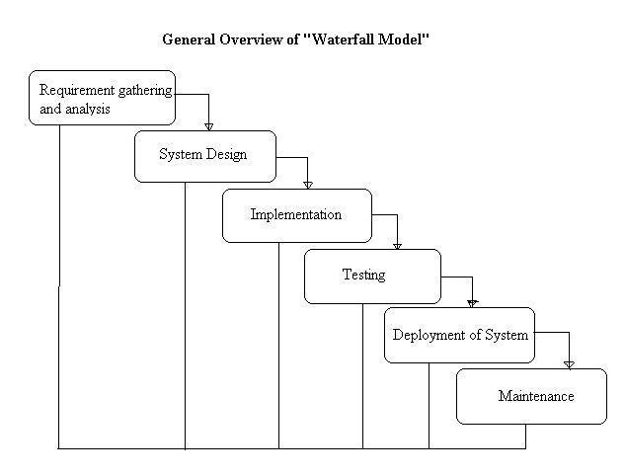

**4. SYSTEM DESIGN**

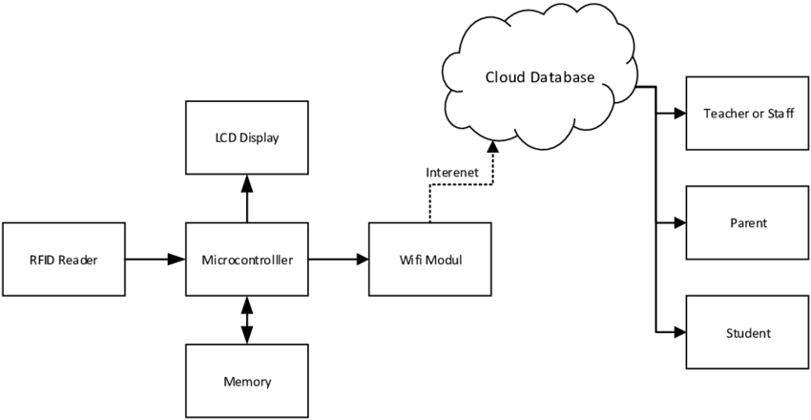

**Block diagram explanation:**

This module is used to designate each student's face with their ID number. The steps are as follows: a video camera records a student's face; using Open CV, send numerous face photos and labels (student ID, and school name) to cloud for training through JSON; cloud will manage the face data and complete the training registration procedure. Stop once you've received feedback from cloud. Each student will take a few seconds to complete this process. It is logical and Trustworthy. Module B: Face Recognition This module is used to keep track of student attendance. The steps are as follows cloud will do face recognition based on the face data on the cloud side,and give back results through JSON, including recognition scores, recognized student ID, and so on. Step Depending on whether the results were recognized (we obtained the student ID) or not, we will proceed to the next step. For instance, storing the student's ID and other information in a local database, or telling the student that we are unable to recognize him or her. The explanation for this could be that he or she is not enrolled in this course or that his or her face has not yet been registered on the cloud side. Class roll is used to prevent students from signing up for the wrong class. Even if the system recognizes a student's face, if he or she is not registered in a class, the system will not keep his or her attendance record in the database.Because the face id recognition system with cloud solves such disadvantages, our approach is effective for occluded faces and some unfocused faces. Module for Voice Synthesis When a face is successfully detected, this module begins to work. The first time a student is recognized; the module will automatically create an MP3 file that says the student's name and play it to notify the student. This MP3 file information will be recorded in the database. If a student is detected for the second time, the module will obtain an MP3 file containing the student's name voice by using the address already entered in the database. Voice synthesis is a feature that notifies students after they have successfully signed up for a course. By delivering a string of the student's name to the platform, the module can obtain a byte array that represents the synthetic voice fragment. A converter and a media player are included in the module. The voice fragment is saved in MP3 format to a cache directory via an output file stream. The MP3 file is subsequently loadedand played via an input stream by the media player. The temporary files will notbe removed when the user closes the application; instead, they will be saved in a specific local directory, with the file name saved in the database. With this design, the speech synthesis module will not have to synthesize the same person's name again the following time the same student arrives. By referencing to the file name contained in the database, it can play the voice saved on the local disc. MySQL is used to create it.Displays the attendance system's four core tables: "checking table," "student," "course table," and "department." (We may need more tables in the future to handle more functionality.) The “checking table" database, as illustrated in, keeps track of a student's check-in date and time, as well as student id, course id, semester, and year.

**4.2 DATA FLOW DIAGRAMS**

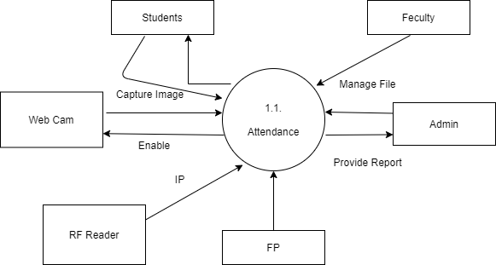

**4.3 USE CASE**

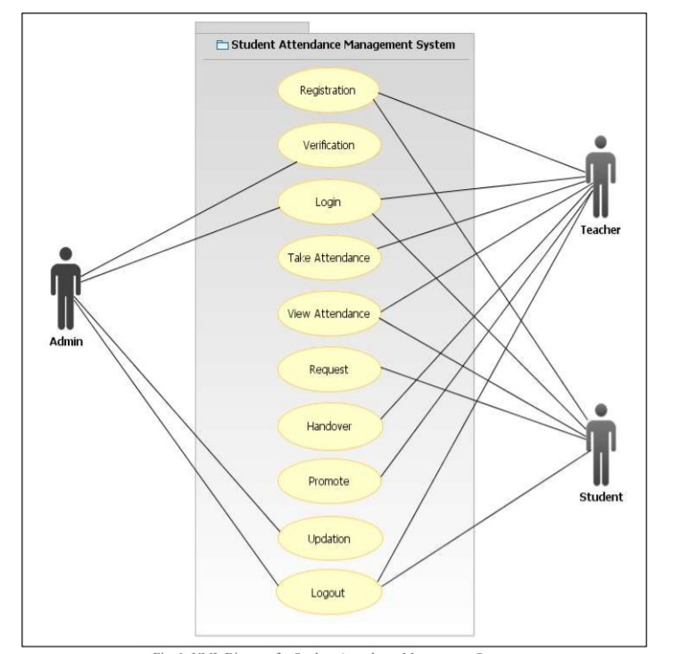

**4.4. Sequence Diagram.**

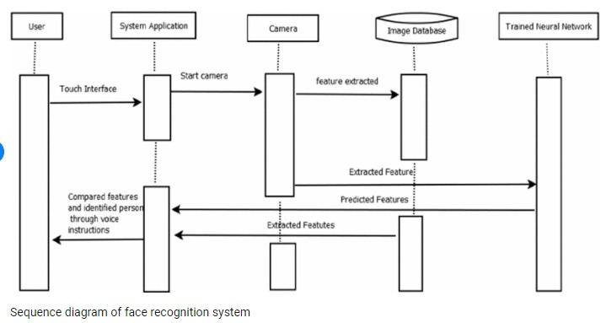

**6.5** **Entity Relationship Diagram**

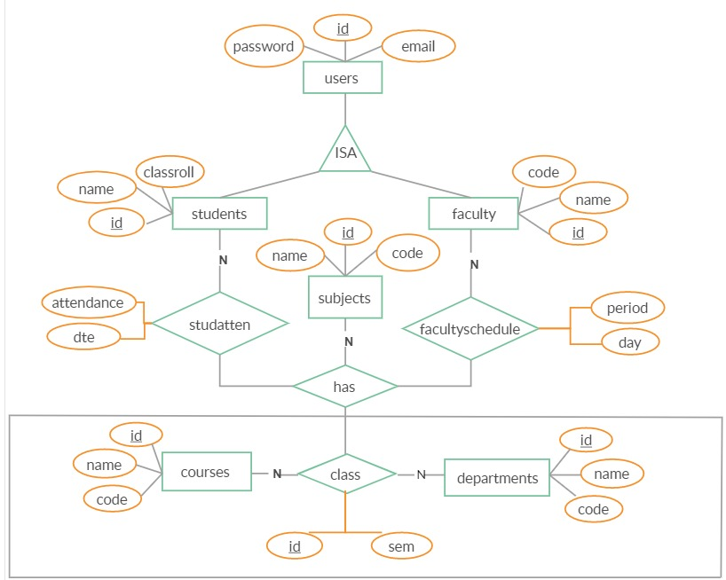

**4.6. Class Diagram**

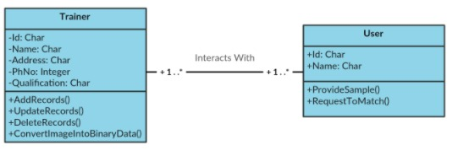

**4.7 Component Diagram**

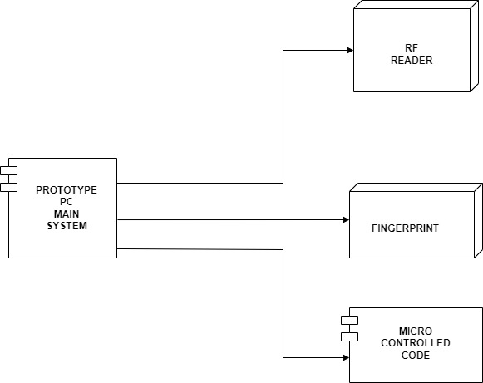

**4.8 State Diagram**

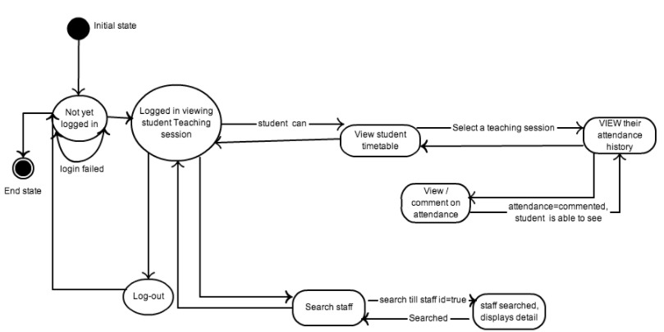

**5. PROJECT PLAN**

**5.1. Project Estimates**

The Iterative SDLC model does not need the full list of requirements before the project starts. The development process may start with the requirements to the functional part, which can be expanded later. The process is repetitive, allowing making new versions of the product for every cycle. Every iteration includes the development of a separate com-ponent of the system, and after that, this component is added to the functional developed earlier.

Speaking with math terminology, the iterative model is a realization of the sequential approximation method; that means a gradual closeness to the planned final product shape. The key to a successful use of an iterative software development life cycle is rigorous validation of requirements, and verification and testing of each version of the software against those requirements within each cycle of the model. As the software evolves through successive cycles, tests must be repeated and extended to verify each version of the software.

**The major steps of the SDLC model are given below:**

Requirement Gathering: All the functional and non-functional requirements of the project were identified. Interaction with the users and all other stakeholders of the project was conducted to identify all the requirements starting from important features like maintaining audit trail, security parameters etc. to the very basic features like the look and the feel of user interface. The different requirements mainly fall into categories:

– System features

– Database requirements

– Security parameters

– User requirements

– Administrator requirements

– User interface

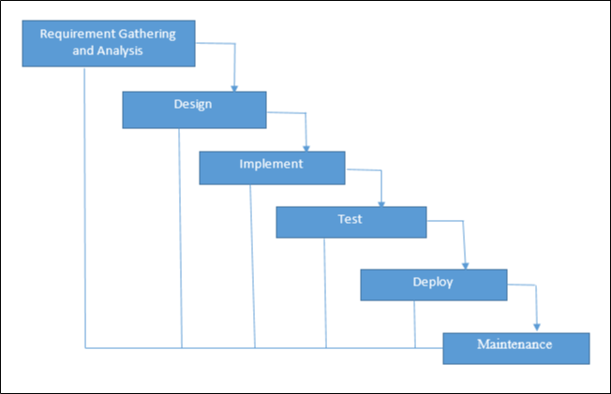

**5.2. Project Estimates**

The number of lines required for implementation of various modules can be estimated as follows:

|  |  |  |
| --- | --- | --- |
| Sr.No | Modules | KLOC |
|  |  |  |
| 1 | Graphical User Interface | 1.80 |
|  |  |  |
| 2 | User authentication Code | 0.80 |
|  |  |  |
| 3 | Device Drivers | 30.60 |
|  |  |  |
| 4 | Interfacing Code | 40.70 |
|  |  |  |

Phase Description:

Thus the total number of lines required is approximately 3.90 KLOC

Efforts E = 3:2 (KLOC)(1:02)

E = 3:2 (3:90)(1:02)

E = 12:82person month

Development Time (In Months) D = E=N D = 12:82=5 D = 2:56months:

Number of Persons 5 persons are required to complete the project with given time span successful.



**Figure 5.1: Waterfall Model**

Design: The first step was database design. A complete database required for the implementation of this project was designed. The second step was project design. The project was designed based on a framework. The framework uses three layers:

– Business entities layer: It identifies all the entities used in the project.

– Business logic layer: This layer operates on the business entity to achieve the goals.

– Data access layer: This layer serves as an interface between backend and the services.

Construction: All modules and user interface was built in this step. Development was done using Java. Database was constructed in MySQL. Integration and system testing: All the modules were integrated together. The user interface was integrated with the modules which made the use web services. Data flow originated from the database built in MySQL. In testing phase project was tested and debugged. Various test cases were developed and the project was tested at the developers end as well as users end. Debugging was done to discover errors and exception which were corrected.

**5.2.1. Reconciled Estimates**

The results gathered from the various estimation techniques must be reconciled to produce a single estimate of effort, project duration, and cost

If widely divergent estimates occur, investigate the following cause’s b

– The scope of the project is not adequately understood or has been misinterpreted by the planner

– Productivity data used for problem-based estimation techniques is inappropriate for the application, obsolete (i.e., outdated for the current organization), or has been misapplied the planner must determine the cause of divergence and then reconcile the estimates

**5.2.1.1 Cost Estimate**

Line Of code (LOC) is 3500 (Appr.)

LOC in KLOC (Kiloes LOC) is 3.5 KLOC. Effort:

The Effort is calculated by formula. E=2.4*(KLOC)Lambda1.05 E=2.4*(3.5)Lambda1.05

E=8.94 Appr.

6.2.1.2 Time Estimates

The Development Time is calculated by formula.

D = 2.5*(E) Lambda0.38

D = 2.5*(8.94) Lambda0.38

D = 5.75 Appr.

**5.2.2 Project Resources**

The resource details include the following:

Skill Level: skills may be – , MySQL, HTML, CSS.

Quantity: This is simply the number of professionals needed for completing a task. Hours Required: According to project requirement we will conform hours.

Controller: Here we need admin as controller

**Risk Management w.r.t. NP Hard analysis**

Risk is inevitable in a business organization when undertaking projects. However, the project manager needs to ensure that risks are kept to a minimal. Risks can be mainly divided between two types, negative impact risk and positive impact risk. Not all the time would project managers be facing negative impact risks as there are positive impact risks too. Once the risk has been identified, project managers need to come up with a mitigation plan or any other solution to counter attack the risk.

**5.3 PROJECT SCHEDULE**

**5.3.1 Project Task Set**

Project is carried out in different phases. There are number of activity/tasks implemented in step by step. The time and graphical chart are tabled below.

|  |  |  |
| --- | --- | --- |
| Activity/task | Start date | End date |
| Collection of different topics & Topic finalization |  |  |
| Literature survey |  |  |
| Define scope |  |  |
| Start implementing the project |  |  |

**5.3.2 TASK NETWORK**

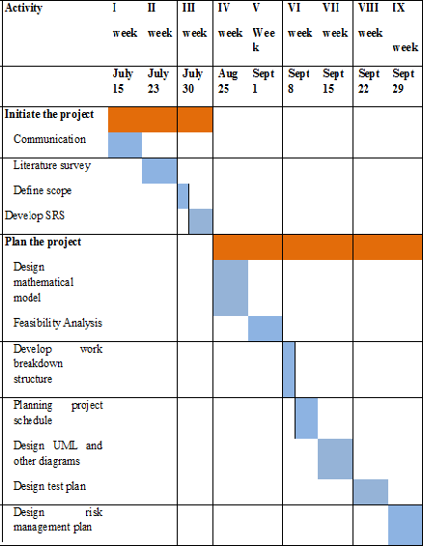

Steps carried out in performing the Simulation:-

1. **Planning:** - It’s about designing the model and planning the simulation its take 40% of time. Planning is essential for initiating our proposed work. It helps to get the details to plan the future estimates and implementation process. Data collection (literature survey) is one of the important process through which we get the relevant information for our project work. It also helps to get the process of analysis and to make comparative analysis.

**2. Implementation**: - It consumes 40% of the time.

Initialization: making the initial settings like setting the protocols and creating the variables

Result Generation: create and generates result and perform all operations like real system do

Post processing: The data collected from the Result generation is in the raw format, that data

will be processed and results are generated from it

**3. Testing**: We need to test whether the simulation result we got is matching to the real world or not and validate it. It takes 20% of the time.

**5.3.3TIMELINE CHART**

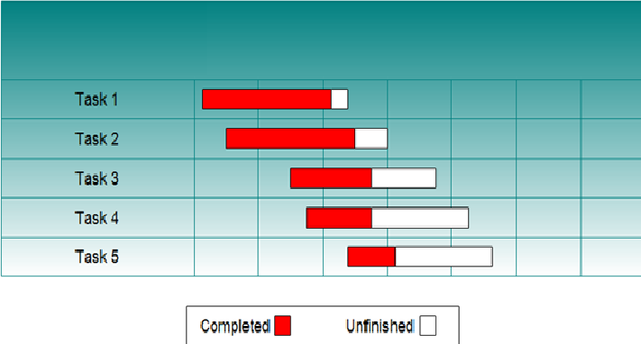

**Plan of Project Execution**

|  |  |  |  |
| --- | --- | --- | --- |
| **Schedule** | | **Date** | **Project Activity** |
| July | 1stWeek | 01/07/2021 | Formation Of Project Group |
| 2ndWeek | 08/07/2021 | Project Topic Selection |
| 3rd Week | 15/07/2021 | Synopsis Submission |
| August | 1stWeek | 05/08/2021 | Presentation On Project Ideas |
| 2ndWeek | 12/08/2021 | Submission Of Literature Survey |
| 3rd Week | 19/08/2021 | Feasibility Assessment |
| September | 1stWeek | 02/09/2021 | Documentation for paper publishing. |
| 3rdWeek | 16/09/2021 | Design Of Mathematical Model |
|  |  |  |
| October | 1stWeek | 07/10/2021 | Report Preparation And Submission |
| December | 3rdWeek | 19/12/2021 | 1stmodule presentation |
| 4thWeek | 26/12/2021 | Discussion and implementation of 2ndmodule |
| January | 1stWeek | 02/01/2022 | Preparation for ANEC conference |
| 2ndWeek | 09/01/2022 | Study of porter stemmer and tf algorithm. |
|  |  |  |
| 3rdWeek | 16/01/2022 | Discussion about modification to Improved K-means |
| 4thWeek | 23/01/202 | 1stand 2ndmodule presentation |
| 5thWeek | 30/01/2022 | Discussion on flow of project and designing new module |
| February | 1stWeek | 06/02/2022 | Modification of modules. |
| 2ndWeek | 13/02/2022 | Designed test cases for our module. |
| 3rdWeek | 20/02/2022 | Worked on user interface. |
| March | 1stWeek | 06/03/2022 | Integration of all modules. |
| 3rdWeek | 20/03/2022 | Final Report and presentation. |

**5.4 TEAM ORGANIZATION**

## TEAM ORGANIZATION

5.4 The team for B.E. final year project consists of a team of college students, a college professor as an internal guide and industry professionals as external guide making collaborative efforts for fulfillment and implementation of project problem statement.

### TEAM STRUCTURE

Each and every member of the team is responsible for the identification of problems, proposing problem solving methodologies, identifying approaches for implementation and documentation.

|  |  |
| --- | --- |
| Sr. No. | Member Responsibilities |
| 1 |  |
| 2 |  |
| 3 |  |
| 4 |  |
| 5 |  |

Prof. , is the internal college guide for providing through domain guidance, doubt removal and suggesting approaches and ensuring timely completion of activities.

### Management reporting and communication

We report the progress of our project to our internal guide twice a week. We show our weekly status to our guide and incorporate the necessary changes. We communicate among ourselves in case we want suggestions

**6. PROJECT MODULE**

**6.1 overview of Project Modules:**

This module is used to associate the face of each student with their ID number. The procedure is as follows: Using Open CV, send various face photos and labels (student ID, and school name) to the cloud for training through JSON; the cloud will manage the face data and finish the training registration method. Once you've received feedback from the cloud, come to a halt. This process will take a few seconds for each student to finish. It's rational and reliable. Face Recognition (Module B) The purpose of this module is to keep track of student attendance. The steps are as follows: On the cloud side, the cloud will do face recognition based on the face data. Stop once you've received feedback from cloud. Each student will take a few seconds to complete this process. It is logical and trustworthy. Module B: Face Recognition This module is used to keep track of student attendance. The steps are as follows cloud will do face recognition based on the face data on the cloud side,and give back results through JSON, including recognition scores, recognized student ID, and so on. Step Depending on whether the results were recognized (we obtained the student ID) or not, we will proceed to the next step. For instance, storing the student's ID and other information in a local database, or telling the student that we are unable to recognize him or her. The explanation for this could be that he or she is not enrolled in this course or that his or her face has not yet been registered on the cloud side. Class roll is used to prevent students from signing up for the wrong class. Even if the system recognizes a student's face, if he or she is not registered in a class, the system will not keep his or her attendance record in the database.

**6.2 TOOLS AND TECHNOLOGIES USED**

**1. Internet of Things**

The Internet of Things has seen steady expansion and interest as the cost of computing devices, sensors, and internet has decreased. At its foundation, the Internet of Things aims to solve real-world problems by providing sensing, processing, and networking capabilities to objects that would otherwise lack these capabilities. A Thing becomes an iot device when these characteristics are added, allowing it to communicate with external devices and transfer data to the outside world, allowing for smart data processing and autonomous decisions. As a result, the Internet of Things (iot) is playing an increasingly important role in the creation of various helpful applications in fields such as transportation, the environment, and health.

**2. Cloud Computing**

Cloud computing has ushered in a paradigm shift in the delivery of computer infrastructure, as well as the development and use of software applications. Cloud Computing is based on virtualization and dynamic provisioning of resources such as operating systems, database storage, and networking. There are numerous cloud service platforms that can meet a user's need for on-demand resource demands. With on-demand computing infrastructures including processors, storage, and networks paas is concerned with the development and deployment of cloud-based software applications, whereas saas is concerned with the direct use of cloud-based software applications without the need to download and install the application on a local machine. All three models will be used in the proposed system.

* 1. **ALGORITHM DETAILS**

1. We use LBPH (Local Binary Pattern Histograms) algorithm to detect faces. It labels the pixels of an image by thresholding the neighborhood of each pixel and considers the result as a binary number.
2. LPBH uses 4 Parameters :

(i) Radius : the radius is used to build the circular local binary pattern and represents the radius aorund the central pixels.

(ii) Neighbors : the number of sample points to build the circular local binary pattern.

(iii) Grid X : the number of cells in the horizontal direction.

(iv) Grid Y : the number of cells in the vertical direction.

3. The model built is trained with the faces with tag given to them, and later on, the machine is given a test data and machine decides the correct label for it.

**7. SOFTWARE TESTING**

**9.1 Type of Testing**

**1. Unit Testing**

**2. Integration Testing**

## Testing strategy

**1.Unit Testing:** Unit testing is a method by which individual units of source code, sets of one or more computer program modules together with associated control data, usage procedures, and operating procedures, are tested to determine if they are fit for use. The goal of unit testing is to isolate each part of the program and show that the individual parts are correct. A unit test provides a strict, written contract that the piece of code must satisfy. Units in the proposed system are display result form, command button etc.

**2. Integration Testing:** It takes as its input modules that have been unit tested, groups them in larger aggregates, applies tests defined in an integration test plan to those aggregates, and delivers as its output the integrated system ready for system testing.

**8. RESULT**

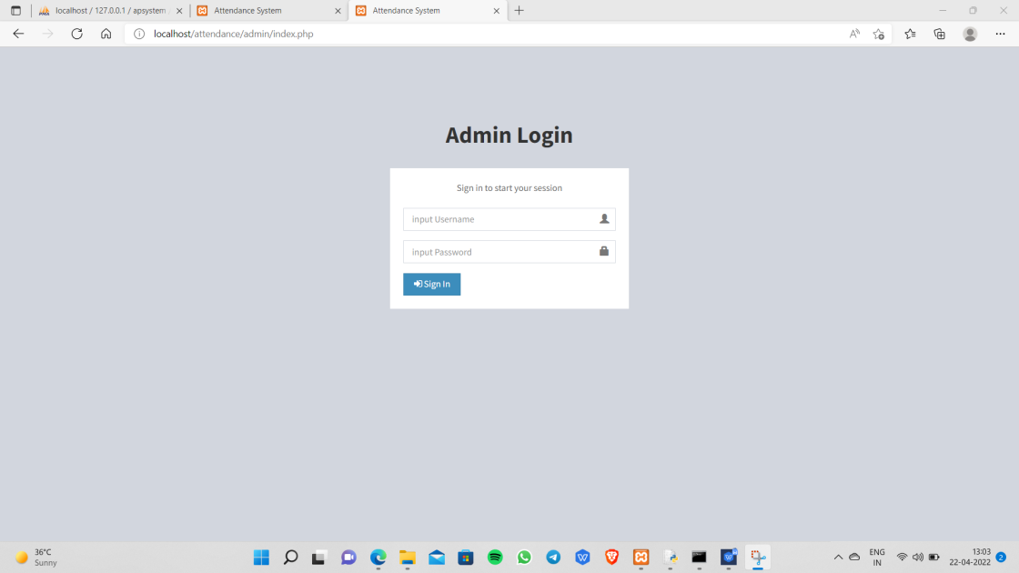

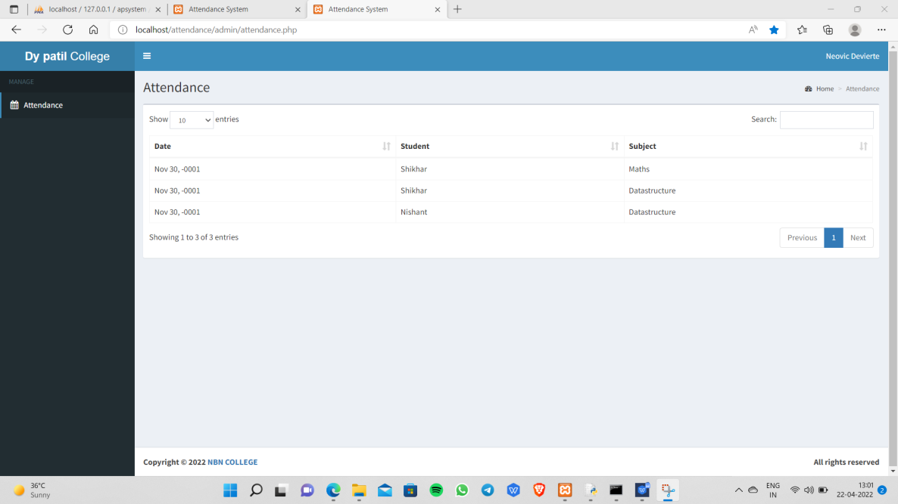

**9. CONCLUSIONS**

**9.1 CONCLUSION.**

### There are a few recommendations that might be taken into consideration in order to improve this system. To begin, we will improve the user interface based on user feedback to make it more user-friendly. Second, the system can send mobile warnings to students who have exceeded their absence limits or who have insufficient attendance information. Finally, we'll complete the mobile application client for attendance tracking. This cbca system based on face detection provided a more efficient and accurate approach for students to sign in and for teachers to analyses data. The system has been put to use and has met all of the design specifications. In the future, we will continue to improve the system and promote it in new industries.

### 9.2 FUTURE SCOPE.

We can integrate a voice announcement system into the current project. As a result, if a user logs in, we will display a message such as "Your group activity has been logged in" or "Your card is invalid." The user will receive this information via the internet. In order for the user to be able to access it remotely via the internet. We are going to use GSM technology. In general, we use Haar's Classifier and Eigen face symbol together; but, in the near future, we will use them separately. PIFR (Pose-Invariant Face Recognition) will be used in conjunction with high-definition cameras. PIFR requires CMU-PIE information in order to save sample images. It will recognize a face in any situation, for any reason, and with any emotion. In the near future, gilded tags and high-capacity readers will frequently be utilized as a substitute for present RFID readers to reinforce the varying of readers to fifty meters.

* 1. **APPLICATION.**

1. School.

2. Collage.

3. Classes.

4. Industry.

**APPENDIX A:**

**RISK MANAGEMENT W.R.T. NP HARD ANALYSIS**

Risk is inevitable in a business organization when undertaking projects. However, the project manager needs to ensure that risks are kept to a minimal. Risks can be mainly divided between two types, negative impact risk and positive impact risk. Not all the time would project managers be facing negative impact risks as there are positive impact risks too Once the risk has been identified, project managers need to come up with a mitigation plan or any other solution to counter attack the risk.

**What is P?**

P is set of all decision problems which can be solved in polynomial time by a deterministic.

Since it can be solved in polynomial time, it can be verified in polynomial time.

Therefore P is a subset of NP.

**P:**

Handling of large data and deploying data on cloud by VMs.

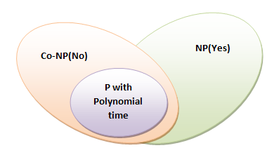

**What is NP?**

"NP" means "we can solve it in polynomial time if we can break the normal rules of step-by-step computing".

**What is NP Hard?**

A problem is NP-hard if an [algorithm](http://mathworld.wolfram.com/Algorithm.html) for solving it can be translated into one for solving any [NP-problem](http://mathworld.wolfram.com/NP-Problem.html) (nondeterministic polynomial time) problem. NP-hard therefore means "at least as hard as any [NP-problem](http://mathworld.wolfram.com/NP-Problem.html)," although it might, in fact, be harder.

**Risk Identification**

Any unauthorized user should be prevented from accessing the system. Password authentication can be introduced. To ensure the safety of the system, perform regular monitoring of the system so as to trace the proper working of the system. An internal staff has to be trained to ensure the safety of the system. He has to be trained to handle extreme error cases.

**Risk Analysis**

Risks can be evaluated based on quantity. Project managers need to analyze the likely chances of a risk occurring with the help of a matrix.

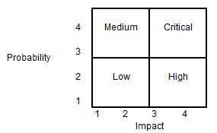

Using the matrix, the project manager can categorize the risk into four categories as Low, Medium, High and Critical. The probability of occurrence and the impact on the project are the two parameters used for placing the risk in the matrix categories. As an example, if a risk for it. Occurrence is low (probability = 2) and it has the highest impact (impact = 4), the risk can be categorized as 'High'.

**Overview of Risk Mitigation, Monitoring, Management.**

## Risk Response

When it comes to risk management, it depends on the project manager to choose strategies that will reduce the risk to minimal. Project managers can choose between the four risk response strategies, which are outlined below.

* Risks can be avoided
* Pass on the risk
* Take corrective measures to reduce the impact of risks
* Acknowledge the risk

## Risk Monitoring and Control

## Risks can be monitored on a continuous basis to check if any change is made. New risks can be identified through the constant monitoring and assessing mechanisms.

## Risk Management Process

## Following are the considerations when it comes to risk management process:

* Each person involved in the process of planning needs to identify and understand the risks pertaining to the project.
* Once the team members have given their list of risks, the risks should be consolidated to a single list in order to remove the duplications.
* Assessing the probability and impact of the risks involved with the help of a matrix.
* Split the team into subgroups where each group will identify the triggers that lead to project risks.
* The teams need to come up with a contingency plan whereby to strategically eliminate the risks involved or identified.
* Plan the risk management process. Each person involved in the project is assigned a risk in which he/she looks out for any triggers and then finds a suitable solution

## Risk Register

Often project managers will compile a document, which outlines the risks involved and the strategies in place. This document is vital as it provides a huge deal of information. Risk register will often consist of diagrams to aid the reader as to the types of risks that are dealt by the organization and the course of action taken. The risk register should be freely accessible for all the members of the project team.

**Project Risk; an Opportunity or a Threat?**

As mentioned above, risks contain two sides. It can be either viewed as a negative element or a positive element. Negative risks can be detrimental factors that can haphazard situations for a project. Therefore, these should be curbed once identified. On the other hand, positive risks can bring about acknowledgements from both the customer and the management. All the risks need to be addressed by the project manager.

**APPENDIX B:**

**REFERENCE**

[1] Tolga Soyata, 2012 IEEE Symposium on Computers and Communications (ISCC), pp. 000059000066.IEEE (Institute of Electrical and Electronics (2012).

[2] "A review of distributed application processing frameworks in smart mobile devices for mobile cloud computing," by Muhammad Shiraz et al. IEEE Communications Surveys and Tutorials, vol. 15, no. 3, pp. 1294-1313. (2013).

[3]"A Combined Feature Extraction Method for Automated Face Recognition in Classroom Environment," by Md Shafiqul Islam and colleagues. Signal Processing and Intelligent Recognition Systems: An International

[4] "Facial Recognition Vendor Test, 2000," US Department of Defense Available: http://www.dodcounterdrug.com/facialrecognition/FRVT \s2000/frvt2000.htm.

Sujatha, Shalini Punithavathani, and Jaya K. Priya

.

[5]Krishnamurthy, Sumatra, Shalini Punithavathani, and Jaya K. Priya.

"Extraction of well-exposed pixels for image fusion in high dynamic range photos using a sub banding technique." 54-72 in International Journal of Image and Data Fusion, vol. 8.1 (2017).

[6] K. Chang, K.W. Bowyer, and S. Sarkar, "Comparing and combining ear and facial images in appearance-based biometrics," IEEE Transactions on Pattern Analysis and Machine Intelligence, vol. 25, no. 9, September 2003.

[7] Goyani, Mahesh, Akash Dhorajiya, and Ronak Paun are the seven members of the group. "Analysis of FDA-based facial recognition performance utilizing correlation, ANN, and SVM." 108-111 in International Journal of Artificial Intelligence and Neural Networks, vol. 1.1 (2011)."Face Detection and Recognition for Automatic Attendance System," by Onur Sanli and Bahar Ilgen. SAI Intelligent Systems Conference Proceedings Cham: Springer, 2018.

[8] m. Lades, j.c. vorbruggen, j. Buhmann, j. Lange, c. Von der malsburg, r.p. wurtz, and cheng jinxing, ding jonquil, liu xia, andqi an Changsha, conference attendance system for embedded systems based on face recognition, mcu and embedded system applications, 14(7), 38-41, 2014**.** Symposium champ: springer, 2017.ieee transactions on computers, vol. 42, pp. 300-311, 1993. M. Konen, "distortion invariant object.