Product Proposal: Cisco AI Sentinel
Shikhar Prakash, Cisco | ISB PCPM Capstone | October 2026
Section 1: Introduction
Start by discussing the company in the case with a brief overview of the product. You may include details like (but not limited to) the name of the company, current product(s), target market, type of customers, an elevator pitch of the product you are proposing, etc.
1.1 The company: Cisco Systems, Inc.
Cisco (NASDAQ: CSCO), founded in 1984 and headquartered in San Jose, California, is a global leader in networking and security. In fiscal year 2026 Cisco reported record revenue of US$63.3 billion (+12% YoY), with networking orders growing for eight straight quarters as enterprises rebuild infrastructure for AI. Cisco serves large enterprises, mid-market and small businesses, service providers and the public sector in more than 180 countries, mostly through a global partner ecosystem.
Current product portfolio

Business | Representative products | Relevance to the new product
Networking | Catalyst, Meraki, Nexus, Silicon One, AI infrastructure | Huge installed base and partner channel, especially Meraki in the mid-market
Security | Secure Access (SSE), Duo (identity / MFA), XDR, Hypershield, Secure Firewall, AI Defense (2025) | Identity, enforcement points, AI-security models from the Robust Intelligence acquisition (2024), Talos threat intel
Observability | Splunk, ThousandEyes, AppDynamics | Security analytics and audit-event sink
Collaboration | Webex suite | Browser and knowledge-worker experience; AI assistant know-how

Target market and customers today
Cisco's customers are mainly organisations, not individuals. Buyers are CIOs, CISOs, network and security architects and IT managers. Mid-market companies (100 to 2,000 employees) are an important and growing segment, served largely through Meraki, Duo and partners. Cisco has little direct relationship with individual end users. This proposal changes that, carefully.
1.2 Why a new product now
• AI use has outpaced governance. 75% of knowledge workers use generative AI at work and 78% of them bring their own AI tools (Microsoft & LinkedIn Work Trend Index 2024).
• Data is already leaking. In Cisco's own 2024 Data Privacy Benchmark, 48% of respondents admitted entering non-public company information into GenAI tools, and 27% of organisations had banned GenAI at least temporarily.
• It is costly. IBM's 2025 Cost of a Data Breach report found that one in five organisations suffered a breach because of shadow AI, which added about US$670,000 to the average breach cost. 97% of organisations with AI-related breaches lacked AI access controls.
• Cisco has started, but at the top of the market. Cisco AI Defense (January 2025) secures AI applications and AI access for large enterprises through Secure Access and the network. Mid-market firms without a full SSE stack, and the individual employees who actually type the prompts, are under-served.
1.3 The proposed product: Cisco AI Sentinel
AI Sentinel is a browser-native security and productivity layer for third-party AI tools such as ChatGPT, Gemini, Claude and Copilot. It is delivered as a lightweight Chromium/Edge extension with a cloud policy and validation service, and it joins the AI Defense family. It brings three capabilities into one workflow:
• Govern: role-based access to AI tools by user, group and application, with allow, warn and block actions driven by centrally signed policy bundles.
• Protect: real-time input and output checks for PII, secrets, confidential data, prompt-injection indicators and toxic content, with local redaction first.
• Optimize: an opt-in Prompt Copilot that rewrites vague prompts and compresses redundant context. It always shows a before/after preview and never overrides a security decision.
Elevator pitch
"Every company wants its people to use AI, but nobody wants the next data leak to start in a chat box. Cisco AI Sentinel sits quietly inside the browser, catches the API key or customer list before it leaves, enforces the company's AI policy across every AI tool, and helps people write better prompts while doing it. Security teams get control and evidence. Employees get better answers with fewer interruptions. It takes about a minute to install."
Who it is for
• Primary buyer: security and IT leaders at mid-market and enterprise organisations (100 to 5,000 employees) that use several AI tools, starting with Cisco's existing Duo, Meraki and Secure Access customers.
• Primary users: knowledge workers in engineering, HR, sales, finance and operations.
• Secondary segment: individual AI power users (developers, researchers, freelancers, students), served through a freemium, product-led tier. It also acts as a bottom-up acquisition channel into their employers.
Vision: enable everyone to use AI confidently, securely and efficiently, across the tools they already prefer. Ask of management: approve a 12-week MVP (one squad, about US$1.2M fully loaded) and a 4-week paid pilot, with a launch / no-launch gate at week 12.

Section 2: Target Market Landscape
Discuss the target market, estimated market size, the competitive landscape, Ansoff’s framework analysis of your product, etc. for the proposed product and company.
2.1 Target market
AI Sentinel serves the intersection of three fast-growing categories: (a) shadow-AI risk and governance, (b) browser and data-loss security for generative AI, and (c) AI productivity tooling. The core segment is mid-market and lower-enterprise organisations (100 to 5,000 employees) in North America, EMEA and India that use several third-party AI tools and have a named security or IT owner. A second segment is individual AI power users, starting in India and English-speaking markets.
2.2 Estimated market size
Top-down (third-party research)
• Shadow AI risk & governance: US$1.39B (2026) to US$8.64B (2032), 35.6% CAGR (MarketsandMarkets, Sept 2026).
• AI Trust, Risk & Security Management (AI TRiSM): US$3.09B (2026) to US$11.61B (2031), 30.3% CAGR (MarketsandMarkets, Aug 2026).
• Generative-AI cybersecurity overall: US$8.65B (2025) to US$35.5B (2031), 26.5% CAGR.
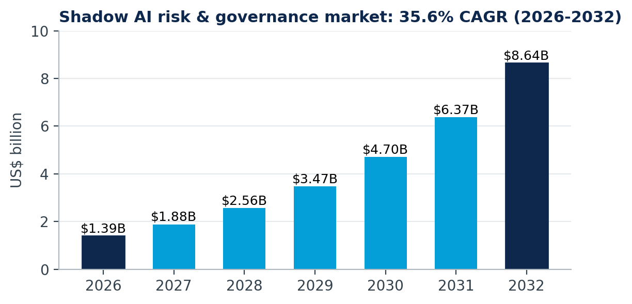
Figure 2.1 - Shadow AI risk & governance market (MarketsandMarkets)
Bottom-up (author estimates, steady state FY2029)

Layer | Logic | Value (US$/yr)
TAM | ~1B knowledge workers x 75% using GenAI x ~40% in 100+ employee firms = ~300M seats x US$72/yr; plus ~150M frequent individual users x US$57/yr | ~$30B potential
SAM | Cisco-reachable mid-market seats in NA, EMEA and India (~25M) x US$72; plus ~20M India and English-speaking power users reachable via PLG x US$57 | ~$2.9B
SOM | Year 3: 3% of SAM seats (0.75M) through Duo/Meraki/Secure Access cross-sell and partners; 2% of SAM individuals paying (0.4M) | ~$77M ARR

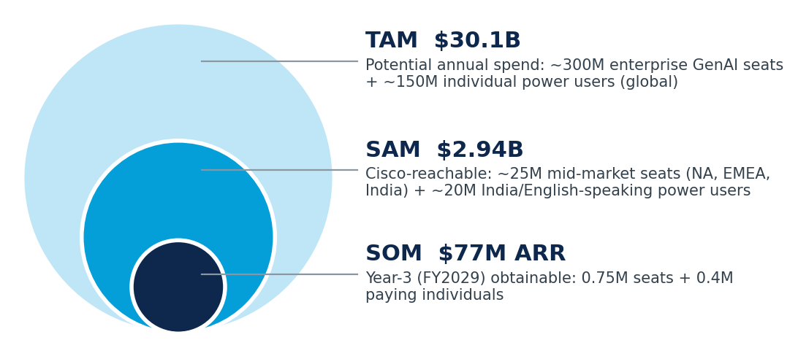
Figure 2.2 - TAM / SAM / SOM
The bottom-up TAM measures potential spend, which is why it exceeds today's realised spend in the analyst reports. SOM is the planning number used throughout this document.
2.3 Competitive landscape
The market consolidated quickly in 2025 as platform vendors bought AI-security start-ups: SentinelOne acquired Prompt Security (Aug 2025), Check Point acquired Lakera (Sept 2025), and Palo Alto Networks turned its Talon acquisition into Prisma Browser. Competitors fall into four groups:

Competitor | Approach | Strength | Gap AI Sentinel targets
Palo Alto Prisma Browser | Enterprise browser + extension; AI governance, DLP | Deep security, SASE bundle | Heavy rollout; little productivity value; enterprise-only
Island | Dedicated enterprise browser | Full browser control | Users must switch browser
Prompt Security (SentinelOne) | Browser ext, desktop, API runtime for GenAI | Early mover, broad coverage | Security-only; no individual tier
Check Point GenAI Protect + Lakera | Network/SSE + runtime guardrails | Strong detection research | Not user-centric; enterprise sales motion
Harmonic, LayerX | Browser extensions for AI data protection | Lightweight, fast to deploy | Start-up scale; limited identity and network integration
Microsoft Purview + Edge for Business | DLP for AI inside the M365 ecosystem | Bundled with E5 | Weaker outside Microsoft tools and browsers
Zscaler / Netskope SSE | Inline GenAI DLP at proxy | Network-level visibility | Needs full SSE; no in-context user guidance
PromptPerfect, AIPRM | Prompt optimisation tools | Productivity | No security or governance

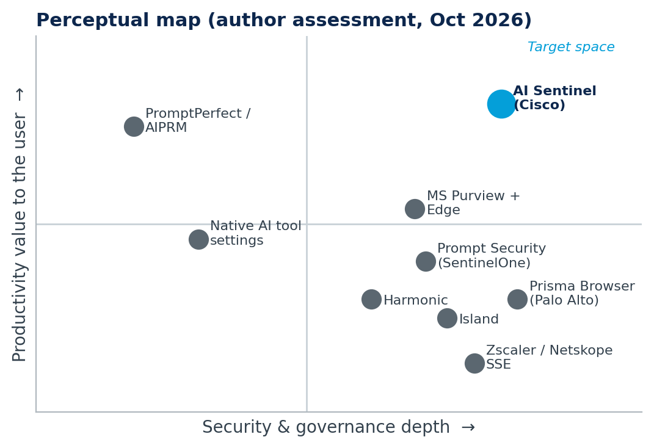
Figure 2.3 - Perceptual map: security depth vs. user productivity value
Insight: competitors treat the user as a risk to be controlled. Nobody owns the upper-right quadrant, where governance and productivity reinforce each other. That is AI Sentinel's positioning wedge: security that employees *want* installed.
2.4 Ansoff matrix analysis

 | Existing products | New products
Existing markets (Cisco enterprise & mid-market security customers) | Market penetration: cross-sell AI Defense and Secure Access AI controls into the installed base (current strategy) | Product development (primary strategy): AI Sentinel for existing Duo, Meraki and Secure Access customers. Same buyer, new browser-native product
New markets (individual users, SMB via PLG, India mid-market) | Market development: take Duo / Secure Access into new regions and segments | Related diversification (secondary): AI Sentinel Personal for prosumers. New buyer and new motion for Cisco, kept to a limited bet

Conclusion: AI Sentinel is mainly a product-development move. It builds on Cisco's brand, identity (Duo), threat intelligence (Talos) and AI Defense models, so risk is moderate. The individual tier is a related diversification. It stays a small, contained bet (freemium, low CAC) and its main job is to feed enterprise demand.

Section 3: Timing
Are you aiming to be the first mover in the market? If yes, how would the order of entry affect your share in the market (calculate and showcase the benefit of being an early entrant). If you would be the second entrant (a significant competitor is already in the market), discuss the cost of being a late entrant. In other cases (multiple competitors already), assume being the third entrant and discuss the cost of being a late entrant.
3.1 Are we the first mover? No. Cisco would be a late (third-wave) entrant
Browser-layer AI data protection was pioneered in 2023 by start-ups (Prompt Security, Harmonic, LayerX, Lakera). Platform vendors followed in 2024-25 (Palo Alto Prisma Browser, Microsoft Purview for AI, Zscaler/Netskope GenAI DLP, then the SentinelOne and Check Point acquisitions). Following the brief, we model Cisco as the third entrant into the contested segment: browser-layer AI usage security for the mid-market, worth an estimated US$300M a year by FY2029 in Cisco's regions.
3.2 Cost of being a late entrant: order-of-entry model
Urban, Carter, Gaskin & Mucha (1986) found that, holding other factors equal, an entrant's long-run share relative to the pioneer is (order of entry)^-0.49. The full model also adjusts for relative product preference (^1.11), relative advertising/marketing spend (^0.28) and entry lag (^0.07).

Entrant | Relative share (n^-0.49) | Normalised share | Revenue on US$300M segment
Pioneer (1st) | 1.000 | 43.6% | US$131M
2nd entrant | 0.712 | 31.0% | US$93M
Cisco (3rd) | 0.584 | 25.4% | US$76M

Cost of entering third: about 18.1 share points below the pioneer. That is roughly US$54M of annual revenue forgone by FY2029, or about US$163M over three years. Cisco cannot win on timing.
3.3 How Cisco closes the gap: late-mover advantages
The same model shows how the penalty can be offset. If AI Sentinel achieves a 1.2x relative preference (Govern + Protect + Optimize in one product, no browser switch) and Cisco invests 1.5x the marketing and channel weight of the average rival, with a two-year lag, then Cisco's relative share becomes 0.584 x 1.2^1.11 x 1.5^0.28 x 2^0.07 = 0.84. That gives a normalised share of 32.9% (about US$99M), better than the second entrant and close to the pioneer.
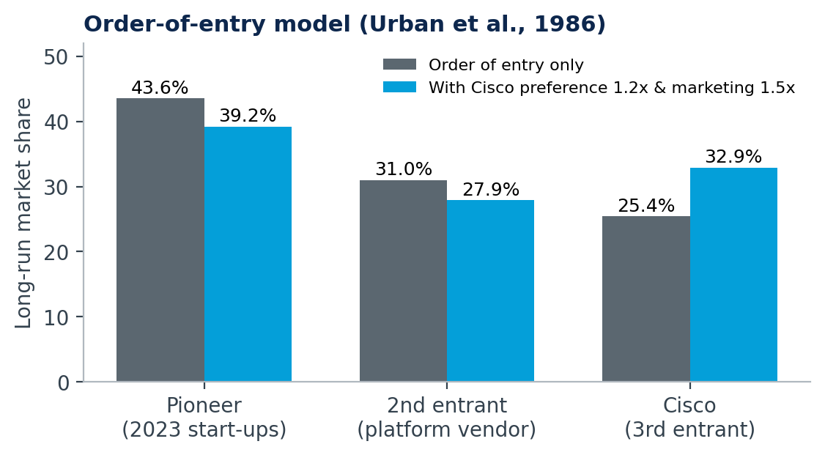
Figure 3.1 - Long-run share by order of entry, base vs. Cisco-adjusted
• Lower market-education cost: pioneers already convinced CISOs that GenAI data leakage is real. Cisco sells into existing budgets.
• Learn from pioneers' mistakes: competitor reviews show heavy rollouts, noisy false positives and alert fatigue. We design for low friction from day one.
• Distribution advantage: Duo, Meraki and Secure Access customers, plus thousands of channel partners, cut CAC well below a start-up's.
• Bundling and trust: Enterprise Agreements, Talos threat intelligence and a trusted brand make Cisco the 'safe choice' for risk-averse buyers.
• Technology maturity: AI Defense classifiers and smaller, cheaper models make local and remote checks faster and cheaper than they were in 2023.
Timing recommendation: the window is still open (35.6% CAGR, no dominant mid-market standard), but it is closing as SSE vendors bundle GenAI controls. Each six months of delay lets rivals lock in enterprise renewals. We should therefore ship a focused MVP in 12 weeks, not a full platform in 12 months.

Section 4: Customers
Define the persona of your potential customers. Include details like demographics, psychographics, goals and ambitions, pain points, and other relevant information. Once you have identified your customers, discuss the expect customer journey (different touchpoints the customer will go through with your brand from not knowing about you to becoming your customer and an advocate).
To acquire all these details, speak with 5 people who you believe could be potential customers for your product (could be you friends, family, or colleagues). Also create a list of different aspects / benefits / features of your product to carry out… Importance rating scale OR Rank ordering scale any one) while interacting with the potential customer (refer week 7). Within the presentation deck, provide customer persona, a brief customer journey map, and your findings analysed through importance ranking or rank ordering.
Note: the interview responses and ratings below are ILLUSTRATIVE placeholders built from the personas. They must be replaced with the student's real conversations before submission.
4.1 Customer personas

 | Persona A: Ananya, the AI power user | Persona B: Vikram, the security leader | Persona C: Meera, the everyday knowledge worker
Demographics | 27, software developer at a Bengaluru SaaS start-up; B.Tech; earns Rs 18-25 LPA; uses ChatGPT, Claude and Copilot daily | 44, CISO at a 1,200-employee IT-services firm in Pune; 20 years in security; reports to the CIO; owns a US$2M security budget | 33, HR business partner at a 600-employee fintech in Mumbai; MBA (HR); non-technical; uses AI for JDs, policies and summaries
Psychographics | Early adopter, efficiency-obsessed, privacy-aware, dislikes 'corporate' tools that slow her down | Risk-averse but pragmatic; does not want to be the 'department of no'; values evidence and audit trails | Conscientious, time-poor, anxious about doing something wrong with employee data
Goals | Ship code faster; get precise answers first time; stay within her token limits | Enable safe AI adoption; pass audits (ISO 27001, DPDP Act); prove ROI of controls | Finish routine writing faster; look competent with AI; never leak employee PII
Pain points | Vague prompts give vague answers; repeats context; once pasted an API key into a chat | No visibility into which AI tools are used; blanket bans backfire; existing DLP is noisy and blind to chat boxes | Does not know what counts as 'sensitive'; warnings she has seen are cryptic and block her work
Buying role | User and buyer (Rs 299-599/month) | Economic buyer & decision-maker | End user and influencer

4.2 Customer journey map (enterprise, with the individual path noted)

Stage | Touchpoints | Customer thinking / feeling | Our action / metric
1. Unaware | News of AI data leaks, peer CISOs, LinkedIn, Talos blogs | "Are my people pasting data into ChatGPT?" (worried) | Thought leadership; free 'Shadow AI Risk Check'
2. Aware | Cisco account team, partner webinar, Chrome Web Store (individuals) | "Cisco has something for this?" (curious) | Reach and click-through to landing page
3. Consider | Demo, comparison sheet, free individual tier, peer reviews | "Will it slow people down? False positives?" (sceptical) | Interactive demo; latency and precision proof
4. Trial / pilot | 4-week paid pilot in monitor mode, then enforce | "Show me data from my own environment" (testing) | Pilot report: exposures prevented, overrides, latency
5. Purchase | Partner quote, EA add-on, Cisco marketplace; in-app upgrade (individual) | "Is the price justified vs. a breach?" (rational) | ROI calculator; pilot credit
6. Onboard & use | Managed deployment via MDM/Duo, admin console, inline tips | "It actually helps people" (relieved) | Weekly active users, suggestion acceptance
7. Advocate | Case study, Cisco Live session, referral credits | "I'd recommend this to peers" (proud) | NPS, references, expansion revenue

4.3 Primary research: conversations with 5 potential customers
Each participant took part in a 30-minute semi-structured conversation covering current AI usage, past near-misses with sensitive data, tolerance for security friction, trust in an optimiser, and who would pay. They then completed an importance rating scale (1 = not important, 5 = critical) across ten candidate features.

# | Participant | Profile | Key quote (illustrative)
1 | Ananya | Developer, SaaS start-up, Bengaluru (Persona A) | "If it adds even a second to every prompt, I'll uninstall it."
2 | Vikram | CISO, IT services, 1,200 staff (Persona B) | "I need monitor mode first, then evidence I can show the auditors."
3 | Meera | HR business partner, fintech (Persona C) | "Just tell me what is wrong and fix it for me. Don't just block me."
4 | Rahul | IT & security manager, 350-staff manufacturer, Meraki customer | "We can't afford an SSE rollout. A browser extension I can push via MDM is perfect."
5 | Priya | MBA student and freelance content consultant | "Better prompts matter more to me than security, but I don't want my clients' data leaking."

Importance rating results (1-5)

Rank | Feature | Ananya | Vikram | Meera | Rahul | Priya | Mean
1 | Sensitive-data detection & redaction | 4 | 5 | 5 | 5 | 4 | 4.6
2 | Low latency, no workflow friction | 5 | 4 | 5 | 4 | 5 | 4.6
3 | Local-first, on-device checks | 5 | 4 | 4 | 4 | 5 | 4.4
4 | Works across multiple AI tools | 4 | 5 | 4 | 4 | 4 | 4.2
5 | Before/after preview with undo | 5 | 4 | 4 | 3 | 5 | 4.2
6 | Prompt optimizer (rewrite & structure) | 5 | 3 | 4 | 3 | 5 | 4.0
7 | Token / cost savings dashboard | 4 | 3 | 2 | 4 | 4 | 3.4
8 | Approved / blocked AI tool controls (RBAC) | 2 | 5 | 3 | 5 | 1 | 3.2
9 | Output checks on AI responses | 3 | 4 | 3 | 4 | 2 | 3.2
10 | Admin audit log & reports | 1 | 5 | 2 | 5 | 1 | 2.8

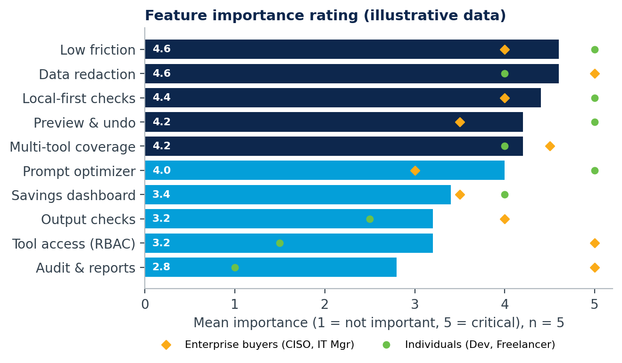
Figure 4.1 - Mean importance with enterprise vs. individual splits
Findings
• Data redaction (4.6) and low friction (4.6) tie for first place. Protection is the reason to buy, and friction is the reason to uninstall. Latency and false positives are product-critical.
• Local-first checks (4.4) matter to every segment. 'Your data never leaves your device for basic checks' is a key message.
• There is a sharp segment split. RBAC (5.0) and audit/reports (5.0) are must-haves for enterprise buyers but near-irrelevant for individuals (1.5 and 1.0). The prompt optimiser shows the reverse pattern (5.0 vs. 3.0). This confirms a shared core with separate packaging.
• The savings dashboard (3.4) is a 'nice to have'. We move it to P1 and lead with quality, not token savings.
• Multi-tool coverage (4.2) matters because people use 2-3 AI tools. The MVP must cover at least the two most-used tools.

Section 5: Product
Define the product you are planning to develop in this section. Utilize the framework of opportunity cost and development risk framework. Also, discuss product/company fit and product/market fit frameworks to find issues that must be tested while concept testing. Along with this, you may also include pointers such as (but not limited to, topics to be extended as per your suitability and learnings).
- Define the marketing mix (4Ps) for your product.
- Three levels of the product.
- Product positioning.
- Business model and revenue model.
5.1 Product definition
AI Sentinel = a Chromium/Edge browser extension (local detection, inline UX, application adapters) + a Cisco cloud service (identity and policy, AI Defense-powered advanced validation, optional prompt optimisation, metering) + an admin console. The MVP supports ChatGPT and Gemini on the web.
5.2 Opportunity cost and development risk
Investing one squad in AI Sentinel means not investing it elsewhere. We compared three uses of the same 12-week budget (score 1-5; 5 = most attractive or lowest risk):

Criterion | A. AI Sentinel (browser layer) | B. Extend Secure Access AI-DLP only | C. Stand-alone prompt optimiser
Market opportunity / growth | 5 | 4 | 3
Strategic fit with Cisco | 4 | 5 | 2
Differentiation | 5 | 2 | 2
Revenue potential (3 yr) | 4 | 3 | 2
Technical development risk | 3 (DOM brittleness, accuracy) | 4 | 4
Market / adoption risk | 3 (crowded, new motion) | 4 | 2 (commoditised)
Weighted total (opportunity avg x 60% + risk avg x 40%) | 3.9 | 3.7 | 2.6

Result: option A scores highest (3.9). B is a close, safer second (3.7) and remains part of the plan, since AI Sentinel integrates with Secure Access later. The opportunity cost of *not* building it is also high, because rivals would own the user-facing AI layer in Cisco's own accounts. On the opportunity-cost / development-risk grid, A sits in 'high opportunity, moderate risk: build, but de-risk through an MVP', not a full-scale build.
5.3 Product/company fit

Cisco strength that fits | Gap to close
Duo identity and device trust, so policies know who the user is | No consumer / product-led growth (PLG) experience inside Cisco
AI Defense and Robust Intelligence models for advanced validation | Browser-extension UX and site-adapter maintenance skills
Talos threat intelligence for injection and malicious patterns | Prompt-optimisation quality evaluation (new ML capability)
Splunk for audit events; partner channel; Enterprise Agreements | Speed: a start-up-style squad with autonomy is needed

5.4 Product/market fit hypotheses to test in concept testing
1. Users understand inline warnings and prefer 'Redact & send' over being blocked.
2. Added friction stays acceptable (p95 under 100 ms locally; one click to resolve).
3. Individuals trust an optimiser from a security vendor and accept 40% or more of suggestions.
4. Mid-market IT buyers will pay about US$6-8 per user per month without buying a full SSE.
5. The enterprise buyer accepts a browser extension as a sufficient control for an MVP.
5.5 Marketing mix (4Ps)

P | Decision
Product | Extension + console; Govern / Protect / Optimize; tiers: Personal Free, Personal Plus, Business, Enterprise
Price | Freemium + per-seat subscription + metered advanced operations (see Section 9)
Place | Chrome Web Store and Edge Add-ons (individuals); Cisco account teams, partners, Cisco and cloud marketplaces, EA add-on (enterprise)
Promotion | Talos research on AI leaks, Cisco Live launch, partner enablement, developer communities, LinkedIn thought leadership, in-product referral

5.6 Three levels of the product
• Core benefit: confidence to use any AI tool without fear of leaking data, and better results with less effort.
• Actual product: the AI Sentinel extension, inline warnings and redaction, Prompt Copilot, admin console, policy templates, Cisco brand and design, and a clear protection-status badge.
• Augmented product: Duo and Entra ID single sign-on, Splunk and XDR integration, Talos-updated detection packs, audit-ready reports (DPDP, GDPR, ISO), Cisco support and Customer Success, and policy best-practice playbooks.
5.7 Positioning
*For security leaders and AI-using employees at organisations that rely on third-party AI tools, Cisco AI Sentinel is the browser-native AI usage layer that combines role-based governance, real-time data protection and transparent prompt optimisation. Unlike enterprise browsers and SSE add-ons that only restrict users, AI Sentinel makes the secure way the easiest and most productive way to use AI, backed by Cisco's identity, threat intelligence and trust.*
5.8 Business model and revenue model
• Business model: B2B SaaS with a product-led B2C on-ramp. Individuals adopt for free; usage signals within a company domain create qualified enterprise leads; partners deploy and manage.
• Revenue streams: (1) per-seat subscription (Business / Enterprise); (2) metered advanced validation and optimisation beyond the included pool; (3) Personal Plus subscriptions; (4) premium add-ons (extended retention, advanced reporting); (5) pull-through of Duo, Secure Access and Splunk.
• Cost structure: squad and site-adapter maintenance, inference compute (kept low through local checks), cloud hosting, partner margin. Target 75%+ gross margin on seats.

Section 6: Concept testing
Before the product development comes into consideration, how would you test your product concept? In this section, you will do following activities:
  - Create low-fi prototype of your product using tools like Balsamiq or Figma. Create a rough sketch or a paint (if, physical good).
  - Test the concept of your product by having 3 of your potential customers (from the 5 you engaged with earlier) interact with your prototype. At the end, describe the results, your learnings, and how you plan to utilize the learnings. The concept testing could be done through any one of these methods (refer week 6).
i) Qualitative: Focus group or brainstorming session (group or 1-on-1) with your potential customers. Note down through thoughts/ideas and your findings while going through this exercise.
ii) Quantitative: Survey your customers through a set of questions. Asking smart questions that would help you gain more insights is of importance here.
Note: concept-test results are ILLUSTRATIVE placeholders. Replace them with the outcomes of real sessions with 3 of the 5 interviewees before submission.
6.1 Low-fidelity prototype
We built three clickable low-fi screens (sketch-style wireframes, Figma/Balsamiq equivalent) covering the three pillars. Participants completed realistic tasks on each screen.
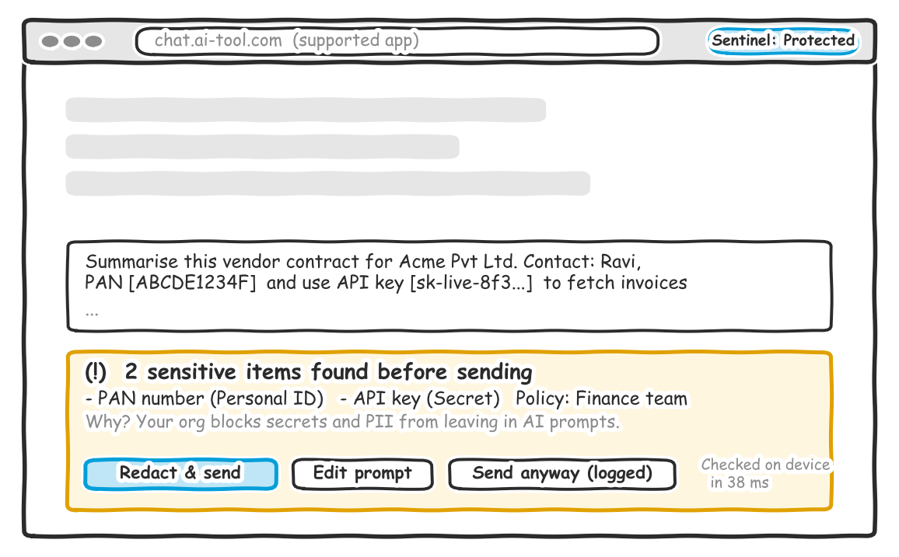
Screen 1 - Protect: inline detection with one-click 'Redact & send'
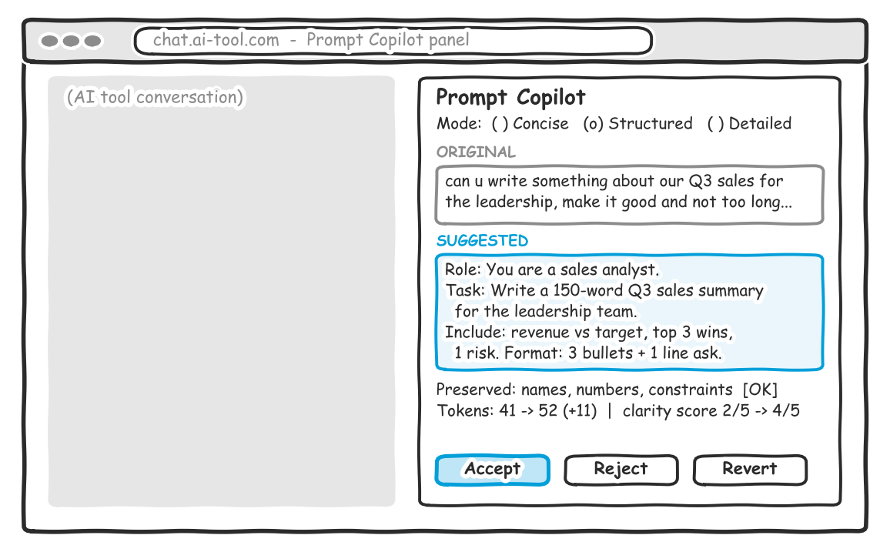
Screen 2 - Optimize: Prompt Copilot with before/after, accept / reject / revert
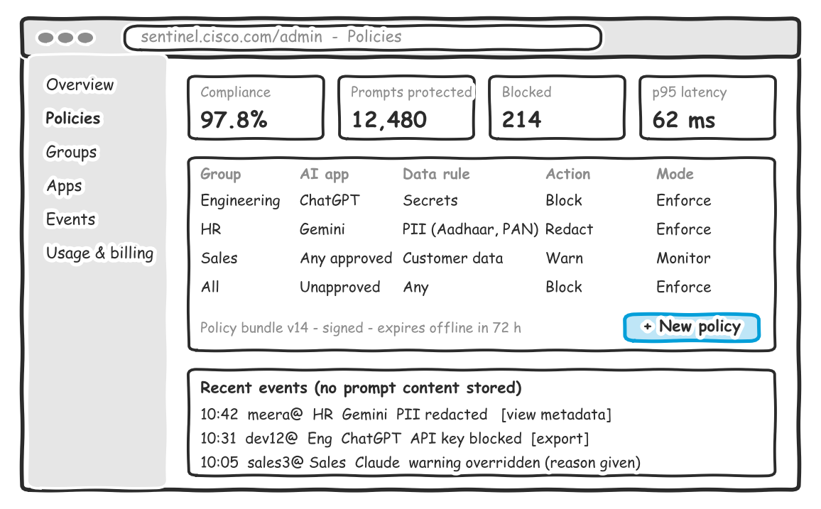
Screen 3 - Govern: admin console with group policies, monitor/enforce modes and events
6.2 Method: qualitative 1-on-1 sessions + a short quantitative survey
Participants: Ananya (individual developer), Vikram (CISO) and Meera (HR knowledge worker), one per persona. Each 45-minute moderated session used a think-aloud protocol: (1) paste a prompt containing a PAN number and an API key; (2) improve a vague prompt with Prompt Copilot; (3) Vikram only: create an HR policy in the admin console. Each session ended with a 10-question survey.
Survey questions (Likert 1-5 unless noted)
1. The warning clearly explained what was wrong and why.
2. I would trust 'Redact & send' to remove the sensitive data correctly.
3. The suggested prompt is better than what I wrote.
4. The tool interrupted my flow (reverse-scored).
5. I understood that basic checks run on my device.
6. How likely are you to keep this installed after a week? (1-5)
7. How would you feel if you could no longer use it? (very / somewhat / not disappointed)
8. At what monthly price would this be too cheap to trust / a bargain / getting expensive / too expensive? (Van Westendorp)
9. Which ONE feature would you remove?
10. What is missing for you (or your company) to adopt this?
6.3 Results

Measure | Ananya | Vikram | Meera | Avg / result
Task 1 completed unaided (redact) | Yes | Yes | Yes, after 1 hesitation | 3/3
Task 2 accepted suggestion | Yes (wanted 'concise') | Partly | Yes | 2.5/3
Q1 warning clarity | 5 | 4 | 5 | 4.7
Q2 trust in redaction | 4 | 4 | 4 | 4.0
Q3 suggested prompt better | 5 | 3 | 5 | 4.3
Q4 interrupted my flow (lower = better) | 3 | 2 | 2 | 2.3
Q5 understood local checks | 4 | 5 | 2 | 3.7
Q7 'very disappointed' without it | Yes | Yes | No (somewhat) | 67%
Q8 acceptable price | Rs 249-499/mo | US$5-8/user/mo | Employer should pay | Rs 399; US$6-8

6.4 Key learnings and how we will use them

Learning | Evidence | Change to the product
Fix, don't just block | Meera hesitated at 'Send anyway'; all three preferred 'Redact & send' | Make 'Redact & send' the default primary action; 'Send anyway' requires a reason and is logged
The optimiser must be on demand | Ananya disliked auto pop-ups; wanted a 'concise' mode | Copilot appears as a button / shortcut only; add Concise, Structured and Detailed modes; no auto-suggest
Monitor before enforce | Vikram will not block on day one without data | Monitor mode is the default pilot mode; one-click policy promotion to Enforce
Evidence for auditors | Vikram asked for exportable, metadata-only events | Event export (CSV / Splunk) in the MVP; prompt content excluded by default
Explain privacy visually | Meera did not notice the on-device message (3.7) | Persistent 'Checked on device' badge with a hover explanation
Token savings are not the hook | Nobody mentioned token savings unprompted | Lead with quality and safety; move the savings dashboard to P1

Conclusion: the concept is validated well enough to justify an MVP. All three completed the core task, two of three would be 'very disappointed' without it (above the 40% PMF bar, though with a tiny sample), and price ranges match our hypotheses. Friction and privacy communication are the main design risks to carry into the MVP.

Section 7: MVP & PMF
As your lo-fi prototype turns a success, as the next step – decide based on your findings through opportunity cost and development risk framework as well as your concept testing learnings, would you need to build an MVP (or should you directly build a fully developed product)?
Only if yes, what would your MVP look like? Based on your understandings while having potential customers interact with your prototype, what are some factors that will define the early-stage success of your MVP that will be improved over time through experimentation to a full-fledged product.?
If no, note down your justification on why you should directly move towards product development.
In both cases, also discuss…
- Your product development roadmap.
- How do you plan to achieve Product-market fit?
- What kind of growth experiments could you perform on your product to test the product’s success towards acquiring more users, getting more users to use the product, getting more people to achieve success through the product, getting more people to stick to the product, etc.?
7.1 MVP or a fully developed product? Build an MVP
• Development risk is moderate to high: site adapters break when AI tools change their UI, detection accuracy needs real-world tuning, and latency budgets are tight.
• PMF is promising but unproven: n = 3 concept tests; enterprise willingness to pay must be validated with real money (paid pilots).
• Opportunity cost: a full platform would take about 12 months and 3 squads. An MVP takes 12 weeks and 1 squad, preserving capacity while the market window is still open.
7.2 What the MVP looks like

P0 capability | MVP scope
App adapters | ChatGPT and Gemini web on Chrome and Edge; protection-status badge; degraded state disclosed
Protect | Local pattern checks for secrets, PAN, Aadhaar, email, phone, card numbers; 'Redact & send'; warn/block
Govern | Duo / Entra ID SSO; groups; allow/warn/block per app; monitor and enforce modes; signed policy bundles with offline expiry
Optimize | On-demand Prompt Copilot (3 modes), before/after diff, accept/reject/revert, token estimate
Console | Policy editor, user/group view, metadata-only event log with export
Metering | Idempotent usage events, quotas, Personal Free/Plus entitlements
Out of scope | Native desktop apps, API traffic, all AI sites, autonomous routing, compliance certification

Early-stage success factors (MVP exit criteria)

Factor | Target at pilot end | Why it matters
Activation: first safe/optimised prompt in session 1 | >= 60% of installs | Proves time-to-value
p95 added latency (local checks) | <= 100 ms | Friction was the #1 uninstall risk
Precision, high-confidence detections | >= 95% | Keeps false positives and alert fatigue low
Recall on critical secrets | >= 99% | Core security promise
Suggestion acceptance | >= 40% | Optimiser value
Week-4 retention (individuals) | >= 35% | Habit formation
Pilot-to-paid conversion (enterprise) | >= 30% of pilots | Willingness to pay
Unauthorised transmission of test data | 0 cases | Trust and safety

7.3 Product development roadmap

Phase | Timing | Key deliverables | Gate
Discovery & feasibility | Weeks 1-2 (Oct-Nov 2026) | 20-25 interviews, threat model, adapter spike, pricing tests | Segment + buyer confirmed
Working prototype | Weeks 3-6 | Extension for 2 apps, local checks, preview UX, basic policy | Internal dogfood at Cisco IT
Alpha & hardening | Weeks 7-9 | Policy service, RBAC, console, metering, security testing | Red-team findings closed
MVP pilot | Weeks 10-12 (Jan 2027) | 5 design-partner pilots + 500 individual beta users | Launch / no-launch
Commercial launch | Months 4-6 (Feb-Apr 2027) | Cisco Live EMEA preview; Business tier GA; +2 AI apps | Targets in Section 10
Scale | Months 7-12 | Secure Access and Splunk integration, AI Defense classifiers, Firefox/Safari, agentic-browser guardrails | PMF in two segments

7.4 How we will achieve product-market fit
• Pick the beachhead: mid-market Duo/Meraki customers in India and the US, plus developers as the individual beachhead. Do not try to serve everyone.
• Measure PMF with leading and lagging signals: Sean Ellis test (40% or more 'very disappointed'), flattening retention curves by cohort, organic installs within pilot companies, and pilot-to-paid conversion.
• Weekly learning loop: review false positives, overrides and abandonment every week; ship adapter and detection fixes within the sprint.
• Design partners as co-builders: 5 partners with a shared Slack/Webex space, monthly roadmap reviews and a discount in exchange for references.
• Iterate positioning and packaging per segment until each shows strong retention on its own.
7.5 Growth experiments (AARRR)

Stage | Experiment | Hypothesis / success metric
Acquisition | Chrome Web Store listing A/B: 'Stop AI data leaks' vs. 'Better, safer prompts' | Productivity framing lifts install rate by 20%+
Acquisition | Free 'Shadow AI Risk Check' for Meraki/Duo admins (one-week monitor mode) | 15% of checks convert into pilots
Activation | Guided first-run with a sample risky prompt vs. blank start | Session-1 activation rises from 45% to 60%
Engagement | Keyboard shortcut + subtle Copilot button vs. side-panel only | Copilot uses per WAU +25%
Success | 'Fix it for me' redaction default vs. warn-only | Overrides down 30% with no drop in task completion
Retention | Weekly 'You were protected X times' digest email | Week-4 retention +5 points
Referral | Invite a teammate = +100 advanced operations for both | K-factor >= 0.2
Revenue | Annual-plan discount 2 months free vs. 1 month | Annual mix >= 40% without ARPU loss

Section 8: Product development
Having a product roadmap in place, write your approach towards building the product. Knowing that your upper management is inclined towards thinking of product development in a user-centric manner, design how would you use the design thinking approach towards building the product. Also discuss, how would you use Agile methodology combined? Feel free to refer to this article from HotJar to get more clarity.
8.1 Approach: user-centred, evidence-led, incremental
Management wants user-centric development, so we combine Design Thinking (deciding *what* to build and *why*) with Agile (delivering it *fast and safely*). In practice this is a dual-track model: a discovery track runs one to two sprints ahead of a delivery track, and both share one backlog and one set of outcome metrics.
8.2 Design thinking applied to AI Sentinel

Stage | Activities for AI Sentinel | Output
Empathise | Interviews with CISOs, IT managers, employees and power users; shadowing real AI sessions; reviewing support tickets and competitor reviews | Empathy maps; journey map; pain-point inventory
Define | Synthesise insights into problem statements, e.g. 'Meera needs to use AI on HR documents without knowing data rules, because warnings confuse and block her' | 3 POV statements; 'How might we...' questions; success metrics
Ideate | Cross-functional workshops (PM, design, engineering, security research, sales); Crazy 8s; prioritise with impact/effort and the importance ratings | Concept options (inline fix, side panel, admin templates)
Prototype | Lo-fi wireframes, then clickable Figma, then a coded spike on one AI app | Testable prototypes at increasing fidelity
Test | Moderated usability tests, concept surveys, pilot telemetry, A/B tests | Validated or killed hypotheses that feed the backlog

8.3 Agile delivery
• Team (one squad, about 10 people): PM (product owner), product designer, 5 engineers (extension, backend, console), 1 ML engineer, 1 security researcher, 1 QA/automation. Shared SRE and privacy counsel.
• Cadence: Scrum with 2-week sprints: planning, daily stand-ups, sprint review with design partners, retrospective. Kanban lane for adapter breakages (24-hour SLA).
• Backlog: user stories written from POV statements, with acceptance criteria taken from MVP targets (e.g. 'as Meera, I can redact and send in one click, p95 under 100 ms').
• Definition of Done includes passing the detection evaluation set (no precision/recall regression), privacy review (no prompt content in logs), accessibility, and adapter health checks.
• Release: continuous delivery to an internal ring (Cisco IT), then design partners, then general availability, behind feature flags.
8.4 How the two combine

Sprint | Discovery track (Design Thinking) | Delivery track (Agile)
1-2 | Empathise + define with 20-25 interviews | Architecture spike, CI/CD, threat model
3-4 | Ideate + lo-fi test of inline UX | Extension shell, adapters, local detection
5-6 | Hi-fi test of Copilot modes | Redaction UX, policy service v1
7-8 | Admin console usability tests with CISOs | Console, RBAC, metering
9-10 | Pricing tests and pilot onboarding research | Hardening, red-team fixes, pilot release
11-12 | Pilot interviews and synthesis | Fixes, analytics, launch readiness

Continuous feedback tools (in-product feedback widget, session heat-maps on the console, Hotjar-style surveys) close the loop between the tracks. Every sprint review asks two questions: *did we build it right?* (Agile) and *did we build the right thing?* (Design Thinking).
8.5 Governance and risk controls during development
• Security-before-optimisation principle enforced in code: optimisation runs only after policy checks pass.
• Least-privilege extension permissions, reviewed by the Cisco PSIRT process before each release.
• Monthly steering review with the Security BU GM: metrics, risks and scope changes.

Section 9: Pricing
Discuss your pricing strategy for the product and the thought-process behind why the pricing strategy will work the best? What price point would you initially test at the time of the launch, and then later how would you increase AND decrease based on the elasticity?
9.1 Pricing strategy: freemium + value-based tiers + metered advanced usage
We combine three logics, each matched to a cost or value driver:
• Freemium for individuals (penetration): basic local checks cost us almost nothing to run, so we give them away. This builds trust, installs and bottom-up enterprise leads. Charging for basic safety would discourage safe behaviour.
• Value-based seats for organisations: the reference value is risk avoided. IBM's 2025 report puts the average breach at US$4.44M globally (US$10.22M in the US), and shadow AI adds about US$670K. For a 500-seat company at US$8/user/month (US$48K/year), preventing a single incident pays for the product many times over. We price below enterprise-browser suites to win the mid-market.
• Usage-based for expensive inference: advanced remote classification and model-assisted optimisation cost real compute, so a pooled allowance is included and overage is metered. Revenue then scales with cost, protecting gross margin.
9.2 Launch price points to test

Tier | Launch price | Includes | Rationale
Personal Free | Rs 0 / US$0 | Local PII and secret checks, basic prompt clean-up, 50 advanced ops/month | Acquisition and trust
Personal Plus | Rs 399/month (Rs 3,999/yr); US$6.99 international | 1,000 advanced ops, all Copilot modes, personal usage view | Inside the Rs 249-499 range from concept tests
Business (25-2,000 seats) | US$8/user/month (Rs 499 in India) | RBAC, console, event export, Duo/Entra SSO, 500 pooled ops/user | Below Prisma/Island; matches CISO's US$5-8
Enterprise | US$6-7/user at volume; EA bundle | Splunk/XDR, extended retention, premium support, custom policies | Volume and bundle pricing
Overage | US$2 per 1,000 advanced ops | Spending caps and alerts by default | ~60% margin on inference

Unit economics check
A Business seat (US$96/year) uses about 300 advanced operations a month at about US$0.0008 each, or roughly US$2.90/year in inference. Hosting, adapters and support add about US$12/seat/year, and the partner margin is 20%. That leaves a contribution margin of about 65% of list price (about 80% of net revenue after partner margin), which improves as local checks handle more of the traffic.
9.3 Managing price over time based on elasticity
We will measure price elasticity of demand (PED = % change in quantity / % change in price) through randomised price cells on new Personal Plus sign-ups and through win/loss and discount data for Business deals.

Illustrative test (per 1,000 trial users) | Cell A: Rs 399 | Cell B: Rs 549
Trial-to-paid conversion | 4.0% | 3.4%
Monthly revenue | Rs 15,960 | Rs 18,666
Change | - | Price +37.6%, quantity -15.0%
PED | - | -0.40 (inelastic)

When to increase price
• If |PED| < 1, as in the illustration (-0.40), revenue rises with price (+17%). We would move Personal Plus toward Rs 499-549 for new users and keep earlier users on their original price for 12 months.
• Raise enterprise list prices when new value ships (Secure Access integration, AI Defense classifiers, compliance reports), using good / better / best packaging rather than flat increases.
• Use value metrics: as customers expand AI use, pooled operations grow and revenue grows with them.
When to decrease price
• If |PED| > 1 (conversion falls faster than price rises), test Rs 299 and annual-only discounts. Offer a student plan at Rs 149 and purchasing-power pricing in emerging markets.
• Use volume discounts and EA bundles for large deals; competitive displacement offers when a rival SSE bundle is the alternative.
• Use temporary promotions (Cisco Live launch, Diwali / year-end) rather than permanent cuts, so the reference price is preserved.
• Guardrails: never price critical safety checks out of reach; keep them in the free tier even when a quota is exhausted.

Section 10: GTM
Describe your GTM strategy for the product. How would you launch the new product in the market (explain it through sales funnel: Awareness, Interest, Consideration, Intent, Purchase)? i.e. explain, in brief, your plan of engaging your customer through different stages of the funnel (how would you generate awareness, how would you generate interest, how would you close the customer to make the purchase, etc.). Apart from the sales funnel, you could briefly explain your plan towards acquiring few initial paying customers and your plan towards scaling your marketing and growth from zero to ten to hundreds of customers.
10.1 GTM strategy overview
Two motions on one platform: (1) a sales-led and partner-led enterprise motion into Cisco's installed base, and (2) a product-led individual motion that builds awareness and creates bottom-up demand inside companies. Launch: private preview at Cisco Live EMEA (Feb 2027), Business-tier GA in April 2027, showcase at Cisco Live US (June 2027).
10.2 Sales funnel plan

Funnel stage | Enterprise (CISO / IT manager) | Individual (power user) | Stage KPI
Awareness | Talos 'State of Shadow AI' report; Cisco Live keynote demo; LinkedIn; partner newsletters; security podcasts | Developer communities, YouTube/Instagram creators, Product Hunt, Chrome Web Store SEO | Reach, report downloads, store impressions
Interest | Webinars with design-partner CISOs; free 'Shadow AI Risk Check' in monitor mode | Short demo videos of 'Redact & send' and Copilot; free tier | Sign-ups, risk checks started
Consideration | Comparison guides vs. enterprise browsers/SSE; ROI calculator; reference calls | Ratings and reviews, transparent privacy page, in-product wins | Demo requests; WAU
Intent | 4-week paid pilot (credit applied on purchase); security review pack; pilot report | Usage nudges at quota limits; trial of Plus | Pilots started; trial starts
Purchase | Partner quote, EA add-on, Cisco/AWS marketplace; seat-based contract | In-app upgrade via UPI/cards; annual plan offer | Pilot-to-paid %, paid conversion

10.3 From zero to the first 10 paying customers
• Customer zero: Cisco IT runs AI Sentinel internally first. This gives a credible case study and real telemetry.
• Design partners: account teams nominate 15 mid-market Duo/Meraki customers (India and US). We recruit 5 for pilots and aim to convert 3-4.
• Founder-led selling: the VP Product and PM join every early call. Pilot reports are tailored to each customer's data.
• Pilot economics: 4-week paid pilot at US$2,500, credited against an annual contract. Goal: 10 paying logos by the end of month 6.
10.4 From 10 to 100s of customers
• Partner channel: enable 50 Gold/Premier partners and MSSPs with a packaged 'AI Safe Adoption' service, deal registration and margin incentives.
• Installed-base campaigns: in-console offers to Duo and Meraki admins; Secure Access bundle for EA renewals.
• Product-led signals: when 10 or more free users share a company domain, alert the account team and offer the admin a free org trial (PQLs).
• Content flywheel: quarterly Talos AI-leak research, case studies and Cisco Live sessions.
• Scale targets: 100 business customers and 50,000 individual users by month 12; 1,000 customers and US$20M ARR by month 24, on the path to the US$77M SOM by FY2029.
10.5 Launch metrics and governance

Metric | Month 6 | Month 12
Paying business customers | 10 | 100
Individual users (free / paid) | 15,000 / 600 | 50,000 / 2,500
Pilot-to-paid conversion | >= 30% | >= 40%
Blended CAC payback | < 18 months | < 12 months
Net revenue retention | - | >= 115%

Decision requested: approve the 12-week MVP squad (~US$1.2M) with a launch / no-launch review at week 12 against the exit criteria in Section 7.

Sources and notes
1. Cisco newsroom, 'Cisco Unveils AI Defense to Secure the AI Transformation of Enterprises', 15 Jan 2025.
2. Cisco, Q4 and FY2026 earnings release, Aug 2026 (FY2026 revenue US$63.3B).
3. Cisco 2024 Data Privacy Benchmark Study, press release, 25 Jan 2024.
4. Microsoft & LinkedIn, 2024 Work Trend Index: 'AI at Work Is Here. Now Comes the Hard Part'.
5. IBM / Ponemon, Cost of a Data Breach Report 2025, press release, 30 Jul 2025.
6. MarketsandMarkets, Shadow AI Risk & Governance Market (Sept 2026); AI TRiSM Market (Aug 2026); Generative AI Cybersecurity Market.
7. SentinelOne press release, 'SentinelOne to Acquire Prompt Security', 5 Aug 2025.
8. Check Point press release, 'Check Point Acquires Lakera', 16 Sep 2025.
9. Palo Alto Networks, Prisma Browser product page (accessed Oct 2026).
10. Urban, G., Carter, T., Gaskin, S. & Mucha, Z. (1986). Market Share Rewards to Pioneering Brands. Management Science, 32(6).
11. Product_Idea.md (AI Sentinel product concept), author's working document.
12. Bottom-up market sizing, competitor scoring, interview and concept-test data are the author's estimates / illustrative and are labelled as such.

