Integrated Bioinformatics Workflow for Comparative Genomic and Antimicrobial Resistance Profiling of Clinical E. coli Isolates

Abstract
This study explores the genomic landscape and antimicrobial resistance (AMR) profiles of three Escherichia coli strains—GN3, GN6, and GN9—isolated from septic patients and sequenced using PacBio HiFi technology. A comprehensive bioinformatics workflow was employed, incorporating quality control, de novo genome assembly, annotation using Prokka, and pangenome analysis through Panaroo. The pangenome analysis revealed 3,728 core genes shared across all strains and 2,387 shell genes present in a subset, highlighting genetic diversity and potential adaptive traits. AMRFinderPlus was used to identify AMR genes, detecting resistance determinants such as acrF, emrD, and blaEC. These genes are associated with multidrug efflux and β-lactam resistance, underscoring the clinical relevance of these isolates.(Gerald Tegha1​, 2020)[ The study provides valuable insights into the genomic basis of virulence and resistance in clinical E. coli isolates, contributing to the understanding of bacterial adaptation under selective pressure. These findings have potential applications in informing antimicrobial therapy and guiding infection control strategies for septic patients.
Introduction
Escherichia coli is a versatile pathogen responsible for a wide range of infections, including sepsis and diarrheal diseases. Antibiotic resistance in E. coli, particularly in clinical isolates, has become a growing concern, limiting treatment options and complicating clinical management.(Haihong Han, 2024) This study focuses on the genomic characterization of three E. coli strains isolated from septic patients to better understand their genetic diversity, antimicrobial resistance patterns, and potential pathogenicity. Using high-throughput sequencing and bioinformatics tools, we explored the core and accessory genomes, identifying key resistance genes and variations among strains GN3, GN6, and GN9. By leveraging advanced pan genomic and AMR detection methods, this research contributes to the growing knowledge on the evolutionary dynamics of E. coli and its capacity to adapt to clinical environments, potentially guiding future therapeutic interventions.

Material methods
Sample Download and collection for reanalysis
All of the Samples addressed here were retrieved from the given website (https://cgr.liv.ac.uk/454/acdarby/LIFE748/) and may downloaded using wget command with in ubuntu v24.04 .(Shaw, 2024)The file format of raw files were .fastq the standard file format for representing nucleotide and protein sequences (W R Pearson ). The samples GN 3, 6, 9 is Three separate clinical samples from THREE separate septic patients sequenced with PacBio HiFi reads, identified as E. coli x30 refers to 30-fold coverage. The study involved bacterial culturing on standard LB liquid media overnight at 37 degree Celsius, DNA extraction using a Qiagen Power Max Soil kit, library preparation using PacBio's SMRTbell prep kit 3.0, and sequencing using PacBio's Sequel IIe machine, with base calling by SMRT LINK V13.0.(PacBio)
Sample analysis with different command base search engines
All analyses were performed using command-line bioinformatics tools within ubuntu v24.04 Linux v6.12 .(Shaw, 2024, acdarby, 2025) system and create isolated environment for each analysis to maintain reproducibility, security and Dependency because different analysis requires different version of libraries, tools and coding languages so its reduce the chances of conflict and limited the damage cause by the untrusted packages. Table.1. show all the packages need to install for each analysis. For quality control and preprocessing, raw sequencing data in FASTQ format (GN3.fastq, GN6.fastq, GN9.fastq) was analysed using FastQC v0.12.1 (acdarby, 2025)to assess read quality, including GC content, per-base sequence quality, and adapter contamination. The analysis was performed using the command fastqc raw/*.fastq -o fastqc_output/, generating .html and .zip files with graphical representations of sequence quality metrics.

Table.1 : Overview of bioinformatics tools and packages used in the analysis pipeline

Analysis | Packages | purpose | Reference
Quality Control & Preprocessing | FastQC | Assess read quality (e.g., GC content, per-base sequence quality, adapter contamination). | (acdarby, 2025)
Genome Assembly Evaluation | Flye,  QUAST | Evaluate the assembly quality, contiguity, and completeness. | (acdarby, 2025)
Genome Annotation | Prokka, Bakta | Identify coding sequences, rRNA, tRNA, and gene functions | (acdarby, 2025)
Pangenome Analysis | Panaroo,  roary | Identify core, accessory, and unique genes across the three E. coli samples. | (Tonkin-Hill, 2025, andrewjpage, 2022)
Antimicrobial Resistance (AMR) Gene Identification | AMRFinderPlus | Identify antibiotic resistance genes | (NCBI)
Genome assembly was conducted using Flye v2.9.2 (acdarby, 2025) for de novo assembly of long-read sequences. The input was the pre-processed FASTQ files, and the assembly was executed using flye --nano-raw raw/GN3.fastq --out-dir flye_output_GN3 --genome-size 5m. The assembled genome was then evaluated using QUAST v5.2.0 (acdarby, 2025), with quast flye_output_GN3/assembly.fasta -o quast_results_GN3/, generating reports on contiguity metrics such as N50, total genome length, and the number of contigs.
For genome annotation, Prokka v1.14.6 and Bakta v1.8.1 (acdarby, 2025) were used to identify coding sequences, rRNA, tRNA, and gene functions. The assembled FASTA file was provided as input, and the annotation was performed with prokka --outdir annotation_GN3 --prefix GN3_annotation flye_output_GN3/assembly.fasta. The results included .gff, .gbk, .faa, and .ffn files containing functional annotations.
Pangenome analysis was performed using Panaroo v1.3.3 and Roary v3.13.0 (andrewjpage, 2022, Tonkin-Hill, 2025) to identify core, accessory, and unique genes across multiple E. coli samples. The annotated .gff files were used as input, and the analysis was conducted with panaroo -i annotation/*.gff -o panaroo_output --clean-mode strict, producing a gene_presence_absence.csv file and a pan_genome_reference.fa file.
To identify antimicrobial resistance genes, AMRFinderPlus v3.11.2 (NCBI) was employed with the assembled genome as input. The analysis was executed using amrfinder -n flye_output_GN3/assembly.fasta -o amr_output_GN3.txt, generating a text file listing detected AMR genes and their resistance classes.

Results
Quality Control & Preprocessing
FastQC analysis revealed that the raw reads (GN3.fastq, GN6.fastq, and GN9.fastq) demonstrated high overall sequencing quality and normal distribution. The per-base sequence quality and per-sequence quality scores both received a 'PASS', indicating consistently high Phred scores across all positions. No overrepresented sequences or adapter contamination were detected, suggesting successful library preparation and/or adapter trimming. Additionally, the low level of N content and acceptable duplication levels confirmed the quality and complexity of the sequencing library.(Robert Schmieder, 2011)
Genome Assembly & Evaluation
The genome assembly using Flye produced 4 contigs for each of the samples (GN3, GN6, and GN9), indicating a well-structured assembly with a relatively low number of fragmented sequences. The N50 values were 4,947,120 bp (GN3), 5,248,224 bp (GN6), and 5,028,452 bp (GN9), suggesting high contiguity across all samples. The total genome size varied between 5.24 Mb and 5.48 Mb, which is within the expected range for the studied organism. These results indicate a high-quality assembly with long contiguous sequences, suitable for downstream analysis such as annotation and comparative genomics.(Yan Guo, 2025)

Genome Annotation
The genome annotation of the three strains (GN3, GN6, and GN9) using Prokka and Bakta identified a total of 4841 coding sequences (CDS) in GN3, GN6, and GN9, respectively. The annotation also revealed the presence of 22 rRNA genes and 87 tRNA genes in each of the three strains, indicating consistent ribosomal and transfer RNA presence across the genomes. Furthermore, a total of 228 hypothetical proteins were identified in GN3 and GN6, while GN9 displayed a remarkably higher number of 4841 hypothetical proteins, highlighting a significant region with unknown or uncharacterized functions in each strain. (Koonin EV, 2003)The functional annotation further revealed the presence of key virulent and resistance-related genes across the strains. These findings are particularly useful for subsequent Antimicrobial Resistance (AMR) analysis, which will allow us to assess the potential for resistance in these strains and better understand their pathogenicity and survival strategies.

Pangenome Analysis
The pangenome analysis of GN3, GN6, and GN9 identified 3728 core genes shared by all strains and 2387 shell genes present in some strains Fig. 1. GN6 had 5134 unique genes, potentially contributing to its distinct phenotypic traits and environmental adaptations.(Tonkin-Hill, 2025) These findings enhance our understanding of strain evolution and can inform antimicrobial resistance or virulence factor discovery. Fig. 2 shows the gene presence/absence network, distinguishing the core genome (shared by all strains) from the accessory genome (present in some strains), highlighting their genetic relationships.
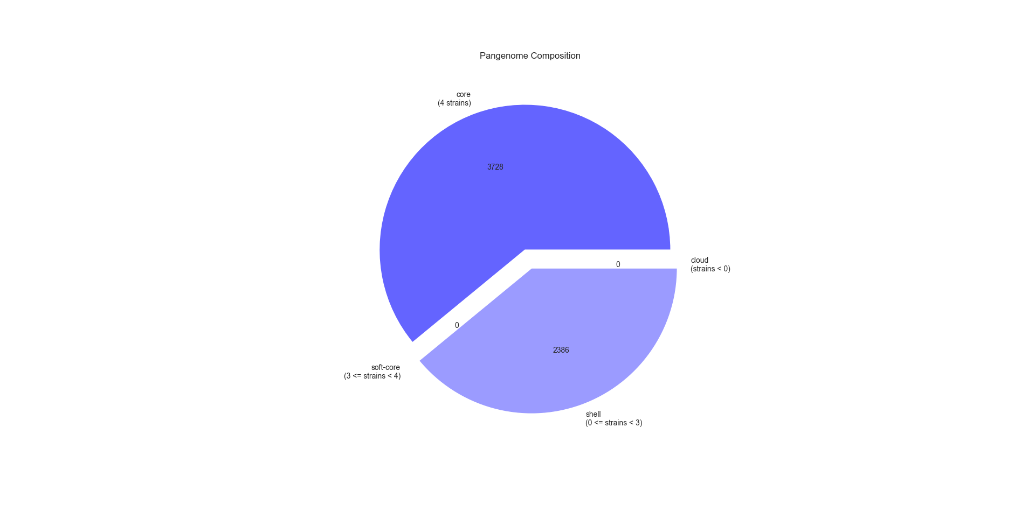
Fig.1: Pangenome classification of the strains revealed 3728 core genes (present in ≥99% of strains), 2387 shell genes (present in 15-95% of strains), and no soft core or cloud genes. The total number of genes across all strains was 6115.

Fig.2 : Nodes represent individual genes, while edges indicate shared presence of genes between strains.

Antimicrobial Resistance Gene Identification
AMRFinderPlus detected a total of 4 AMR genes in GN3, 4 in GN6, and 12 in GN9. The most commonly identified resistance genes across the strains were acrF, emrD, and blaEC. Notably, blaEC was absent in the E. coli K12 strain, highlighting a potential difference in antibiotic resistance profiles among the strains. In Fig.3 The acrF gene demonstrates higher structural stability (IDDT) and greater sequence coverage compared to the emrD gene, suggesting better representation and more reliable predictions for acrF. In contrast, emrD shows significant fluctuations in structural confidence and a sharp decline in coverage beyond position ~150, indicating potential challenges in modelling its structure or data incompleteness.

Fig.3 : Graphical representation of predicted Intrinsic Disorder Tolerance (IDDT) and sequence coverage for antimicrobial resistance genes acrF (A) and emrD (B)

Discussion
The results of this study offer significant insights into the genomic features and antimicrobial resistance profiles of E. coli isolates GN3, GN6, and GN9. High-quality genome assemblies and comprehensive annotations reveal detailed information on both core and accessory genomes, highlighting key genes related to virulence, pathogenicity, and resistance. The identification of AMR genes, particularly in GN9, indicates adaptation to environmental pressures and contributes to the understanding of E. coli evolution and resistance mechanisms. These findings have important implications for improving diagnostic and treatment strategies. Further investigations, including analysis of virulence gene identification and experimental validation of resistance genes, will be crucial to comprehensively address the challenges posed by antimicrobial resistance.

Referances
ACDARBY. 2025. LIFE_748 [Online]. Available: [https://github.com/acdarby/LIFE748/blob/main/conda_install.md] [Accessed 01-04-2025 2025].
ANDREWJPAGE. 2022. Roary [Online]. Available: https://github.com/sanger-pathogens/Roary [Accessed 01-04-2025 2025].
GERALD TEGHA1​, EMILY J. CICCONE2​,†ORCID ICON, ROBERT KRYSIAK1​, JAMES KAPHATIKA1​, TARSIZIO CHIKAONDA1​, ISAAC NDHLOVU3​, DAVID VAN DUIN2​ORCID ICON, IRVING HOFFMAN2​, JONATHAN J. JULIANO2​,4​,5​,‡ORCID ICON AND JEREMY WANG6​,‡ORCID ICON 2020. Genomic epidemiology of Escherichia coli isolates from a tertiary referral center in Lilongwe, Malawi. Microbiology society.
HAIHONG HAN, W. L., JIKAI LIU, XIAOAI ZHANG, XIANG HUO, YONG SUN, JIANCAI CHEN, RUYUE FAN, JING ZHANG, YONG CHEN, HONGXIA YANG, SHUAI CHEN, YANFEN LI, DONGMEI TAN, XUEMIN MA, PENGHUI FAN, SHAOFEI YAN & YUNCHANG GUO 2024. Seven-year overview of antimicrobial resistance in diarrheagenic Escherichia coli from sporadic human diarrhea cases in 20 Chinese provinces. Springer Nature
KOONIN EV, G. M. 2003. Sequence - Evolution - Function: Computational Approaches in Comparative Genomics.
NCBI. AMRFinderPlus [Online]. Available: https://www.ncbi.nlm.nih.gov/pathogens/antimicrobial-resistance/AMRFinder/ [Accessed 01-04-2025 2025].
PACBIO. Library prep + barcoding kits
Reagent kits for preparing HiFi and Onso sequencing libraries [Online]. Available: [https://www.pacb.com/products-and-services/consumables/library-prep-and-barcoding-kits/Links to an external site.] [Accessed 01-04-2025 2025].
QIAGEN. 2024. DNA Purification [Online]. Available: [https://www.qiagen.com/us/products/discovery-and-translational-research/dna-rna-purification/dna-purification/microbial-dna/dneasy-powermax-soil-kitLinks to an external site.] [Accessed 01-04-2025 2025].
ROBERT SCHMIEDER, R. E. 2011. Quality control and preprocessing of metagenomic datasets Oxford academic.
SHAW, E. 2024. ubuntu.com codebase [Online]. Available: https://github.com/canonical/ubuntu.com [Accessed 01-04-2025].
TONKIN-HILL, G. 2025. Panaroo [Online]. Available: https://github.com/gtonkinhill/panaroo/tree/master/docs [Accessed 01-03-2025].
W R PEARSON , D. J. L. Improved tools for biological sequence comparison.
YAN GUO, Y. S., LIMIN JIANG, YU CHEN, MICHELE CECCARELLI, MIN GAO & ZECHEN CHONG 2025. A detailed guide to assessing genome assembly based on long-read sequencing data using Inspector.

