**Module–1(Fundamental)**

* What is SDLC

Software development life cycle is a structure. It explains the process of planning, implementation, deployment, maintenance and support of product development.

* What is software testing?

Software testing is about meeting the requirements of clients. Requirements being, there should be no bugs, All the functions included and all the functions working properly.

* What is agile methodology?

Agile models are a combination of iterative and incremental models. In which, products will be delivered faster to customers in an adaptive manner.

* What is SRS

Software Requirement specification is like a manual for user to guide them how to use the software.

There are 3 types of requirements.

1. Customer requirements
2. Functional requirements
3. Non-Functional requirements

* What is oops

Object Oriented Programming System (OOPS) is a collection of objects which contain all the data and functions.

* Write Basic Concepts of oops

There are 6 Concepts.

1. Class
2. Object
3. Encapsulation
4. Inheritances
5. Polymorphism
6. Abstraction

* What is object

Object is representation of instance of Class. It is like a basic unit of OOPS.

* What is class

Class is a collection of data member (variable) and member function (process, methods) with its behaviors. Kind of a guideline to create object.

* What is encapsulation

Encapsulation is about the privacy of your data. It will be in hidden form. It is like a barrier or protection around data.

* What is inheritance

Properties of parent child extends into child class. Which means the new class will have the same properties as the previous class.

There are 5 types.

1. Single
2. Multilevel
3. Hierarchal
4. Multiple
5. Hybrid

* What is polymorphism

It is about having the same names, but their forms or functions can be different. They can share the same behavior.

1. Compile time (Method Overloading)
2. Run time (Method Overriding)

* Draw Usecase on Online book shopping

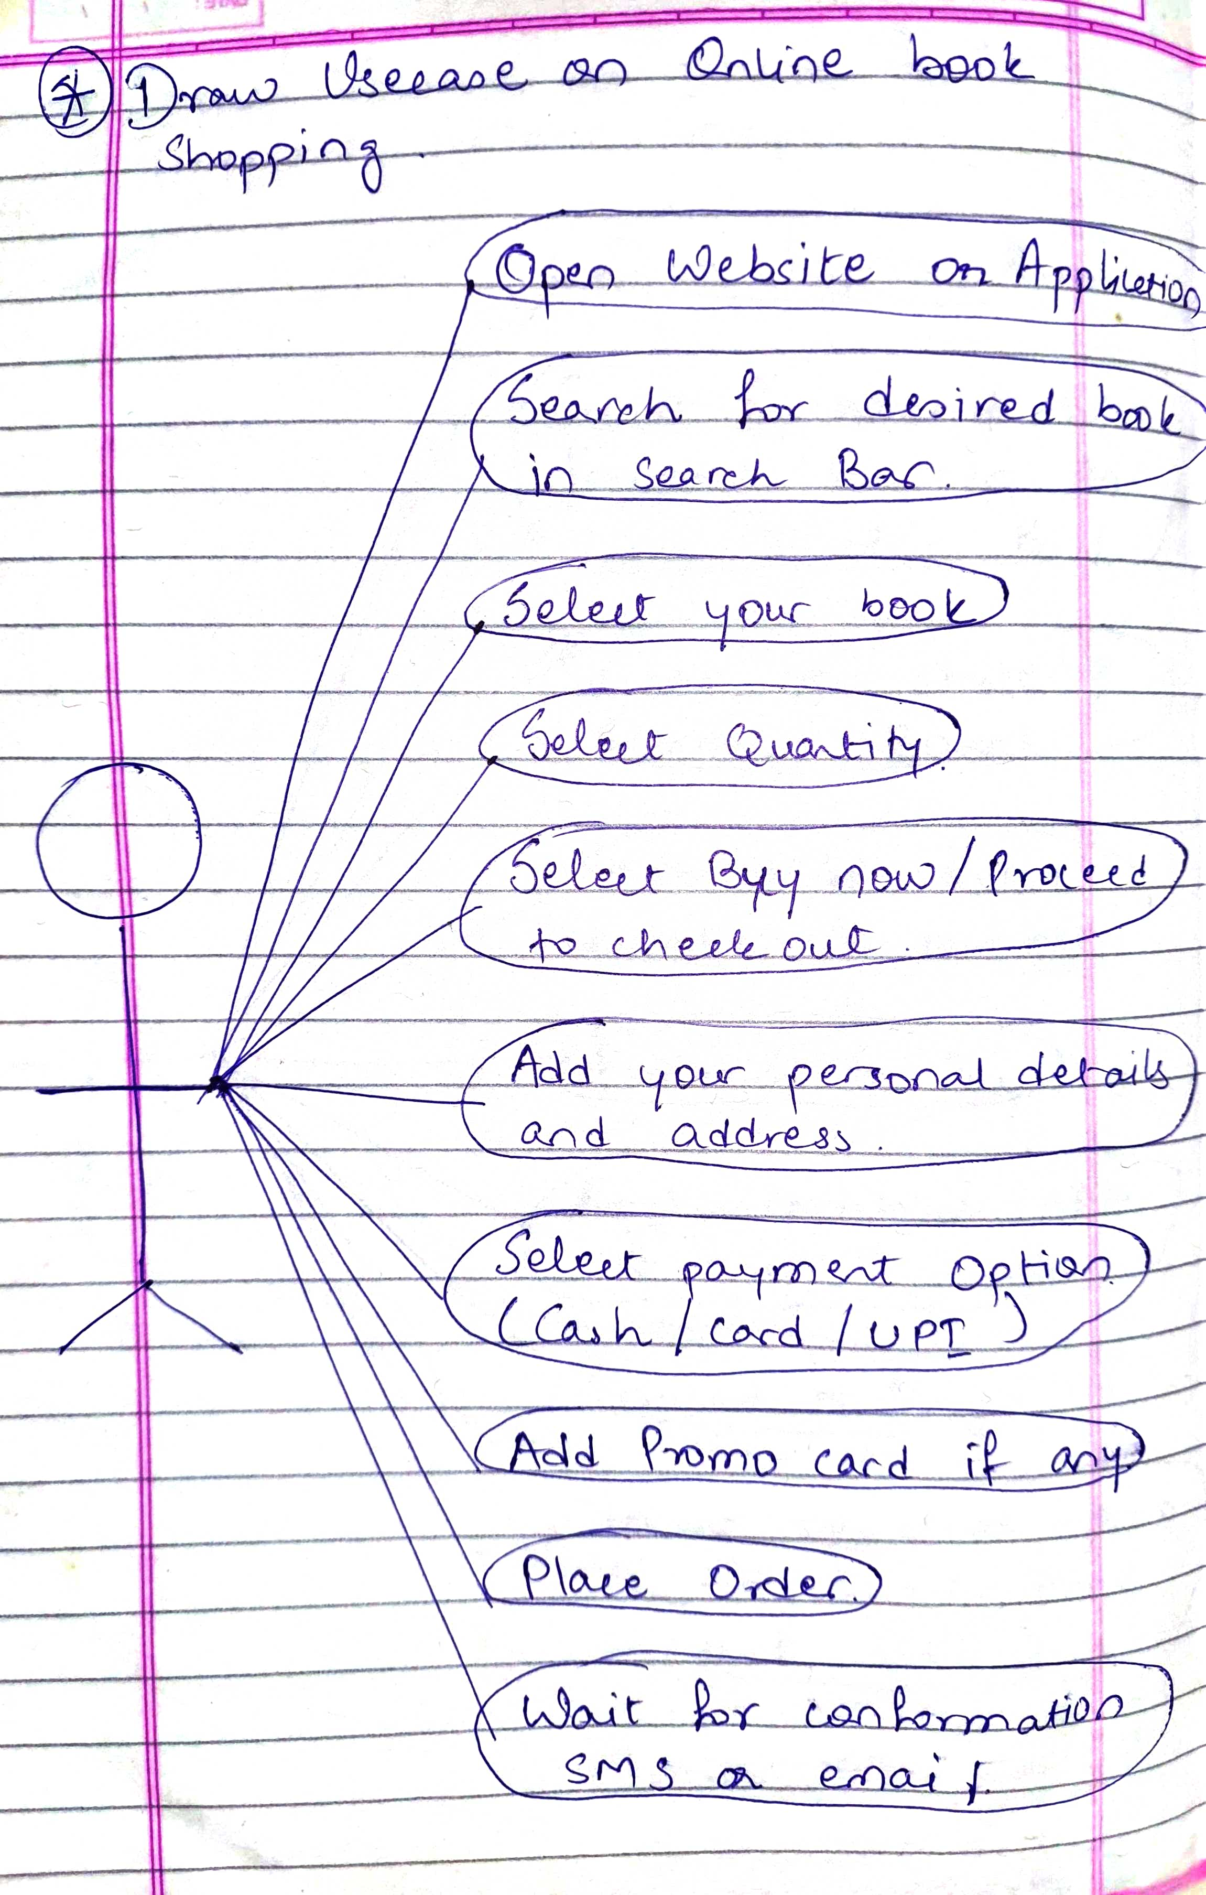

* Draw Usecase on online bill payment system (paytm)

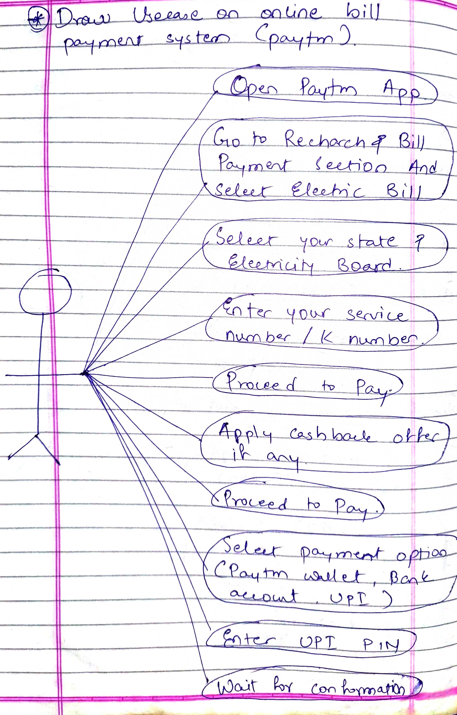

* Write SDLC phases with basic introduction

There are 6 phases of SDLC.

1. Requirement gathering – it invloves customer interaction to know about what their reuirements are.

2. Analysis - it involves documentation of how their requirements will be fulfilled.

3. Design - Based on analysis document, whole designing/planning is done to achieve high quality.

4. Implementation - it includes coding, critcal error removal. End results is product which is made exaclty how it was meant to be on based of requirement documentation.

5. Testing - Testing is done to check quality. To gain trust of clients, high quality must be delivered.

6. Maintenance - It is a document to track defects if any. It will repair and enhance the deployed software.

* Explain Phases of the waterfall model

The waterfall model is a classical software cycle which proceeds through each phase of SDLC like a step-by-step waterfall.

Application - Requirements are well documented.

Technology is not too dynamic.

Project duration is small.

Pros. - It is simple and easy to manage.

Works well for small projects

The tasks are easy to manage

Cons. - High risk involved.

It is not suitable for long and complex projects.

Changing requirements are not accommodated.

* Write phases of spiral model

There are 4 Phases.

* Planning
* Risk analysis
* Engineering
* Customer Evaluation
* Write agile manifesto principles

There are 4 reasons why Agile model is so famous in the software industry.

1. Individual Interaction
2. Working Software
3. Customer collaboration
4. Responding to Change

* Explain working methodology of agile model and also write pros and cons.

In Agile Methodology, there can be many incremental builds. Each time they are provided iteration. It mainly focuses on Individuality. After each iteration, the prototype will be shown to the client. This process takes 1 to 3 weeks. Tasks are divided into small portions and assigned to individual people.

Pros.:

It has a very realistic approach.

It is very flexible and adaptive to the client.

It gives an opportunity to each person to contribute.

Requires minimum planning and documentation.

Cons.:

It has more risk of sustainability, maintainability and extensibility.

It will compulsorily require an Agile leader, project leader and a plan to work otherwise it will not work.

Because it involves high interaction with customer, there is a high chance of confusion if the customer is not clear about the requirements.

There is minimal documentation available, so it is tough to hand over to new employees.

* Draw usecase on Online shopping product using COD.

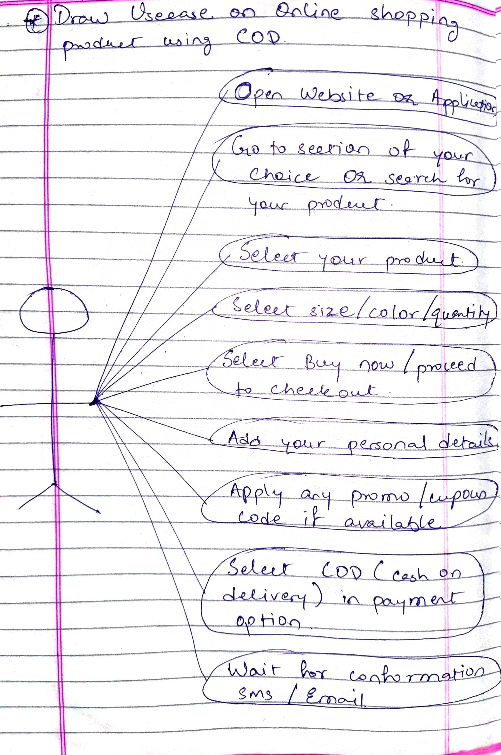

* Draw usecase on Online shopping product using payment gateway.

