**Pages**

1. Explore page - different llm models. Search by name, by description, filter, different views - grid, list, card

2. Model detail page - image, description, try out, use cases, snippet of code, example

3. Add model

4. Try out - chat || image add

------------------------------------------------------------------------------------------------------------------

**Model**

0. id

1. model_name

2. model_description

3. provider_name

4. provider_description

5. code_snippet

6. examples – [{ title:"",description:"",input:"",output:"" }]

7. model_image

8. provider_images

9. try_out_flag

10. redirect-link

IMP - model_implementation - function for trying out models (ChatGPT; Gemini)

------------------------------------------------------------------------------------------------------------------

**Design**

* Text – small(inner content), medium(subheading) & large(heading); grey - secondary

**Mocks**

1. 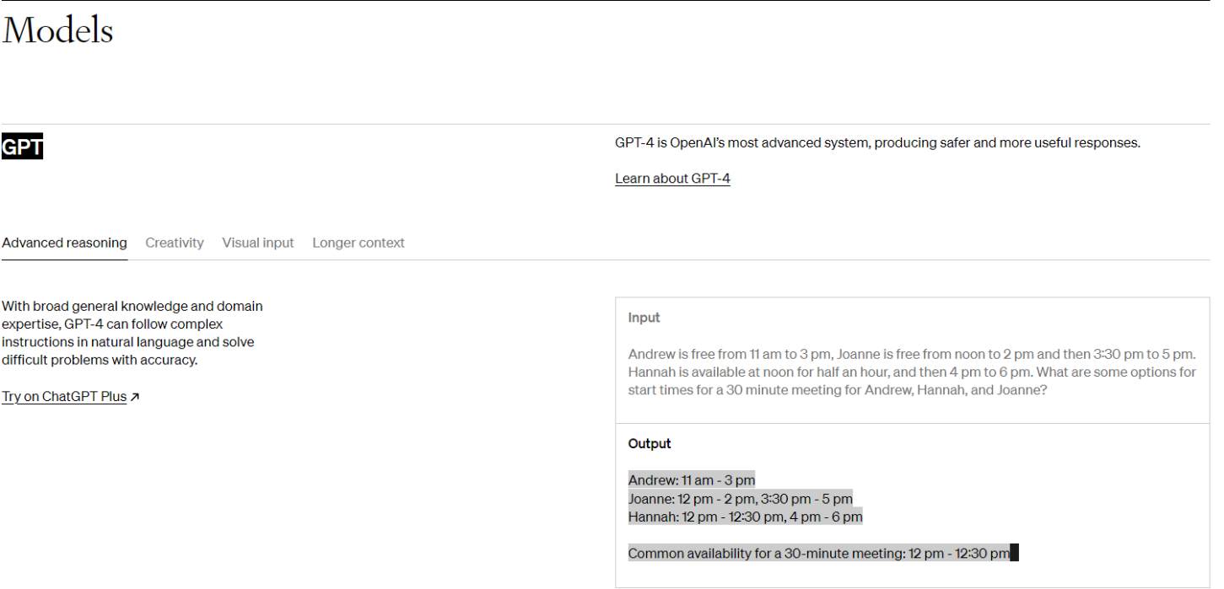Model detail page