**Employee Tracking Application**

**-:Wireframe Documentation:-**

***1.*MainClassForEmpTrackingProj**: This is the main page of Employee Tracking Application. Execution of application will start from here. We can say that it is home-screen of our application

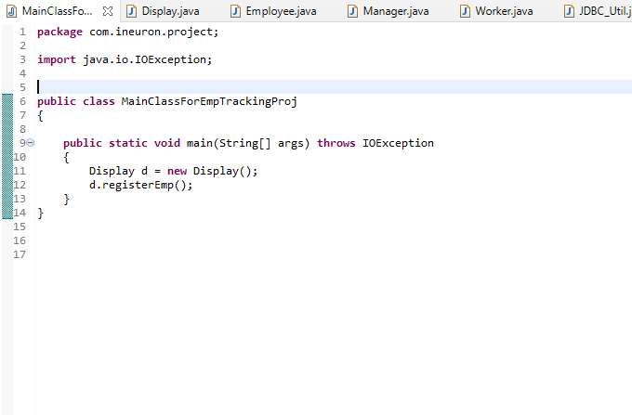

**2**.**Employee**:After selecting right option from the homepage, employee registration screen will open.And all new employee registration related task perform in Employee class.we can also check for givien id that employee is present or not.

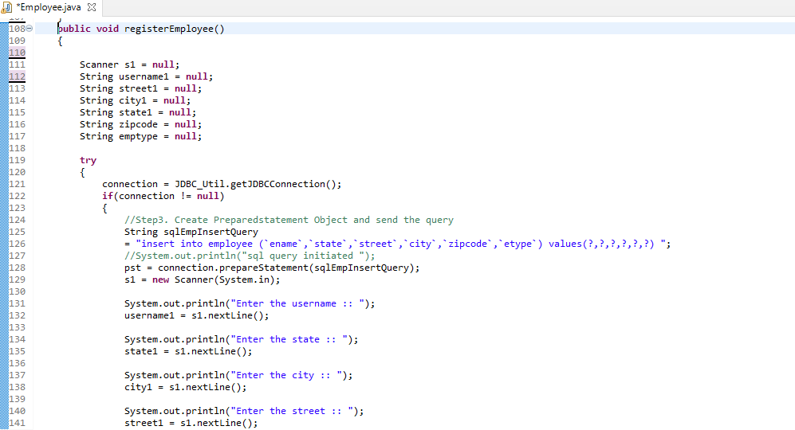

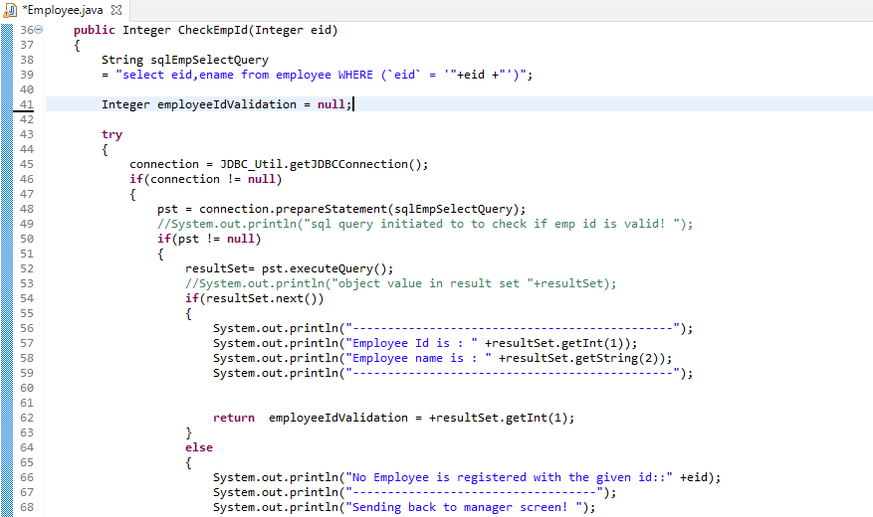

**3.Manager**: Manager class extends Employee class.Manager Related activies written in this class.Manager can set or change the status of the employee,update or add more information to the employee data.Manager can also display all the information of the employee in the console.

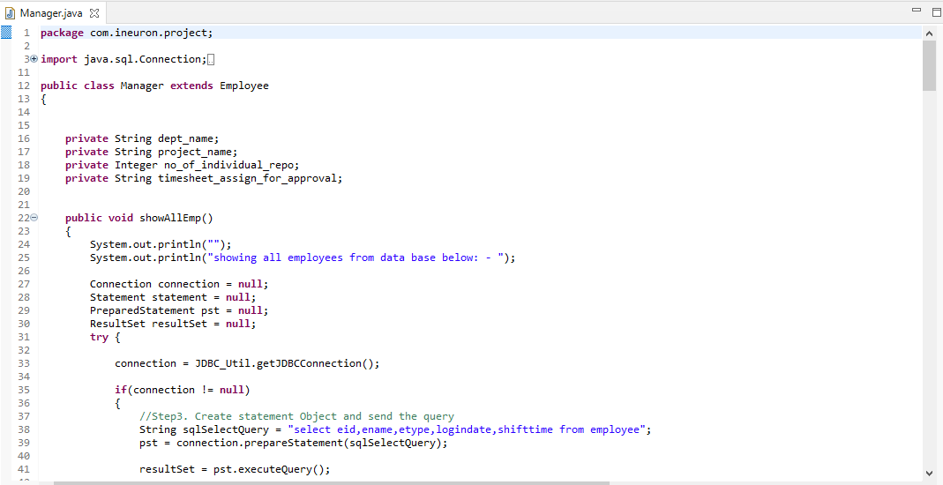

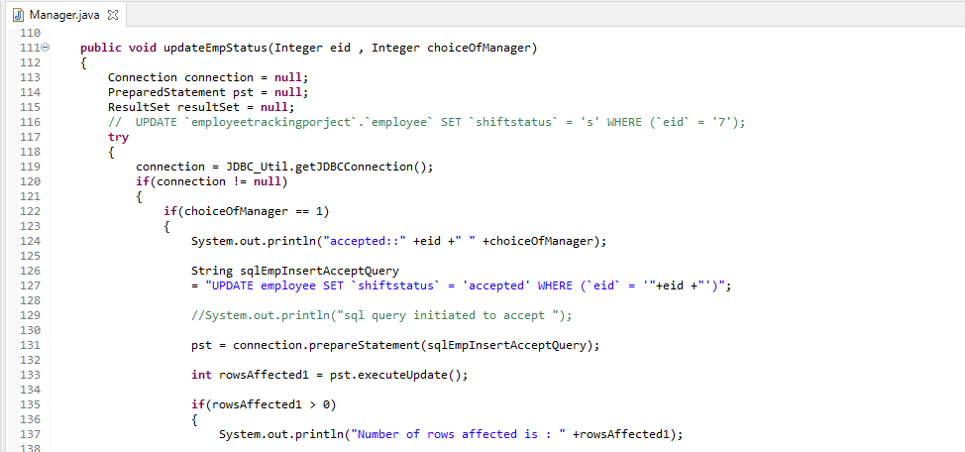

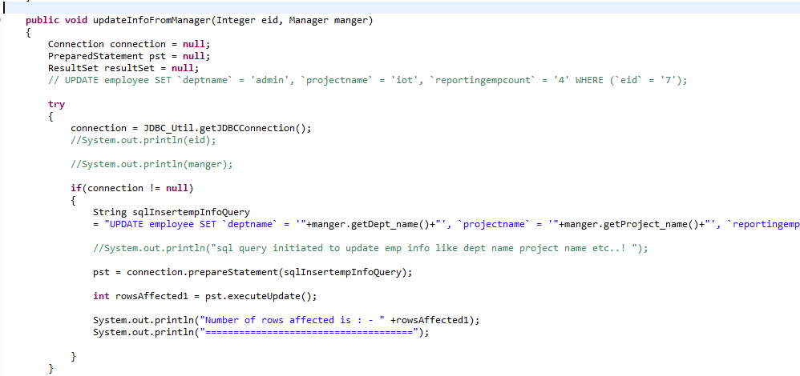

**4.Worker**:Worker class also extends Employee class. All worker related activities perform in this class. Workers can insert their login date and login time here. They can also see their status which is set by Manager.

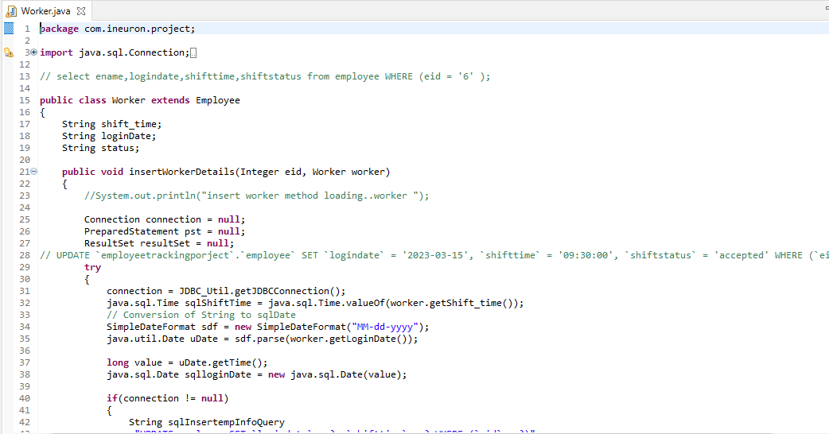

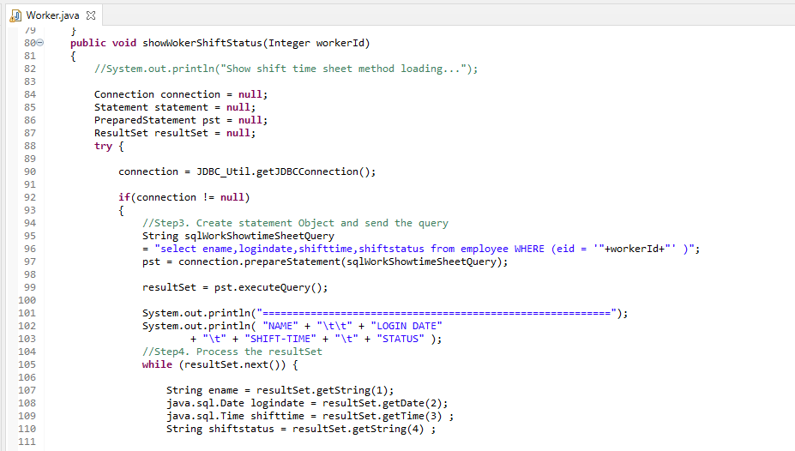

**5. JDBC_Util**:All Database related information written in this class.

