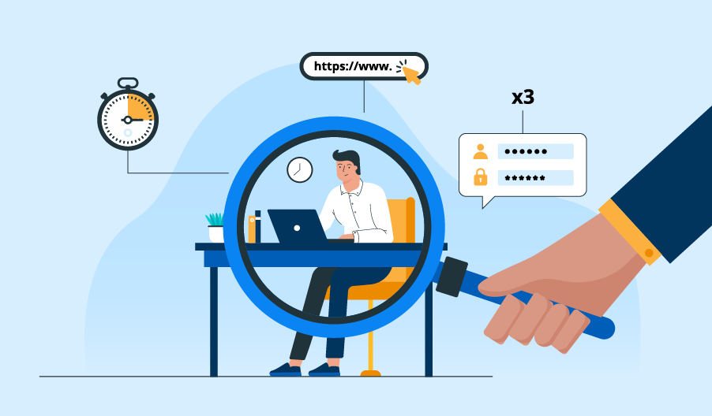 **Employee Tracking Application (2023)**

**AUGUST 20**

**iNeuron Internship project Authored by:**

**Shivani Barsainya,Shikha Verma,Siddharth Mone**

**Gopal Sharma**

**Table of Content**

1. Introduction
2. Features
3. Design

**Introduction**

This is a Console Based Employee Tracking System, which has been design in Java Technology and for database we are using MySql. In this application, we are trying to make some basic functionality for end user. There are some basic operations that user can perform.

General purpose of this application is to keep track of employee and their activities.

**Features**

The anticipated features of the Employee Tracking application are listed below.

* The worker should be able to make time.
* Every day, a sheet with the proper details.
* Before submitting a timesheet for approval, the employee should be able to view it. Timesheets that are awaiting approval should be visible to the manager, who should be able to approve or reject them.
* The supervisor should have access to timesheets employee wise or date wise

**Design**

1. Class Diagram :

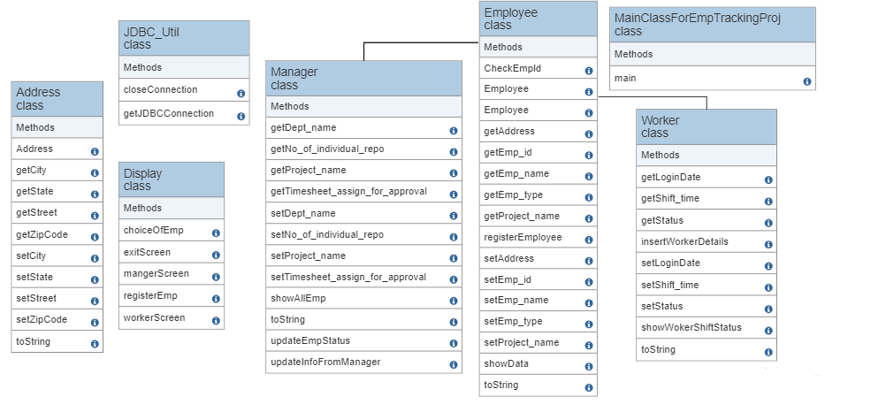

1. Use-Case Diagram :

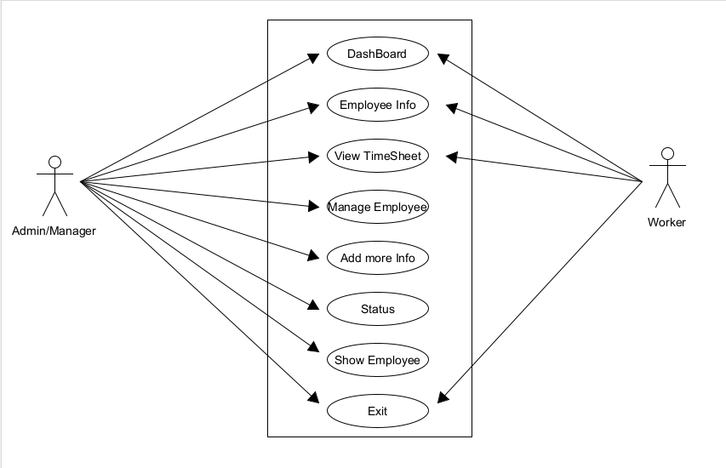

1. Database :

