# Low Level Design (LLD)

Submitted By:

***Sidhharth Mone Shikha Verma***

***Gopal R Sharma Shivani Barsaniya***

Contents

1. Introduction 2
   1. Why this Low-Level Design Document? 2
   2. Scope 2
2. General Description 3
   1. Product Perspective 3
   2. Problem statement 3
   3. Proposed Solution 3
   4. Further Improvements 3
   5. Technical Requirements 3
   6. Data Requirements 4
   7. Tools used 4
3. Design Details 5
4. System Study and Technology 8
5. Output 9
6. Conclusion 12

## 1 .Introduction

* 1. What is Low-Level design document?

The goal of LLD or a low-level design document (LLDD) is to give the internal logical design of the actual program code for Employee Tracking Application. LLD describes the class diagrams with the methods and relations between classes and program specs. It describes the modules so that the programmer can directly code the program from the document.

#### Scope

Low-level design (LLD) is a component-level design process that follows a step-by-step refinement process. This process can be used for designing data structures, required software architecture, source code and ultimately, performance algorithms. Overall, the data organization may be defined during requirement analysis and then refined during data design work

#### Product Perspective

**2 General Description**

The project main goal is to create This document also outlines the low-level design of the Console-Based Employee Tracking Application with JDBC integration. The application provides functionality for employee registration, manager login, and various features related to employee tracking.

.

#### Problem statement:

#### To track an employee and the activity so having an application to make it easy is important hence iNeuron Solutions Ltd made the decision to monitor how much time Employees spent on daily tasks. The goal was to generate response while efficiently tracking the time spent by staff on various tasks.

#### Proposed Solution

The solution proposed here is an Console Based Java Application .without manually Tracking whether the employee is doing its task or login/logout , shift status .It provide basic functionality based on the manager/supervisor requirement.

#### Further Improvements

Our project is limited to only one user working only with the help of console input .where here we are not using UI(User Interface) to make it more interactive which provide service to the multiple user based one there manager or supervisor request .we can even develop this project by using using MVC or using Servlets, JSP or Thymleaf .and we make this project more advance making it web based application by deploying it on Server.

#### Technical Requirements

As it is console based basic project we may not require much technology we just require IDE(Integrated Development Environment).So we using eclipse for providing console based application and Database MySql for storing details.

#### Tools used

Java programming language and eclipse and MySql Database

## Design Details

### 

### 3.1 Class Structure:

### 

4.1

DB DIAGRAM

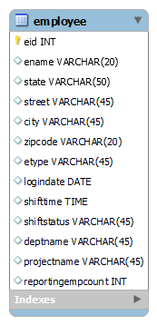

1. **SYSTEM STUDY AND TECHNOLOGY**
   1. **BENEFITS OF ONLINE:**

* Time saving.
* Less paper works.
* Cost efficient.
* More comfortable environment.
* Convenience and flexibility
  1. **SOFTWARE REQURIMENTS:**
* Eclipse(IDE)
* MySQl Database Workbench /SQLYog

### OUTPUT

Fig:5.1

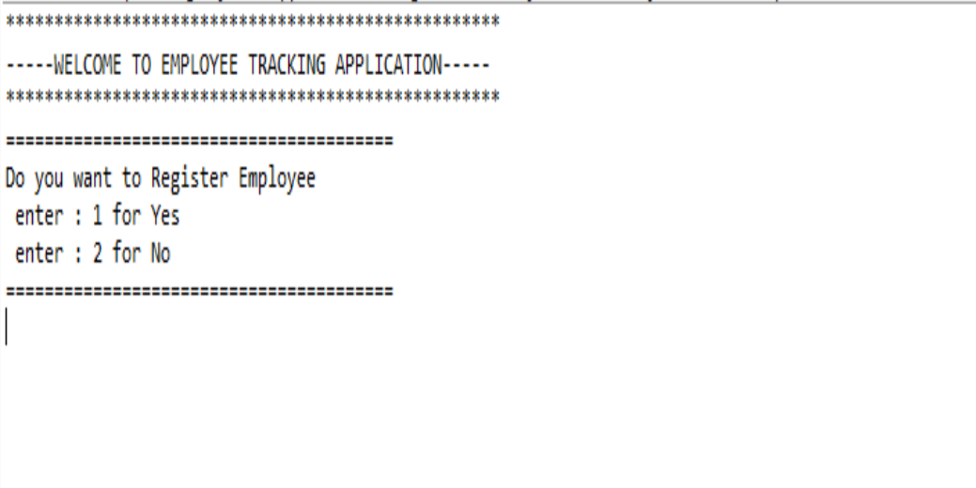

#### Fig : 5.2

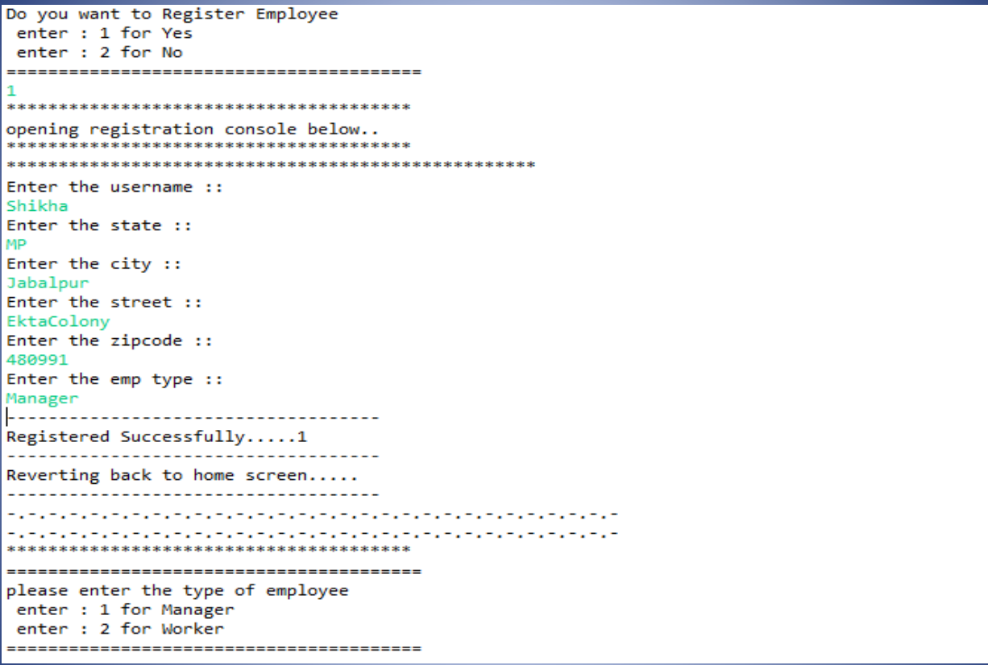

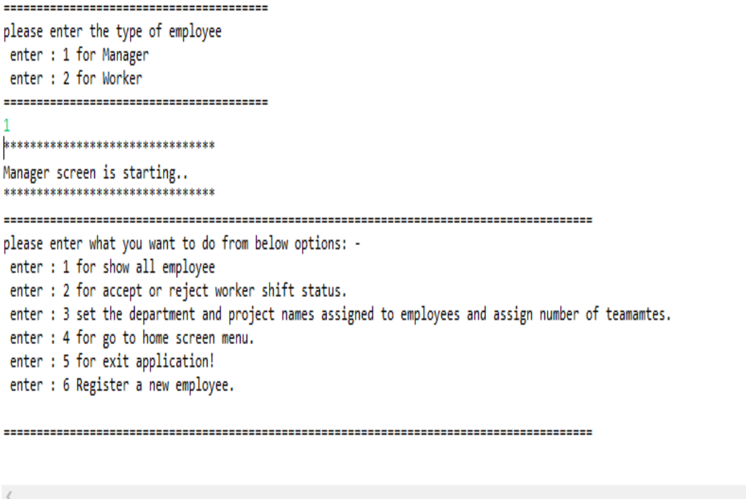

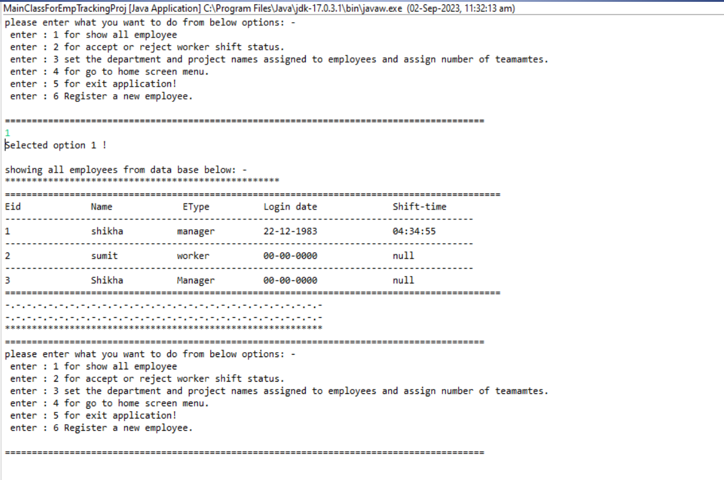

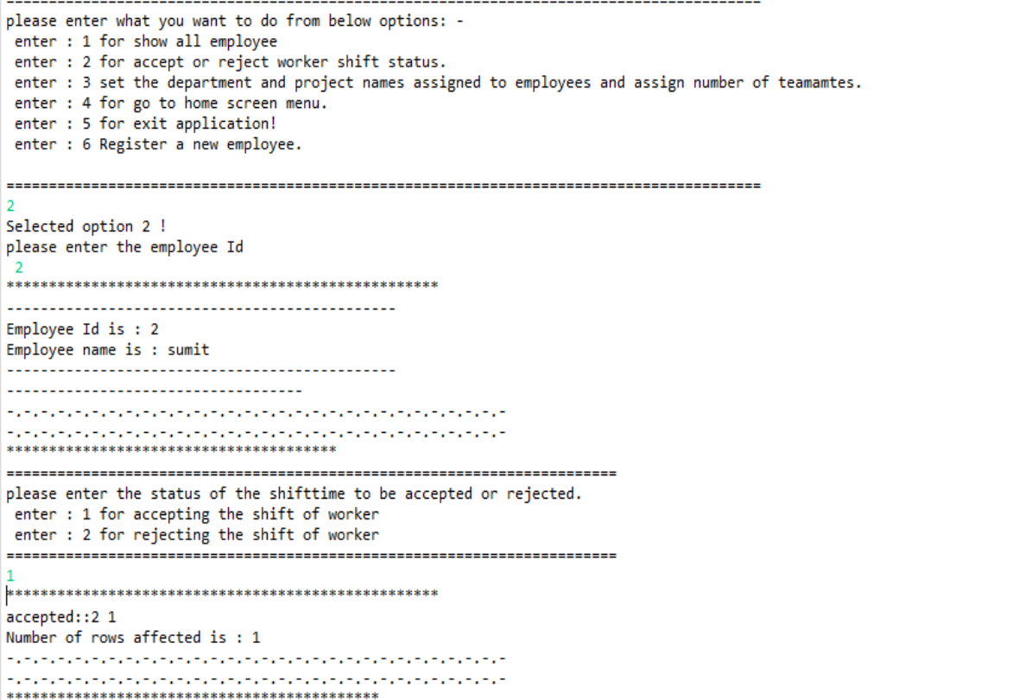

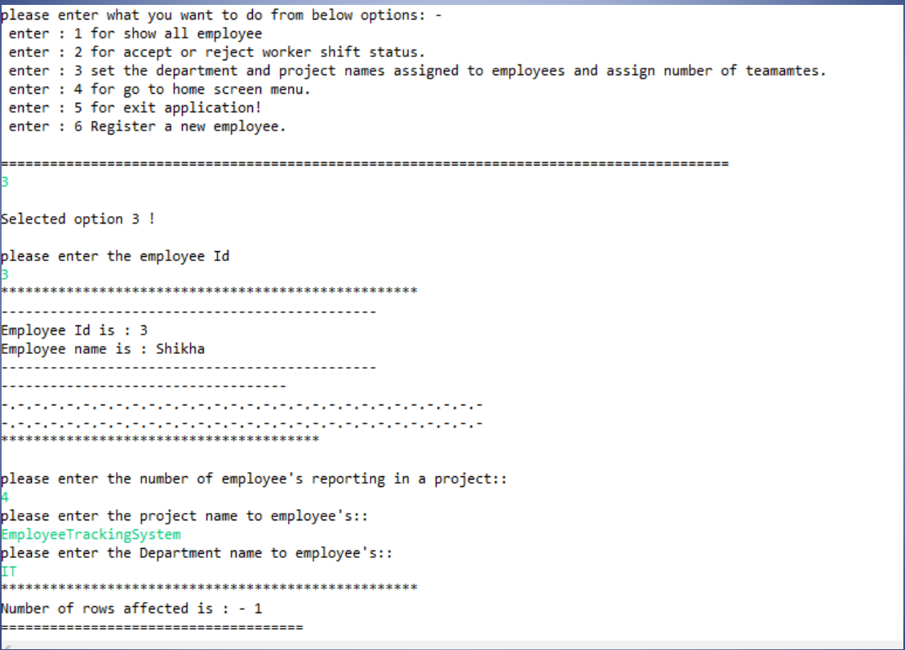

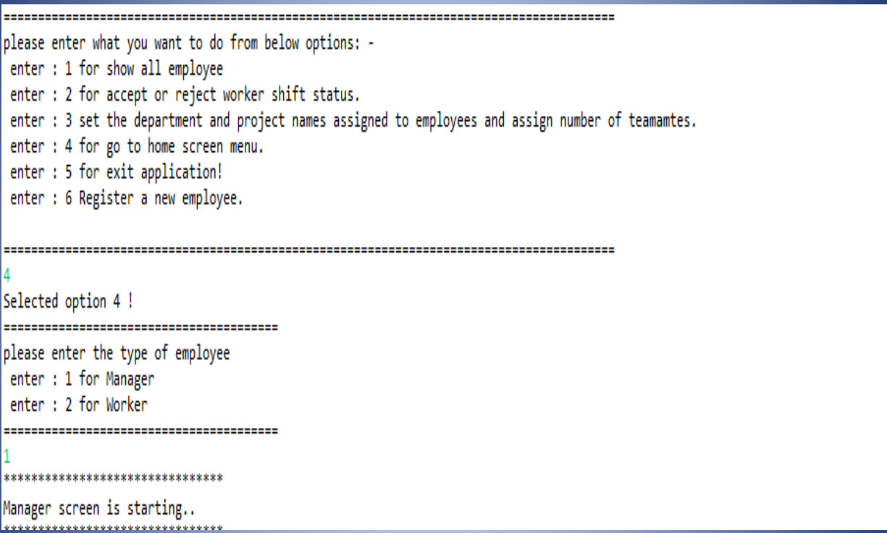

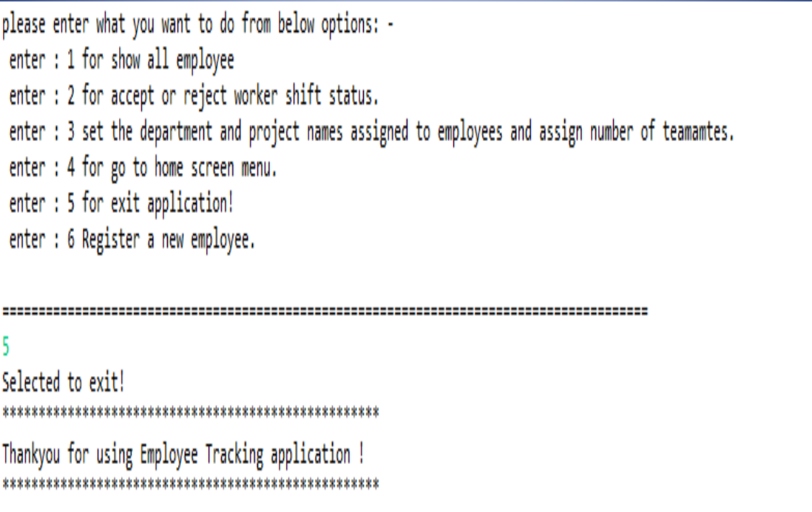

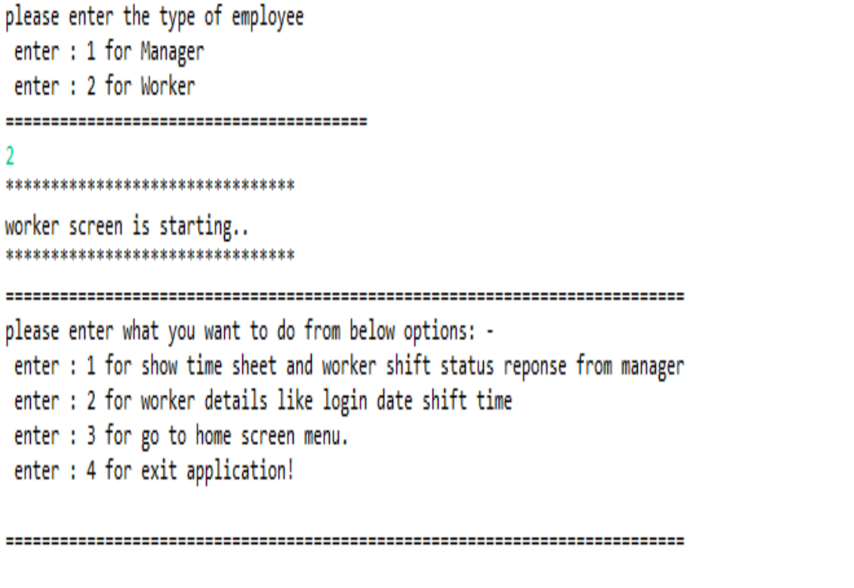

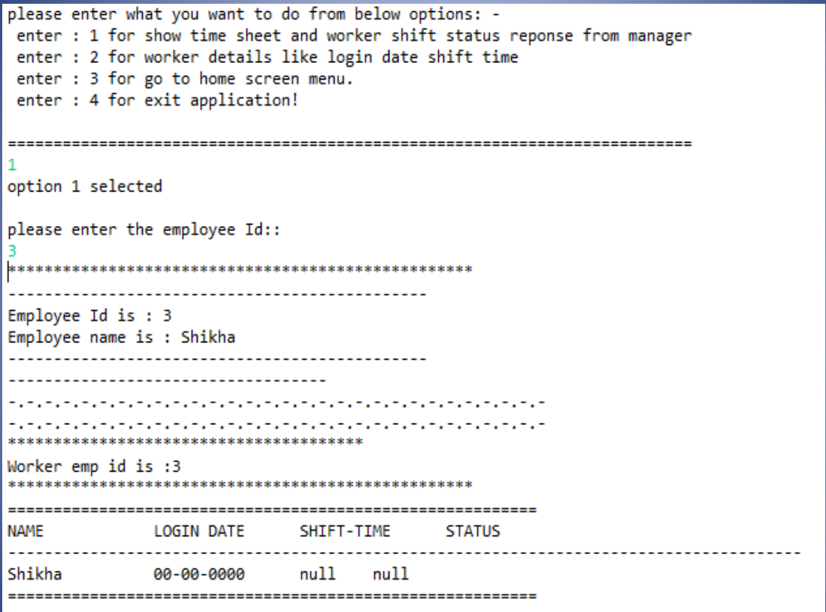

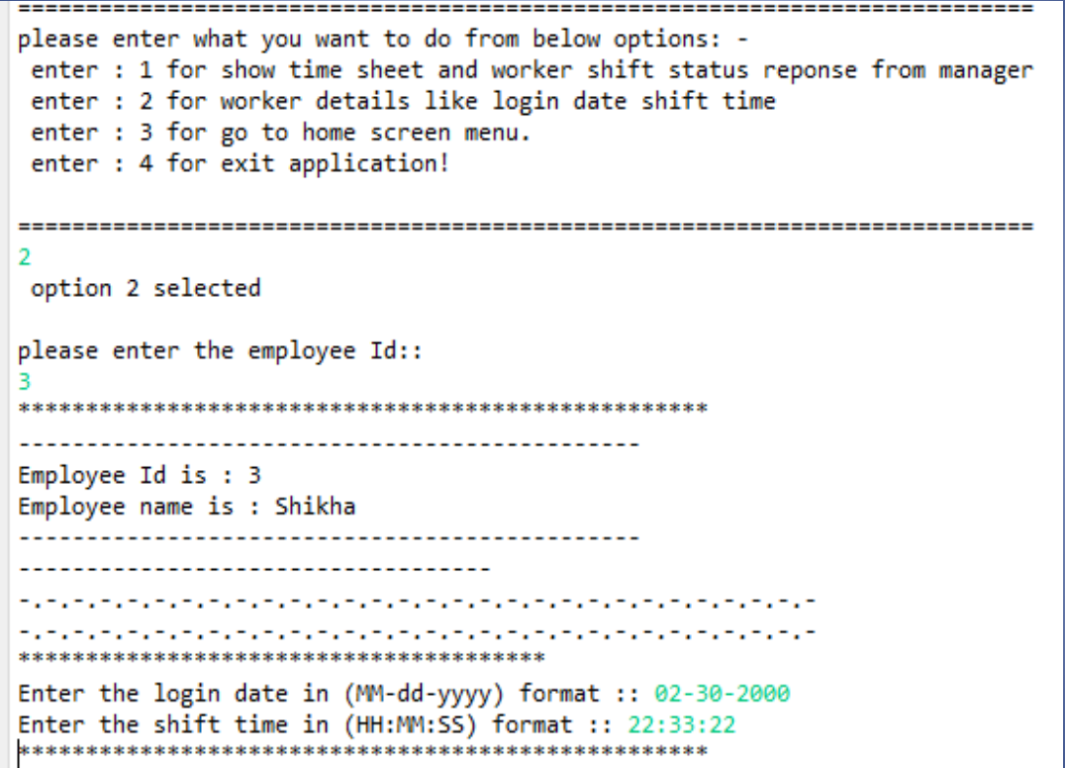

1. CONCLUSION

This low-level design document outlines the class structure, responsibilities, and flow of the Console-Based

This low-level design document outlines the class structure, responsibilities, and flow of the Console-Based Employee Tracking Application with JDBC integration. The design aims to provide employee registration, manager login, and timesheet management functionalities. The described classes and interactions provide a foundation for implementing the application.

Top of Form