**Date: 12/06/2023**

**Place: Bengaluru**

**To Whomsoever It May Concern**

**Subject: Declaration of the Authorized Person**

We, (**NORTCELE SYSTEMS PRIVATE LIMITED)**, would like to authorize, (**ASHOK KUMAR SINGH)**, (**DELIVERY HEAD)** to sign on behalf of our company for Telemarketer/ Enterprise related activities.

**Contact Person Name:** ASHOK KUMAR SINGH

**Contact Number:** +919380528940

**Email ID:** aks@nortcele.in

**ID Proof Type:** AADHAR CARD

**ID Proof Number:** 2394 4136 9306

**Copy of ID Proof:**

**(Insert Image here)**

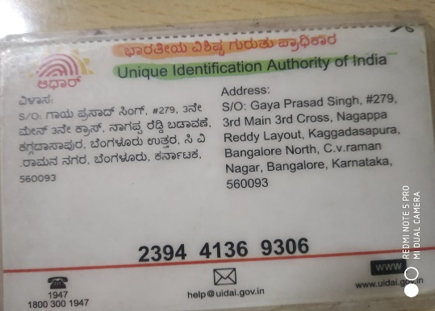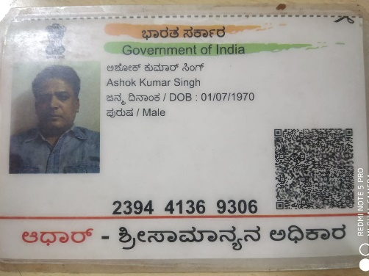

Yours Sincerely,

**(DEEPA SINGH)**

**(DIRECTOR)**