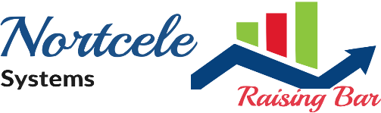

2nd Floor, #78, B.K. Plaza, Kagadasapura main road,

Vignan Nagar, New Tippasandra Post,

Bangaluru-560075, Karnataka (India)  
(+91) 804-126-3798 | 854-800-7734  
contact@nortcele.in

**NORTCELE SYSTEMS PVT.LTD.**



**Connect with us   
[](https://m.facebook.com/story.php?story_fbid=pfbid0haRAMU9yszdWdKMPNR8wnai49sy2wdQiCqwbmmgwHPaWeXNxrvpQ48TkhjJvv3kjl&id=106066444260367&mibextid=Nif5oz)**

WE PROVIDE

SMART IDEAS

TO GROW YOUR BUSINESS

**Coding the future, one line at a time. At our software development company, we thrive on innovation, transforming visionary ideas into powerful, user-centric solutions. With a passionate team of tech enthusiasts, we craft elegant code, driving success through cutting-edge technology and unwavering commitment to excellence.**

Our approach to software development is driven by collaboration, innovation, and a commitment to excellence. We start by deeply understanding our clients' needs, goals, and challenges. Through close consultation and analysis, we define project objectives, scope, and key milestones. Our multidisciplinary team of experts then translates these insights into a comprehensive roadmap and development plan.

* Community Management System
* Hospital Management System
* School Management System
* Property Evaluation System
* Inventory Management System
* Accounting Management System
* Ecommerce Management System
* Video Conferencing System
* Secure Meetings Coordination System.
* In addition, many more….

**PRODUCTS**

We specialize in empowering businesses through cutting-edge software solutions. Our expertise lies in crafting custom software tailored to your unique needs, spanning from innovative mobile applications and intuitive web platforms to robust enterprise solutions.

**WHAT WE PROVIDE**

**HOW WE**

**WORK**



**GET IN**

**TOUCH**

**+91-786-080-8000**contact@nortcele.in  
**https://nortcele.in/**