**ONLINE AVAILABLE TOOLS - SENTIMENT ANALYZER**

**How our Project is Better**

1. **TWEET SENTIMENT VISUALIZATION**

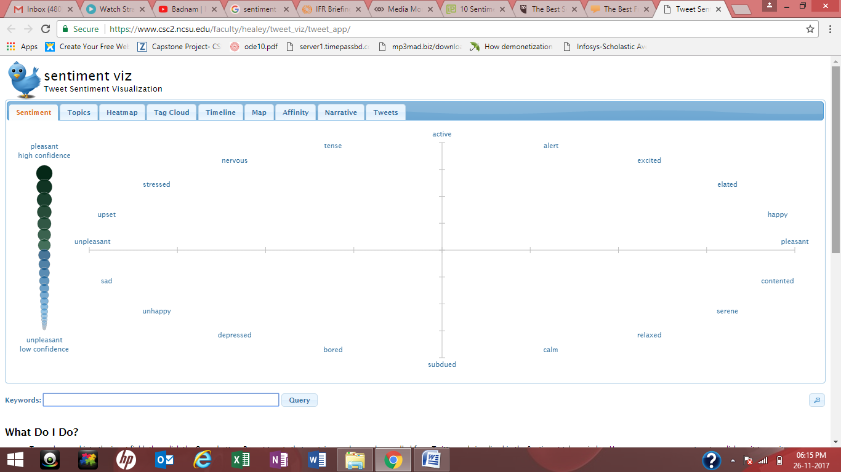

**How it works :**

Type a keyword into the input field, then click the Query button. Recent tweets that contain your keyword are pulled from Twitter and visualized in the Sentiment tab as circles. Hover your mouse over a tweet or click on it to see its text. Words highlighted in ***bold blue italics*** or ***bold orange italics*** are the words being used to estimate the sentiment of a tweet. Blue words are evaluated as-is. Orange words are evaluated as though they are negated, for example, "***happy***" versus "not ***happy***".

PIC :

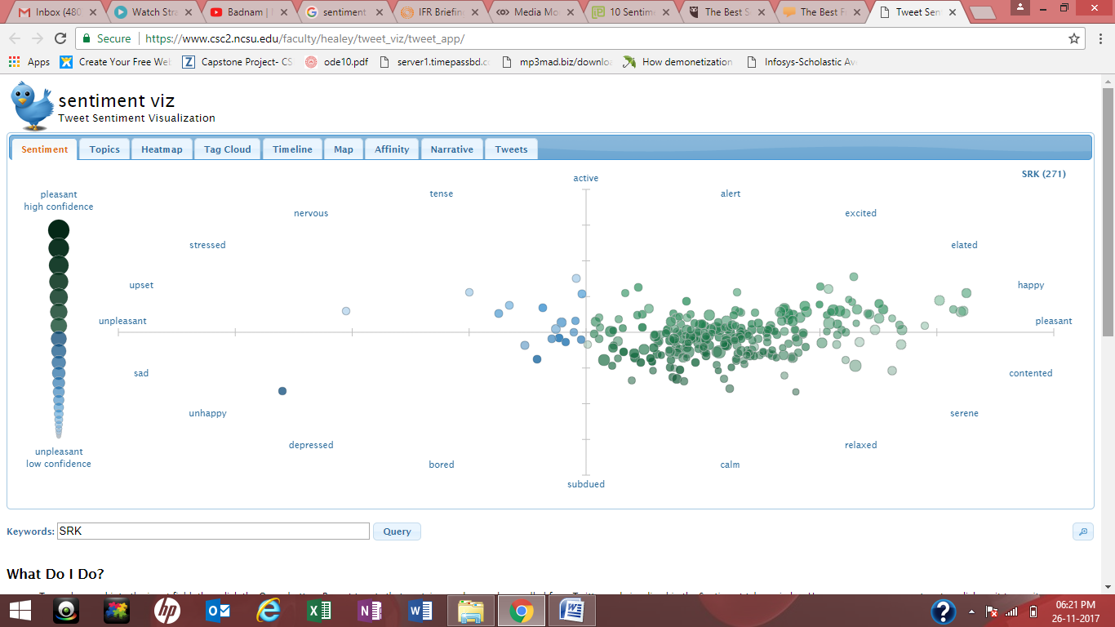

In the Tweet Visualizer’s visualizations, you can mouse over bubbles in scatter plots etc. to pull up individual tweets from identified Twitter users and see where they fall in the emotional spectrum.

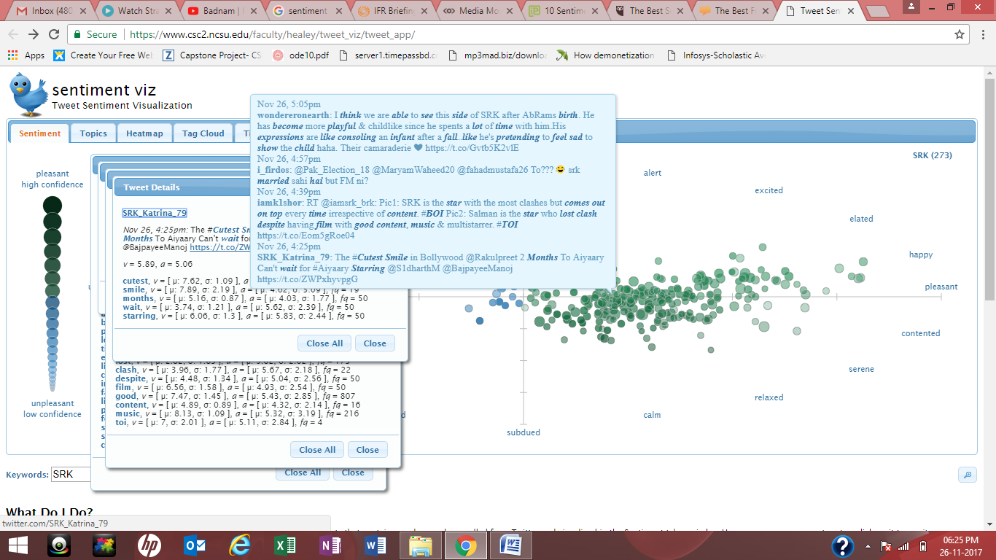

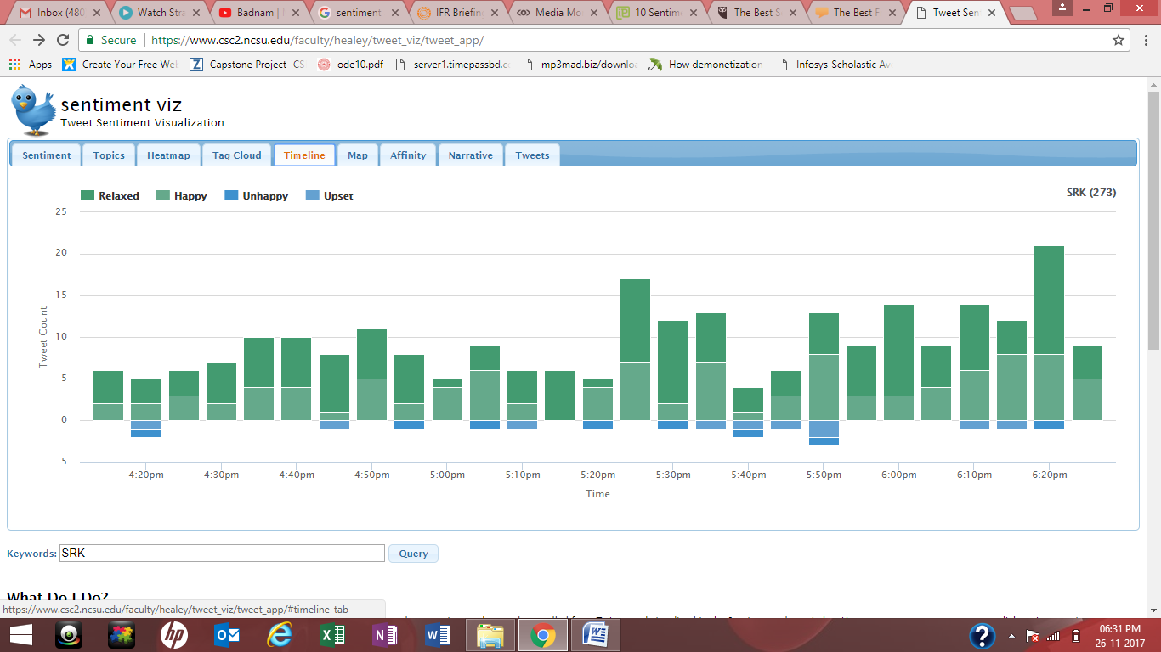

There are a lot of options above the screen. You can choose in which you want to see the result.

**Our project is better than this because our project shows the result as simple as possible. Above tool has a lot of emotions i.e. alert, excited, elated, pleasant, contented, relaxed, calm etc. which makes the whole thing complicated.**

1. **ENGINUITY**

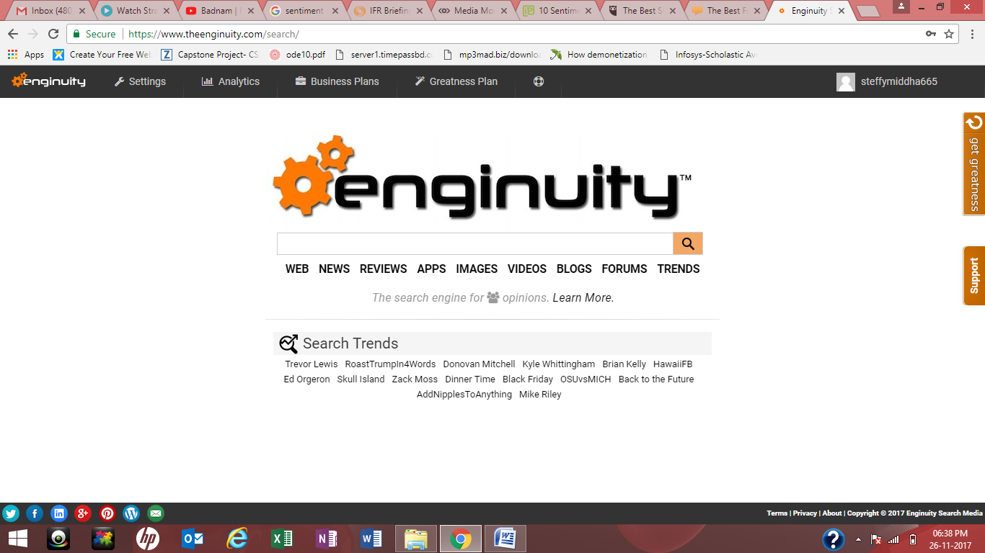

Put any keyword and it will show you the related tweets.

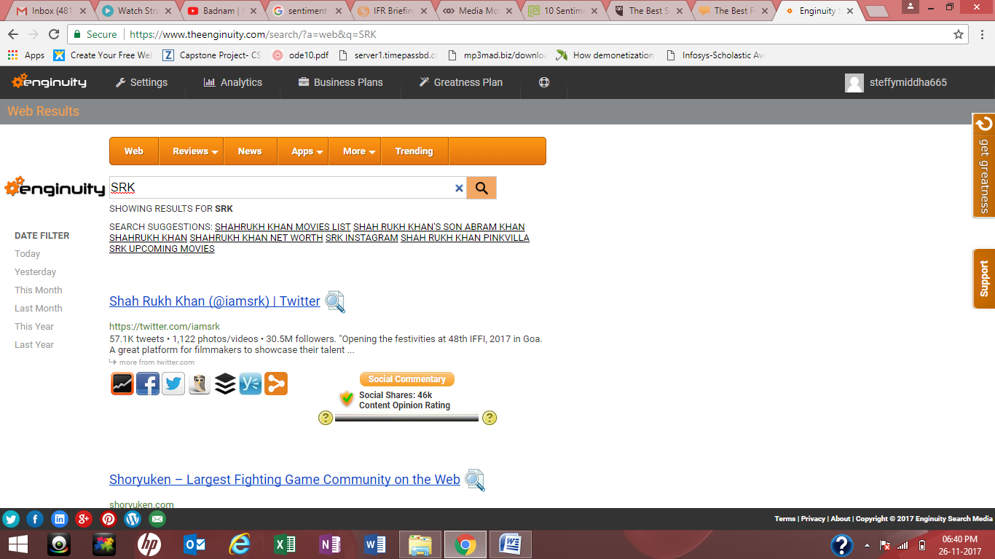

It can show you the images, videos etc. of the related topic under “MORE” on the top of the screen.

**In this, they are showing all the recent tweets related to the keyword but not telling the emotion of all the tweets. Our project is showing the No. of emotions of the related keyword.**

**Showing us the result in wordcloud format and many more**.

1. **SOCIAL MENTION**

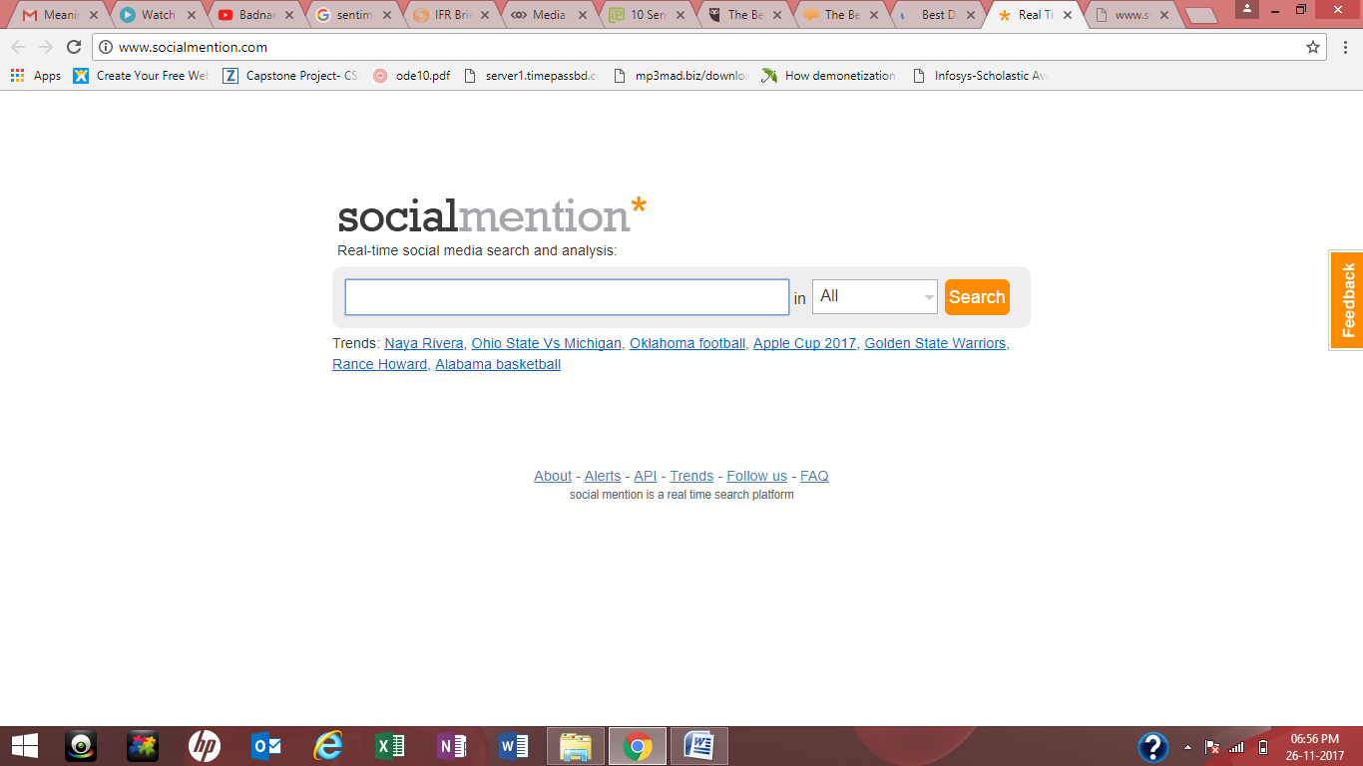

[Social Mention](http://www.socialmention.com/) is a basic, search engine-style web app for topic-level sentiment analysis on Twitter data. You can enter a keyword, and the tool will return aggregate sentiment scores for the keyword as well as related keywords.

One neat feature of Social Mention is support for basic brand management use cases—the tool returns a “passion” score that measures how likely Twitter users are to discuss your brand, as well as the average reach of the Twitter users discussing your brand.

**The caveat is that the tool still returns wonky results for lesser-known brands.**

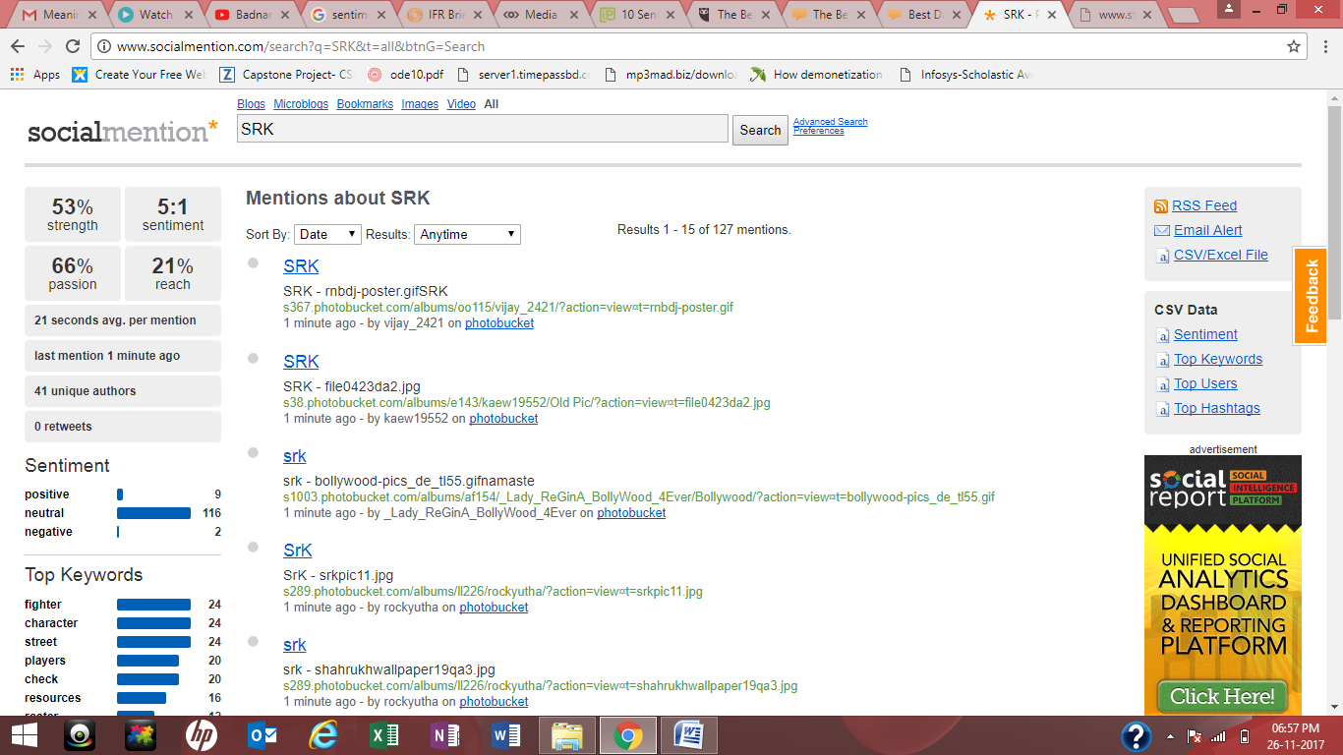

1. **GOOGLE ALERTS**

Google Alerts is a FREE sentiment analysis tool that allows businesses to track and listen to conversations about them on social media. The [beauty of Google Alerts](https://www.google.com/url?q=https://www.google.com/alerts&sa=D&ust=1505811766697000&usg=AFQjCNEZJxz6LGmmHGeQcydSdK0_IYSW1g) is that you can keep a close eye on everyone linking to your brand and business. Use it to:

* Monitor your company’s online presence
* Check to see if your prospects support your business with comments and likes
* Check to see if your prospects have complaints

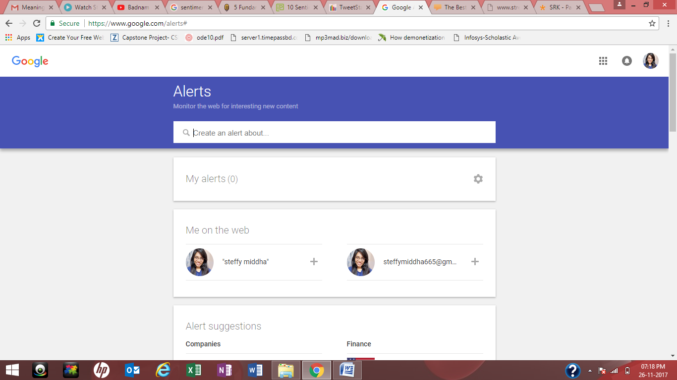

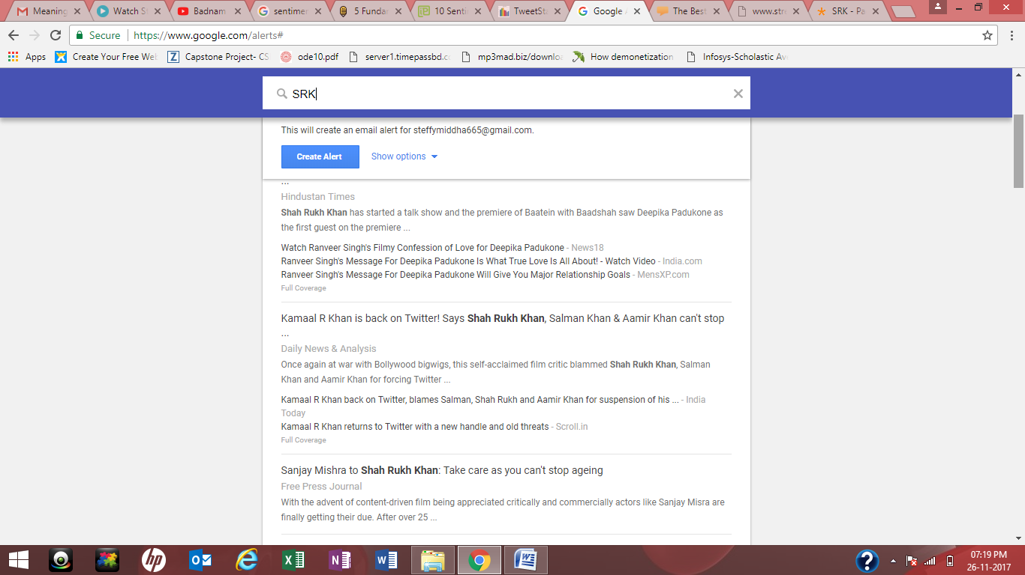

1. **TWEET STATS**

Tweet stats is a sentiment analysis tool that helps marketers track and measure specific Twitter parameters, including:

* Average tweet number per day
* Followers growth rate
* Reply statistics
* Tweet timeline
* Tweets per hour/month

With Tweet stats you can compare different Twitter accounts to get an overview of the page’s overall progress and general relationship you have with your key competitors.

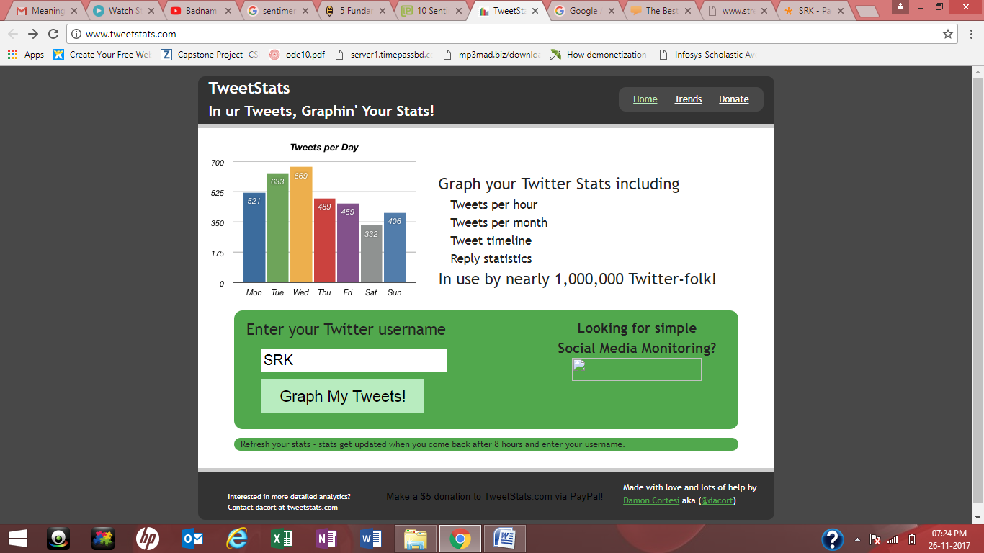

Above only shows you the graph of tweets that you have posted on the related keyword.

**Our project shows user every twitter post that has been posted on the related keyword. Our project is easy to use and shows all the results systematically.**