**OUTPUTS**

1. Web page showing

a) 3 paragraph boxes

b) Click me button

c) Hover your Mouse Here button

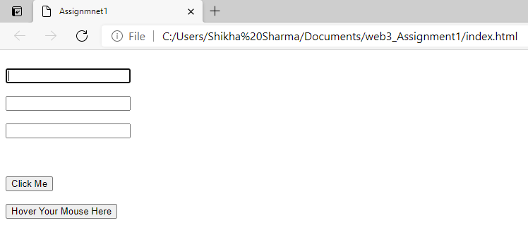

1. Enter the text in paragraph boxes and click me button.

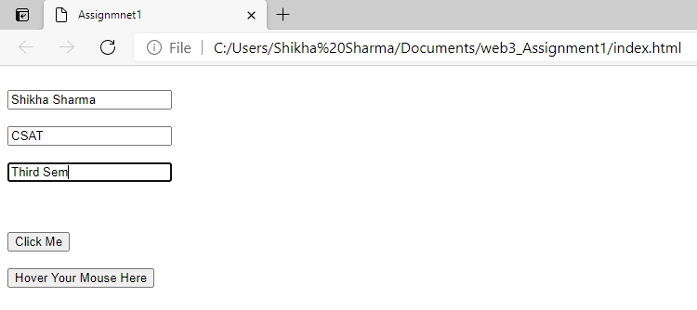

1. When press Click me Button “NEW PARAGRAPH ADDED” with “green” colour and “12” text size

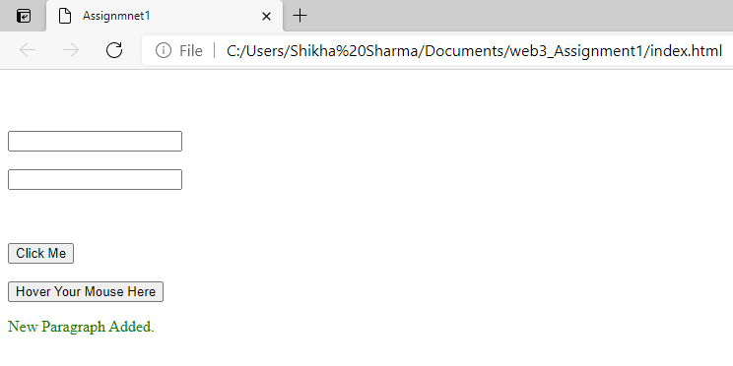

1. For Add second paragraph the id does not exist on the page and alert message displays

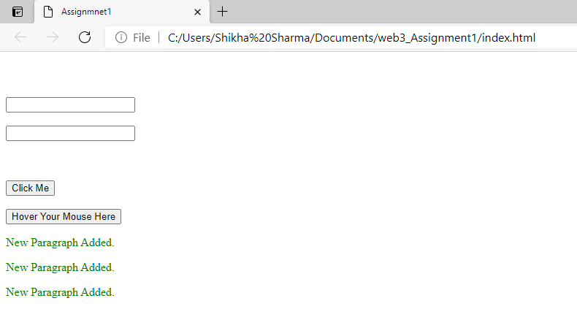

1. New paragraph added and when click on “HOVER YOUR MOUSE HERE” it changes colour red and create new same button “HOVER YOUR MOUSE HERE” with same property.

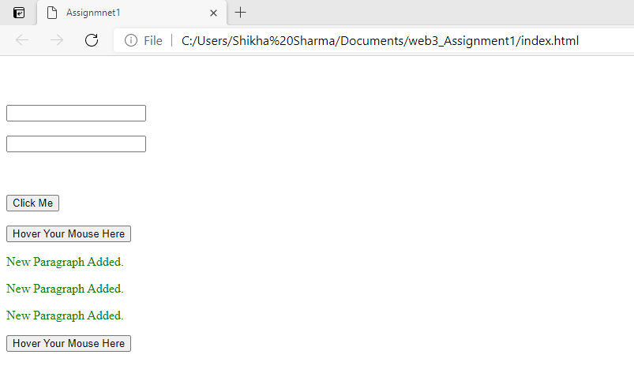

**NOTE: “RED” colour is not showing in the screenshot because once the mouse hovers on this button, the background of the button should get changed to red. Once the mouse leaves this button area, the background color should get changed back to the default value(white).**