Warwick Business School
Loan Risk Analysis
Policy Evaluation, Borrower Segmentation and Deep Learning for Default Prediction
Group 20
3-23-2026

Table of Contents
1. Introduction (129) 3
2. Data Preparation and Cleaning (126) 3
3. A/B Testing of Loan Review Policies (679) 3
3.1 Policy Definition (65) 3
3.2 Evaluation Metric and Hypotheses (266) 4
3.3 Policy Comparison (211) 5
3.4 Limitations (135) 6
4. Borrower Segmentation via Cluster Analysis (665) 6
4.1 Feature Selection and Methodology (147) 6
4.2 Cluster Profiles (174) 7
4.3 Policy Performance by Cluster (344) 9
5. Deep Learning for Default Prediction (537) 10
5.1 Prediction Task and Data Split (121) 10
5.2 Model Design and Training (178) 11
5.3 Model Evaluation (238) 11
6. Integrated Recommendation (336) 13
6.1 Integration Methods (156) 13
6.2 Policy Insights and Next Steps (180) 13
7. References 14

List of Figures
Figure 1 Default Rate by Loan Grade with Policy Boudaries 5
Figure 2 Policy A vs. Policy (approval rate, default rate and good loans rejected) 6
Figure 3 Optimal Number of Clusters (elbow method & silhouette analysis) 7
Figure 4 Borrower Segmentation — Feature Profiles (heatmap), Default Rates, Cluster Sizes, and Income vs DTI scatter. 9
Figure 5 Training and Validation Loss and AUC Curves 11
Figure 6 ROC Curve (AUC=0.688) and Precision-Recall Curve (AP=0.314) on the Held-Out Test Set 13

List of Tables
Table 1 Policy A vs. Policy B comparison 5
Table 2 Borrower cluster profiles 8
Table 3 Policy performance within each borrower cluster 9
Table 4 Model performance on the held-out test set 12

List of Equations
Equation 1 Portfolio Default Rate 4

1. Introduction (129)
This report analyses a LendingClub consumer loan dataset to support evidence-based loan approval decisions for a lending company evaluating changes to its review strategy. The analysis proceeds in three consecutive stages. First, a simulated A/B testing framework compares two sub-grade-based approval policies, quantifying the risk-return trade-off between a conservative and a selectively expanded lending stance. Second, K-means cluster analysis identifies distinct borrower segments, revealing differences in default behaviour that aggregate metrics conceal. Third, a prototype deep learning model is trained to predict individual loan default probabilities, in order to form a probability-based loan approval policy and compare it with the sub-grade-based cutoffs set in the first stage. Together, these methods form a layered analytical approach, each layer building on the next, to support recommendations for improving the company’s overall process.

2. Data Preparation and Cleaning (126)
The raw dataset contained 50,000 loan observations. A key challenge was 6,621 loans labelled ‘Current’, representing loans still being repaid with unknown final outcomes. Retaining these as non-defaults would introduce systematic bias into the target variable. As such, they were removed consistent with Turiel and Aste (2020), leaving 43,379 loans with resolved outcomes; Fully Paid, Charged Off, Default or late-stage delinquency.
To simulate a realistic origination-time environment, all post-decision variables (payment totals, recovery amounts, and disbursement figures) were excluded to prevent data leakage. Identifier fields, near-constant variables, and high cardinality free text columns were also removed. Variables with no discriminatory power were dropped, including pymnt_plan (only 3 positive cases) and initial_list_status (identical default rates across categories). Revolving account data was cleaned using a systematic 12-scenario consistency check across revolving balance, total credit, and utilisation; 30 illogical combinations were dropped and remaining values recalculated where possible. Revolving balance and total credit revolving were then dropped, as their predictive value is captured in revolving utilisation. Installment was verified against the loan amortisation formula and 37 rows with greater than 5% deviation were removed; the column was then dropped as it is mathematically determined by loan amount, interest rate and term. Total accounts was dropped due to its correlation (0.66) with open accounts. Missing values were handled via median imputation with binary missingness flags, except for total collection amount (13,690 missing) which was imputed with zero as missingness likely indicates no collections. Continuous monetary variables were capped at the 99th percentile and discrete count variables at risk-informed thresholds. The final cleaned dataset comprised 43,312 observations with a default rate of 18.02% and 30 variables.

3. A/B Testing of Loan Review Policies (643)

3.1 Policy Definition (65)
Policy A (Conservative) approves loans graded A-C, accepting 34,231 of 43,379 loans (79.8%). Policy B (Expanded) extends approval to grade D, accepting 40,227 loans (92.7%). Policy B is structurally Policy A with 5,996 marginal Grade D loans added, creating an incremental comparison. The Grade D boundary was chosen because it is the last tier before subprime classification and represents the most commercially contested risk profile.

3.2 Evaluation Metric and Hypotheses (266)
Portfolio Default Rate (PDR) was selected as the primary evaluation metric. This is defined as the proportion of approved loans that subsequently default, as shown in Equation 1. This metric directly reflects the loss rate of the booked portfolio, aligning closely with the lending company’s primary operational objective. In addition, a secondary proxy for interest income was computed to provide directional insight into profitability.
$$PDR= \frac{\# of Defaults Under Specified Policy}{Total \# of Loans}$$
Equation 1 Portfolio Default Rate
Default rates increase monotonically across loan grades. Figure 1 illustrates the relationship between loan grade and default rate, forming the basis for defining the cutoff boundaries under Policy A and Policy B. Grades A–C exhibit default rates ranging from 7.2% to 20.8%, with an average interest rate of 12.2%. In contrast, Grade D loans have a substantially higher default rate of 27.1% but offer a higher average interest rate of 18.5%. The central business question is whether this additional yield sufficiently compensates for the increased default risk.
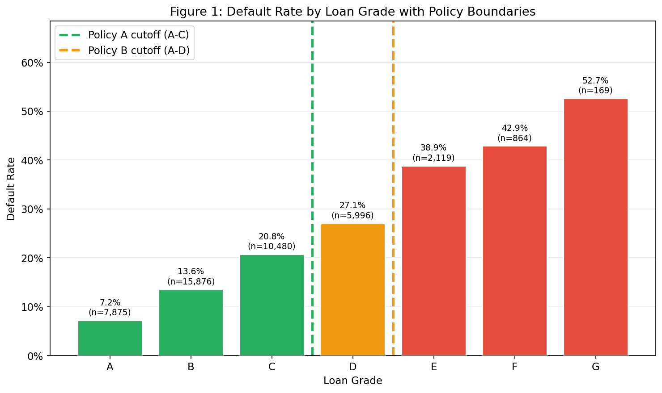
Figure 1 Default Rate by Loan Grade with Policy Boudaries
Since Grade D inclusion is expected to increase defaults, a one-sided hypothesis was specified:
$H_{0}:$ DR(Policy B) ≤ DR(Policy A)
$H_{0}:$ DR(Policy B) > DR(Policy A) [α = 0.05]

3.3 Policy Comparison (211)
Policy A’s approvals are a strict subset of Policy B’s, as such the samples are not independent violating standard z-test assumptions. The comparison was conducted via deterministic decomposition and validated with non-parametric bootstrap (5,000 resamples) following Efron Tibshirani (1993). The decomposition confirms the shared A-C pool defaults at 14.33%, the marginal grade D pool at 27.10% and the combined portfolio at 16.23% - the 1.90 pp increase driven entirely by grade D inclusion. The key outcomes for each policy across the full dataset, including approval volumes, default rates and the financial proxy, are summarized in Table 1.
Table 1 Policy A vs. Policy B comparison
Metric | Policy A (A–C) | Policy B (A–D) | Difference
Approved loans | 34,231 | 40,227 | +5,996
Approval rate | 78.9% | 92.7% | +13.8 pp
Default rate | 14.33% | 16.23% | +1.90 pp
Good loans rejected | 6,239 | 1,868 | −4,371
Financial proxy | $13.3M ($388/loan) | $12.0M ($298/loan) | −$1.3M

The three key trade-offs between the policies – approval volume, portfolio default rate and opportunity cost associated with rejecting creditworthy borrowers - is illustrated in Figure 2. The bootstrap analysis yields a 95% confidence interval of [+1.72%, +2.08%], with Policy B outperforming Policy A in 100% of resamples (p < 0.0001), providing strong evidence to reject the null hypothesis (H₀). The interest-income proxy indicates that Policy A generates approximately $13.3M, compared to $12.0M under Policy B. However, this proxy does not account for partial recoveries or early repayments, meaning the financial case for expanding approvals remains sensitive to underlying recovery assumptions.
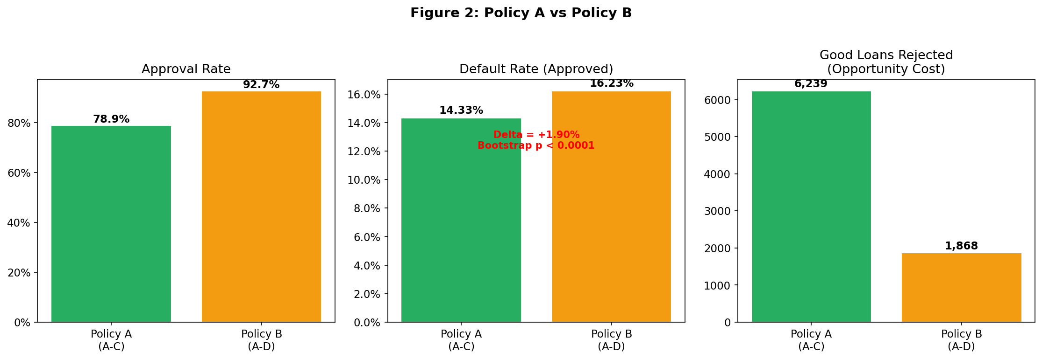
Figure 2 Policy A vs. Policy (approval rate, default rate and good loans rejected)

3.4 Limitations (135)
This analysis is based on a simulated comparison using observational data rather than a randomized, controlled experiment. Several key limitations should therefore be acknowledged. First, selection bias is a concern, as only funded loans are observed; counterfactual outcomes for rejected applicants cannot be estimated as discussed in Banasik et al.,(2003). Second, grade endogeneity arises because LendingCLub grades are used as policy thresholds; lending grades embed lender risk assessment introducing circularity. Third, label ambiguity exists, with 505 loans classified as late/grace period treated as defaults, despite the possibility of partial recovery, potentially overstating the default rate by approximately 1 percentage-point (pp). Finally, the financial proxy excludes recoveries and pre-default payments, limiting its accuracy as a measure of realized profitability.
Accordingly, the estimated +1.90 pp difference should be interpreted as a descriptive association rather than a casual effect.

4. Borrower Segmentation via Cluster Analysis (665)

4.1 Feature Selection and Methodology (147)
K-means clustering was applied to 10 continuous application-time variables: annual income, DTI, loan amount, interest rate, revolving utilization, credit history length, delinquencies in the prior 2 years, recent enquiries, open accounts and revolving balance. Interest rate was included as it captures risk-based pricing at origination. Categorical variables were excluded as Euclidean distance is not meaningful for nominal categories (K-Means was preferred over hierarchical methods for computational tractability at 43,000+ observations and over DBSCAN as the objective is broad behavioural archetypes rather than density-based clusters. Features were z-score standardized with 99.5th percentile outlier capping to prevent extreme values from distorting centroids. K = 4 was selected via elbow and silhouette analysis as shown in Figure 3. The silhouette score of ~0.13 is low but that is to be expected for overlapping credit data. Cluster labels were assigned post-hoc; the default outcome was not used as a clustering input.
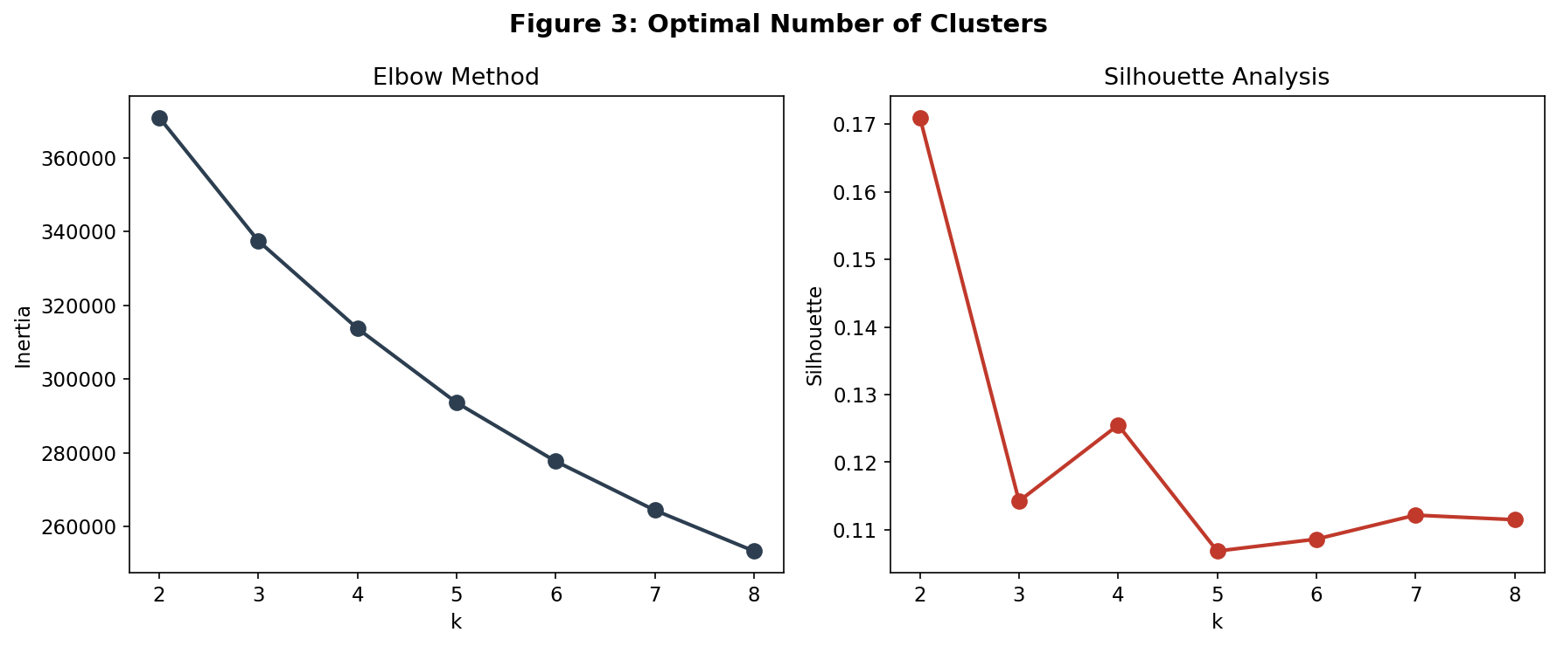
Figure 3 Optimal Number of Clusters (elbow method & silhouette analysis)

4.2 Cluster Profiles (174)
Table 2 profiles each cluster across key financial and behavioural variables, enabling direct comparison of risk characteristics. The Low-Risk Prime cluster has the lowest default rate (11.1%), with 87% of loans graded A-B. The Mid-Risk Mainstream cluster is distinguished not by income, which is above average, but by elevated delinquency history (2.73 events per borrower), making past repayment behaviour the primary risk driver. The High-Income Leveraged cluster is counterintuitive; despite the highest average income ($109,600), it carries a 20.7% default rate, explained by large loan sizes (~$22,000) and high utilisation suggesting overextension. The High-Risk Stressed cluster, comprising 45% of the portfolio, has the weakest profile across every dimension. Figure 4 provides a fuller view of the segmentation through standardised feature profiles and an income vs DTI scatter plot.

Table 2 Borrower cluster profiles
Cluster | Size | Default Rate | Avg Income | Avg DTI | Revol Util | Key Characteristic
Low-Risk Prime | 12,088 (27.9%) | 11.1% | $65,600 | 12.1 | 33.6% | 87% Grade A–B; lowest risk
Mid-Risk Mainstream | 1,777 (4.1%) | 18.6% | $80,900 | 17.1 | 58.8% | High delinquency history (2.73 avg)
High-Income Leveraged | 9,885 (22.8%) | 20.7% | $109,600 | 18.5 | 65.9% | Highest income; largest loans ($22k)
High-Risk Stressed | 19,629 (45.2%) | 20.9% | $52,200 | 19.8 | 69.7% | Lowest income; highest DTI and utilisation

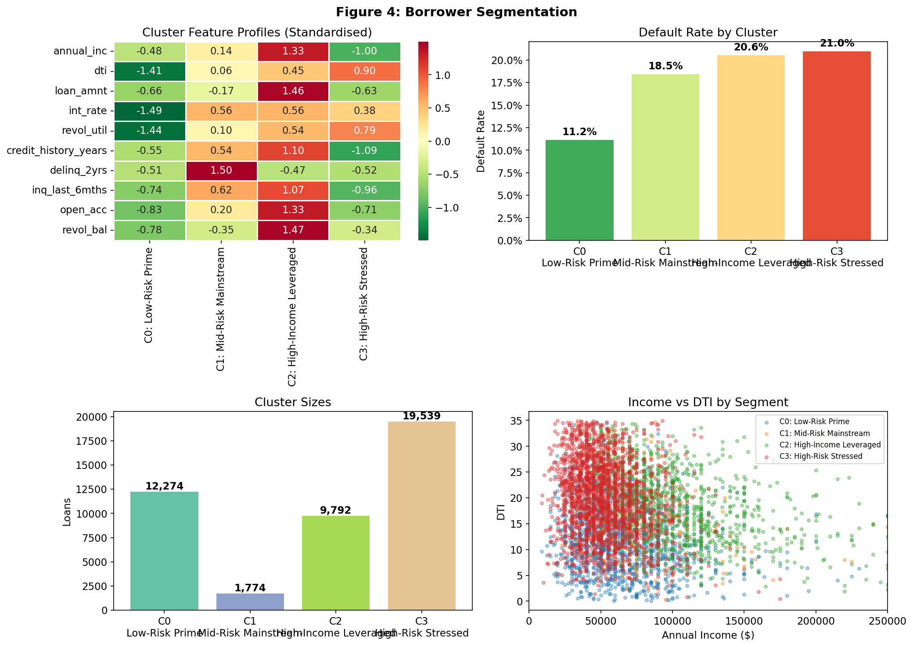
Figure 4 Borrower Segmentation — Feature Profiles (heatmap), Default Rates, Cluster Sizes, and Income vs DTI scatter.

4.3 Policy Performance by Cluster (344)
Table 3 breaks down policy performance within each cluster, revealing how the aggregate +1.9 pp default rate increase masks a seven percentage-point spread in marginal Grade D default rates; from 20.8% in the Low-Risk cluster to 28.0% in the High-Risk.
Table 3 Policy performance within each borrower cluster
Cluster | Policy A DR | Policy B DR | Marginal D Loans | Marginal D Default Rate
Low-Risk Prime | 10.8% | 11.0% | 245 | 20.8%
Mid-Risk Mainstream | 13.5% | 16.4% | 328 | 27.7%
High-Income Leveraged | 14.3% | 16.7% | 1,673 | 25.8%
High-Risk Stressed | 17.2% | 19.4% | 3,750 | 28.0%

This variation demonstrates that the risk associated with expanding approvals to Grade D loans is highly segment-dependent. In lower-risk segments, the incremental default exposure remains relatively contained, whereas in higher-risk segments it increases substantially.
A cluster-informed, selective expansion strategy could therefore improve overall outcomes by approving Grade D loans within lower-risk segments while maintaining stricter cutoffs for higher-risk groups. For example, extending approvals to Grade D within the Low-Risk Prime cluster would capture revenue from approximately 245 relatively lower-risk loans, while avoiding the disproportionately higher default exposure associated with the 3,750 loans in the High-Risk Stressed cluster.
This level of granularity is not captured in aggregate A/B analysis, demonstrating that segmentation provides a critical complement to policy evaluation by uncovering segment-specific risk–return trade-offs and enabling more targeted decision-making.

5. Deep Learning for Default Prediction (537)

5.1 Prediction Task and Data Split (121)
The task is a binary classification problem aimed at predicting whether a loan will default (loan_is_bad = 1) using only application-time features. The dataset was restricted to 42,872 loans with strictly terminal outcomes, excluding 505 late/grace period loans whose labels are ambiguous, in order to minimize label noise in both training and evaluation ().
The data were split into training (70%), validation (15%) and test (15%) sets using stratified sampling to preserve the class distribution across all subsets. All preprocessing steps, including standard scaling for numerical variables and one-hot encoding for categorical variables, were fitted exclusively on the training data, thereby preventing information leakage and ensuring an unbiased evaluation of model performance.

5.2 Model Design and Training (178)
The model uses 49 input features, comprising 28 standardised numerical variables and 21 one-hot encoded categorical indicators derived from grade, home ownership, verification status, purpose and listing status. A feedforward neural network was selected over logistic regression due to its ability to capture non-linear interactions between borrower characteristics. The architecture consists of three hidden layers (128→64→32 units) with RelU activations, batch normalization applied after the first two layers and dropout rates 0.3, 0.3 and 0.2 respectively for regularization. A sigmoid output layer produces the predicted probability of default, with the model trained using binary cross-entropy loss and the Adam optimiser.
Class imbalance (approximately 17% defaults) was addressed by upweighting default observations by a factor of 4.87, avoiding the information loss associated with resampling techniques. Early stopping was applied based on validation AUC, alongside learning rate reduction, with the optimal model selected between epochs 13 and 21. As illustrated in Figure , 5the training and validation loss and AUC curves stabilise without divergence, indicating that early stopping effectively mitigated overfitting.
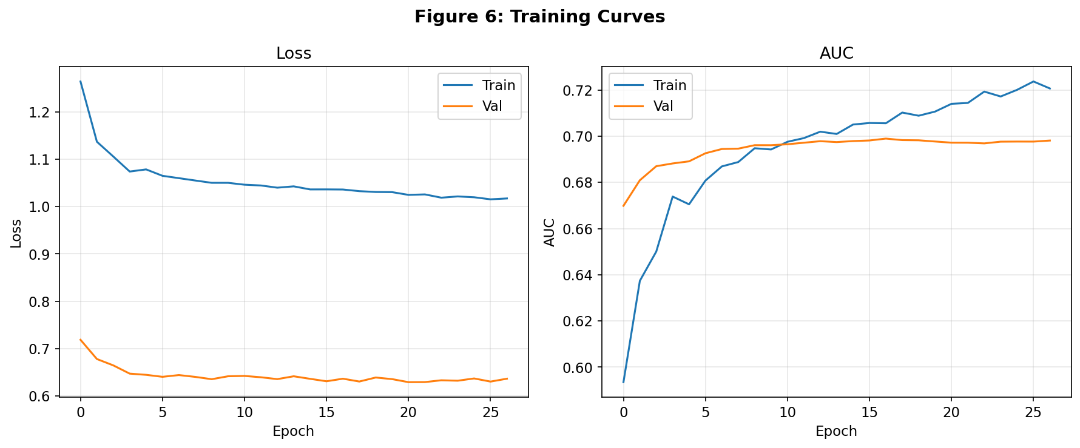
Figure 5 Training and Validation Loss and AUC Curves

5.3 Model Evaluation (238)
Model performance on the held-out test set is summarized in Table 4, which reports the three primary evaluation metrics alongside their interpretations. An ROC-AUC of approximately 0.69 represents a reasonable baseline for credit risk prediction, where future borrower outcomes, such as income shocks or job loss, remain unobservable at origination. The model achieves an average precision of approximately 0.31, reflecting a substantial improvement over the random baseline of 0.17, while the F1 score of around 0.37 at a 0.5 threshold indicates a balanced trade-off between precision and recall.
Table 4 Model performance on the held-out test set
Metric | Value | Interpretation
ROC-AUC | ~0.69 | In ~69% of pairs, model correctly ranks default above non-default
Average Precision | ~0.31 | ~1.8× improvement over 0.17 random baseline
F1 Score (@ 0.5 threshold) | ~0.37 | Balanced precision/recall at default threshold

Performance varies across borrower segments. The High-Income Leveraged cluster achieves the strongest discrimination (AUC ~ 0.71), likely due to its distinctive income-leverage profile, whereas the noisier relation Mid-Risk Mainstream cluster performs worse (AUC ~ 0.64), reflecting the noisier nature of delinquency-based risk signals. At a lower decision threshold of 0.25, the model approves approximately 10% of test loans with an observed default rate of around 5.7%, substantially below the corresponding default rates under Policy A (13.5%) and Policy B (15.5%) for the same subset. This indicates that probability-based screening can isolate a low-risk cohort that is not captured by grade-based cutoffs. The models discriminatory performance is further illustrated in Figure 7, where the ROC and Precision-Recall curves demonstrate clear separation from the random baseline and highlight the trade-off between sensitivity and precision across different classification thresholds.

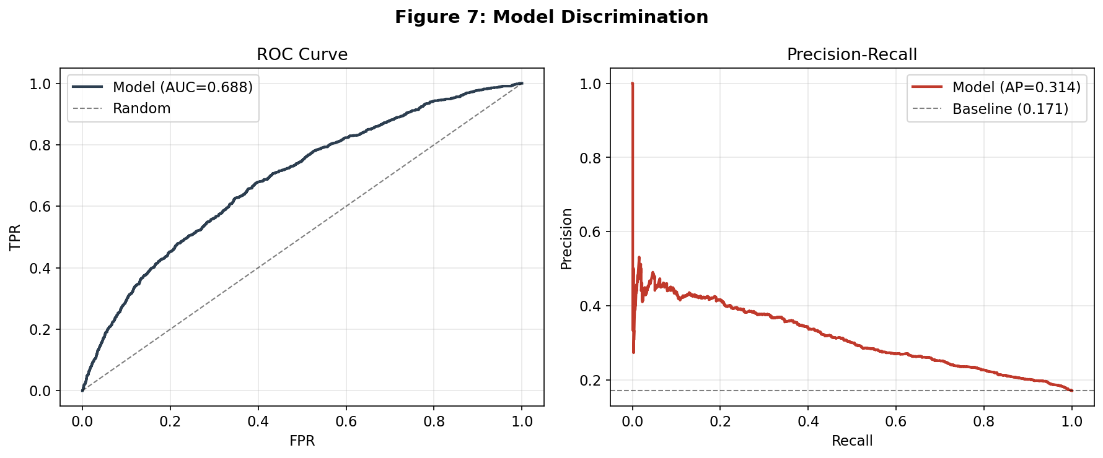
Figure 6 ROC Curve (AUC=0.688) and Precision-Recall Curve (AP=0.314) on the Held-Out Test Set

6. Integrated Recommendation (164)
The three analytical components form a coherent and complementary decision making framework. The A/B analysis establishes the core business question: whether expanding approvals to Grade D loans improves overall profitability. Results show a +1.90 pp increase in default rate under expansion, indicating a deterioration in portfolio quality. However, clustering reveals that this aggregate effect masks substantial heterogeneity, with marginal Grade D default rates ranging from 20.8 % in Low-Risk segments to 28.0 % in High-Risk.
The predictive model further enhances decision-making by capturing non-linear relationships between borrower characteristics. AT a 0.25 threshold, it identifies a subset of loans with an approximate default rate of 5.7%, significantly outperforming both grade-based policies.
Taken together, these findings suggest that borrower risk cannot be effectively managed using a single grade cutoff. Instead, a hybrid approach is recommended; use model-based probability thresholds for loan approval, supported by clustering for segment-level monitoring and strategy refinement. Before deployment, further validation is required, including temporal testing, probability calibration and addressing selection bias.

7. References
Banasik, J., Crook, J., & Thomas, L. (2003). Sample selection bias in credit scoring models. Journal of the Operational Research Society, 54(8), 822–832.
Efron, B., & Tibshirani, R. J. (1993). An Introduction to the Bootstrap. Chapman & Hall.
Turiel, J. D., & Aste, T. (2020). Peer-to-peer loan acceptance and default prediction with artificial intelligence. Royal Society Open Science, 7(6), 191649.

