Module: IB98D0
Loan Approval Strategy Optimisation
Policy Evaluation, Borrower Segmentation and Deep Learning for Default Prediction
Group 20
22/03/2026

Table of Contents
1. Introduction 3
2. Data Preparation and Cleaning 3
3. A/B Testing of Loan Review Policies 3
3.1 Policy Definition 3
3.2 Evaluation Metric and Hypotheses 4
3.3 Policy Comparison 5
3.4 Limitations 6
4. Borrower Segmentation via Cluster Analysis (Q2) 7
4.1 Feature Selection and Methodology 7
4.2 Cluster Profiles 8
4.3 Policy Performance by Cluster 9
5.1 Prediction Task and Data Split 11
5.2 Model Design and Training 11
5.3 Model Evaluation 12
6. Integrated Recommendation 14
6.1 Integration of Methods 14
6.2 Policy Insights and Next Steps 14
7. References 15

List of Figures
Figure 1 Default Rate by Sub-Grade with Policy Boundaries 4
Figure 2 Policy A vs. Policy B (approval rate, default rate and good loans rejected) 6
Figure 3 Optimal Number of Clusters (elbow method & silhouette analysis) 7
Figure 4 Borrower Segmentation - Feature Profiles (heatmap), Default Rates, Cluster Sizes, and Income vs DTI scatter. 9
Figure 5 Policy Performance Across Borrower Segments 10
Figure 6 Training and Validation Loss and AUC Curves 12
Figure 7 ROC Curve (AUC = 0.690) and Precision-Recall Curve (AP = 0.322) on the Held-Out Test Set 13
Figure 8 Model Performance Across Borrower Segments 13

List of Tables
Table 1 Policy A vs. Policy B comparison 5
Table 2 Borrower cluster profiles 8
Table 3 Policy performance within each borrower cluster 10
Table 4 Model performance on held-out test set 12

1. Introduction
This report analyses a LendingClub consumer loan dataset to support evidence-based loan approval decisions. The analysis proceeds in three stages: a simulated A/B test comparing two sub-grade-based approval policies, K-means cluster analysis to identify borrower segments, and a prototype deep learning model to predict individual default probabilities. Together, these form a layered framework. A/B testing answers a binary strategic question (expand or not). Clustering explains why the answer depends on which borrowers are considered. The default probability model moves beyond segment-level rules to individual-level scoring, which is the form a production system would ultimately take.

2. Data Preparation and Cleaning
The raw dataset contained 50,000 loans. 6,621 ‘Current’ loans with unknown outcomes were removed to avoid systematic bias, leaving 43,379 resolved loans.
Post-decision variables were excluded to prevent data leakage, and identifier, near-constant, and high-cardinality fields were removed. Revolving balance and total credit were dropped as their signal is captured in revolving utilisation. Total_acc was removed (correlation 0.66 with open_acc). Instalment was validated using the amortisation formula; 37 rows exhibiting a deviation greater than 5% was removed. Instalment then was dropped as it is derivative of loan amount, interest rate and term. Missing values were imputed with median and missingness flags, except total collection amount (imputed with zero). Continuous variables were capped at the 99th percentile and discrete counts at risk-informed thresholds. The final dataset comprised 43,312 observations with an 18.02% default rate and 30 variables.

3. A/B Testing of Loan Review Policies

3.1 Policy Definition
Analysis of default rates across LendingClub’s 35 sub-grades reveals a significant risk cliff between sub-grades C2 (18.0%) and C3 (23.5%), where default risk escalates by 5.5 percentage-points without proportional interest rate compensation (15.2% to 15.8%). This structural break motivates the design of two sub-grade level policies.
Policy A (Conservative) approves all A1-C2 applicants accepting 29,431 loans (68.0%). Policy B (Selective Expansion) approves the same cohort unconditionally and additionally approves C3-C5 borrowers with debt-to-income (DTI) below 20%, accepting 32,305 loans (74.6%), adding 2,874 marginal loans. Policy B tests whether a behavioural filter can capture additional volume from riskier sub-grades without proportionally increasing defaults; which is a question grade-level analysis cannot answer.

3.2 Evaluation Metric and Hypotheses
The false negative rate was considered but rejected as its denominator (total defaults) remains fixed across policies, making it uninformative for comparing strategies that vary in approval volume. Instead, Portfolio Default Rate (PDR), defaults among loans divided by total approved loans, was selected as the primary evaluation metric as it directly reflects portfolio loss rate. A financial impact model using LGD = 70% provides directional profitability insight.
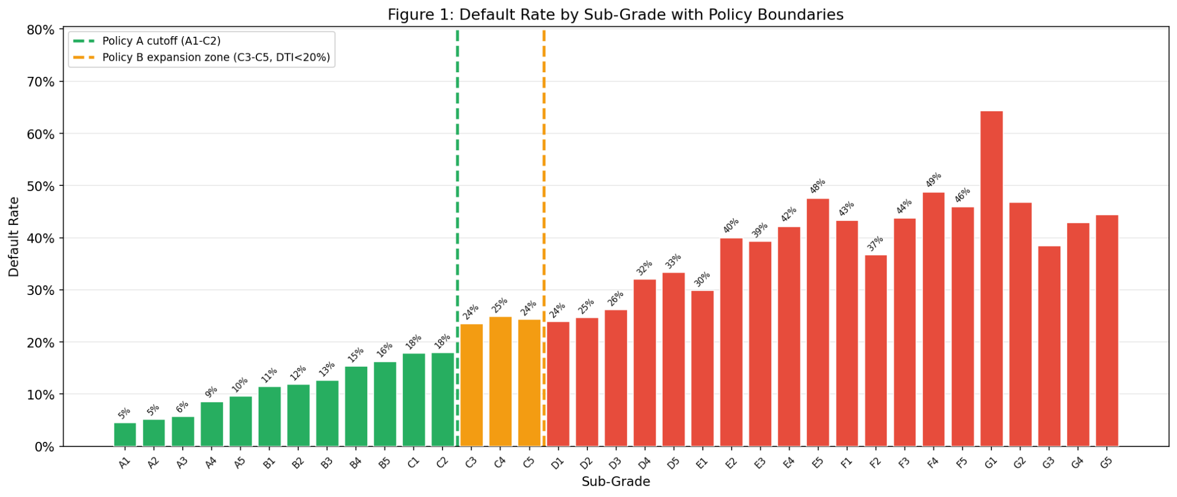
Figure 1 Default Rate by Sub-Grade with Policy Boundaries
Default rates increase monotonically across sub-grades (Figure 1). The risk cliff between C2 (18.0%) and C3 (23.5%) is clearly visible, and the central question is whether Policy B’s DTI-filtered expansion sufficiently controls for this increased risk.
Since the selective expansion is expected to increase defaults, a one-sided hypothesis was specified:
H₀: DR(Policy B) ≤ DR(Policy A)
H₁: DR(Policy B) > DR(Policy A) [α = 0.05]

3.3 Policy Comparison
As Policy A’s approvals are a strict subset of Policy B’s, standard z-test assumptions are violated. The comparison was conducted via deterministic decomposition and validated with non-parametric bootstrap (2,000 resamples) following Efron & Tibshirani (1993). The shared A1-C2 pool defaults at 12.74%, the marginal C3–C5 (DTI<20%) pool at 21.78%, and the combined portfolio at 13.54%. The main outcomes for each policy across the full dataset, including approval volumes, default rates and the financial impact, are summarized in Table 1.
Table 1 Policy A vs. Policy B comparison
Metric | Policy A (A1–C2) | Policy B (Selective) | Difference
Approved loans | 29,431 | 32,305 | +2,874
Approval rate | 68.0% | 74.6% | +6.6 pp
Defaults | 3,749 | 4,375 | +626
Default rate | 12.74% | 13.54% | +0.80 pp
Avg interest rate | 11.49% | 11.92% | -
Good loans rejected | 9,827 | 7,579 | −2,248
Net financial impact | $3.17M ($108/loan) | $1.86M ($58/loan) | −$1.31M

The bootstrap yields a 95% CI of [+0.67%, +0.95%], p < 0.0001, providing strong evidence to reject H₀ (Figure 2). Policy A maximises risk-adjusted return and suits capital-constrained lenders; Policy B sacrifices per-loan efficiency for volume, which makes it suited growth-oriented strategy.
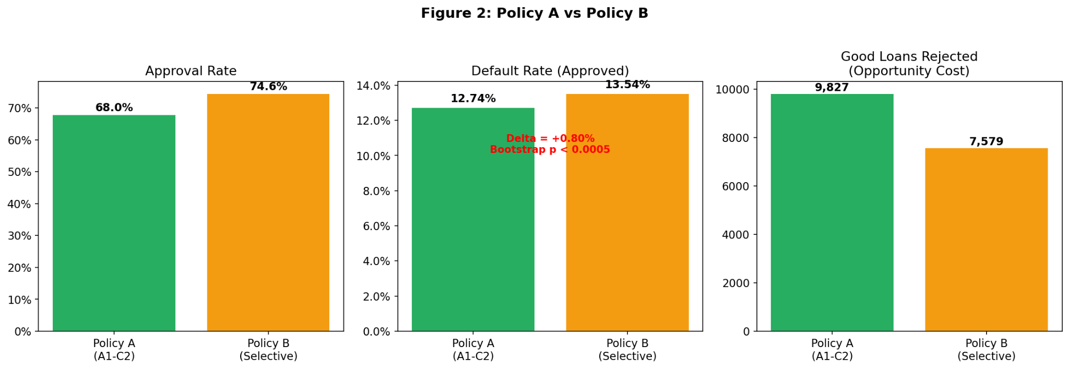
Figure 2 Policy A vs. Policy B (approval rate, default rate and good loans rejected)

3.4 Limitations
Key limitations include: selection bias, as only funded loans are observed and counterfactual outcomes cannot be estimated (Banasik et al., 2003); sub-grade endogeneity, as LendingClub’s grades introduce circularity when used as policy thresholds; label ambiguity with 505 late/grace-period loans treated as defaults potentially overstating the default-rate by ~1 pp; and a simplified LGD model that excludes recoveries and multi-year interest. The DTI<20% threshold was chosen by domain reasoning rather than optimisation, so the +0.80 pp difference should be interpreted as descriptive rather than causal.

4. Borrower Segmentation via Cluster Analysis (Q2)

4.1 Feature Selection and Methodology
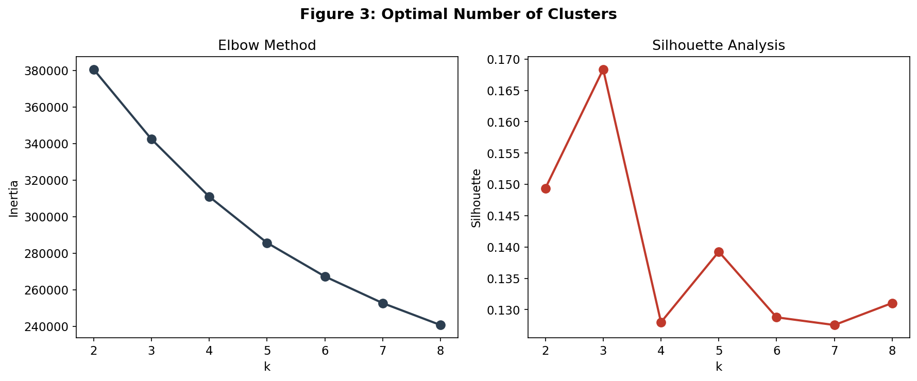
K-means clustering was applied to 10 continuous application-time variables: annual income, DTI, loan amount, interest rate, revolving utilisation, credit history length, delinquencies in the prior 2 years, recent enquiries, open accounts and public derogatory records. Interest rate was included as it captures risk-based pricing at origination. Categorical variables were excluded as Euclidean distance is not meaningful for nominal categories. K-Means was preferred over hierarchical methods for computational tractability at 43,000+ observations and over DBSCAN as the objective is broad behavioural archetypes rather than density-based clusters, consistent with standard practice in clustered credit risk modelling (Bakoben, Bellotti & Adams, 2020). Features were z-score standardized with 99.5th percentile outlier capping to prevent extreme values from distorting centroids. K = 4 was selected via elbow and
Figure 3 Optimal Number of Clusters (elbow method & silhouette analysis)

silhouette analysis (Rousseeuw, 1987) as shown in Figure 3. The silhouette score of ~0.13 is low but that is to be expected for overlapping credit data. Cluster labels were assigned post-hoc; the default outcome was not used as a clustering input.

4.2 Cluster Profiles
Table 2 profiles each cluster across key financial and behavioural variables used in segmentation, enabling direct comparison of risk characteristics across groups. The Low-Risk Prime cluster (C0) exhibits the lowest default rate at 10.1%, with the lowest DTI (12.3), lowest interest rates (9.9%) and moderate income ($66,842). This is a genuinely low-risk borrower profile.
Table 2 Borrower cluster profiles
Cluster | Size | Default Rate | Avg Income | Avg DTI | Revol Util | Key Characteristic
Low-Risk Prime (C0) | 11,624 (26.8%) | 10.1% | $66,842 | 12.3 | 33.9% | Lowest DTI, rate and default risk
Mid-Risk Mainstream (C3) | 1,948 (4.5%) | 20.0% | $65,390 | 16.0 | 54.8% | Small cluster; moderate across dimensions
High-Income Leveraged (C1) | 18,935 (43.7%) | 20.1% | $51,313 | 20.1 | 70.1% | Largest cluster; highest DTI and utilisation
High-Risk Stressed (C2) | 10,805 (24.9%) | 22.4% | $101,157 | 17.8 | 64.7% | Highest income but largest loans ($21.4k)

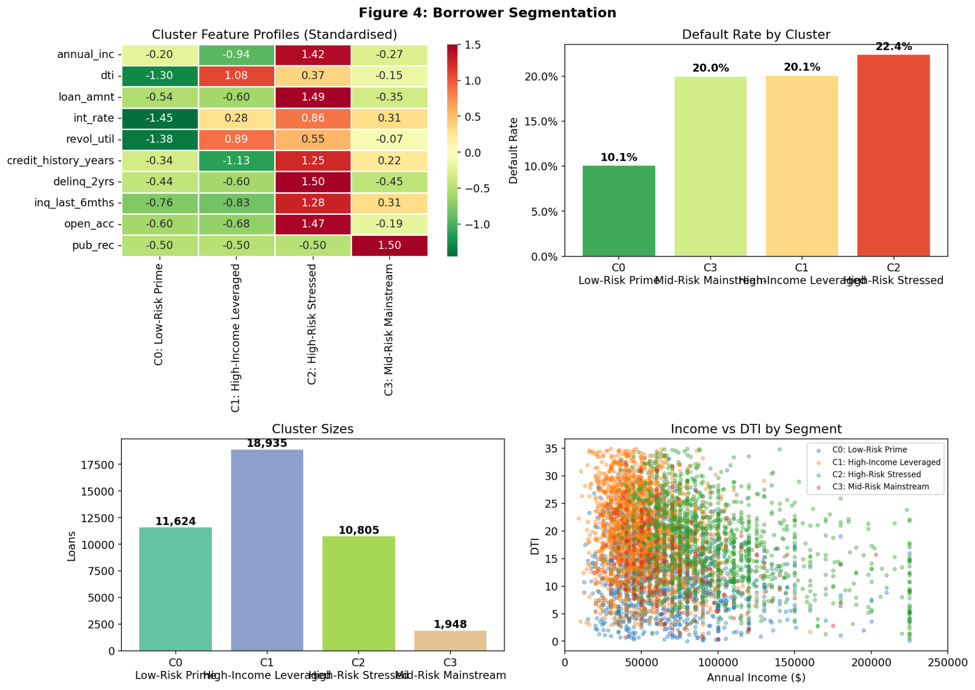
The High-Risk Stressed cluster (C2) presents an unexpected profile: despite the highest average income ($101,157), its default rate is 22.4%, driven by larger loan sizes ($21,400) and more delinquencies (0.46). This demonstrates that income alone is insufficient for predicting creditworthiness. A plausible explanation is that high earners qualify for larger loans, and if their spending habits or financial commitments scale with their income, the absolute exposure at default is greater. The High-Income Leveraged cluster (C1), the largest segment at 43.7%, shows the highest DTI and utilisation despite the lowest income. This reflects genuine financial strain; marginal improvements in default prediction here would have the greatest portfolio impact. Figure 4 provides a fuller view via heatmap and scatter plot.
Figure 4 Borrower Segmentation - Feature Profiles (heatmap), Default Rates, Cluster Sizes, and Income vs DTI scatter.

4.3 Policy Performance by Cluster
A more detailed examination of policy performance is presented in Table 3, which segments results by borrower cluster.
Table 3 Policy performance within each borrower cluster
Cluster | Policy A DR | Policy B DR | Marginal Loans | Marginal DR
Low-Risk Prime | 9.52% | 9.87% | 303 | 22.8%
Mid-Risk Mainstream | 15.43% | 15.78% | 227 | 17.6%
High-Income Leveraged | 15.45% | 16.11% | 1,386 | 21.9%
High-Risk Stressed | 12.66% | 14.23% | 958 | 22.3%

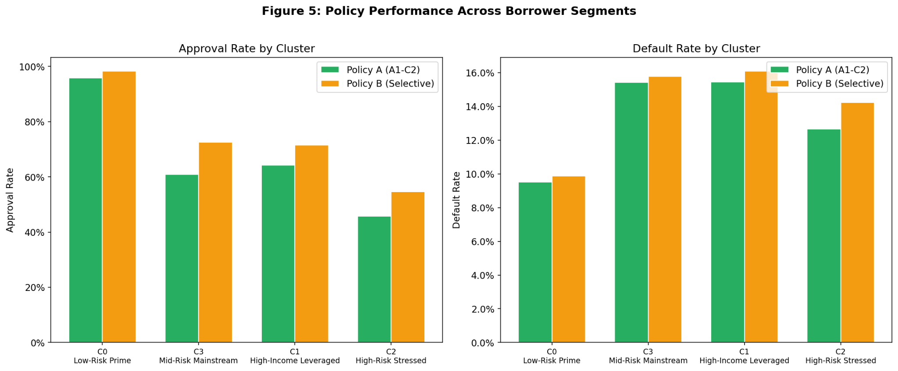
Marginal default rates range from 17.6%-22.8% which indicates the DTI filter is most effective in the Mid-Risk segment, revealing the aggregate +0.80 pp masks substantial heterogeneity. The DTI filter is most effective while maintaining stricter cutoffs elsewhere. A cluster informed strategy would approve C3-C5 loans for Mid-Risk Mainstream borrowers (Marginal DR 17.6%) while rejecting the same applications from Low-Risk Prime borrowers (Marginal DR 22.8%); the opposite of what a uniform policy would prescribe. This granularity is not captured in aggregate A/B analysis, confirming that segmentation is a necessary complement to policy evaluation.

Figure 5 Policy Performance Across Borrower Segments
5. Deep Learning for Default Prediction

5.1 Prediction Task and Data Split
The binary classification task predicts loan default using application-time features only. The dataset was restricted to 42,807 terminal-outcome loans, excluding 505 ambiguous late/grace period loans to minimise label noise.
Data were split into training (70%, 29,981), validation (15%, 6,404) and test (15%, 6,422) sets using stratified sampling (17.05% default rate). All preprocessing was fitted on training data only to prevent leakage.

5.2 Model Design and Training
The model uses 69 input features, comprising 22 standardised numerical variables and 47 one-hot encoded categorical indicators derived from sub-grade, home ownership, verification status, and purpose. Grade was excluded as sub-grade fully determines grade and carries strictly more information. A feedforward neural network (Goodfellow, Bengio & Courville, 2016) was selected over logistic regression for its ability to capture non-linear borrower characteristic interactions. The architecture comprises three hidden layers (128→64→32 units, 20,097 parameters) with ReLU activations, batch normalisation (Ioffe & Szegedy, 2015) applied after the first two layers and dropout rates 0.3, 0.3 and 0.2 respectively for regularisation (Srivastava et al., 2014). A sigmoid output layer, trained using binary cross-entropy loss and the Adam optimiser produces predicted default probabilities (Kingma & Ba, 2015).
Class imbalance (~17% defaults) is a well-documented challenge in credit risk modelling (He & Garcia, 2009) and was addressed by upweighting default observations by a factor of 4.87, avoiding the information loss associated with resampling techniques. Early stopping was applied based on validation AUC, alongside learning rate reduction, with the optimal model selected at epoch 13. As illustrated in Figure 6, the training and validation loss and AUC curves stabilise without divergence, which suggests that early stopping effectively mitigated overfitting.

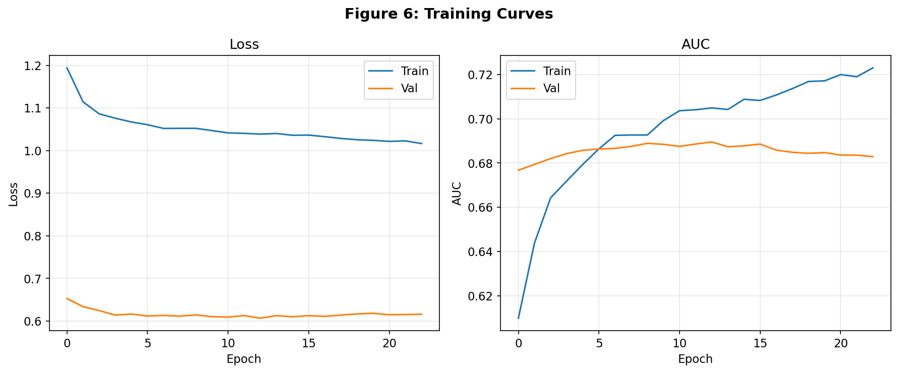
Figure 6 Training and Validation Loss and AUC Curves

5.3 Model Evaluation
Model performance on the held-out test set is summarized in Table 4. An ROC-AUC of 0.690 (Hanley & McNeil, 1982) is moderate but realistic as default is partly driven by future events unobservable at origination (illness, job-loss, or macroeconomic-downturns) placing a ceiling on models using strictly application-time features. The model’s value lies in its ability to rank borrowers by risk more accurately than grade-based rules. The model achieves an average precision of 0.322 representing a 1.9× improvement over the 0.17 random baseline, and an F1 score of 0.370 reflecting a balanced precision-recall trade-off at the 0.5 threshold.
Table 4 Model performance on held-out test set
Metric | Value | Interpretation
ROC-AUC | 0.690 | In ~69% of pairs, model correctly ranks default above non-default
Average Precision | 0.322 | 1.9× improvement over 0.17 random baseline
F1 Score  (at 0.5 threshold) | 0.370 | Balanced precision/recall at default threshold

Performance varies by segment: the High-Risk Stressed cluster achieves the strongest discrimination (AUC = 0.713), while the High-Income Leveraged cluster is weaker (AUC = 0.625) due to noisier risk signals. At a 0.25 threshold, the model approves 859 loans (13.4%) with a 5.01% default rate; substantially below Policy A (12.16%) and Policy B (12.82%), demonstrating that probability-based screening isolates a low-risk cohort inaccessible to sub-grade cutoffs (Figures 7 and 8).
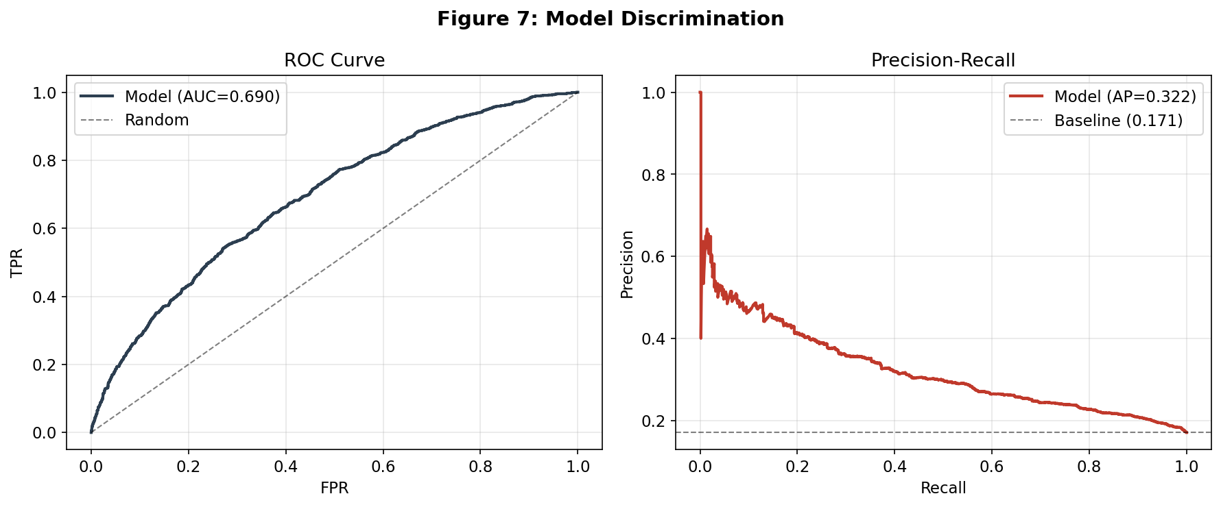

Figure 7 ROC Curve (AUC = 0.690) and Precision-Recall Curve (AP = 0.322) on the Held-Out Test Set

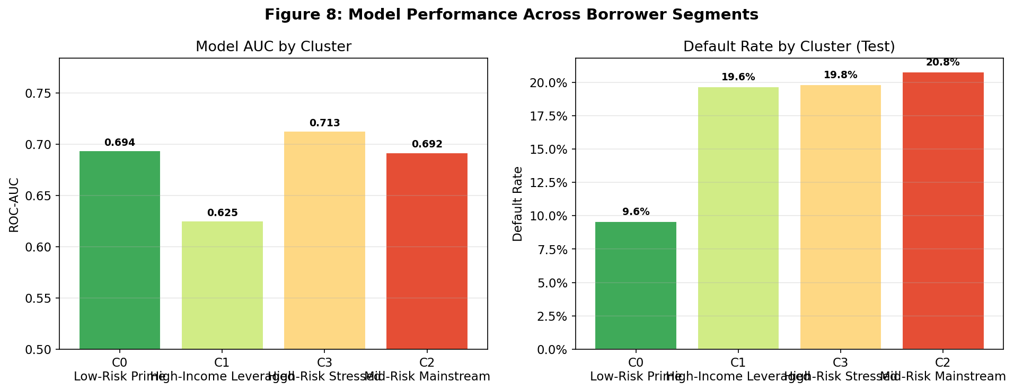

Figure 8 Model Performance Across Borrower Segments

6. Integrated Recommendation

6.1 Integration of Methods
The A/B test establishes whether expanding beyond the C2 risk cliff outweighs additional interest income. Cluster analysis reveals that the aggregate +0.80 pp increase conceals heterogeneity (marginal default rates: 17.6% to 22.8%). The deep learning model achieves a 5.01% default rate at a 0.25 threshold, less than half of either rule-based policy.
Together, these form a layered framework: A/B testing defines the risk-return trade-off, clustering localises heterogeneity, and the default probability model operationalises these insights at the individual loan level.

6.2 Policy Insights and Next Steps
Borrower risk is multi-dimensional and cannot be captured by a single cutoff. The C2/C3 risk cliff (18.0% to 23.5%) is invisible at grade level and Policy B’s DTI filter only partially reduces the marginal default rate from ~24% to 21.78% with variation across clusters. A practical implementation would use the neural network as the primary screening tool, with cluster membership supporting portfolio monitoring and concentration risk reporting.
Before deployment, four steps are required. First, temporal validation on loans from a later period (e.g. 2014 onwards) to test robustness beyond a training period. Second, neural network benchmarking against gradient-boosted trees such as XGBoost, which frequently outperform neural networks on tabular data (Friedman, 2001) and offer greater interpretability. Third, probability calibration to ensure predicted default rates reflect observed rates, which is necessary for expected loss calculations. Finally, reject inference to address the selection bias from only observing funded loans, as noted by Banasik et al. (2003).

7. References
Bakoben, M., Bellotti, T., & Adams, N. (2020). Identification of credit risk based on cluster analysis of account behaviours. Journal of the Operational Research Society, 71(7), 1144–1157.
Banasik, J., Crook, J., & Thomas, L. (2003). Sample selection bias in credit scoring models. Journal of the Operational Research Society, 54(8), 822–832.
Efron, B., & Tibshirani, R. J. (1993). An Introduction to the Bootstrap. Chapman & Hall.
Goodfellow, I., Bengio, Y., & Courville, A. (2016). Deep Learning. MIT Press.
Hanley, J. A., & McNeil, B. J. (1982). The meaning and use of the area under a receiver operating characteristic (ROC) curve. Radiology, 143(1), 29–36.
He, H., & Garcia, E. A. (2009). Learning from imbalanced data. IEEE Transactions on Knowledge and Data Engineering, 21(9), 1263–1284.
Ioffe, S., & Szegedy, C. (2015). Batch normalization: Accelerating deep network training by reducing internal covariate shift. Proceedings of the 32nd International Conference on Machine Learning (ICML), 448–456.
Kingma, D. P., & Ba, J. (2015). Adam: A method for stochastic optimization. Proceedings of the 3rd International Conference on Learning Representations (ICLR).
Rousseeuw, P. J. (1987). Silhouettes: A graphical aid to the interpretation and validation of cluster analysis. Journal of Computational and Applied Mathematics, 20, 53–65.
Srivastava, N., Hinton, G., Krizhevsky, A., Sutskever, I., & Salakhutdinov, R. (2014). Dropout: A simple way to prevent neural networks from overfitting. Journal of Machine Learning Research, 15(1), 1929–1958.
Friedman, J. H. (2001). Greedy function approximation: A gradient boosting machine. Annals of Statistics, 29(5), 1189-1232.
Turiel, J. D., & Aste, T. (2020). Peer-to-peer loan acceptance and default prediction with artificial intelligence. Royal Society Open Science, 7(6), 191649.

