I used Bidirectional LSTM
Using the jicksaw dataset not original data set here are my results

F1- score of 0.84
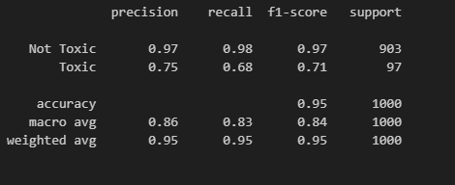

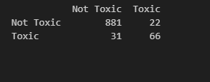

Confusion matrix

Using original cellula data here are the results
