Using BI- directional RNN here are the results

The F1 score is 0.8
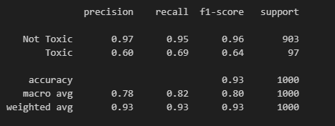

Confusion matrix
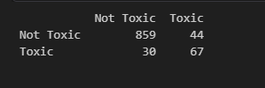

Using original cellula data here are the results

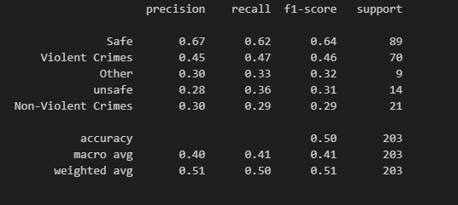

Macro F1 score of 0.41

ROC curve
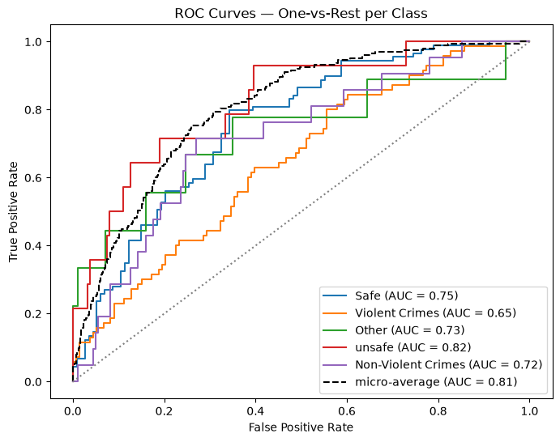

Confusion matrix
