**Conestoga** **College** **–** **SET**

**Milestone #1**

**Preliminary Investigation**

**Jennifer Klimova (6950851)**

**Nathan Nickel (6763692)**

**Wes Thompson (6992143)**

**Alex Martin (6693659)**

**Date** **of** **Submission** **:** **Document** **Revision** **:**

**2016-10-14** **Revision** **A1**

PD   
 (INFO 3020)

**Revision History**

|  |  |  |  |
| --- | --- | --- | --- |
| **Rev** | **Date** | **Description** **of** **Change** | **By** |
| A1 | 2016-09-28 | • Initial release of document | Jennifer Klimova  Nathan Nickel  Wes Thompson  Alex Martin |
| A2 | 2016-10-14 | • Total revision of document | Jennifer Klimova  Nathan Nickel  Wes Thompson  Alex Martin |

Contents

Report Scope 4

Product Concept 4

Mock Up Diagrams 5

Product Market 8

Product Benefits 8

Similar and Competing Products 9

Product Feasibility 13

References 14

# Report Scope

The purpose of this document is to present a detailed description of the Employee Scheduler that Lily Systems is developing. This report will include the product concept, the competition that the product is competing with, where the product will be used, what the intended market is for that product, the benefits to using our product, descriptions of similar products, and finally the feasibility of the product will also be discussed. This document is intended for both the stakeholders and the developers of the system. This report is considered to be valid for the time period from 10-5-2016 till 12-12-2016.

# Product Concept

The product is able to allow managers, employees, and human resources to access schedules and statistics being created in our application according to the implemented security level checks. Inside the application, an employee is able to send email like messages to their managers and coworkers, are able to request time off by either clicking on the hour and day in the virtual calendar or through email, and are able to rate and review their coworkers.

The managers are able to create their schedules easily and efficiently with our easy to use virtual calendar and are able to refer to a list of constraints that they have manually created in order to ensure that they have the best work flow they possibly can. A great feature that will be added to this program will be that managers will be able to scan all pre-existing paper schedules, saving managers the time and effort of having to re-input all of their old schedules into the software. If the business uses Excel or Word for scheduling, they can load in their schedule from these applications to scheduling software.

Managers are able to efficiently change the schedule in the event of an employee requesting a change as the request will include the original hours and the new hours and the manager can simply accept, allowing the changes to be made automatically to the calendar. As for human resources, out of the information being gathered from the organizations, special graphs and statistics will be formulated and be nicely organized for them to analyze at a need be basis.

There are 3 interfaces of which the schedule will be interfacing with. These interfaces include, the user, the system, and the software. The schedule will be designed with a variety of features to accommodate both technological experienced and rudimentary users.

# Mock Up Diagrams

A mock up diagram displaying the home page of the website of the product. Here you can see what an employee would be viewing when they are logged in. It displays any notifications, the current date and calendar, and information tabs for the user to explore.

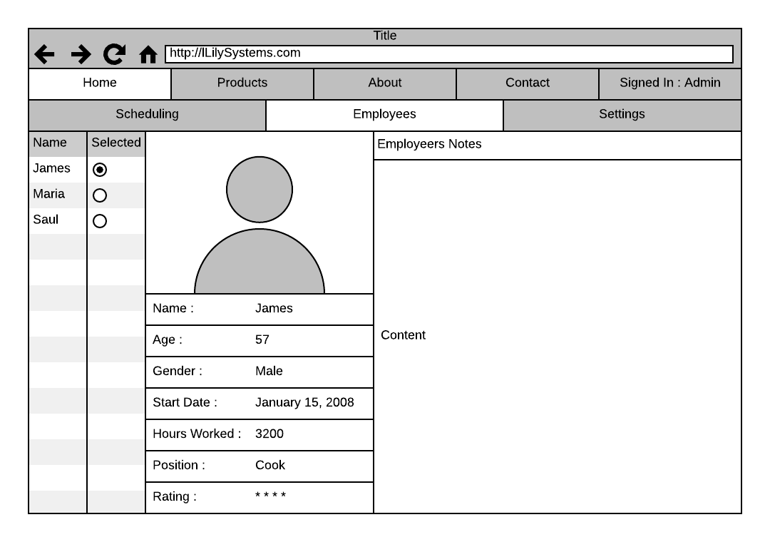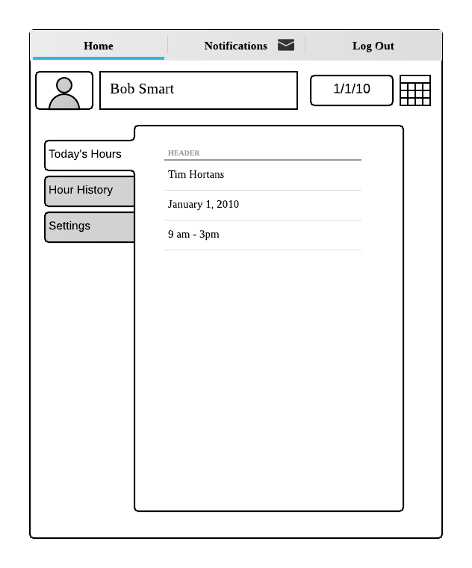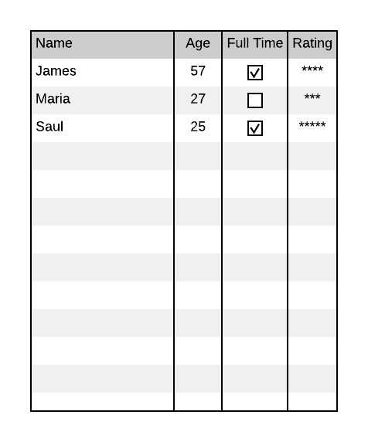

The top three diagrams display what the user will be interacting with. This includes the employee’s profile page, the mobile app home page for the employee, and the ratings page.

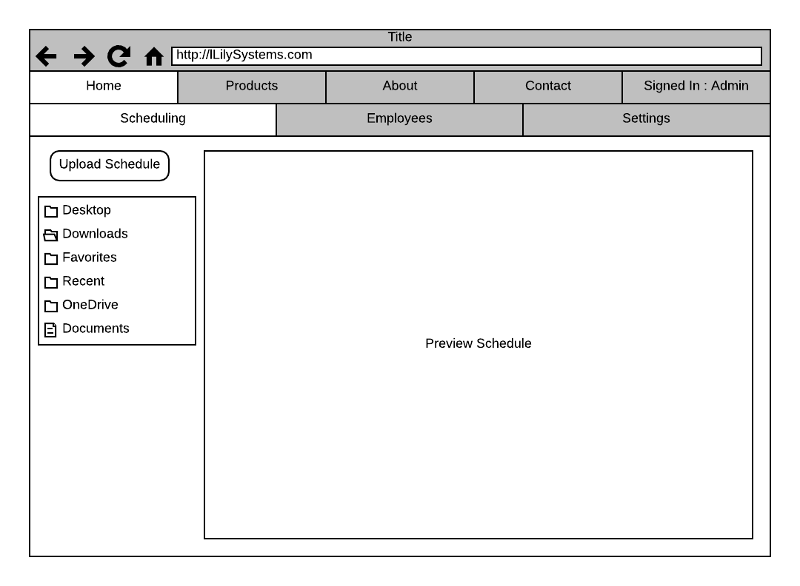

The diagram above shows how the managers can manage their schedules, either by downloading templates, or by uploading their own already made schedules through applications like Excel.

# Product Market

The product will be used in businesses that already use employee scheduling (on a paper medium). This encompasses small businesses all the way to large franchised businesses. It is aimed to be used mainly in businesses that deal with many employees (particularly part-time as this product will solve the issue of shifts and hours being changed constantly).

The intended market includes fast food chains like Tim Hortons, McDonalds, Starbucks, and can be used by retailers and restaurants who also have to manage their employees (particularly part time employees). These businesses tend to use a paper medium and excel to prepare and manually input employee schedules which are always at subject to be changed. Currently there are paper, excel, and companies like wheniwork, that are being used to aid managers and employees in dealing with schedules.

The product will be used by employees, managers, supervisors, human resources, and potentially other positions that businesses require.

# Product Benefits

This product will benefit companies by giving them an easy to use and access tool that will ease the stress for managers and employees. It is able to take in constraints and help the managers create a schedule that meets everyone's’ needs and even allows reviews of employees which help both employees and managers to manage team workflow.

# Similar and Competing Products

|  |  |  |  |  |  |
| --- | --- | --- | --- | --- | --- |
| Competitor Name | URL | Competing Product | URL | Similarities | Differences |
| wheniwork | [1] | wheniwork | [2] | * Phone app * Approve time off requests * Moderate swap and drop requests * Employees can request shift trades * Employees notified with schedule updates * Intuitive scheduling management and tools * Clock in/out integration | * Web based portion * Ability for staff to check their full schedule online * Employee profiles * Schedule manager can scan paper schedules into the software for quick and easy software adoption * Schedule manager can load schedule into software from a word or excel document for quick and easy software adoption |
| Synerion | [3] | Synerion Employee Scheduling Software | [4] | * Analytics * Advanced scheduling options for businesses with special requirements  such as needing a min number of nurses working at all times * Absence management * Intuitive scheduling management and tools * Clock in/out integration | * Web based portion * Ability for staff to check their full schedule online * Employee profiles * Schedule manager can scan paper schedules into the software for quick and easy software adoption * Schedule manager can load schedule into software from a word or excel document for quick and easy software adoption * Mobile app * Free support |
| 7 Shifts | [5] | 7 Shifts Scheduling Software | [6] | * Employees can request shift trades * Employees notified with schedule updates * Intuitive scheduling management and tools * Phone app * Approve time off requests * Moderate swap and drop requests * Built in manager log book * Multi location support * Free support * Clock in/out integration | * Web based portion * Designed for all business types including restaurants * Employee profiles * Schedule manager can scan paper schedules into the software for quick and easy software adoption * Schedule manager can load schedule into software from a word or excel document for quick and easy software adoption |
| Jolt | [7] | Jolt Scheduling system | [8] | * Intuitive scheduling management and tools * Mobile app * Employees notified with schedule updates * Approve time off requests * Moderate swap and drop requests * Employees can request shift trades * Forecast labour costs and percentages * Clock in/out integration | * Employee profiles * Web based portion * Schedule manager can scan paper schedules into the software for quick and easy software adoption * Schedule manager can load schedule into software from a word or excel document for quick and easy software adoption |
| Shift  planning | [9] | Shiftplanning Employee scheduling software | [10] | * Intuitive scheduling management and tools * Clock in/out integration | * Mobile app * Employees notified with schedule updates * Approve time off requests * Moderate swap and drop requests * Employees can request shift trades * Forecast labour costs and percentages * Schedule manager can scan paper schedules into the software for quick and easy software adoption * Schedule manager can load schedule into software from a word or excel document for quick and easy software adoption * Employee profiles |
| Deputy | [11] | Deputy | [12] | * Intuitive scheduling management and tools * Mobile app * Employees notified with schedule updates * Approve time off requests * Moderate swap and drop requests * Employees can request shift trades * Clock in/out integration * Employee profiles | * Schedule manager can scan paper schedules into the software for quick and easy software adoption * Schedule manager can load schedule into software from a word or excel document for quick and easy software adoption |
| Nimble  Schedule | [13] | nimbleschedule | [14] | * Intuitive scheduling management and tools * Multi department/location flexibility * Employees notified with schedule updates * Approve time off requests * Moderate swap and drop requests * Employees can request shift trades * Clock in/out integration * Employee profiles * Mobile app * Web based portion * Analytics | * Schedule manager can scan paper schedules into the software for quick and easy software adoption * Schedule manager can load schedule into software from a word or excel document for quick and easy software adoption |
| ScheduleAnywhere | [15] | ScheduleAnywhere | [16] | * Intuitive scheduling management and tools * Multi department/location flexibility * Employees notified with schedule updates * Approve time off requests * Moderate swap and drop requests * Employees can request shift trades * Clock in/out integration | * Schedule manager can scan paper schedules into the software for quick and easy software adoption * Schedule manager can load schedule into software from a word or excel document for quick and easy software adoption * Employee profile |
| eSchedule | [17] | eSchedule | [18] | * Intuitive scheduling management and tools * Employees notified with schedule updates * Approve time off requests * Moderate swap and drop requests * Employees can request shift trades | * Schedule manager can scan paper schedules into the software for quick and easy software adoption * Schedule manager can load schedule into software from a word or excel document for quick and easy software adoption * Clock in/out integration * Mobile app * Forecast labour costs and percentages * Employee profiles |
| Resource Guru | [19] | Resource Guru Employee scheduling software | [20] | * Employee profiles * Intuitive scheduling management and tools * Employees notified with schedule updates * Approve time off requests * Moderate swap and drop requests * Employees can request shift trades * Web based | * Schedule manager can scan paper schedules into the software for quick and easy software adoption * Schedule manager can load schedule into software from a word or excel document for quick and easy software adoption * Mobile app |

# Product Feasibility

The estimation of income that could be coming in could be anywhere from $60-120 yearly per store. This is the gross income that we would receive. There will be a $100 start-up fee which includes customization for the company. There are currently two different offers on the table to be considered; the price will be based off of how many employees there are in the company, or the price will be set to $5-$10 a month. There can also be an upfront payment, where the company can pay $60-120 times the many years they would like to be subscribed to our program, removing monthly payments.

Currently there is no confirmed payment structure yet for the Employee Scheduler, only three options are currently being considered as stated above.

The program is meant to be a very efficient and be an inexpensive alternative. Other companies have the payment option that sets the price according the number of employees (Each employee costs between $1-7 for this company).

# References

[1] <http://wheniwork.com/about>

[2] <http://wheniwork.com/l/aw-schedule-maker?utm_source=adwords&utm_medium=search&utm_campaign=Search-General_App-US-Exact-GP&utm_term=online_schedule_makers&ref=adwords-nonbrand&gclid=CjwKEAjw-Oy_BRDg4Iqok57a4kcSJADsuDK17Kga36Y1FrgEOfJ7iuDQd3d6YbUe30dYMPootdbM5xoCFpDw_wcB>

[3] <http://www.synerion.com/ca-en/>

[4] http://www.synerion.com/ca-en/scheduling

[5] http://7shifts.com/?utm_source=capterra&utm_campaign=listing&utm_medium=employee-scheduling-software

[6] http://7shifts.com/restaurant-employee-scheduling-software/

[7] https://joltup.com/products/scheduling-software/

[8] https://joltup.com/products/scheduling-software/

[9] https://www.shiftplanning.com/top-ten-reviews?utm_source=capterra&utm_medium=cpc&utm_campaign=employee-scheduling&optimizely=ID3-a

[10] https://www.shiftplanning.com/top-ten-reviews?utm_source=capterra&utm_medium=cpc&utm_campaign=employee-scheduling&optimizely=ID3-a

[11] https://www.deputy.com/?utm_source=capterra_es&utm_medium=cpc&utm_campaign=capterracpc

[12] https://www.deputy.com/features

[13] http://www.nimbleschedule.com/?utm_source=capterra&utm_medium=cpc&utm_campaign=employee-scheduling

[14] http://www.nimbleschedule.com/easy-employee-scheduling/

[15] https://www.scheduleanywhere.com/employee-scheduling-software/online-employee-scheduling-software.aspx

[16] https://www.scheduleanywhere.com/employee-scheduling-software/online-employee-scheduling-software.aspx

[17] http://www.eschedule.ca/free-trial/

[18] http://www.eschedule.ca/why-eschedule/

[19] https://get.resourceguruapp.com/resource-scheduling-software/?utm_source=capterra&utm_medium=ppc&utm_campaign=employeescheduling&kw=Employee%20scheduling%20software&desc=The%20simple%20way%20to%20manage%20your%20employee%27s%20schedules%20and%20time%20off.

[20] http://resourceguruapp.com/resource-planning-software