Multi-Branch Enterprise Network Design

Cisco Packet Tracer | Enterprise Networking Simulation

A simulated six-branch enterprise network featuring VLAN segmentation, VLSM addressing, OSPF routing and secure remote administration.

Developed by: Mateus N Shikongo
Tools: Cisco Packet Tracer
Project type: Personal Networking Project00--

1. Introduction
This project involves the design and simulation of a multi-branch enterprise network using Cisco Packet Tracer. The network is built around a fictional organisation called Venus Technologies, with its headquarters in Windhoek and five additional branches in Oshakati, Grootfontein, Mariental, Lüderitz and Opuwo.
The main objective is to develop a structured, scalable and secure network that allows communication between all six locations while maintaining proper departmental separation and controlled access to network devices.
The design uses the assigned IPv4 address block of 172.27.0.0/19, with Variable Length Subnet Masking (VLSM) to allocate addresses efficiently. VLANs are implemented at four branches, while OSPF provides dynamic routing between the different locations. Additional configurations include SSH for secure remote administration, device access security and Spanning Tree Protocol (STP) for Layer 2 loop prevention.
The network is implemented and tested in a simulated environment, providing a practical demonstration of enterprise network planning, configuration and troubleshooting.

2. Project Objectives and Requirements
The network was designed around the following technical and operational requirements:
- Scalability: the addressing plan must support the current 505 employees and future expansion.
- VLAN segmentation: four branches use VLANs to separate Admin, IT and HR traffic.
- Inter-branch communication: all branch networks must be reachable through routing.
- Routing efficiency: OSPF is used for dynamic route exchange across the internal network.
- Security: routers and switches require controlled administrative access.
- Remote administration: Windhoek IT must be able to securely manage remote routers using SSH.
- Reliability: STP prevents Layer 2 loops and supports redundancy on switched networks.
- Manageability: the network is divided into logical branch, department and WAN segments.

3. Design Scope and Assumptions

3.1 Project Objectives
- Provide communication between employees in all six branches.
- Give each department its own subnet.
- Use VLANs at Windhoek, Oshakati, Lüderitz and Mariental only.
- Provide secure remote management from Windhoek.
- Use OSPF for dynamic internal routing.
- Protect network devices from unauthorized configuration access.
- Reserve address space for future expansion.

3.2 Design Assumptions
- Each employee has one desktop computer.
- The three departments are Admin, IT and HR.
- The four VLAN branches use multilayer switches for inter-VLAN routing.
- Opuwo and Grootfontein use routed departmental interfaces rather than VLAN-based departmental switching.
- The ISP is represented by an ISP router and is directly connected to the Windhoek router.
- The number of employees in each department is not specified, so VLSM was used to allocate practical subnet sizes.

4. Network Architecture and Topology
The simulated network follows a centralised headquarters-and-branches architecture, with Windhoek serving as the primary site. The headquarters connects to the ISP and the five remote branches. Each location has its own departmental networks, while the WAN connections allow communication across the organisation.
Branch | VLANs | Departments | Main Layer 3 Device
Windhoek | Yes | Admin, IT, HR | WDH-CORE
Oshakati | Yes | Admin, IT, HR | OSH-CORE
Lüderitz | Yes | Admin, IT, HR | LUD-CORE
Mariental | Yes | Admin, IT, HR | MAR-CORE
Opuwo | No | Admin, IT, HR | Opuwo Router
Grootfontein | No | Admin, IT, HR | Grootfontein Router

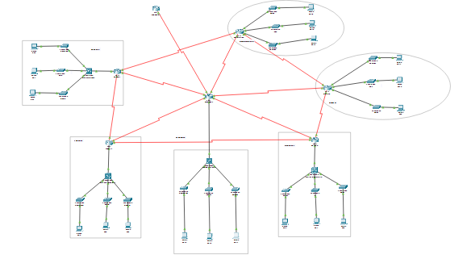

5. IP Addressing and Subnet Allocation
The assigned IPv4 block is 172.27.0.0/19. Variable Length Subnet Masking was used so that larger branches receive larger subnets while smaller branches use smaller subnets. Point-to-point links use /30 networks.
Segment | Network / Prefix | Mask | Gateway
Windhoek Admin VLAN 10 | 172.27.0.0/25 | 255.255.255.128 | 172.27.0.1
Windhoek HR VLAN 30 | 172.27.0.128/25 | 255.255.255.128 | 172.27.0.129
Windhoek IT VLAN 20 | 172.27.1.0/26 | 255.255.255.192 | 172.27.1.1
Oshakati Admin VLAN 10 | 172.27.1.64/26 | 255.255.255.192 | 172.27.1.65
Oshakati HR VLAN 30 | 172.27.1.128/26 | 255.255.255.192 | 172.27.1.129
Lüderitz Admin VLAN 10 | 172.27.1.192/26 | 255.255.255.192 | 172.27.1.193
Oshakati IT VLAN 20 | 172.27.2.0/27 | 255.255.255.224 | 172.27.2.1
Lüderitz HR VLAN 30 | 172.27.2.32/27 | 255.255.255.224 | 172.27.2.33
Mariental Admin VLAN 10 | 172.27.2.64/27 | 255.255.255.224 | 172.27.2.65
Lüderitz IT VLAN 20 | 172.27.2.96/28 | 255.255.255.240 | 172.27.2.97
Mariental HR VLAN 30 | 172.27.2.112/28 | 255.255.255.240 | 172.27.2.113
Opuwo Admin | 172.27.2.128/28 | 255.255.255.240 | 172.27.2.129
Opuwo HR | 172.27.2.144/28 | 255.255.255.240 | 172.27.2.145
Grootfontein Admin | 172.27.2.160/28 | 255.255.255.240 | 172.27.2.161
Grootfontein HR | 172.27.2.176/28 | 255.255.255.240 | 172.27.2.177
Mariental IT VLAN 20 | 172.27.2.192/29 | 255.255.255.248 | 172.27.2.193
Opuwo IT | 172.27.2.200/29 | 255.255.255.248 | 172.27.2.201
Grootfontein IT | 172.27.2.208/29 | 255.255.255.248 | 172.27.2.209

5.1 WAN and Routed Links
Connection | Network | Usable Addresses
Windhoek – Oshakati | 172.27.2.216/30 | 172.27.2.217 – 172.27.2.218
Windhoek – Grootfontein | 172.27.2.220/30 | 172.27.2.221 – 172.27.2.222
Windhoek – Opuwo | 172.27.2.224/30 | 172.27.2.225 – 172.27.2.226
Windhoek – Lüderitz | 172.27.2.228/30 | 172.27.2.229 – 172.27.2.230
Windhoek – Mariental | 172.27.2.232/30 | 172.27.2.233 – 172.27.2.234
Windhoek – WDH-CORE | 172.27.2.240/30 | 172.27.2.241 – 172.27.2.242
Oshakati – OSH-CORE | 172.27.2.244/30 | 172.27.2.245 – 172.27.2.246
Lüderitz – LUD-CORE | 172.27.2.248/30 | 172.27.2.249 – 172.27.2.250
Mariental – MAR-CORE | 172.27.2.252/30 | 172.27.2.253 – 172.27.2.254
Windhoek – ISP | 203.0.1.0/30 | WDH: 203.0.1.2, ISP: 203.0.1.1

The ISP connection uses 203.0.1.0/30. The ISP interface is 203.0.1.1 and the Windhoek router interface is 203.0.1.2. The Windhoek router therefore uses 203.0.1.1 as the next hop for its default route.
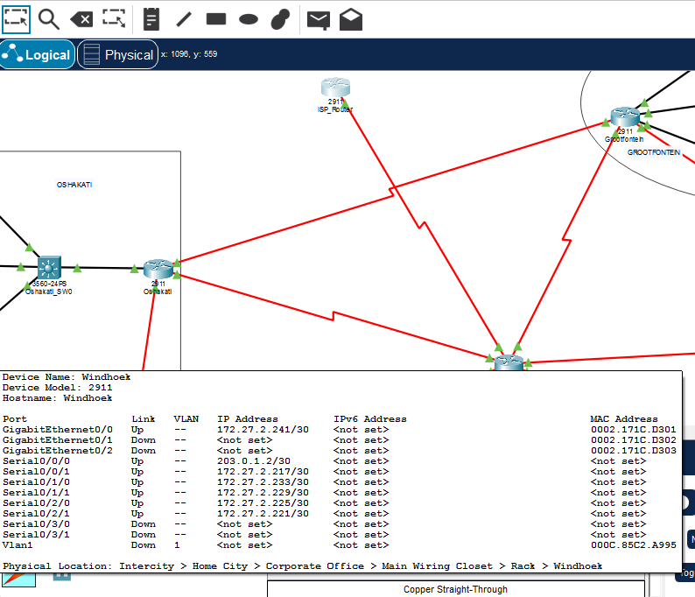

6. Address Space Management and Future Expansion
The following networks are reserved for future expansion. Reserving these networks prevents the current design from using the entire address block and provides room for additional users, departments or branch infrastructure.
Reserved Network | Capacity
172.27.3.0/24 | 256 addresses
172.27.4.0/22 | 1,024 addresses
172.27.8.0/21 | 2,048 addresses
172.27.16.0/20 | 4,096 addresses
Total reserved | 7,424 addresses

The total above is calculated from the listed reserved networks. It is important that the final documentation uses 7,424 rather than the earlier figure of 7,680.

7. VLAN Implementation and Inter-VLAN Routing
VLANs are implemented at four branches: Windhoek, Oshakati, Lüderitz and Mariental. VLAN 10 is used for Admin, VLAN 20 for IT and VLAN 30 for HR. The multilayer switch at each VLAN branch provides the VLAN gateway and performs inter-VLAN routing.
VLAN ID | Department | Purpose
10 | Admin | Administrative users
20 | IT | IT users and network administration
30 | HR | Human Resources users

- Access ports connected to end devices are assigned to the appropriate VLAN.
- SVIs on the multilayer switches provide the default gateways.
- IP routing is enabled on the multilayer switches.
- The router-to-core connections use routed Layer 3 links.

Branches Without VLANs
Opuwo and Grootfontein are the two branches that do not use VLANs. Their departmental networks are routed through separate router interfaces. This satisfies the requirement that only four branches use VLANs.
Branch | Department | Network | Gateway
Opuwo | Admin | 172.27.2.128/28 | 172.27.2.129
Opuwo | HR | 172.27.2.144/28 | 172.27.2.145
Opuwo | IT | 172.27.2.200/29 | 172.27.2.201
Grootfontein | Admin | 172.27.2.160/28 | 172.27.2.161
Grootfontein | HR | 172.27.2.176/28 | 172.27.2.177
Grootfontein | IT | 172.27.2.208/29 | 172.27.2.209

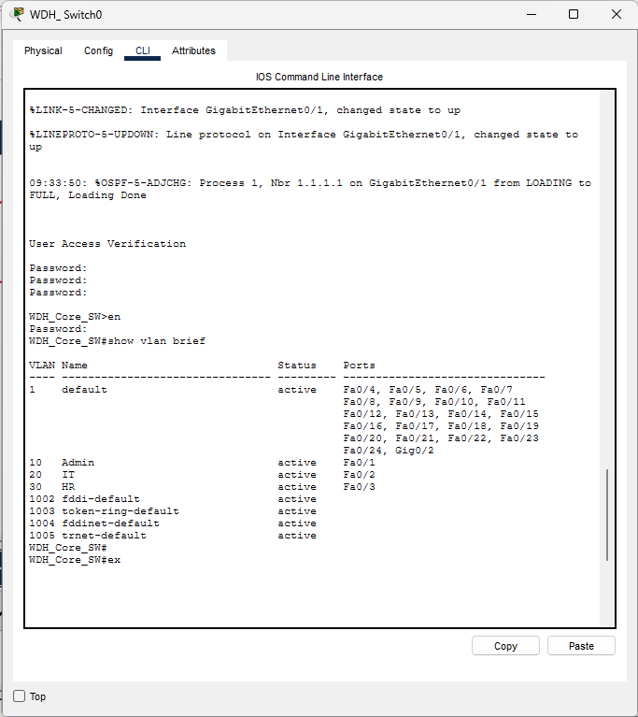
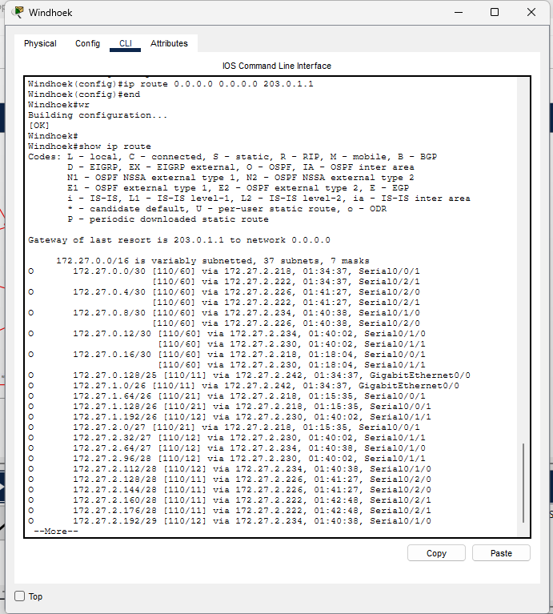

8. Dynamic Routing Configuration (OSPF)
OSPF process 1 is used as the internal dynamic routing protocol. All internal routers and multilayer switches that participate in Layer 3 routing advertise their connected networks in OSPF area 0. Router IDs are configured for the branch routers.
Device | Router ID
Windhoek | 1.1.1.1
Oshakati | 2.2.2.2
Lüderitz | 3.3.3.3
Mariental | 4.4.4.4
Grootfontein | 5.5.5.5
Opuwo | 6.6.6.6

Windhoek has the direct ISP connection. Its default route points to 203.0.1.1 and OSPF uses `default-information originate` to advertise the default route into the internal OSPF domain. Cisco documentation confirms that default-information originate is used to generate a default external route in a normal OSPF area when the advertising router has a default route.
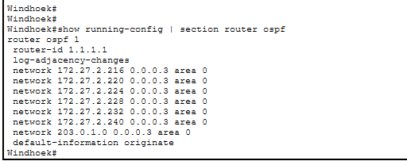
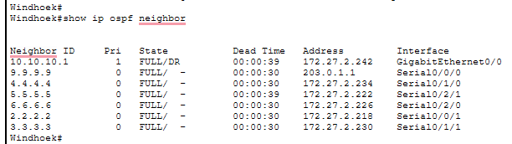
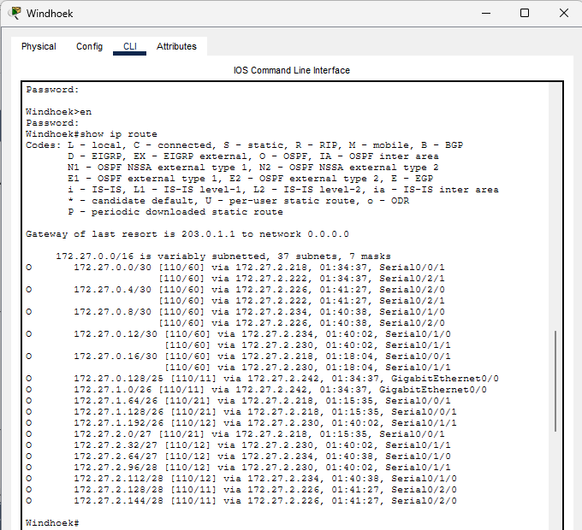

9. Network Device Security
Network devices are protected against unauthorized access using local authentication, privileged access protection, password encryption, login banners and restricted remote management.
- Enable secret is configured for privileged access.
- Console access requires authentication.
- Password encryption is enabled on configured devices.
- A warning banner is displayed for unauthorized access.
- A local administrator account is used for secure remote management.
- VTY lines are restricted to SSH.

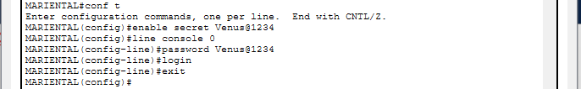

10. Secure Remote Administration (SSH)
SSH is configured to allow the network administrator at Windhoek to securely manage routers across the company network. The configuration uses SSH version 2, local authentication and VTY lines configured for SSH. Access-list 10 permits the Windhoek IT subnet 172.27.1.0/26 as the source network for management access.
Security Item | Configuration
Management protocol | SSH
SSH version | 2
Authentication | Local username and secret
Management source network | 172.27.1.0/26
Access control | Standard ACL 10
VTY transport | SSH only

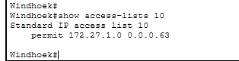
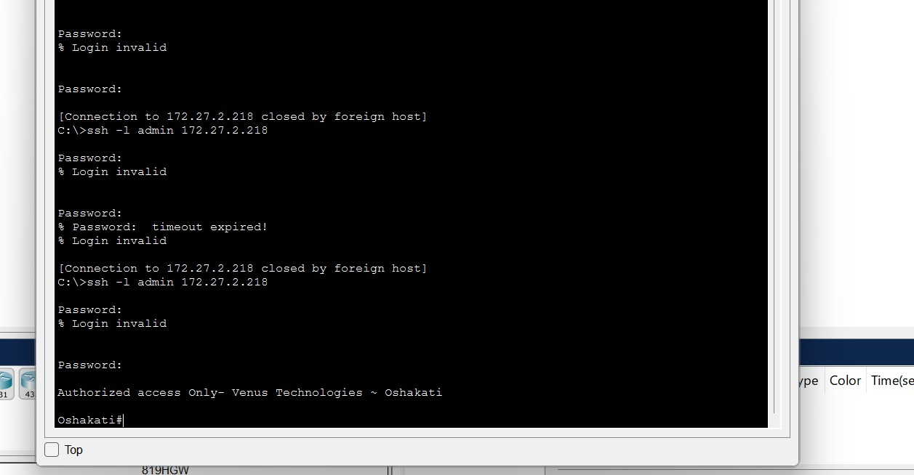
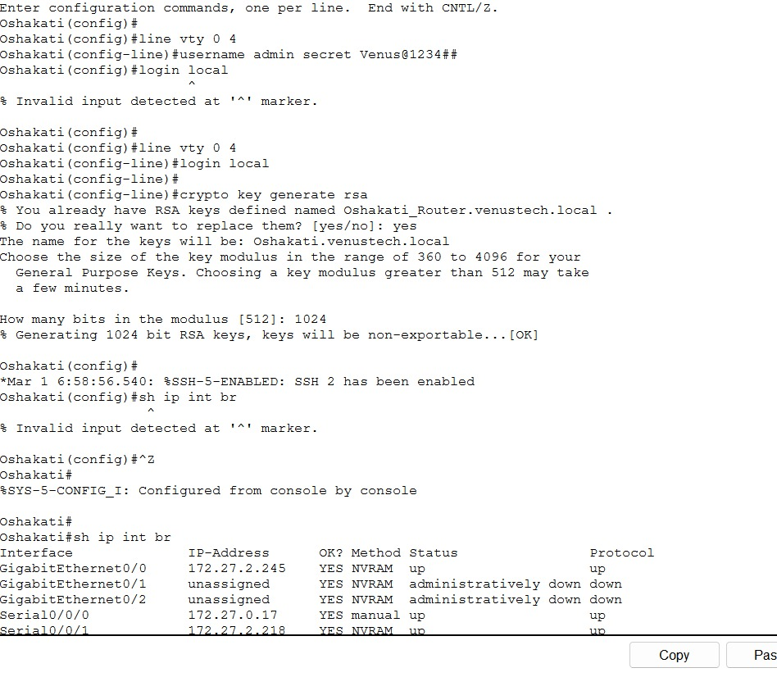

11. Layer 2 Loop Prevention and Redundancy (STP)
Spanning Tree Protocol is used to prevent Layer 2 switching loops. When redundant Layer 2 paths exist, STP selects a loop-free forwarding topology and places selected redundant interfaces into a blocking state. If an active path fails, STP can recalculate the topology and allow a redundant path to forward traffic. This provides loop prevention while supporting redundancy on switched networks.
PortFast is used on appropriate end-device access ports so that host-facing ports can move to the forwarding state without waiting through the normal STP transition. Port security is also configured on the specified Windhoek access ports.

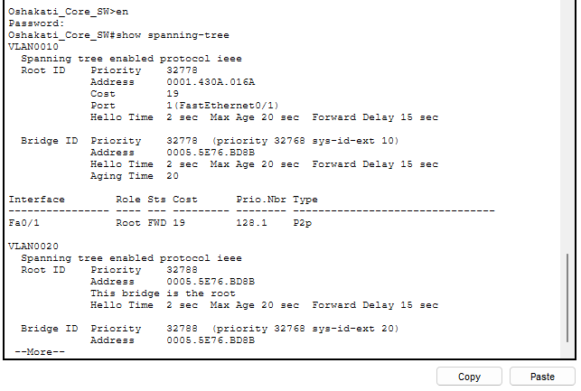12. 12 Network Implementation and Verification
Connectivity testing is used to demonstrate that the gateways, VLAN routing, OSPF routes and WAN links are operating. The final screenshots should show successful communication between Windhoek and remote branch networks.
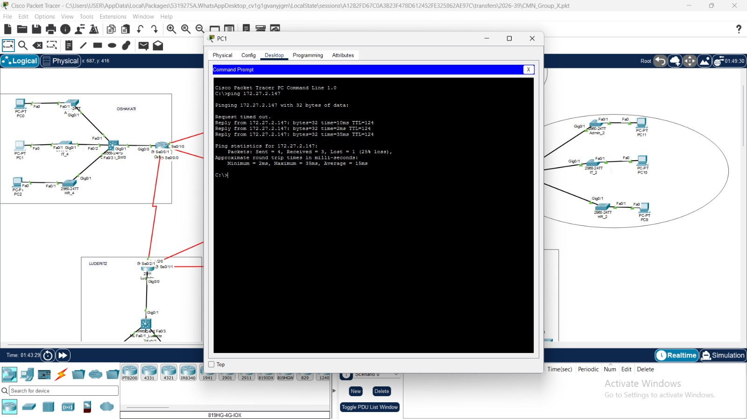
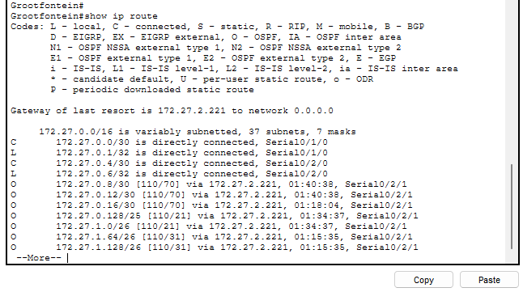

14. Conclusion
The project demonstrates the design and implementation of a multi-branch enterprise network using Cisco Packet Tracer. The simulated infrastructure connects six geographical locations through a central headquarters while providing logical separation between departments and controlled access to network devices.
The implementation brings together several important networking concepts, including VLSM-based IP addressing, VLAN segmentation, inter-VLAN routing, OSPF dynamic routing, SSH remote administration and Spanning Tree Protocol. These technologies work together to provide a structured network design that supports communication, security, efficient address allocation and future expansion.
Beyond the network design itself, this project provided practical experience in configuring Cisco network devices, planning IP addressing schemes, establishing routing relationships and verifying network connectivity.
The completed simulation serves as a practical demonstration of enterprise networking principles and provides a foundation for further exploration of network infrastructure, administration and security.

END OF DOCUMENT

