Towards collective action on community health in West Bengal: A research-informed approach
Cardiological Society of India and Shiksha Alochana
July 1, 2024

Executive Summary
The new millennium has arrived with newer challenges of non-communicable diseases. The threat has been multiplied by a growing level of pollution on one hand and changed behaviour among the population in general and among the children in particular on the other. Alarming as the situation is, global experience, however, shows that committed collective action can bring about sustained positive change into the lives of millions of people, especially in resource poor settings. With the above context in mind, the Cardiological Society of India (CSI) and Shiksha (SA) came to an understanding of carrying out a pilot programme on school and community health in select areas of West Bengal. The pilot programme was carried out in 150 primary schools across 12 districts of West Bengal. The work was taken up in stages, which included a series of workshops and meetings with varied groups – known experts in the fields, school teachers, ICDS and health workers, community representatives, and finally, carrying out health awareness in the classroom using comic colouring books and cartoon videos, leading health awareness campaign by students, leading “Say NO to Junk Food” programme by students, and developing health and hygiene practices in the schools in an amalgamative manner so that these practices could be made part of their daily curriculum.
Also, the program very much aimed to ensure full involvement of the local communities surrounding the schools with a comprehensive health programme including behavioural changes, improvement of public health initiatives, and strengthening of communication between the population and policymakers. The major achievement of the programme is an unimaginably huge progress in students’ quitting junk food. While before the initiation of the programme 90 percent of the students used to eat junk foods, a quick survey carried out in the last week of June 2024 showed that only 15 percent of them have not been able to get rid of the habit. In response to the question what made the students quit junk food, above 90 percent said that it was their active involvement in the programme – special campaigns, door to door visits, pursuing the shop owners not to sell junk food, pursuing the parents and local communities about the implication of junk food – that instilled in them the resolution that “first we students have to quit eating junk food, or else why should other listen to our appeals?”

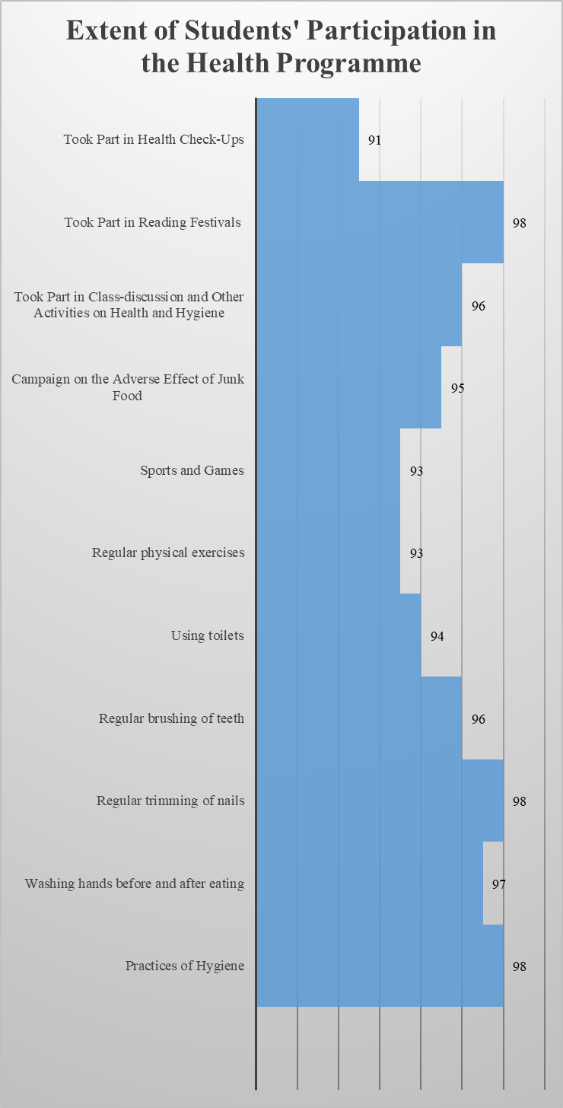

Introduction
Population health across the globe in general, and in India in particular, has been changing rather rapidly. While the previous century was marked with challenges of communicable diseases and substantial achievements made to curb the menace, the new millennium has arrived with newer challenges of non-communicable diseases. Of all the causes of death, according to the World Health Organisation,“all non-communicable diseases together accounted for 74% of deaths globally in 2019”. India, however, has a dual burden of diseases: Many communicable diseases are still haunting the health sector, while non-communicable diseases are growing as a major threat. Majority of the Indian population suffers from inherited social, economic, and cultural disadvantages (low education, malnutrition, hunger, poverty, sticking to customary beliefs, etc.). In addition to these hindrances that lead to the occurrence of communicable and non-communicable diseases, the profit-oriented forces that promote junk foods, sugar-sweetened beverages (SSBs), tobacco, and alcohol, have been adding terribly to the threat of non-communicable diseases. The threat has been multiplied by a growing level of pollution on one hand and changed behaviour among the population in general and among the children in particular on the other. Spending long hours on computers and mobile games and other physically immobile practices are adding much more to the concern not only for our biological and mental health but also for our social health.
Alarming as the situation is, global experience, however, shows that committed collective action can bring about sustained positive change into the lives of millions of people, especially in resource poor settings. Collective action can take a plurality of forms, including informed discussions, debates, and setting up of examples of change by using different combinations of actions, particularly by involving the communities concerned. Important in their own right, case examples also have a particular bearing on policy since the examples demonstrate, in an increasingly cynical world, the plausibility of change.
With the above context in mind, the Cardiological Society of India (CSI), an organization dedicated to the wellbeing of humanity, and Shiksha Alochana (SA), a solidarity of educational activists committed to making the schools into vibrant social institutions, came to an understanding of carrying out a pilot programme on school and community health in select areas of West Bengal. The alliance between the two organizations was realized through a common understanding: likewise, in education, health has to be seen in integration with the social process, involving several groups (students, teachers, parents, local communities, public workers, and other volunteers) on one hand, and intersectionality of concepts and actions on the other.
The pilot programme was carried out in 150 primary schools across 12 districts of West Bengal (Kochbihar, Jalpaiguri, Uttar Dinajpur, Dakshin Dinajpur, Murshidabad, Nadia, North 24 Parganas, South 24 Parganas, Kolkata, Purba Medinipur, Paschim Medinipur, and Jhargram). Nevertheless, owing to certain local and administrative problems the project could not be initiated in Dakshin Dinajpur and Kolkata, and the schools selected from these districts were replaced by some additional schools chosen from Purba Medinipur and Paschim Medinipur.
The work was taken up in stages, which included a series of workshops and meetings with varied groups – known experts in the fields, school teachers, ICDS and health workers, community representatives, and finally, carrying out health practices in the schools in an amalgamative manner so that these practices could be made part of their daily curriculum. Also, the program very much aimed to ensure full involvement of the local communities surrounding the schools with a comprehensive health programme including behavioural changes, improvement of public health initiatives, and strengthening of communication between the population and policymakers.
Previous experiences in the delivery of education firmly suggested that it was the involvement of the community – parents and others in the localities – that was centrally important to changing the reality. This was more relevant in any initiative of health action. Also, it would require advancing toward making a consortium of the local grass root level public institutions – the primary schools, Integrated Child Development Scheme (ICDS) Centers that cater to children under 6 and their mothers, and health centers. While the Cardiological Society of India had already prepared a conceptual foundation for an integrated health action, Shiksha Alochana had started to build ground for incorporating health issues in the schooling processes. Strenuous as it appeared, teachers found huge support from diverse communities – parents, common villagers, women’s self-help groups and ICDS, and health workers, as well as academics, journalists, and others.
The process of the programme
The pilot programme in West Bengal was planned through a series of discussions among the members of the two organisations. The objectives of the programme were as follows:
- Developing a research-informed action on community health with community involvement;
- Developing an advocacy chain; and
- Documenting the entire process so as to add meaningfully to the body of knowledge on healthcare delivery.
Action Plan
Physical area of intervention: 30 primary schools in three zones of West Bengal – North, Central, and South. The programme was designed such that each school could exert sympathetic resonance in at least another four schools in its surrounding. While school was the primary unit, our actions invariably included the entire population of the catchment areas of the schools.
The expected outcomes of the action were as follows:
(a) Positive delivery of healthcare in the respective areas – both in terms of changing health and health-seeking behavior;
(b) Contributing to the body of knowledge on community based interventions in the social sector in general and in healthcare delivery in particular; and
(c)Providing documented evidence with which to formulate meaningful policy changes.
Given the diverse settings of the localities, as explained earlier, micro-level planning of the implementation of the action had to be done at the school level; yet, it required a broader organizational design, which would take into account three distinct but interrelated areas, namely, (a) school health; (b) community health; and (c) public partnership.
- School Health: The proposed action was to go beyond the existing program of school health by making its scope much broader. The current program was limited both in scope – periodical health check-up and distribution of anthelmintic drugs and vitamin supplementations being the main components – and well-nigh dormant. A meaningful School Health program inevitably required a comprehensive design with promotion of cleanliness and other health practices, integrating health into the curriculum, and involving students in some community health activities, namely, a regular campaign on health and hygiene in the community.
One special intervention that was planned was to make a dent in the increasing food habits of the children in particular and the community in general. The consumption baskets were changing fast in areas well beyond the big cities and among all sections of the society. Whether we call it the 'demonstration effect' or invoke the power of 'aspiration', various sections of the working class are trying to emulate the lifestyle of the urban rich, and food habits are a very important part of that. The implications of changing food habits for health can be quite different for different socio-economic categories. We can try to inform the society, particularly those sections of the society for which the realised access to such information is inadequate, about the real (lack of) value of the food baskets available in the market and their nutritional and health implications.

(B) Community health: The action will have in its remit issues related to public health as well as a paired goal of utilization of publicly delivered curative health services, and improving their delivery. It will take the route of social health education through unrelenting health discourses at the community level. Further, it will advance these health discourses to their actual implementation, including improved utilization of health services. Both actions have the potential of improving not only the publicly delivered health facilities but also some other public programs, such as the ICDS, Public Distribution System (PDS), and so on. Also, the intervention will involve local level research and documentation to revitalize the actions through informed health discourse.

(C) Public partnership: The lack of public communication and demonstration of demand seem to influence the delivery of public services negatively. Owing to the social fabric in India, with several layers of stratification on the basis of caste, gender, economic class, and so on, while the average Joe lacks a voice, the privileged display socially extracted capacity to negatively influence implementation of public policies. The rectification of the delivery of public programs is, thus, contingent to the effective use of collective voices of the underdogs, through informed agency and evidence-based actions. However, informed discussion, practical interventions, and wider social support can be realized through public activism of social activists, teachers, and others to generate and enhance the collective voice that is thus enabled to bring positive changes.

The work was taken up in stages. The first step involved a thorough review of available global and national experiences in this area, including our own extensive previous works. Based on this information, the next step incorporated a series of workshops and meetings with varied groups – known experts in the fields, school teachers, ICDS and health workers, and community representatives – in order to develop the design of implementation, identifying the training needs, identifying and arranging the resources for training, and modes of advocacy.
Table 1. The Intervention at a Glance
Intervention category | Intervention components | Mode of action
Preparatory Works and documentation | Research and base building | • Review of literature  •Baseline survey on students’ perception on health and healthcare  • Workshops and meetings  • Qualitative interviews with key informants –community members as well as service providers  • Assessment of the programme by external experts.  •Preparing a report based on research and other documentations
School Health | ● Hygiene | • Integrated with daily school routine
School Health | ● Sanitation | •Integrated with daily school routine
School Health | ● Health check-up, and subsequent action | • Regularizing school visits by health personnel, and taking necessary actions
School Health | ● Health education and health action by students | • Integrating health education in curriculum, and carrying out health campaign by students
School Health | ● Mental Health | •Training of teachers as well as local community by experts
School Health | ● Adolescent Health | •Training of teachers as well as local community by experts
 | ● Sector-wise linkages | •Coordinating with ICDS, ANM, and others
Community Health | ● Sanitation and water | •Setting up of usable and proper sanitary system; ensuring clean water
Community Health | ● Prevention | •Ensured immunization; deworming; dealing with pests and insects;
Community Health | ● Health education and health discourse | • Enhancing health knowledge through regular meetings, workshops, campaign materials, reading materials, etc.
Community Health | ● Increased utilization of public run health facilities | •Enhanced visits to the public run facilities, and raise collectively demand for betterment
Advocacy | ● Improving the delivery of public services, especially health centres | Encouraging people to visit the government health facilities;  Highlighting the delivery issues in media;  Organizing regular meetings between health officials and other public servants and representatives and the local community
Advocacy | ● Coordinating with different public offices
Advocacy | ●Interactivity between policy and people

Activities and Achievements
Initiation
Despite initiation of the programme being planned for April 1, 2023, the launch of the programme had to wait mainly for two reasons: (a) an early declaration of school closure due to excessive heat wave, and late opening of the schools due to the same reason, and (b) the nature of the programme that involved several activities with which neither the programme organisers nor the grassroots level implementers were thoroughly acquainted. For example, two of the major activities of the programme were (a) colouring comic books by students in the classroom, and (b) showing cartoon videos on health aspects in the classroom. The texts of the colouring books and videos were prepared jointly by CSI members (concept), primary school teachers (script writing), and artists (pictures and cartoons). These works took longer than expected.
Therefore, our Central Workshop to launch the programme was organized on 7 August, 2023. This was followed by three regional workshops organized in Cooch Behar, Nadia and West Medinipur. One teacher from each of the participating districts participated in the central workshop.
The regional workshops were attended by one teacher from nearly every participating schools under the project. They were also attended by some Anganwadi and ASHA workers.

Despite the unintentional delay in launching, the work progressed rather enthusiastically. The immediate programmes taken up were as follows:
●Informing the students about harmful effects of junk food with the help of various examples;
● Discussing the rules of regular hand washing and its benefits;
● Prohibiting the students from spitting or responding to nature’s call in public and inspiring them to create school-based nutritious kitchen gardens;
●Promoting public health awareness by making posters and displaying them on the walls of the neighbouring areas;
● Organising placard processions with the students;
● Arranging awareness campaigns against substance abuse and addiction;
● Organizing discussions on benefits of physical exercise;
● Writing plays on various health awareness.
Under the guidance of the teachers of respective schools, the activities were also expanded to bring parents into the fold. Community meetings held under the programme helped greatly to ensure parents’ participations in some of the activities. The involvement of mothers in particular was spectacular. Discussion regarding how this awareness can be conveyed to every level of the society has also taken place. At the end of the day, the teachers felt that it was not enough just to convey the message; regular health practices also needed to be maintained simultaneously. In this regard, various plans came up from the discussions held in the meetings. To remember the statement of a parent made at a school meeting in Murshidabad district,
Continuous and comprehensive programme should be continued throughout the year. It is particularly important that students themselves understand the relevance. If they can keep this awareness alive among friends and their own family members, this initiative will play a very significant role.

Table 2. Final Status of the ‘School and Community Health Programme' at a glance
Sl. No. | Description of activities | Number of activities | Status
1. | Central Workshop | 1 | Done
2. | Regional Workshop | 3 | Done
3. | Baseline Survey (1 in each participant school) | 150 | Partially Done*
4. | Community meetings on health (150 Schools ×2 in each) | 300 | 288
5. | Health Check-up | 150 | 148
6. | Special Campaigns (30 Cluster × 2 in each) | 60 | 52
7. | Reading festival (Cluster wise) | 30 | 30
8. | Swasthya Mela (Health Fair) | 9 | 9
9. | Color Books and Crayons distribution | 150 schools | 150 schools
10. | Daily health awarness activities, campaign against bad food habits and wrong life styles | Daily in 150 Schools | Continued in 150 schools
11. | Final Survey | 150 | Done among 4192 Students

* Government’s decision to prolong the closure of school due to climatic adversities on one hand and delay in preparing the survey tools on the other had had their negative impact on the particular activity.
Active participation of mothers has been observed in most of the schools. At a parent meeting of a school in North 24 Parganas, a tribal mother said that there were at least two points of awareness which were to be highlighted to everyone in their area right now. The first was the rules and procedures of hand washing, and the second was to talk about the harms created by the consumption of alcohol – country made liquor in this case. If teachers and students went to their neighbourhood to campaign about these, she would also be willing to co-operate with a few others in that initiative. A mother from Nadia thought that to spread this health awareness message in the community, it was necessary to reach a wide range of areas and approach people repeatedly. The health awareness handbook of the Cardiological Society has been found to be very useful for teachers as well as mothers. Mothers were particularly interested in the information provided in the book in connection with developing child’s food habits. They enthusiastically tried to understand the importance of home-made food instead of packaged food.
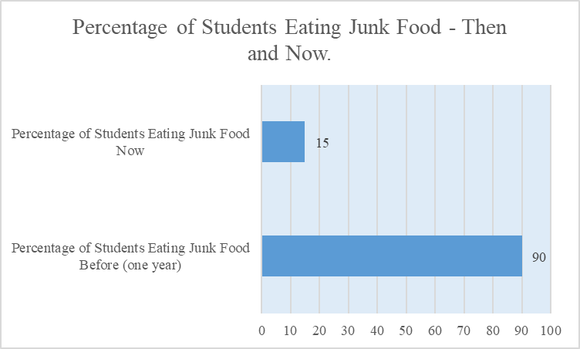
In most of the cases, the main responsibility of this parent meeting was taken up by the child cabinets of the respective schools. Apart from parents’ meetings, regular public health discussions are also going on. Various discussions on proper eating habits of children to keep them healthy, developing the habit of being compassionate towards each other, avoiding plastic, identifying and eradicating social problems like gender and caste discrimination etc. are also being organised at regular intervals.
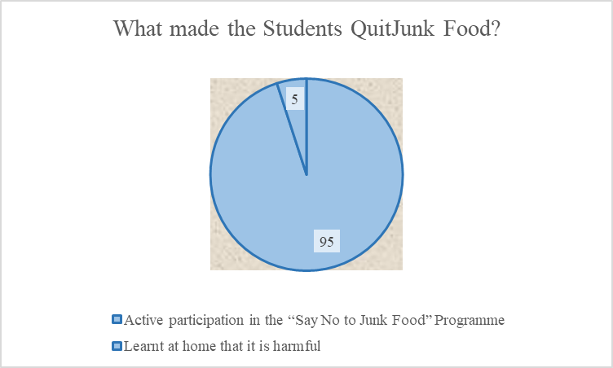
The comic books, mentioned above, and colouring pencils were supplied to the schools. The cartoon videos were also supplied online. These books and colour pencils created a lot of interest among the students. The students intended to read these plays playfully. Through this playful and interesting manner, they understood, to a great extent, the health awareness message conveyed through the dramas and will subsequently be able to convince others. In fact, when the books were handed over to the students, they received them with a lot of interest, coloured the figures, and in some schools the students even tried to stage the plays themselves. At several places, children were seen trying to articulate dialogues in their own words while acting. Teachers accepted the books as very useful teaching-learning materials.

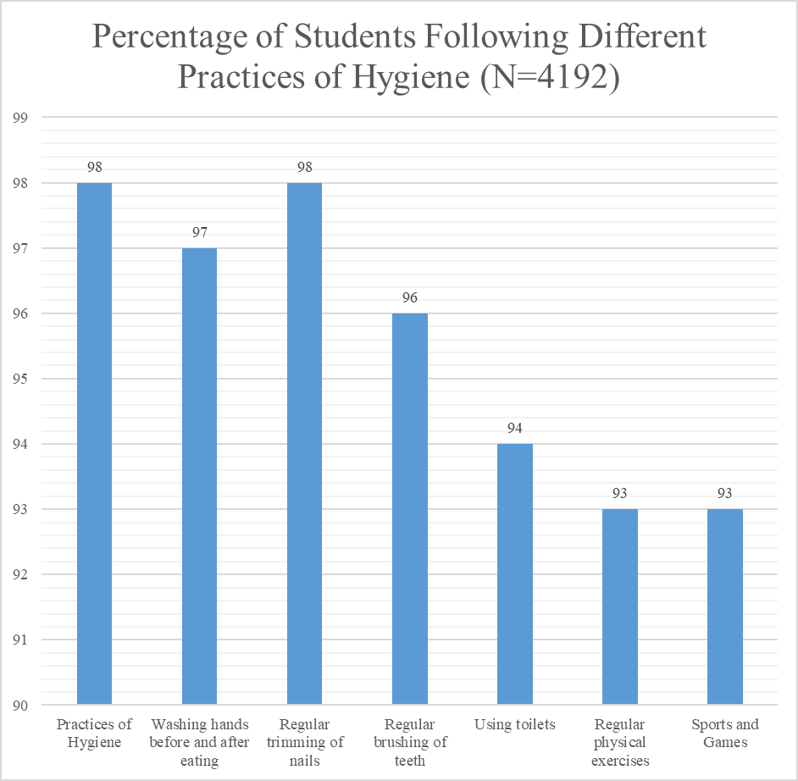

Students not only understood the subject, the teachers thought, but also showed interest in applying them in the real world. A teacher in South 24 Parganas district has decided to apply these books in the remedial classes for disadvantaged students. Let us note his exact words:
On March 13, I first presented a book experimentally in front of the special class for the backward students in our school after recess. All of them can't read well, some can't recognize letters, some can't form words. These special classes are arranged to make up for this learning deficit. I opened the book 'The Benefits of Exercise' written by Suman Chatterjee, held it in front of them and asked them to tell what they could see. Strangely, they said by looking at the cover of the book, it is the story of Bantul the Great. They watched the cartoon of Bantul the Great on mobile. After seeing the pictures on the inside pages, they described as they understood. I found the description almost accurate. In their observation, if one exercises, one will get a body like Bantulda. Then I showed the pictures for a while and told a bit of the story. Then I started asking small questions. I saw that they all answered almost correctly. I didn't realize that kids would overwhelm my needs like that.
… In the next step, I decided that I would inspire them to act. Everyone got interested. At first, three of them were called and the drama started. The play started based the dialogues given in the book. Mostakin played the role of Ghantu. Mostakin now sat on top of the cloth. Then he first leaned on the table and fell asleep. At the end, he fell asleep just like the clock in the story. Then I didn't have to say anything else. He started reading alone with a book and pretended to laugh at something which he had read. At that time Ghantu's father Rahan entered and started delivering his dialogues. Amazingly they started exchanging the dialogue between themselves with little help from me.
Ghantu's father: Do you know, Narayan Debnath died today!
Ghantu (jumping up): What are you talking about, father! This Corona has taken away many people from us, Lata Mangeshkar, Shankha Ghosh.
Now it was my turn to be surprised. I asked him, "Do you know the two of them Mostakin?” To my utter surprise, the near illiterate boy of the class said, "Yes sir. I saw it on TV. But I didn't know before who Sir Narayan Debnath was. Now I came to know that he was the creator of 'Bantul the Great'.”
After the drama ended, I said to them, "Then who should exercise at least half an hour every morning?" Hearing my question, all the hands of the class went up. I said again, "Tell me what Bantul Da said. What are the benefits of exercise for the human body?” Mostakin said, "If you exercise, your heart will be fine, blood circulation will be good, you will be hungry in time." "And if your father does these exercises, what will it do? Said Bantul Da a little while ago." Hearing my question, he said, "If father's blood is thick, it will be thin, if he has diabetes, it will also be well managed, the heart will be fine. And whatever benefits I am supposed to get from exercise, father will also have them."
This time I thought I would ask all the children in the school to read every play. And I would encourage them to stage them all.
A teacher from Cooch Behar was also highly excited. He also shared the wonderful experience he had by handing over the books to the children:
They had a lot of fun when they got the books. First, the group started reading the dialogues. Then, an argument started between the two parties over the food that the Bhooter Raja had mentioned and Ghantu's favorite food. I just kept encouraging arguments, but did not take any side. The reason for not taking either of the sides was to see if they could get it right. At the end of the argument, the ghost king got the most number of votes. But those who were in favour of eating junk food, I asked them to read the rest of the play. We also showed them the cartoon videos we got from the two plays. They all decided that on the next day there would be a discussion on the harmful effects of junk food.
Another teacher described:
After understanding these plays well, students should be encouraged to write more new plays on health awareness. And they can show it by acting in other schools of the cluster.

Along with dramas, cartoon videos have also become very attractive to children. In fact, it can be said with certainty that this project will not only make children health conscious, but will also accelerate their mental and intellectual development.

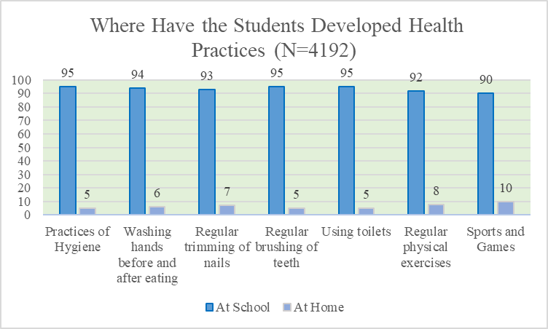

Expansion of activities

Subsequently the programme expanded its activities, which included Reading Festivals, Health Fair, Special Campaign, Health Check-up, Community Meeting, Baseline, Baseline Survey on the perception of the students, and Special Initiatives for Cardiac Examination and Treatment.
Reading Festivals
Many of our teaching friends were particularly familiar with the Reading Festivals as Shiksha Alochana has implemented it very successfully on several occasions. Thus, it was arranged in such a tested and trusted method. Several books were scattered on the floor. Children choose and read the books of their choice.
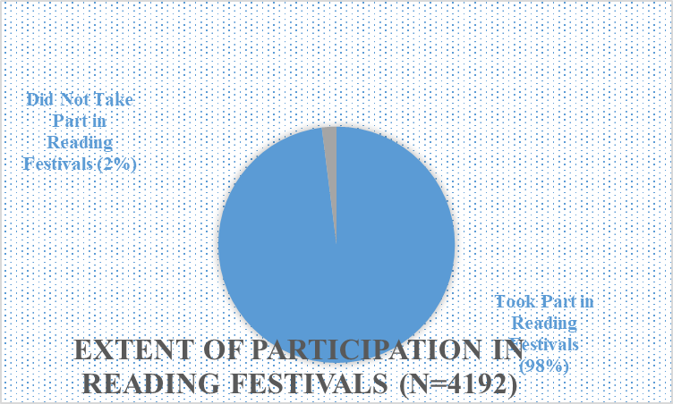
Then they participated in various activities after understanding the content of the book. For example, matching the words/sentences/pictures on the right with the sentences/words/pictures on the left, discussing new words or concepts known from the content, making lists and explaining them, etc. Then they wrote something and drew pictures relating their thoughts with the given content. Finally, their new writings and drawings were combined and published as Wall Magazines. In this case, however, we emphasized on health awareness while doing this work. Moreover, the host teachers of the cluster in which it was organized added some new spices using their creativity.

Health Fair
The health fairs (swasthy mela in Bengali) were organized in the following manner:
Each participating school set up one health awareness stall in the fair. Community members and members of local clubs participated in the fair. It was ensured that mothers and local health workers in particular took active part in the health fair. Along with that, the local residents of the area were invited to participate in the fair. A stage was raised in the fair ground. Students performed on the stage dance, song, recitation, drama with special relevance and reference to health. There took place discussion on nutrition. Seminars were organized involving parents, health workers and doctors. Teachers of the host district had the freedom to customise the proposal using their own intellect.
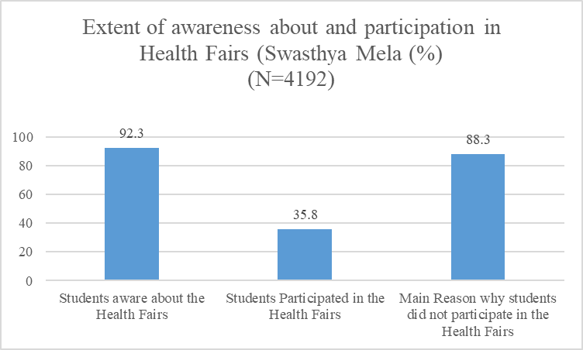
Special Campaign
This part of the project was done jointly by all of the clusters. In that case, various programs could be taken up with the help of local panchayats such as poster campaign, procession with students, staging street plays in respective school areas. Teachers of the five schools of the cluster joined hands in order to chalk out a plan for the special campaign. They concentrated particularly to help the project reach the local people as much as possible.

3. A. 4. Health Check-up
Health check-up was another important component of the programme. This was implemented in most of the school under the project. Health check-up of students in primary schools was performed once a year as a part of the State government initiative. Having been shut down for two years due to COVID -19, it has recently been resumed. But the health checkup under our programme involved was to make the activity much more serious and rigorous. Help of local doctors and health workers were sought to carry out the activity. Some of the health issues found among the children were addressed immediately, and some were referred to the Block Health Centres or Hospitals.
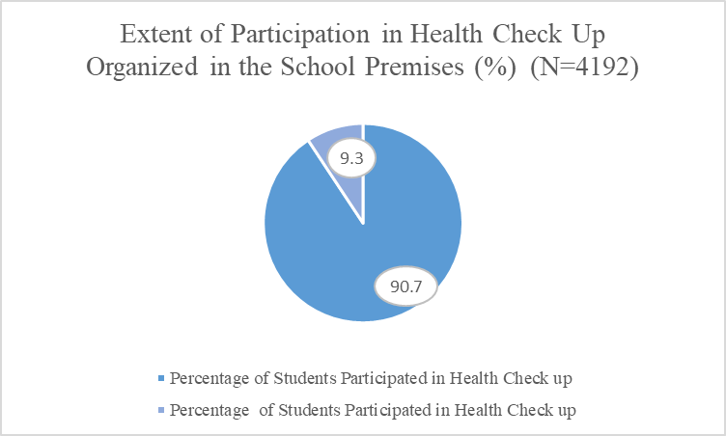

Special initiatives for cardiac examination and treatment

The Cardiological Society of India added a very important activity to the programme. This involved Echocardiography on 101 selected children from five schools under the initiative of the society. These included four schools in North 24 Parganas and one in South 24 Parganas. After the test was done, eminent cardiologists visited the schools and performed ECG of those children with the help of a stethoscope through a specific mobile app. The next year’s programme will involve an expansion of this screening and initiating treatment on the basis of the results.
A Special Programme
Besides the School and Community Health Programme, a proposal of 'Student-Teacher Workshop in Pursuit of Education' was proposed and taken up at the last State Annual General Meeting of Shiksha Alochana Society. The aim of this plan was the realization of education in its true sense – so that, the students could be observed more closely. We often learn many things without knowing why we are learning them. As a result, learning turns out to be an artificial, mechanical and boring process. The purpose of the proposed workshop was to explore interchange of dialogues between students and teachers on such issues, leading to deeper understanding. Three such workshops were held and promising initiatives were offered, including one that could involve children’s mental health.
In addition to the above activities, regular hygiene observance, periodic meetings with parents, arguments, discussions, and debates among students as well as various health awareness campaigns will also continue.
Major Achievements
In order to measure the effectiveness of the programme we ran a quick survey among 4192 students from the participating schools. The size of the respondents had to be kept small because of the climatic adversities that prolonged the school closure. Nevertheless, small as the number of respondents is (about 25% of the total participants in the programme), the responses, which corroborates our open eye observations, are telling. While before the launching of the programme 90 of the students were in the habit of eating junk food, now it has come down dramatically: only 15 percent could not get rid of the habit. As to how did they overcome the temptation of junk food more than 90 percent said that it was their active involvement in the programme – special campaigns, door to door visits, pursuing the shop owners not to sell junk food, pursuing the parents and local communities about the implication of junk food – that instilled in them the resolution that “first we students have to quit eating junk food, or else why should other listen to our appeals?” More than 90 percent of the students were brought under the health check-up programme. Those who remained outside the programme was because of their absence in school on the particular days when the health check-ups happened. While asked about practices of hygiene, washing hands before and after eating meals, regular trimming of nails, using toilets, and carrying out physical exercises regularly, more than 90 percent of the students responded in the positive. More than 90 of the students were aware about Health Fairs organized in the cluster schools, and 35 percent of the respondents had attended the fairs. Those who could not attend was because the number of participants in the fairs was limited and thus only a section of students was picked up for the event. Almost all the respondents (98%) joined the reading festivals organized in the schools.

Conclusion
Despite the initial hiccups in launching the programme, it was be organized meaningfully in the schools. The most important success of the programme was the involvement of students as the most active partners. They appeared, not merely as recipients of ‘advices’, but in several cases added substantially to both the conceptual and implementational aspects of the programme. There were, however, some weaknesses both in terms of designing the programme and implementing it at the grassroots levels. One major weakness was the relative frailty of communication between the centre and the grassroots. This often resulted in other problems like making the funds available on time or planning the activities well in advance. A robust communication system with a solid communication mechanism is required.

Table 2. District and clusterwise programme details
Disrtict | No. of Cluster | No. of Schools | Swasthya Mela | Reading Festivals Clusterwise | Special Campaign Clusterwise | Community Meeting Schoolwise | Health Check-up Schoolwise
South 24 Parganas | 2 | 10 | 01 | 02 | 04 | 20 | 10
Nadia | 4 | 20 | 01 | 05 | 08 | 40 | 20
North 24 Parganas | 3 | 15 | 01 | 05 | 06 | 30 | 15
Murshidabad | 3 | 15 | 01 | 03 | 06 | 30 | 15
Coachbehar | 3 | 15 | 01 | 03 | 06 | 30 | 15
Alipurduar | 2 | 10 | 01 | 02 | 04 | 20 | 10
Jhargram | 2 | 10 | - | 02 | 04 | 20 | 10
Jalpaiguri | 2 | 10 | 01 | 02 | 04 | 20 | 10
Purba Medinipur | 4 | 20 | 01 | 04 | 04 | 40 | 20
Paschim Medinipur | 3 | 15 | 01 | 02 | 04 | 30 | 15
Kolkata | 2 | 10 | - | - | 02 | 08 | 08
Total | 30 | 150 | 09 | 30 | 52 | 288 | 148

Table 3. Receipt and expenditure of allocated funds at a glance (All expense details have been submitted to the Cardiological Society of India)
Fund Received | Amount | Fund Utilised | Amount
1. 1st allotment  2. 2nd allotment  3. For Heart check-up(ECO) | Rs. 2,43,530.00  Rs. 2,35,690.00  Rs. 19,600.00 | 1. Swasthya Mela  9 X 10,000  2. Reading Festivals  30 X6,500  3. Spl. Campaign  52 X1,000  4. Community meeting  288 X 200  5. Health Check-up  148 X 200  6. Heart check-up Exp.  7. Other Expences  8. Cash in hand | Rs. 90,000.00  Rs. 1,95,000.00  Rs. 52,000.00  Rs. 57,600.00  Rs. 29,600.00  Rs. 20,000.00  Rs. 50,359.00  Rs. 4,261.00
Total | Rs. 4,98,820.00 | Total | Rs. 4,98,820.00

The Cardiological Society of India (CSI), an association of Indian cardiologists, is committed to improve the cardiac health of the population and has been carrying out various programs towards meeting this objective. Nevertheless, since cardiac health is inseparably related with other heath aspects, which demand urgent attention and consorted action, the CSI has expanded the purview of interventions to the community level actions, and has chosen the schools as the units of interaction. The experience of such expansion – a programme carried out in some high schools of Kolkata – while reinforcing the justification of the expansion, guided us to widen the scope of such programmes, especially to the primary school level, where both students and their parents can be made fully involved in a school and community health intervention.
Siksha Alochana (SA), literally – Discussion on Education – has made a very significant beginning of transforming the plausibility into real achievements. It is an initiative of a number of primary school teachers, and some of the academics and activists of the state. It aims to enhance primary education in West Bengal through interactions between primary school teachers of various schools at one level and between concerned teachers and larger public on the other. With plausibility of change being the main driving force behind the organization of the platform SA, has been active in emboldening the examples of positive changes set by some of the teachers in alliance with the local communities and is engaged in expanding those experiences. To illustrate, the initiative that was begun in only about a score of schools across mainly two districts, North 24 Parganas and South Dinajpur, has now taken root in about three hundred schools across twenty districts. Contrasting sharply with the popular belief of absenteeism being a congenital characteristic of teachers, many teachers have proactively reached out to SA to join the course of transforming the traditionally poorly functioning primary schools into the institutions of effective delivery of education. What is more encouraging is that many of the teachers have received extremely positive response to their invitation to the poor and disadvantaged communities to participate in the process of transformation.
To illustrate, in Shiksha Alochana’s work, the concept of school has been expanding its boundaries from the primary task of correctly presenting the teaching-learning activities to incorporate numerous additional activities, including sports and games, cultural engagements, the practice of health and hygiene, kitchen gardening, the children’s own store, and regular meeting with parents and the community. In addition, some of the schools have made the advancement of mobilizing community’s to stop open defecation, one of the greatest single threats to health.

