**Modeling**

In the modeling section. There are five subsections which are identity problem, inputs, variables, constraints and objective value. This section includes all the details of setting up a model and all the modeling techniques.

**Identity problem**

In this problem, our objective is to maximize the net income of the 2018 Iowa liquor store procurement plan. The procurement plan makes each category of liquor must be an integer. In another word, optimization models in which some or all of the variables are constrained to be integer are known as integer programming models.

**Inputs**

From the dataset we used in Iowa government official website, there are three parts we will be used as inputs in our model. There are three major city bottles sold, liquors information and warehouse capacity information.

First, three major city bottles sold in 2017 is the dataset including nine categories of liquor we classified in the data classification stage (scotch and whiskey, tequila, rum, brandy, gin, vodka, cocktail, liqueur and spirit), three highest sales record cities we chose (Cedar Rapids, Davenport and Des Moines) and the number of stores in each city.

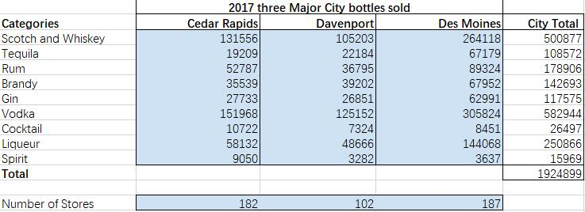

Second, from the origin dataset from Iowa government official website, we filtered and calculated three valuable cost-retail information, there are average bottle volume, average bottle cost and average bottle retail price. They will be use to calculate the total capacity used, total cost and total revenue.

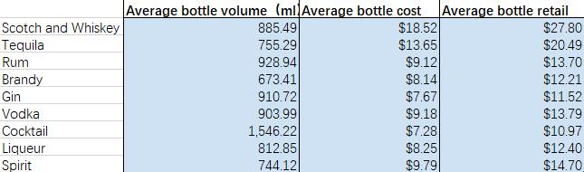

Third and last, from the origin dataset from Iowa government official website, we take the warehouse capacity information for each city. The warehouse capacity is recorded in milliliters. This input is valuable in setting capacity constraint in the constraints subsection.

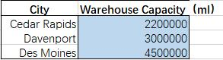

**Variables**

In this problem, variables are each store of three cities procurement plan in 2018. Because each store has nice categories of liquor to purchase, so the total variables are three cities times nice categories equal to twenty-seven variables.

**Constraints**

In this problem, there are three major constraints. We set the constraints base on the reality situation in Iowa liquor business. First is the demand constraint. The numbers of demand in each city are based on the 2017 bottles sold input. We use each category divided by the number of stores, in this way we get each city demand for each category of liquor. Furthermore, we set the variables to be smaller or equal than demands because in this problem we wish to reduce leftover as low as possible to cut off the storage fees.

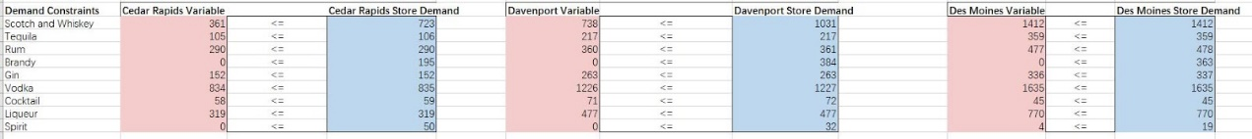

Second is capacity constraint. In the reality situation, the store volume cannot excess the warehouse capacity. For the store volume, it can be calculated as the sum product of each city variables and average bottle volume.

https://lh4.googleusercontent.com/W3FlROlT-eSQv4bSN7WWPwFg1B3g8kPpSA8Xi3AitmSVh8OsnroElBv4iV3k7bK74V7ZNXuyfHEGf7EsjuGvalOEF6_8-r3MKrA5bHmndbiAcZ9E3lahUTBb3Inf9BWuO0gmP3oNl_w

https://lh6.googleusercontent.com/tAWh_hLV8xZzN7G7f9vr8uDcDj4RdCvosYtum83NHCxfpsWaLTHoeKMgoUC5BPGIUWB9tupD24y6K-kcps1RGypHW3Z9hlSe_nG-Jr9b4-ihXIm-QmtV0hc44kHgyAYoalEAfsuKy4w

https://lh3.googleusercontent.com/kb0AuF8IECPAfvPLp-2V9SOREaOI9bkUa9lKdfGbqpEO0XeBDvloLiZCPt2nnWp0M5JaWX5LGfkuSgEqxQXIohRzfT_DDizqQbLnUwv5DO-Zbh1PljbhGpOBzhVM2VOLjaf4f3tQrp8

Third is budget constraint. The total cost for procurement plan cannot excess the budget plan. For the total cost, it can be calculated as the sum product of total variables and average bottle cost.

https://lh4.googleusercontent.com/WALNJj0E1YtDhHyoSDVTgU8F4vfJcy3cCBZF4GtghBhMYbP3PRsNLeexjEwhF23QWj9Wjy-hvztDNrqmaTfBcmYec_MuLciDz-E5OWrBsfpmNd__EiAyHVLj1yIge39Gi01xl0fjrws

**Objective Value**

The objective value is the maximum net income of the 2018 Iowa liquor procurement plan. The simplify objective function is net income equal to total revenue minus total cost. For the total revenue, it’s the same formula as total cost, it can be calculated as the sum product of total variables and average bottle retail price.

