**\*LINUX ASSIGNMENT\***

**1. Creating and Renaming Files/Directories**

**Create a directory named test_dir using mkdir.**

**Inside test_dir, create an empty file called example.txt.**

**Rename example.txt to renamed_example.txt using mv  
  
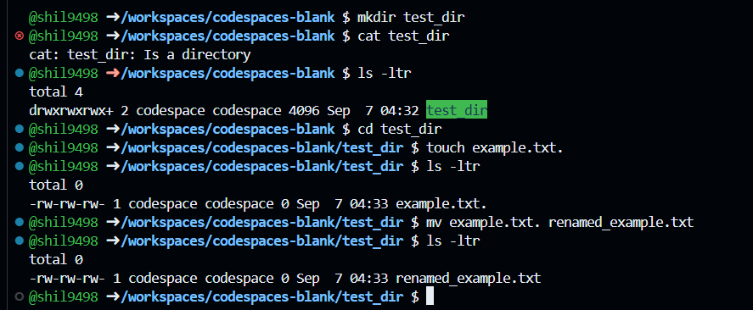  
  
2. Viewing File Contents**

**Use cat to display the contents of /etc/passwd.**

**Display only the first 5 lines of /etc/passwd using head.**

**Display only the last 5 lines of /etc/passwd using tail.**

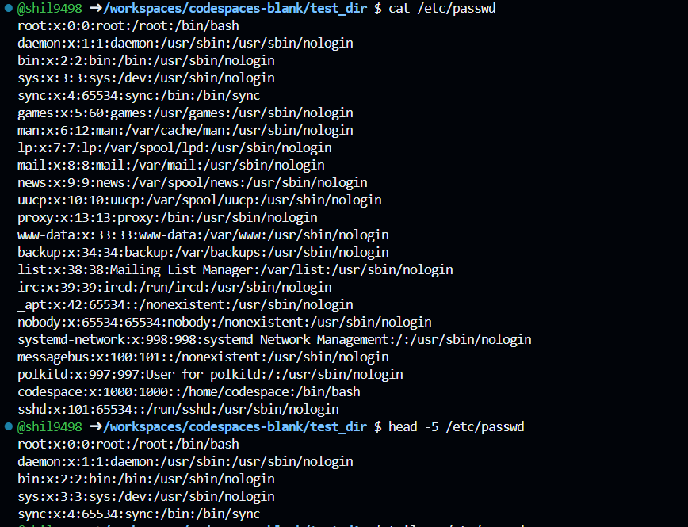

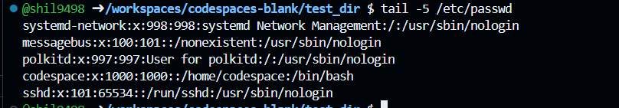

**3.Searching for Patterns**

**Use grep to find all lines containing the word "root" in /etc/passwd.  
  
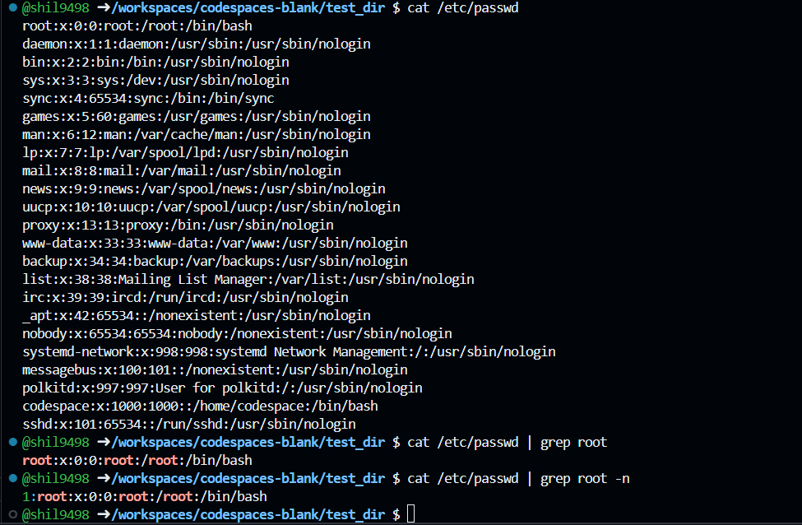**

**4. Zipping and Unzipping**

**Compress the test_dir directory into a file named test_dir.zip using zip.**

**Unzip test_dir.zip into a new directory named unzipped_dir.**

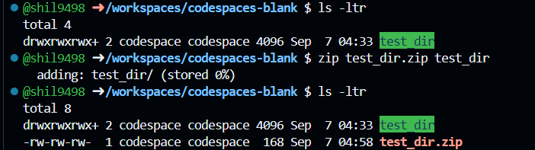

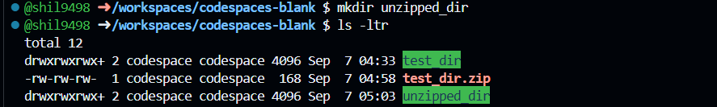

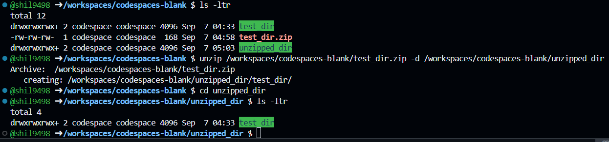

**5. Downloading Files**

**Use wget to download a file from a URL (e.g.,** [**https://example.com/sample.txt**](https://example.com/sample.txt)**).  
  
🡪 Unable to access URL (**[**https://example.com/sample.txt**](https://example.com/sample.txt)**)  
So I have downloaded file from this link (** [**https://gist.githubusercontent.com/Talha-Altair/b8a27d2b45add1dd7658fd34fa1968db/raw/bc45208c96df65e8e659c04e7d1f1bb54ec5b7e2/linux_commands.txt**](https://gist.githubusercontent.com/Talha-Altair/b8a27d2b45add1dd7658fd34fa1968db/raw/bc45208c96df65e8e659c04e7d1f1bb54ec5b7e2/linux_commands.txt) **)  
  
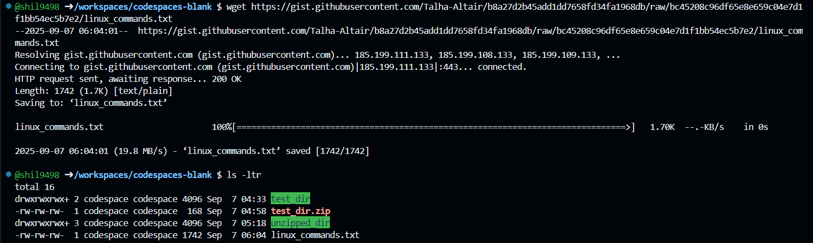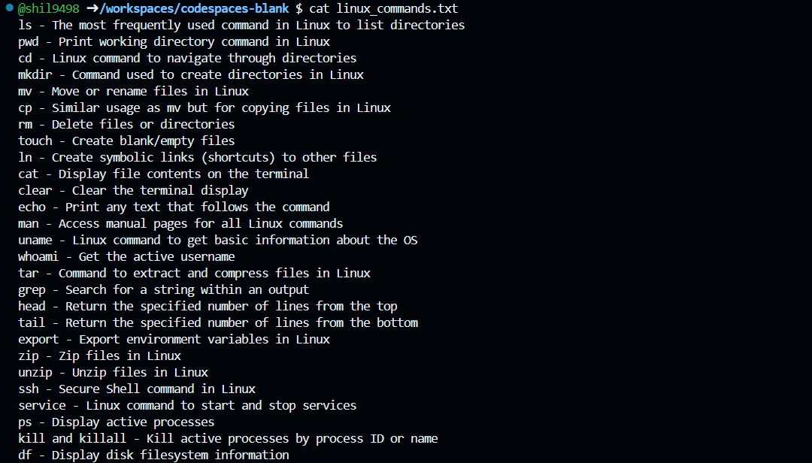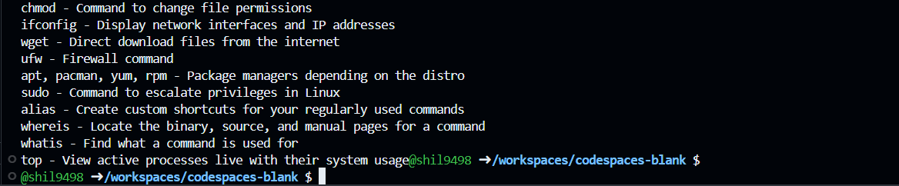**

**6. Changing Permissions**

**Create a file named secure.txt and change its permissions to read-only for everyone using chmod.**

**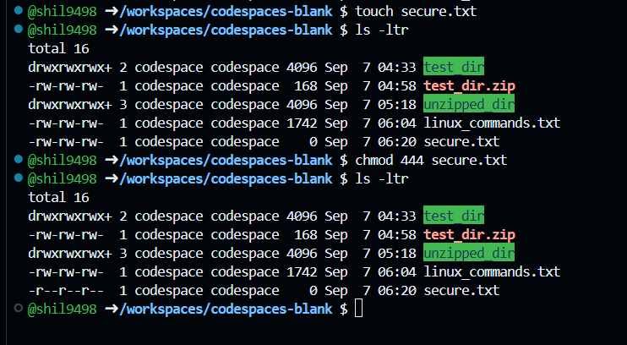  
  
7. Working with Environment Variables**

**Use export to set a new environment variable called MY_VAR with the value "Hello, Linux!".**

**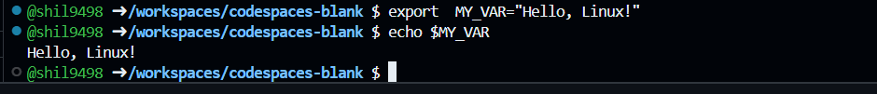  
  
  
  
-------------------------------------------------------------END-------------------------------------------------------------------**