PHARMVILLE | ARCHITECTURE SERIES

Customer Platform
  - HLD 01 / Web · account, shopping cart, checkout and customer orders

Document type | High-Level Design (HLD)
Version / date | v1.0 • 20 October 2026
Basis | Complete Order Journey v3.0 + heathcare_db.zip
Status | Proposed architecture for product, pharmacy and engineering sign-off

DESIGN ANCHOR One customer journey. P needs pharmacist review; M and O never trigger it on their own.

How to read this HLD
The main design explains responsibilities, handoffs, and business behavior. Interface and data tables then show how existing database structures support that design. “Existing” means observed in the uploaded database definition, not a running feature. “Proposed” means work to agree or implement.

Approval roles
Product Owner • Engineering Lead • Pharmacy Lead (where applicable) • Security/Privacy Lead • Operations Lead

01 | Executive summary and scope
The Customer Platform is the public web experience at aviorion.com. It owns how a shopper browses, keeps a cart, signs in, manages addresses, submits checkout, follows an order and requests post-order help. It does not itself approve medicines, collect payment directly, decide stock truth, or deliver parcels; those belong to specialist services.
Included in this HLD | Outside its ownership
Home, category browsing, product display; cart and account entry | Catalog master data, classification and search ranking
Addresses, family members, preferences, wishlist | Staff roles, pharmacist judgments, patient clinical records
Checkout summary, P branch, payment initiation UI | Gateway capture, stock reservation truth, order allocation
Order history, delivery milestones, cancellation/return request UI | Courier control, finance settlement and refund execution

CONFIRMED RULE Any active P order line requires prescription upload and pharmacist review. An M/O-only cart takes the same checkout but skips that branch. P rejection never silently deletes M/O or charges a changed basket.

02 | Users, channels and key outcomes
Actor | Needs to complete | Success indicator
Guest shopper | Browse and add to cart before sign-in | Can see accurate product class/price and return to cart
Registered customer | Checkout, manage addresses, orders and profile | One confirmed order with clear status and no double charge
Caregiver / family member | Select correct patient for P products | Rx linked to intended patient only
Customer support (read-only view) | Explain order and guide recovery | Customer sees same truth as support staff

03 | System context and architecture
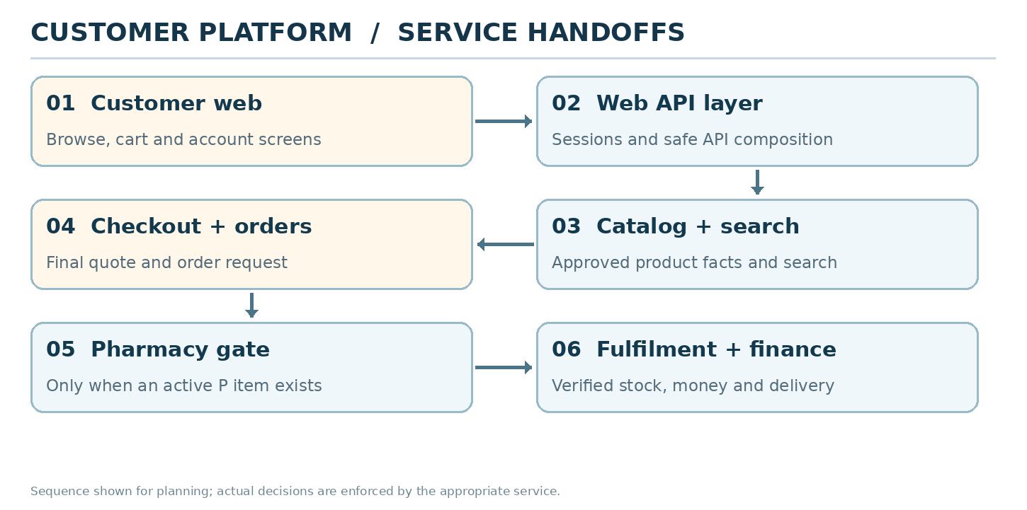
Figure 1. Logical dependencies. Boxes represent responsibilities, not confirmed deployed services.
- Public UI: responsive customer web with server-rendered discoverable pages and authenticated account screens. A Next.js frontend is a recommendation, not a database fact.
- API composition layer: validates sessions, serves customer-safe views, and orchestrates calls; avoid exposing database schemas or pharmacist-only data directly to the browser.
- Specialist domains remain authorities: Identity, Catalog/Search, Pricing, Inventory, Checkout/Orders, Pharmacy, Payments, Delivery and Notifications.
- Shared PostgreSQL is currently schema-owned by the uploaded DB repository; application services do not execute schema changes. Use controlled migration releases.

04 | Complete customer journey and branch behavior
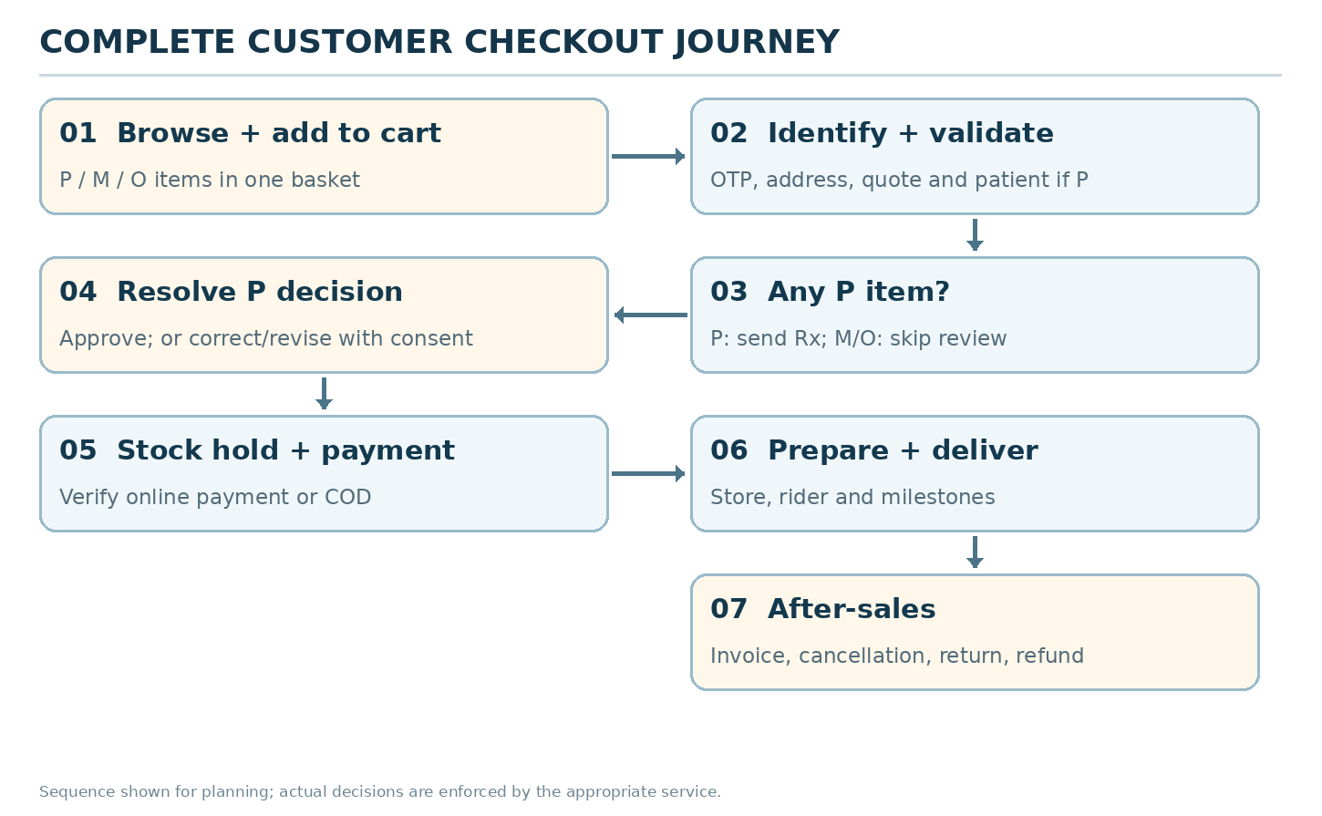
Figure 2. Customer order flow, including conditional P review and explicit revised-basket acceptance.
Step | Customer sees / does | Backend handoff / expected result
1. Browse & choose | Search/category results, pack, price, P badge if needed | Catalog supplies approved products; availability is location-specific and may be provisional.
2. Cart | Edit quantity, remove lines; P labels apply per item | Cart retains variants, quantities; changes invalidate earlier quote.
3. Sign-in & address | OTP, account, serviceable address; choose patient only with P | Identity authenticates; serviceability and selected patient are validated.
4. Final quote | Complete items and total, delivery charges and ETA | Checkout rechecks class, pricing, stock signal and location.
5. P branch | P: patient and Rx upload; M/O: skip | Order creates pharmacist task only for active P lines.
6. Decision | P approved: continue; unclear: correct; rejected: revise | Pharmacy owns decision; approved P needs matching patient/Rx/version.
7. Confirm changes | See exact removed P, retained M/O, revised amount | Customer explicitly accepts change before initiating payment.
8. Pay or COD | Stock temporarily held, online options or eligible COD | Payments verify server-side; COD eligibility checked; avoid duplicate attempts.
9. Prepare & deliver | Confirmed, packed, handed to rider, delivered | Inventory, store and delivery publish verified milestones.
10. After-sales | Order detail, cancel request, invoice, support, return/refund | OMS/finance decides eligibility; UI never promises completed refund early.

Seven basket combinations
Basket | Customer Rx step | Pharmacist task
O | No | No
M | No | No
M + O | No | No
P | Yes — for active P | Yes — P lines only
P + M | Yes — for active P | Yes — P lines only
P + O | Yes — for active P | Yes — P lines only
P + M + O | Yes — for active P | Yes — P lines only

05 | High-level functional components
Component | What it does | What it calls / needs
Storefront shell | Home, navigation, search input, location | Catalog/Search, serviceability
Cart experience | Guest/logged-in cart and item edits | Cart, catalog, price estimate, inventory hint
Identity & profile UX | OTP, saved addresses, family selection, consent | Identity and Customer services
Checkout coordinator | Checkout draft, quote, branch and review state | Checkout/OMS + clinical gate + stock/price
Payment result page | Shows pending/success/failure without guessing | Payment authority: verified state
Order hub | History, detail, tracking, notifications | OMS, fulfillment, logistics, finance
After-sales UX | Cancel, return, contact support | OMS, support, finance
Experience telemetry | Performance and business funnel diagnostics | Analytics events without Rx content

06 | Customer statuses and selection rules
A visible status is a read-only reflection of verified backend events. Customers do not choose “Packed” or “Delivered”. A single status can be current while a separate action (such as “Upload again”) is available. Admin filters are not customer actions.
Customer label | What it means | Possible next action
Awaiting your prescription | Order has active P requiring an uploaded Rx | Upload for selected patient
Prescription being reviewed | Pharmacist checks only P lines; no picking yet | Wait or open correction request
Action needed | Rx issue or revised basket awaits confirmation | Re-upload / accept new quote / cancel
Checking payment | Bank/gateway result still not verified | Do not pay again; refresh verification
Order confirmed | Pay/COD eligible; stock/store stage continuing | View order; ETA may still be updated
Preparing your order | Approved items are picked/checked | Track milestone
Out for delivery | Parcel handed to confirmed rider | Track ETA, prepare OTP/COD if applicable
Delivered | Verified handover complete | View invoice or report an issue
Refund in progress | Refund accepted but not yet confirmed as settled | View refund status; contact support

07 | Data and ownership mapping to supplied PostgreSQL
Existing DB tables | HLD usage / owner / caveat
identity.users; identity.otp_challenges; identity.sessions | Identity owns login and session; browser never writes OTP attempts directly.
customer.profiles; addresses; family_members; consents; preferences | Customer profile store; family member used to resolve patient for P; do not expose sensitive health details broadly.
customer.wishlists; wishlist_items | Wishlist support if launched.
commerce.carts; cart_items; checkouts | Cart and checkout snapshots; quote expiry and idempotency already represented.
commerce.orders; order_items; order_status_history | Order record plus detailed line history; do not derive P approvals from order-wide status only.
platform.idempotency_keys; outbox_events | Safe retries and downstream event publishing.
payment.*; logistics.*; finance.* | Read only via respective services; do not directly access from UI.

PROPOSED GAP The DB already stores order and prescription references, but clear item-level clinical decisions and order revision acceptance need design work. Treat these as dependencies on the Pharmacy/OMS design, not features already supported.

08 | Illustrative service contracts and handoffs
The following API routes are suggested contracts. They are NOT present in the uploaded database repository, which contains no HTTP API.
Use case | Suggested API (illustrative) | Important condition
Load home/search | GET /v1/catalog/products; GET /v1/search?q= | Public; server-safe filters and location context
Cart edit | GET/POST/PATCH /v1/carts/{id}/items | Idempotent item changes, quantity validation
OTP sign-in | POST /v1/auth/otp/send; /verify | Rate limits and expiry
My account | GET/PATCH /v1/me; GET/POST /v1/me/addresses | User-scope authorization
Start checkout | POST /v1/checkouts | Versioned final quote; idempotency key
Upload P Rx | POST /v1/prescriptions/uploads | Private upload session; patient association
Track approval | GET /v1/orders/{id}/clinical-status | Customer-safe summary only
Accept revision | POST /v1/orders/{id}/revisions/{version}/accept | Explicit consent and stale-version protection
Choose payment | POST /v1/orders/{id}/payment-attempts | Requires final eligible basket + short stock hold
Order list / detail | GET /v1/me/orders; GET /v1/me/orders/{id} | Current user owns order
Cancel / return | POST /v1/orders/{id}/cancellation-requests; /return-requests | Policy and stage checks

09 | Failure behavior customers can understand
Trigger | Customer message / action | System guarantee
Address unsupported | “We cannot deliver to this address.” Offer another address. | Do not promise based only on PIN code.
Product becomes P at checkout | “This medicine now requires a prescription.” | No bypass from cached catalog data.
P rejected in mixed basket | “These medicines cannot continue; your other items can.” | Retain M/O; accept new total before charging.
OTP unavailable | “Code delayed. Try again shortly.” | Rate limited retry, available fallback.
Stock lost before payment | “This item is no longer available.” | Do not collect for impossible quantity.
Bank debit but no confirmation | “Checking payment. Please do not pay again.” | Provider verification and exception queue.
Cancellation after pickup | “We’ll check the delivery stage and contact you.” | No impossible instant-cancel promise.
Wrong or unsafe medicine | “Please do not use this item. Contact support.” | Priority quality and clinical escalation.

10 | Security, privacy and reliability
- OTP and payment operations have rate limits, secure sessions, CSRF/origin checks as appropriate and server-owned authorization.
- Do not send prescription files or private medical text to analytics, search logs, public URLs or third-party error traces.
- Use request IDs, checkout idempotency, event trace IDs and clear audit history for order/quote/consent actions.
- Suggested launch targets for review (not promises): 99.9% customer-web monthly availability; customer browsing p95 API < 600 ms excluding upstream latency; resume interrupted checkout.
- Graceful degradation: if recommendations/search fail, categories can still load; if payment status is unclear, keep checkout pending rather than accepting another charge.
- Accessible forms, keyboard navigation, responsive widths, visible selection labels, plain-language customer messages.

11 | Delivery plan, verification and acceptance
Release slice | Outcome | Acceptance proof
C1 — identity, catalog display, cart | Browse, sign-in, edit cart, addresses | M/O cart never asks for patient or Rx; no lost cart after login
C2 — checkout + pharmacy bridge | Final quote and P branch | P-only and mixed basket correctly block; M/O bypass
C3 — payment and stock bridge | Safe order placement and receipt | Double taps and late webhooks do not double-charge
C4 — tracking and after-sales | Orders, milestone view, cancellation and support | Truthful statuses; correct refund path; no unauthorized order access

99 | Source basis, assumptions and sign-off
Source | How it was used
Pharmville_Complete_Order_Journey_Plain_English_v3.0.docx | Business rules, P/M/O journey, S01–S34 states, examples, edge cases, and customer wording.
heathcare_db.zip / app/models + PostgreSQL SQL | Table names, field coverage, constraints and migration/repository boundaries. Static inspection only.
Pharmville_Low_Level_Design_From_Journey_v3.0.docx | Architecture proposals and integration patterns; treated as design input, not as evidence of deployed services.

Evidence boundary: no deployed APIs, live database, regulatory approval, production traffic, or successful integration tests were supplied. Any API path, SLA, hosting choice or newly proposed table is a recommendation requiring validation.

Decisions to sign off
ID / decision | Owner / resolution
C-01 Stock hold + payment timing | Product + OMS + Finance — confirm policy, hold duration and failures.
C-02 Delivery promises & split shipments | Operations — validate one-location launch rule and ETA policy.
C-03 Family-patient ordering | Pharmacy + product — approve one P patient per order at launch.
C-04 Cancellation and return wording | Operations + Finance + Legal — approve stage-dependent rules.

Approval: Product Owner __________ Engineering Lead __________ Pharmacy Lead (if relevant) __________ Date __________

