PHARMVILLE | ARCHITECTURE SERIES

Product Catalog Platform
  - HLD 02 / Product master · search · listing · publishing

Document type | High-Level Design (HLD)
Version / date | v1.0 • 20 October 2026
Basis | Complete Order Journey v3.0 + heathcare_db.zip
Status | Proposed architecture for product, pharmacy and engineering sign-off

DESIGN ANCHOR The catalog decides what a product is. It must not independently decide how much stock is physically available or whether a specific patient may receive P medicine.

How to read this HLD
The main design explains responsibilities, handoffs, and business behavior. Interface and data tables then show how existing database structures support that design. “Existing” means observed in the uploaded database definition, not a running feature. “Proposed” means work to agree or implement.

Approval roles
Product Owner • Engineering Lead • Pharmacy Lead (where applicable) • Security/Privacy Lead • Operations Lead

01 | Executive summary and boundaries
The Product Catalog Platform is the authority for product identity, SKU/variant structure, description, manufacturer/brand, category, P/M/O business classification, publishability and search discoverability. It supplies the customer website, checkout and pharmacist workbench with consistent product facts. A product listing is not a promise that the store has stock, a special price, or clinical approval.
In scope | Owned elsewhere
Product records, variants, category tree, attributes, images and content | Customer cart and order line quantities
Search indexing, filters, synonyms and stable redirects | Actual stock, lot expiry and store assignment
Controlled P/M/O classification and admin publishing workflow | Pharmacist decision for a specific prescription/order
Versioned product changes with audit and downstream notifications | Final sell price, discounts and taxes (Pricing)
Visibility / delisting / recall content response | Recall hold enforcement at stock and order execution

02 | Core principles and product model
CONFIRMED RULE Every sellable item follows Pharmville’s P (prescription-required), M (medicine without Rx at standard checkout), or O (other) shopping behavior. P must never be silently downgraded to M/O to bypass review.

The uploaded schema currently uses product_type values medicine, otc, device, wellness, lab_test and service, and also includes a prescription_required boolean. This is not a single explicit P/M/O authority. A controlled mapping or a dedicated reviewed shopping_class is proposed; neither is confirmed implemented.
Concept | Meaning and rule
Product | Common identity and customer content; product.sku and display attributes in existing model.
Variant / sellable pack | Strength, dosage form, pack size, barcode and variant-specific details; exact SKU must be preserved.
P/M/O shopping class | A controlled, approved business value used by checkout; source of truth must be singular.
Regulatory constraints | Separate information on controlled status, age rules, cold chain and maximum order quantity; class alone is not full compliance.
Publication status | Draft/approved/published/blocked/discontinued lifecycle; do not confuse with in-stock/out-of-stock.
Search document | Rebuildable representation with synonyms, filters and searchable fields.
Product price / stock | Read-time overlays owned by Pricing and Inventory, not catalogue edits.

03 | Architecture and information flow
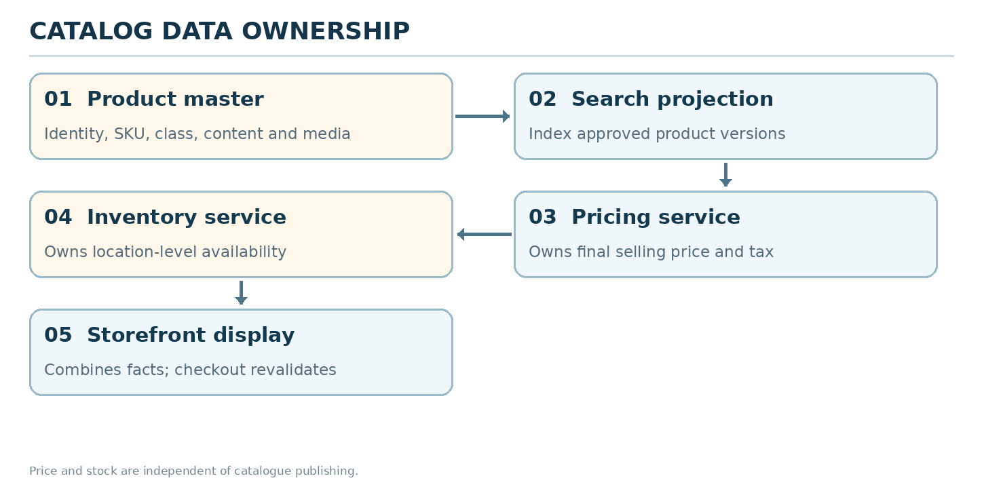
Figure 1. Catalog owns product facts; search is a projection; price and stock are independent authorities.
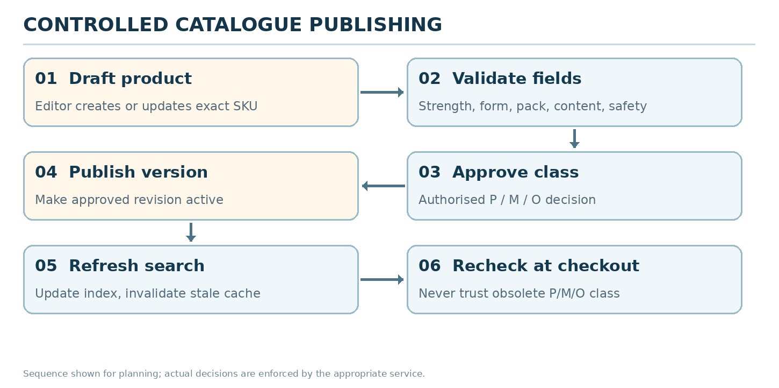
Figure 2. Suggested controlled draft-to-publish flow; publish and index are separate steps.
- Admin catalogue editor writes drafts. Regulatory/pharmacy-authorised approver signs off the shopping class and restricted flags. Publisher makes the approved version customer-visible.
- Publishing emits a product-change event. Index worker updates the search projection and clears customer-facing caches.
- Storefront compositions fetch published product facts, current pricing and location-level available stock from separate owners.
- If search is temporarily unavailable, the core catalogue can serve curated categories and exact SKU/product detail as fallback.

04 | Main catalogue workflows
Workflow | Steps and next outcome
Create a new product | Editor adds identity and product class candidate → variants/attributes → images/content → validation → required approval → publish → index.
Update product strength/pack | Create distinct sellable variant/SKU if necessary → review constraints → publish changed version. Do not mutate an in-flight order snapshot.
Change P/M/O class | Authorised change request with reason → clinical/regulatory sign-off → version/publish → emit update → checkout revalidates all stale carts.
Product becomes restricted/withdrawn | Block buy action immediately; remove stale results; send inventory and OMS safety-hold signals when relevant.
Search and filters | Normalize query/typos → synonym expansion → exact name/strength ranking → category/type/brand facets → location-aware availability hint.
Alternative suggestions | Show controlled informational products only; never silently replace prescribed P with similar active ingredients.
No images/content | Show neutral image placeholder and minimum product facts; publish-block essential missing safety fields.

05 | Search and discovery behavior
Search must prioritize exact name, ingredient, strength, form and pack. Typo tolerance is helpful, but results must never silently substitute a different strength or dosage form. Query data may contain sensitive medicine interests, so retention and privacy require review.
User intent | Expected UI / processing
Search by name or brand | Exact matches first, normalized aliases and typo suggestions next.
Search by salt/composition | Relevant composition results with distinct strength/pack clearly visible.
Filter by category or brand | Allow combining different filters; one or multiple values within a facet is a UX decision to specify.
Availability by PIN/address | Show “Available to check” or verified stock label only from Inventory/fulfilment location signal.
Discontinued or recalled item | No add-to-cart; route to safe information or support. Remove it from promotional suggestions.
No matches | Show suggestions or browse alternatives; never claim an unsafe automatic equivalent.

06 | Detailed data coverage from uploaded DB
Existing table(s) | Purpose and architecture note
catalog.categories; brands; manufacturers; salts; dosage_forms | Reference masters for taxonomy and precise item identity.
catalog.products; product_variants | Core SKUs, status, pack/strength; product_type+prescription_required need normalized P/M/O policy.
catalog.product_salts; product_attributes | Composition and attribute metadata; validate against staff-entered data.
catalog.product_regulatory | Storage requirements, controlled status, max quantity, age/cold-chain restrictions.
catalog.product_content; product_media; product_identifiers | Localized content, media metadata and barcodes; media bytes use file service.
catalog.substitution_groups; product_relationships | Existing related-product structures; not authorization for automatic P substitution.
pricing.product_prices; price_books; promotions; tax_rules | Price authority; catalog can display a price but should not own final quote.
search.documents; synonyms; redirects; indexing_jobs; query_events | Foundation for search index and query telemetry; implementation/search engine not provided.
platform.outbox_events; audit_logs | Event publication and review trail for sensitive classification change.

PROPOSED ADDITIONS Introduce one audited shopping-class policy for P/M/O plus class-effective timestamps, approval history and a clear stale-checkout invalidation rule. Prefer additive evolution and reuse product_regulatory and existing events before adding tables.

07 | Suggested interfaces and events
Suggested endpoints below describe future service interfaces, not existing DB-backed APIs.
Contract | Consumer | Checks / outcome
GET /v1/catalog/categories | Storefront | Only visible categories with defined sort order
GET /v1/catalog/products?filters= | Storefront | Paginated published products, safe filters and location hint
GET /v1/catalog/products/{slug} | Storefront / checkout | Current product revision, exact SKU/variant, class and restrictions
GET /v1/search?q= | Storefront | Ranked results, suggestions and pagination
POST /v1/admin/catalog/products | Catalog manager | Draft only; role-restricted
POST /v1/admin/catalog/products/{id}/submit | Catalog manager | Validates required fields and approval eligibility
POST /v1/admin/catalog/products/{id}/approve-class | Authorized reviewer | Records class and reason; maker-checker where required
POST /v1/admin/catalog/products/{id}/publish | Publisher | Published revision + event, no stale cached type
ProductPublished / ProductBlocked | Checkout, search, inventory consumers | Invalidate stale product data and prevent illegal fulfilment

08 | Data consistency, performance and resilience
- The catalog version/product revision is a stable part of an order-item snapshot; existing orders are never silently rewritten when product text or price changes.
- Checkout must read or revalidate authoritative shopping class; cached product cards are never sufficient to bypass P review.
- Search indexing is eventually consistent and rebuildable; publish confirmation and search refresh are distinct operations. Track search-index lag.
- Use cursor/page pagination, deterministic sorts, normalized query terms, content safe HTML sanitization, image optimization and CDN where appropriate.
- Suggested review targets (not tested): product detail p95 under 350 ms for cached reads; index update lag under 2 minutes in normal operation; 99.9% public catalog availability.
- Fallback: if price or availability services are down, show product facts and label price/stock “temporarily unavailable” rather than inventing values.

09 | Security, audit and quality controls
- Only staff with catalogue roles can create or modify products; class and restricted flag changes require explicitly authorised approval.
- Record before/after values, actor, reason, effective version and downstream event ID for publication/class changes.
- Strip HTML scripts and sanitize rich content; protect media upload path and reject malware/non-compliant assets.
- Apply safety and regulatory policy at publish and again at checkout; publishing status alone does not authorize dispensing.
- Rate-limit abusive search and bulk queries; collect privacy-aware search metrics without Rx attachments or patient details.

10 | Risk and edge-case design
Scenario | Required behavior | Owner
P product incorrectly marked M | Block order progression using reviewed class; quarantine issue and audit correction | Catalog + pharmacy
Class changes while customer checks out | Checkout refreshes class and requires Rx if it became P | Catalog + checkout
Product indexed after withdrawal | Buy remains disabled by authoritative catalog; urgently deindex | Catalog + search
Wrong strength in suggestion | Never autofill different variant into cart | Search + product
Media scan failed | Keep asset unpublished; use placeholder where appropriate | File / Catalog
Price and PDP disagree | Pricing returns authoritative amount; UI requests confirmation before paying | Pricing + checkout
Store stock stale | Do not display guaranteed availability without inventory confirmation | Inventory
Two editors publish conflicting versions | Use version checks and a clear publish owner | Catalog

11 | Implementation stages and acceptance criteria
Release | Deliverables | Acceptance
K1 — foundational records | Catalog CRUD, categories, SKUs, variants, content, media | Draft validations, exact variant identity, publish controls
K2 — classification safety | P/M/O policy and controlled approval | All seven basket combinations correct; stale cart revalidated
K3 — discovery | Search index, suggestions, filters, redirects | Accurate strength/form, no unsafe substitution; rebuild search
K4 — availability + rollout | Price/inventory overlays, alerts, indexing telemetry | Checkout does not trust stale cache; recall disables buying

99 | Source basis, assumptions and sign-off
Source | How it was used
Pharmville_Complete_Order_Journey_Plain_English_v3.0.docx | Business rules, P/M/O journey, S01–S34 states, examples, edge cases, and customer wording.
heathcare_db.zip / app/models + PostgreSQL SQL | Table names, field coverage, constraints and migration/repository boundaries. Static inspection only.
Pharmville_Low_Level_Design_From_Journey_v3.0.docx | Architecture proposals and integration patterns; treated as design input, not as evidence of deployed services.

Evidence boundary: no deployed APIs, live database, regulatory approval, production traffic, or successful integration tests were supplied. Any API path, SLA, hosting choice or newly proposed table is a recommendation requiring validation.

Decisions to sign off
ID / decision | Owner / resolution
K-01 Single authoritative P/M/O field | Catalog + pharmacy: mapping from existing product_type and prescription_required.
K-02 Approval workflow and reviewer roles | Pharmacy / legal / product: what types/flags need two-step sign-off.
K-03 Search engine and rollout size | Engineering / operations: query volume, indexing lag and fallback.
K-04 Alternate-product policy | Pharmacy + product: whether and how suggestions are allowed.
K-05 Regulatory content fields | Pharmacy + legal: required labels and publication restrictions.

Approval: Product Owner __________ Engineering Lead __________ Pharmacy Lead (if relevant) __________ Date __________

