PHARMVILLE | ARCHITECTURE SERIES

Pharmacy Platform
  - HLD 03 / Customer prescription upload · pharmacist verification

Document type | High-Level Design (HLD)
Version / date | v1.0 • 20 October 2026
Basis | Complete Order Journey v3.0 + heathcare_db.zip
Status | Proposed architecture for product, pharmacy and engineering sign-off

DESIGN ANCHOR Clinical review belongs to P items only. The order proceeds only when each retained P line has a current, correct approval; M/O remain outside the review decision.

How to read this HLD
The main design explains responsibilities, handoffs, and business behavior. Interface and data tables then show how existing database structures support that design. “Existing” means observed in the uploaded database definition, not a running feature. “Proposed” means work to agree or implement.

Approval roles
Product Owner • Engineering Lead • Pharmacy Lead (where applicable) • Security/Privacy Lead • Operations Lead

01 | Objective, modules and ownership
Pharmacy Platform connects the patient-facing upload flow with a restricted pharmacist workbench. Its central responsibility is to decide whether each active P order item has adequate prescription evidence, then provide a reliable decision to Order Management. The platform is not a general diagnostic service or doctor-consultation product.
Included | Outside its authority
P-trigger test and patient selection requirement | General M/O checkout and normal inventory selection
Secure Rx upload/validation, document version and linkage | Public storage, search engine indexing, product master classification changes
Queue and pharmacist review of ordered P lines | Gateway payments and refunds
Approve/reject/correction per P line and reason | Automatic substitute product choice or delivery assignment
Audit, privacy and order-gate result | Dispensing/physical packing checks at store (separate SOP)

CRITICAL INVARIANT No active P line can move to picking without a current approved decision linked to the same patient, exact product/variant, quantity and prescription version. No M/O-only basket creates a pharmacist-review task.

02 | User roles and privacy boundaries
Actor | Can do | Cannot do
Customer / caregiver | Attach Rx for selected patient; view reason and correction request | Approve own prescription or see staff/private clinical notes
Verified pharmacist | See assigned P case, Rx image and P lines; approve/reject/correct with reason | Change M/O eligibility or bypass patient linkage
Pharmacy supervisor | Reassign workload, investigate audit and authorise qualified re-review | Remove clinical rejection without qualified documented decision
Support staff | See safe status/reason category and help with upload | Download all Rx documents or override clinical decisions
Order/checkout service | Create only required tasks; wait for reviewed outcome | Interpret Rx text as clinical decision

03 | High-level pharmacy architecture
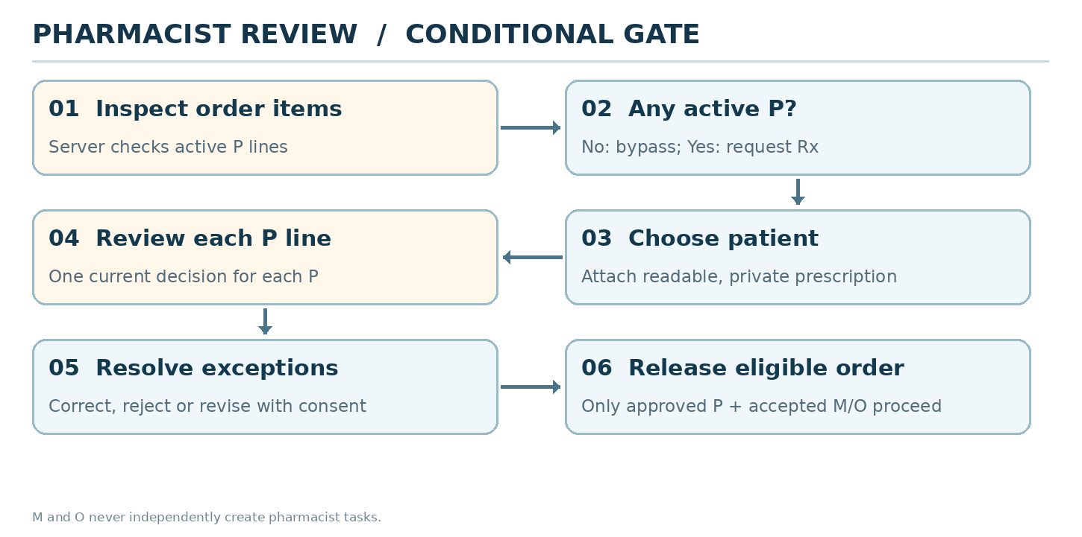
Figure 1. Only active P lines enter the review branch; correction and rejection require explicit next actions.
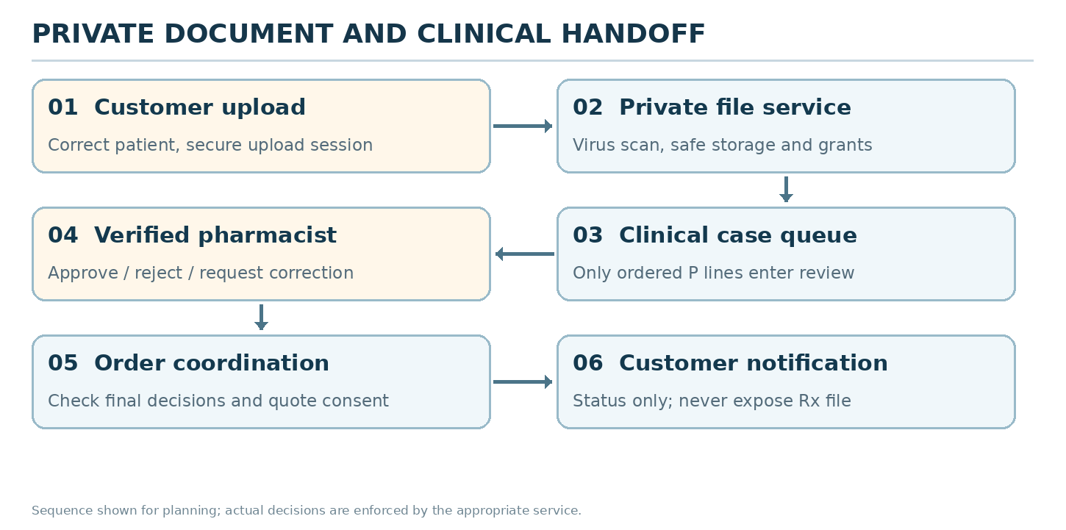
Figure 2. Customer upload, private document handling, pharmacist decision and order handoff.
- Private file service receives uploads, verifies type/size, scans content and grants expiring access only to authorised reviewers.
- Clinical case service stores the patient association, Rx version, P-line list and pharmacist outcome with full actor/audit context.
- Review workbench shows Rx beside exact product, strength, form, quantity and patient; saves per-item decisions, not order-wide blind approval.
- Order orchestration verifies the approved version and builds a customer-approved revised basket if any P items are rejected; payments start only after clinical resolution under the recommended policy.
- Notification service sends secure links and safe status copy; never places prescription files or diagnoses in message text.

04 | Complete clinical journey — normal and exception flows
Stage | What the customer / pharmacist does | Outcome
1. P check | Checkout checks active lines; M/O-only skips clinical service | No P -> NOT_REQUIRED; P -> Rx requirement
2. Patient | Customer chooses self or family member for P | Correct patient is bound; different P patients split into orders at launch (proposal)
3. Upload | Customer uploads photo/PDF and previews it | Private file created; validated/scan status recorded
4. Submit | Order request created once with attached Rx version | One active review task per required request/version (proposal)
5. Review | Pharmacist inspects document and P lines only | Approve each P; reject with reason; request clearer Rx if needed
6a. All approved | Customer notified of approval | Clinical gate APPROVED; proceed toward final quote/payment
6b. Action required | Customer sees specific correction request | Upload new version; review previous decision cannot be silently reused
6c. Partial/rejected | Show rejected P lines; M/O retained unchanged | Reprice changed basket; customer accepts, retries Rx or cancels
7. Final release | Backend rechecks decision matches patient, SKU and version | Only accepted eligible lines continue; no unreviewed P picking

05 | Classification, decision and selection rules
Order combination | Upload required? | Pharmacist outcome
O | No | No review task; no pharmacist selection
M | No | No review task; no pharmacist selection
M + O | No | No review task; no pharmacist selection
P | Yes, P only | Choose exactly one outcome for EACH active P item
P + M | Yes, P only | Choose exactly one outcome for EACH active P item
P + O | Yes, P only | Choose exactly one outcome for EACH active P item
P + M + O | Yes, P only | Choose exactly one outcome for EACH active P item

Pharmacist review is not one “Approved/Rejected” choice for the whole mixed basket. Each ordered P line has exactly one current outcome: Approved, Correction required, or Rejected (subject to approved pharmacy SOP). Multiple P items may receive different outcomes. M/O are displayed, at most, as context and have no clinical decision controls.

What is a sequence versus a choice?
- Upload → scanning → waiting → pharmacist decision is a sequence of stages, not a multi-select checklist.
- For EACH P item, pharmacist selects exactly one current decision. Different P items can be approved/rejected differently.
- When a revision is presented, customer chooses ONE next action: accept revised eligible basket, provide a new Rx, or cancel. Do not silently select on their behalf.
- Customer-facing “Under review”, “Action needed” and “Approved” are read-only statuses. They are never buttons the customer selects.

06 | Core data: what exists and what is proposed
Existing records | Evidence and limitation
clinical.patient_profiles; customer.family_members | Patient identity is represented; family linkage must be verified and scoped to logged-in caregiver.
clinical.prescriptions | Contains patient_profile_id, status, uploaded_by_user_id, reviewed_by_user_id, reviewed_at and review_notes.
clinical.prescription_documents | Links prescription record to private file_object.
clinical.prescription_items | Lists medicines/dosage and review_status; not clearly connected to a specific commerce.order_items row.
platform.file_objects; file_upload_sessions; file_scan_events; file_access_grants | Upload, scan and access-control structures already exist.
clinical.prescription_access_logs | Actor/purpose/request audit foundation for Rx reading.
commerce.order_items.prescription_id; commerce.orders.prescription_status | Useful linkage and overall status, but not sufficient by itself for durable per-order-P-line decisions.
identity.roles; permissions; practitioner_profiles | Staff roles and pharmacist identity/verification represented; enforcement must be implemented.

PROPOSED SCHEMA/WORKFLOW GAP Introduce an order-scoped clinical review case with a revision, and immutable per-order-P-line decision records that link order_item_id, patient_profile_id, exact SKU/quantity, Rx version, reviewer, outcome, reason and time. Confirm whether existing prescription_items can be safely extended before adding new tables.

07 | High-level APIs and events
All paths are illustrative design contracts. The archive is a database definition and does not provide implemented web APIs.
Contract | Purpose / safeguard
POST /v1/prescriptions/upload-sessions | Request private upload only for an authenticated user and eligible patient.
POST /v1/prescriptions/upload-sessions/{id}/complete | Scan and validate upload; attach to correct patient and version.
POST /v1/orders/{id}/clinical-submit | Idempotently open P review only when active P lines exist.
GET /v1/me/orders/{id}/clinical-status | Customer-safe current status and required action, no internal notes.
GET /v1/pharmacy/review-queue | Authorised pharmacist queue; filters do not change clinical state.
GET /v1/pharmacy/reviews/{caseId} | Restricted Rx document, patient and exact P lines.
POST /v1/pharmacy/reviews/{caseId}/decisions | Per-P choices, reason, reviewer identity; optimistic concurrency.
POST /v1/orders/{id}/revisions/{v}/accept | Customer confirms revised lines and final amount.
ClinicalReviewRequired / ClinicalDecisionRecorded / PrescriptionCorrectionRequested | Proposed durable events with case/version/order identity; notifications downstream.

08 | Safety checks and order-gate contract
Validation before release | If it fails
At least one active P exists for clinical-review task | Do not create a task for M/O-only basket; audit accidental queue entry.
Correct patient for all included P lines | Return to patient choice / new Rx association.
Readable, scanned, permitted file available | Remain awaiting correction; never release affected P.
Review outcome for each active P line | Remain blocked for pending P lines.
Decision matches exact SKU/variant, quantity, patient, Rx version | Invalidate stale approval and send impacted P line to new review.
No blocked/withdrawn product or safety hold | Keep clinical and fulfilment hold; escalate.
Changed quote explicitly accepted | Do not initiate payment or packing for altered basket.
Pharmacist reviewer actively authorised | Do not accept unverified/stale/suspended reviewer decision.

09 | Exception behavior and support messages
Trigger | Customer sees | Backend / staff response
File unreadable | “Please upload a clearer prescription image.” | Re-upload new document version; M/O remain intact.
Wrong patient | “This prescription does not match the selected patient.” | Correct patient and restart affected P review.
Partial P approval | “Some medicines need changes. Review your updated order.” | Keep approved P and M/O; request customer confirmation.
All P rejected | “Prescription cannot be accepted for these items.” | P-only: re-upload or cancel. Mixed: offer M/O-only continuation.
Customer disappears | “Your prescription needs attention before [deadline].” | Policy-based reminders; no automatic charge; expiry requires approval.
Two pharmacists click Save | Second reviewer sees “This case has already changed.” | One accepted decision per version; preserve audit.
Approved P modified later | “We need to check the updated medicine.” | Invalidate approval for affected line only; protect other decisions.
Document leaked link attempt | No document shown to unauthorised user | Deny, audit, alert on suspicious activity.

10 | Non-functional, compliance and operations
- Privacy-by-default: clinical documents are private and encrypted as appropriate; access is purposeful and logged; expiring file URLs and least-privilege staff roles.
- India-specific prescribing, dispensing, record retention and pharmacist eligibility require review by an authorised legal/pharmacy compliance lead before go-live. Software classification is not a substitute for dispensing obligations.
- Processing targets to agree (not measured): upload progress feedback within 1 second, review queue refresh within 30 seconds, review SLA controlled by staffing and configurable policy.
- Avoid storing Rx image bytes in database tables and avoid message attachments for ordinary status notifications.
- Queue failure should preserve durable review requests, retry safely and alert operations; never bypass P gate because a worker or reviewer console is down.
- Capture metrics: waiting review cases, oldest case age, correction rate, partial rejection, stale decision blocks, unauthorised access denials, scan failures.
- Deploy feature flags carefully: rollout first to test pharmacists and one store; verify no M/O tasks before expansion.

11 | Delivery milestones and acceptance gates
Slice | Scope | Pass criteria
P1 — secure upload | Patient selection, file service, scanner, private preview | Wrong-user/wrong-patient access blocked; file scan failures handled.
P2 — review queue | Task creation, line-by-line decisions, audit | M/O queue = 0; exactly one current decision for each P line.
P3 — order handoff | Revision consent, gate enforcement, notifications | Rejected P cannot be picked; M/O survive partial rejection.
P4 — recovery/operations | Expiry policy, second reviewer, safety holds, metrics | Duplicate decisions safe; new version forces re-review; cancellation respected.

99 | Source basis, assumptions and sign-off
Source | How it was used
Pharmville_Complete_Order_Journey_Plain_English_v3.0.docx | Business rules, P/M/O journey, S01–S34 states, examples, edge cases, and customer wording.
heathcare_db.zip / app/models + PostgreSQL SQL | Table names, field coverage, constraints and migration/repository boundaries. Static inspection only.
Pharmville_Low_Level_Design_From_Journey_v3.0.docx | Architecture proposals and integration patterns; treated as design input, not as evidence of deployed services.

Evidence boundary: no deployed APIs, live database, regulatory approval, production traffic, or successful integration tests were supplied. Any API path, SLA, hosting choice or newly proposed table is a recommendation requiring validation.

Decisions to sign off
ID / decision | Owner / resolution
P-01 Approved prescribing SOP | Pharmacy lead + legal: valid Rx criteria, rejection reasons, qualification.
P-02 Review deadline and reminders | Product + pharmacy + operations: fixed or configurable response window.
P-03 P-item review decision data design | Engineering + pharmacy: order-item links, revision, reviewer signatures.
P-04 Different patients in one basket | Product + pharmacy: launch rule for splitting orders.
P-05 Refund/payment timing | Finance + product: confirm after-approval payment recommendation.
P-06 Document retention and customer consent | Privacy/legal: purpose, retention, deletion and support visibility.

Approval: Product Owner __________ Engineering Lead __________ Pharmacy Lead (if relevant) __________ Date __________

