**Assignment 2 Physics Report**

Shila Das -101141958

**Question**: Consider a metal loot crate, at the top of a frictionless ramp. If the mass of the loot crate is 12.8kg and the ramp has a rise of 3m and a run of 4m, then compute the following.

1. Compute the **free body diagram** of the loot crate a time 0. (i.e. when the loot crate is at the top of the ramp.)

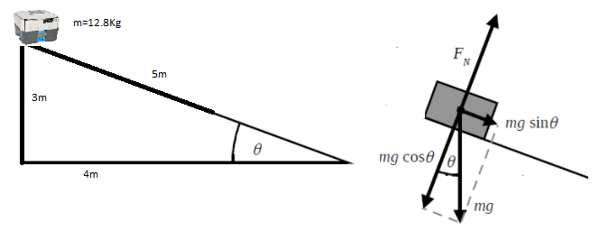

Fig: object in ramp Free body diagram

Length of incline, l= $\sqrt{3^{2}+4^{2}}$ =5 m

$\cos{θ}={\frac{4}{5}}$ and $\sin{θ}={\frac{3}{5}}$

Here m=12.8Kg g=9.8m/s2

1. Compute the **net force** and the **acceleration** of the loot crate at time 0. Given the frictionless surface what do we know about the acceleration as the object moves down the ramp?

Net force down the incline, $\sum{F_{x}}$ = $mg\sin{θ}=12.8*9.8*\frac{3}{5}=75.264$ N

Now acceleration, a= $\frac{\sum{F_{x}}}{m}=\frac{75.264}{12.8}=5.88$

This acceleration is constant and down the incline and the crate increases speed as its move to the down of incline.

1. Consider the loot crate as it leaves the ramp and moves onto a at surface that now has some friction. Compute the **free body diagram** for this situation. If coefficient of kinetic friction is 0.42 (steel on steel), calculate the new **net force** and acceleration.

As, the loot crate is not in a ramp now, the only gravity force is active here

F= m g=12.8*9.8=125.44 N

f = $μ_{k}N$ =0.42*125.44 =52.68 N

Now acceleration when not in ramp, m/s2

Here force work to the left, as a result acceleration also work to the left direction

1. If we assume that the force of friction is **constant** after this point, how long will it take for the loot crate to stop moving? At what distance in meters will the loot crate stop?

we know

$$\frac{1}{2}m{v_{i}}^{2}=mgh$$

$${v_{i}}^{2}=2gh$$

$$v_{i}=\sqrt{2gh}=\sqrt{2*9.8*3}=7.668$$

From the equations of kinematics, we know,

$$v_{f}=v_{i}+a_{1}t$$

And acceleration is in left direction so $a_{1}=-4.11m/s^{2}$

$$t=\frac{v_{f}-v_{i}}{a_{1}}=\frac{0-7.668}{-4.11}=1.86657 s$$

And $v_{f}^{2}=v_{i}^{2}+2a_{1}d$

So, $d=\frac{v_{f}^{2}-v_{i}^{2}}{2a_{1}}=\frac{0^{2}-{7.668}^{2}}{2(-4.11)}=7.153 m$