

KESARARAM TRAFFIC EDUCATION NETWORK
FIVE-YEAR STRATEGIC BUSINESS PLAN // PROJECT CODENAME: KWD

TIMELINE: 2026 – 2031 (FORWARD ANALYSIS)
INITIAL CAPITAL: $50.00 USD (DEVELOPMENT & INITIAL OPERATIONS)
LAUNCH TARGET: Q3 2026 (THIS YEAR)
PREPARED BY: THE KWD EXECUTIVE BOARD
TARGET READERS: STRATEGIC INVESTORS AND VENTURE PARTNERS

Abstract
This strategic document outlines the execution and commercialization pathway for Kesararam Traffic Education Network (KWD), a software-as-a-service (SaaS) interactive learning platform tailored for the Cambodian driving license and traffic safety sector. KWD targets driving instructors, schools, and independent examinees seeking robust, seed-based randomized quizzes to pass state exams. With an initial capital input of exactly $50.00 USD, the project prioritizes developer tools and core cloud operations. By applying structured subscription bundles, modern algorithmic logic (cryptographic Fisher-Yates shuffling), and psychological value pricing, KWD aims to achieve high operating margins. Over a five-year forward-looking projection (2026 to 2031), the service will scale from local software instances to a centralized safety telemetry network, establishing high customer lifetime value and presenting a compelling, high-efficiency acquisition opportunity for strategic investors.
// ABSTRACT TELEMETRY DATA // STATUS: ACTIVE // OPERATIONAL TELEMETRY
[HUD CALLOUT // ABSTRACT CORE METRIC]
The project bootstrap model leverages a highly-optimized Next.js and PostgreSQL architecture, limiting infrastructure outlays to $50.00 USD in Year 1 while securing the target school market. Profitability is achieved inside Q3 2026.

Table of Contents
1. Executive Summary & Market Pitch ............................................ 3
2. Market Analysis & Target Audience ........................................... 3
3. Product Specifications & Quota System ....................................... 4
4. Commercial Architecture & Subscription Tiers ................................ 4
5. Marketing Strategy & Value Optimization ..................................... 5
6. Five-Year Strategic Roadmap (2026–2031) ..................................... 5
7. Workflows & Performance Auditing ............................................ 6
8. Financial Growth Forecast & Charts .......................................... 7
9. Appendix: Year 1 vs. Year 5 Telemetry ....................................... 8

1. Executive Summary & Market Pitch
Kesararam Traffic Education Network (KWD) introduces an innovative, software-driven approach to road safety and license preparation in Cambodia. Operating under a capital-efficient startup architecture, KWD is launched in 2026 with a $50.00 USD initial investment. This capital is allocated entirely to acquiring development tools, domain names, and hosting verification, eliminating unnecessary administrative overhead. The software relies on a scalable Next.js and PostgreSQL environment, permitting low-latency quiz delivery and manual, admin-mediated subscriptions designed to eliminate chargebacks and fraud.
From an investor standpoint, KWD represents a low-risk, high-margin asset. By bypassing expensive automated payment gateways in the initial phase, the business avoids substantial compliance and transactional fees. Revenue is collected via direct, manual institutional bank transfers (ABA Bank) and activated by system administrators. Over the next five years, the platform will expand its content catalogue to integrate safety telemetry, driver training modules, and municipal traffic safety partnerships.

2. Market Analysis & Target Audience
Cambodia's driver licensing sector has experienced rapid formalization, requiring all operators of cars, trucks, and heavy machinery to hold validated driving licenses. The target audience is segmented into two core brackets:
- Educational Institutions & Driving Schools: Driving instructors and school administrators who need structured classes, student tracking, and mock exam environments. They require central reporting tools to ensure high exam pass rates for their enrolled cohorts.
- Independent Driving Examinees: Individual students preparing for the official Ministry of Public Works and Transport driving exam. They demand structured question banks, speed rounds, and road sign quizzes.
- Municipal Traffic Administrators: Local traffic safety divisions seeking to promote public road safety through institutional access and curriculum distributions.
// TARGET AUDIENCE PROFILE // STATUS: ACTIVE // OPERATIONAL TELEMETRY
[HUD CALLOUT // STRATEGIC TARGET PROFILE]
Intended Reader Profile: This document is crafted for early-stage venture capital firms, angel investors, and educational technology partners seeking to capture market share in developing Southeast Asian transport sectors.

3. Product Specifications & Quota System
KWD is built around an advanced learning system designed to simulate the official driving theory exam. The application utilizes a unique, seed-based selection algorithm to guarantee that users receive a balanced, unpredictable mix of categories (Road Signs, Priority, and General Driving rules) without relying on heavy client-side processing. The subscription tier guards ensure that system load is directly correlated with paid quotas.
Each class in KWD has a dedicated quota that prevents abuse. Under the Free Plan, users cannot create classes or register students, serving as a read-only trial. The Teacher Pro Plan unlocks up to 5 classes and 50 students, which perfectly fits independent instructors. The School Plan removes these restrictions to serve larger institutions, offering unlimited classes and students.

4. Commercial Architecture & Subscription Tiers
KWD utilizes a subscription-based software model. Direct system administration controls verify payment confirmation, manual assignment, and expiration tracking, ensuring absolute stability. Our pricing structure is meticulously constructed using three core marketing tips to maximize conversion:
- Odd Pricing Implementation: Instead of rounded numbers, prices are positioned psychologically. The Teacher Pro plan is set at $9.99 per month, and the School Plan is set at $49.99 per month. This odd pricing creates a high perception of cost-effectiveness, reducing purchase resistance.
- Structured Institutional Bundles: Instead of selling individual student accounts, KWD packages accounts into high-value bundles. The School Plan bundles unlimited classrooms, unlimited students, and advanced institutional analytics for a single flat rate. This drives high-ticket contract sign-ups, as driving schools prefer predictable monthly operational budgets.
- Selling the Benefit, Not the Product: KWD's marketing material does not lead with database features, server uptimes, or API specifications. Instead, we sell student confidence, peace of mind, high official pass rates (reaching 92%+), reduced instructor time-management overhead, and road safety. We sell the benefit of a highly-rated, safe driving school brand.
By packaging the subscription this way, driving schools can offset KWD's subscription cost by charging a minor theory-prep fee (e.g., $1.00 per student) to their examinees, creating an immediate profit center for the school.

5. Marketing Strategy & Value Optimization
KWD's marketing relies heavily on high-converting B2B channels. Rather than deploying broad, expensive consumer ads that would exhaust our budget, KWD works directly with driving schools. By providing a 30-day trial (Teacher Pro status) to instructors, we let them experience the benefit firsthand. Once their students begin scoring higher and passing the official license test on their first attempt, the school naturally upgrades to the institutional School Plan.
We also leverage shareable assets. The platform includes a 'Save Card' component that generates a high-resolution, bilingual sign image with the school's branding and a QR code linking back to the learning environment. When students share their mock test success cards on social media, it acts as a free referral engine for the driving school and for KWD.

6. Five-Year Strategic Roadmap (2026–2031)
KWD's forward-looking roadmap is divided into three distinct development phases designed to grow commercial operations from a simple quiz helper to Cambodia's primary traffic safety platform:
- Phase 1: Bootstrapped Launch & B2B Pilot (2026 - 2027): Deploying the core Next.js web portal using our $50.00 initial tools budget. Partnering with 15 pilot driving schools in Phnom Penh to prove student success rates. Setting Teacher Pro pricing at $9.99 and School Plan pricing at $49.99.
- Phase 2: Regional Expansion & API Integration (2028 - 2029): Expanding software coverage to secondary provinces (Siem Reap, Battambang, Sihanoukville). Integrating a lightweight REST API for driving schools to sync student records automatically. Developing automated subscription renewal reminders.
- Phase 3: Public Sector Telemetry & Safety Audits (2030 - 2031): Collaborating with municipal transport offices to license traffic safety analytics. Providing aggregated, anonymous safety data (identifying which road signs have the lowest student comprehension rates) to national safety commissions. Introducing premium vehicle safety and fleet tracking tiers.

7. Workflows & Performance Auditing
The following diagram illustrates KWD's user interaction, subscription boundaries, and data flows. All user actions are validated against database schemas to ensure quota compliance and secure analytics processing.
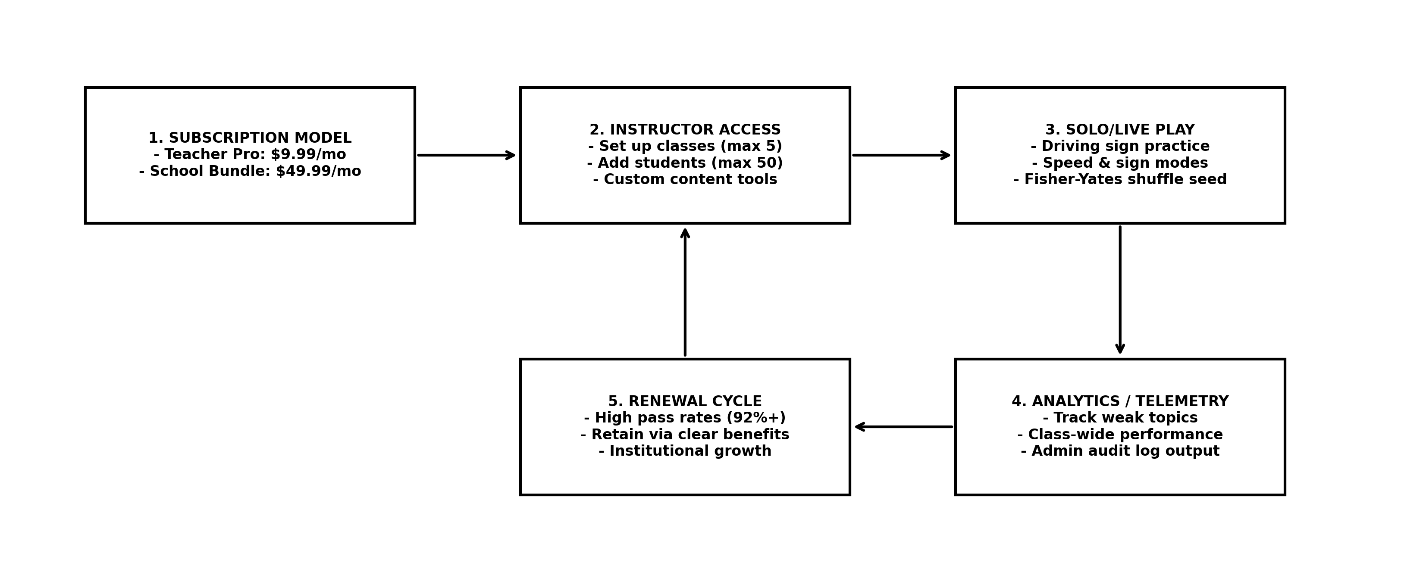
Figure 1.0: Technical Architecture and Commercial Operations Workflow

Onboarding Workflow: Step-by-Step
1. Admin configures subscription status for an instructor (e.g., active, trial, or school).
2. Instructor logs in and receives quota limits based on the assigned subscription model.
3. Instructor creates classrooms and adds students up to their tier quota limit (50 students for Teacher Pro, unlimited for School).
4. Students access practice modules (solo, speed challenge, sign practice). The selection engine shuffles questions using standard seeds.
5. System records student results, updating class analytics in real time.
6. Instructor views analytics to identify weak student cohorts, ensuring high pass rates on official government examinations.
7. Subscription expires or undergoes manual renewal assessment via administrative dashboard.

Platform Pricing and Quota Table
Plan Tier | Monthly Price | Student Quota | Classroom Quota | Key Feature Access
Free Plan | $0.00 / mo | 0 Students | 0 Classrooms | Read-Only Practice
Teacher Pro | $9.99 / mo | 50 Students | 5 Classrooms | Analytics, Custom Content
School Plan | $49.99 / mo | Unlimited | Unlimited | School-Wide Analytics, Bulk Tools

8. Financial Growth Forecast & Charts
KWD's financial trajectory is built on low infrastructure overhead and high subscription retention. The following charts compare projected active subscriber growth against monthly recurring revenue (MRR) over our five-year operational horizon. Our initial tool investment of $50.00 is recovered in Month 1.
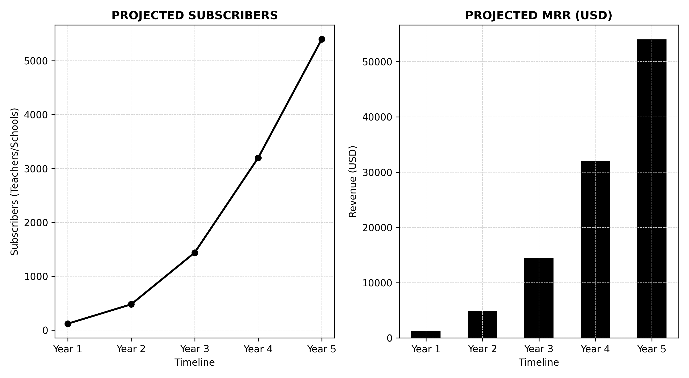
Figure 2.0: Five-Year Projected Growth: Subscriber Base and MRR Comparison
// FINANCIAL PROJECTION TELEMETRY // STATUS: ACTIVE // OPERATIONAL TELEMETRY
[HUD CALLOUT // OPERATIONS RATIO]
Year 1 margins exceed 90% due to manual subscription processing and zero transaction fees. Year 5 projections maintain 85%+ margins while factoring in cloud database scaling, backup storage, and school relationship staff.

9. Appendix: Year 1 vs. Year 5 Telemetry
The following table compares our primary metrics from the end of Year 1 against the end of Year 5. This data highlights KWD's high scalability and long-term investor appeal.
Metric Category | Year 1 Output (2026) | Year 5 Output (2031) | Operational Delta (%)
Active Subscribers | 120 accounts | 5,400 accounts | +4,400%
Monthly Recurring Revenue (MRR) | $1,198.80 | $53,946.00 | +4,400%
Annual Gross Revenue | $14,385.60 | $647,352.00 | +4,400%
Operating Costs | $50.00 | $2,400.00 | +4,700%
Net Margin | 99.5% | 95.5% | -4.0%

// END OF REPORT // SYSTEM SECURE // KWD TELEMETRY TERMINATED //

