Practical - 4
Practical Title: 4: JavaScript DOM Manipulation, Event Handling, and UI Interactivity

Problem Definition: Add dynamic UI components such as collapsible FAQ, modal popup,image/content slider, notification banner, hamburger menu, and light/dark

theme switcher using JavaScript.

A. Theory
1. How are DOM elements selected and modified?
ANSWER:
Common methods are:
- document.getElementById("id") → selects an element using its ID.
- document.querySelector("selector") → selects the first element matching a CSS selector.
- document.querySelectorAll("selector") → selects multiple matching elements.
After selecting an element, JavaScript can modify it using properties such as:
- .textContent → changes text.
- .style → changes CSS styles.
- .classList.add() → adds a CSS class.
- .classList.remove() → removes a CSS class.
- .classList.toggle() → adds/removes a class depending on its current state.
- .classList.contains() → checks whether an element has a particular class.

2. Are event listeners attached correctly?
ANSWER:
Yes, event listeners should be attached to the elements that the user interacts with.
The most common and used method is:
element.addEventListener("click", function() {
// code to execute
});

3. Is localStorage used for remembering theme choice?
ANSWER:
Yes. localStorage can be used to remember whether the user selected light or dark mode.
For example:
localStorage.setItem("theme", "dark");
This saves the user's theme preference in the browser.

4. Does interactivity improve usability without breaking accessibility?
ANSWER:
Yes, if the interactive components are implemented properly.
Modal popup → displays additional information without leaving the page.
Light/dark theme → allows users to choose a comfortable viewing mode.
However, interactivity should not depend only on visual effects or mouse clicks.
For accessibility:
- Buttons should be actual <button> elements where appropriate.

Implementation/ Output/Result:

Evidence of Work (Screenshots):

The LIGHT mode for LOGIN PAGE:
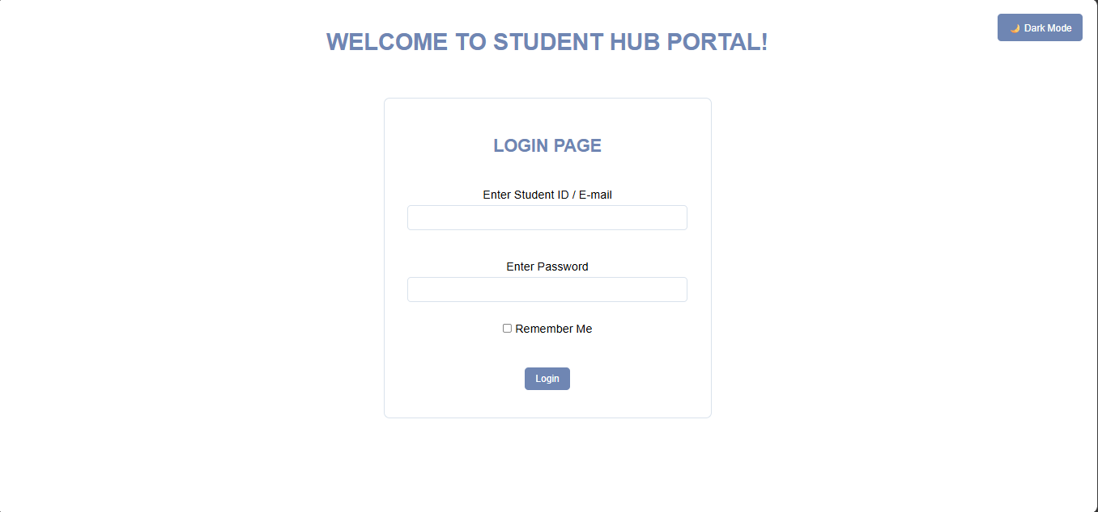

The DARK MODE for LOGIN PAGE:
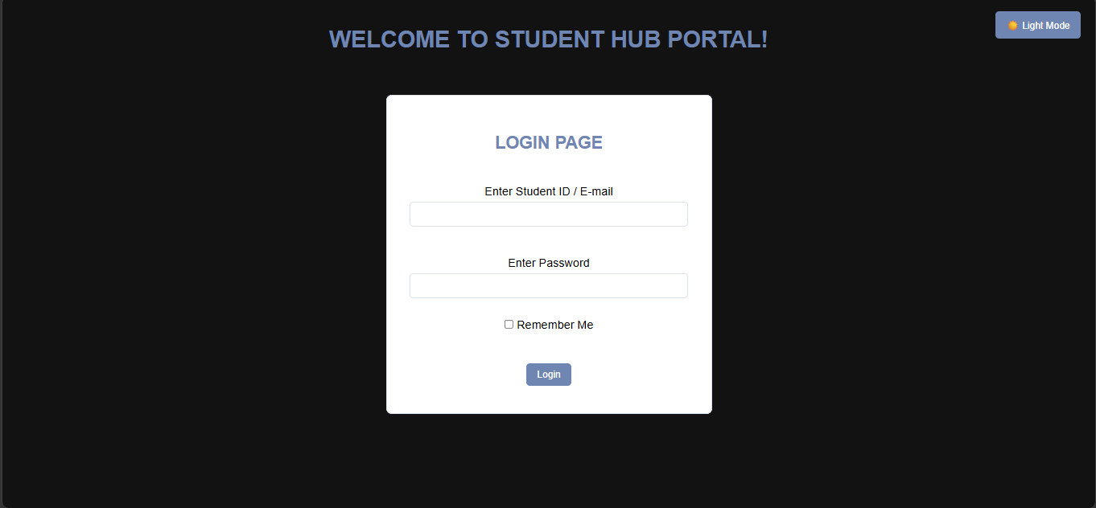

Pop-up message and red border line for empty field of PASSWORD.
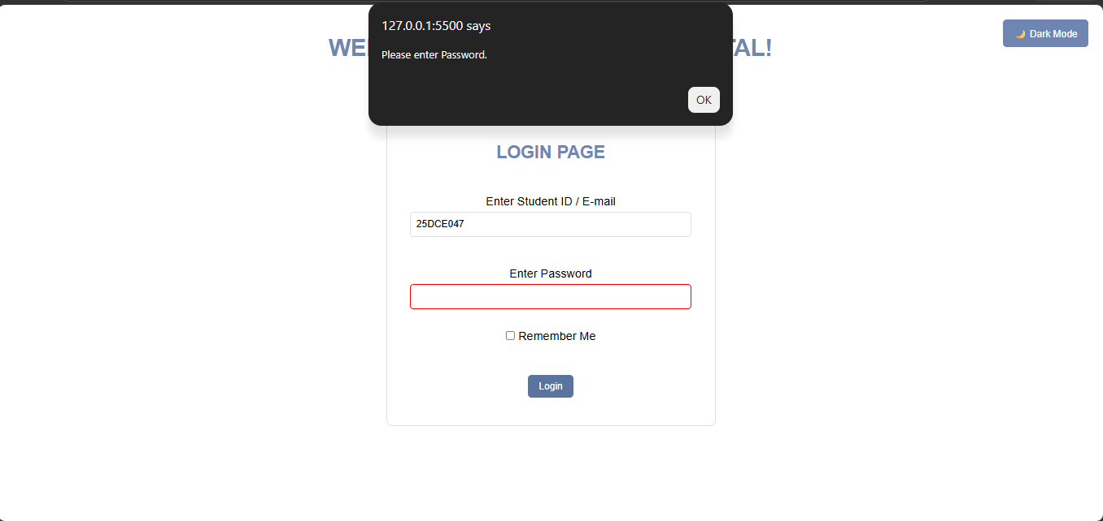

Pop-up message and red border line for empty field of USERNAME.
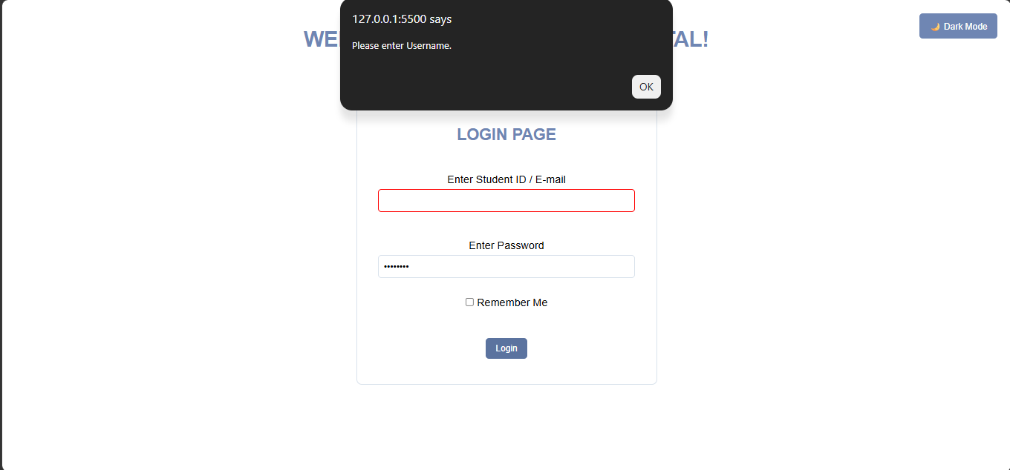

Added that PASSWORD should contain atleast 6 characters.
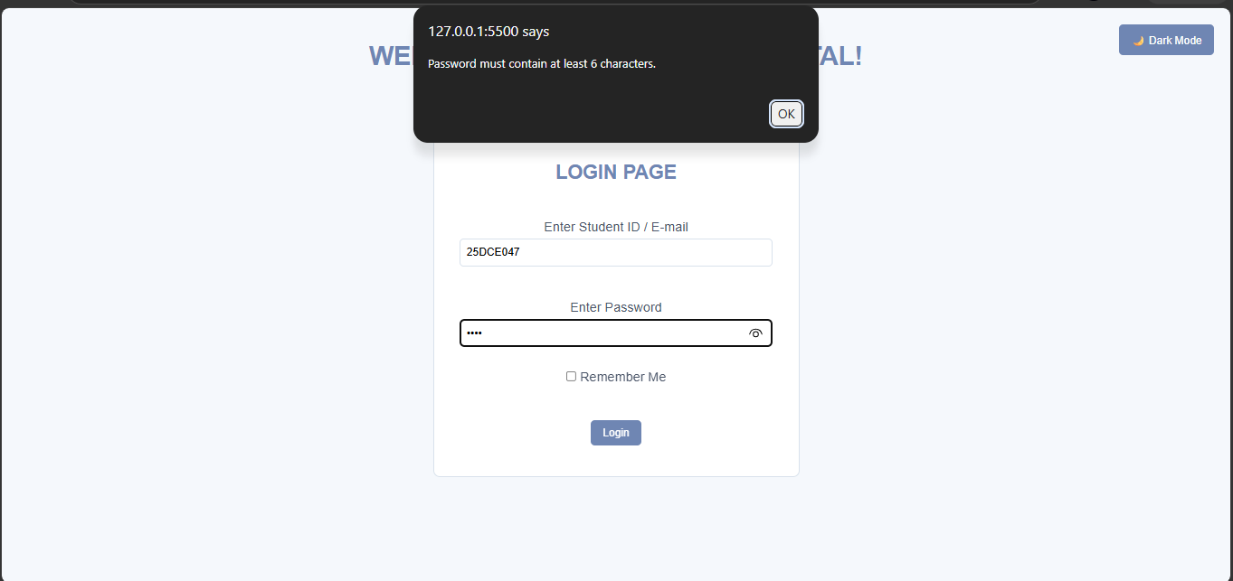

Finally, LOGIN Successful.
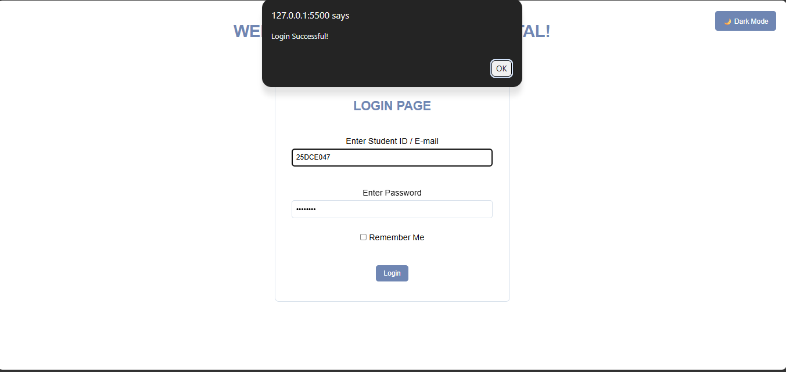

GitHub Repository Link:

https://github.com/shiloni28/WDF.git

E.Challenges Faced:

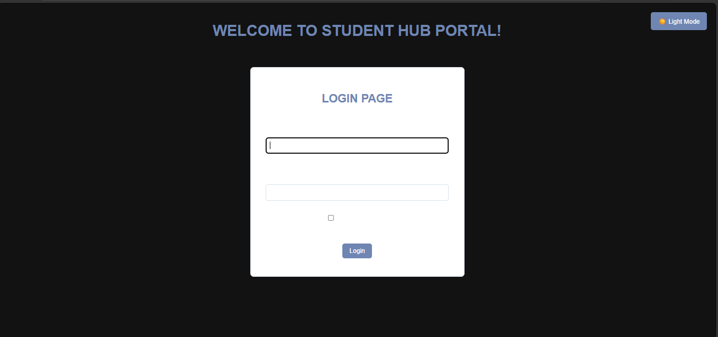

- After doing the DARK MODE, the contents of the field where not visible.
- So then it is fixed using the else part in the code.

- To Handling different JavaScript events in the code.
- Ensuring that the interactive components work properly without affecting the usability and accessibility of the website.

F.Learning Outcomes:
- Learned how to use JavaScript DOM methods to select, modify, add, and remove HTML elements dynamically.
- Learned how to use event listeners to make webpage elements interactive.
- Learned how to create a light/dark theme switcher using JavaScript.
- Learned how to use different themes as per the user's theme preference.
- Understood the importance of accessibility and user-friendly interactivity while designing dynamic web pages.

Faculty Remarks:

