Practical - 1
Practical Title: Project Initiation, Requirement Analysis, Sitemap, Wireframe, and GitHub Setup

Problem Definition: Initiate the semester-long StudentHub portal by identifying the problem scope, user roles, key modules, navigation flow, and minimum 10 pages. Create a sitemap, low-fidelity wireframe, project folder structure, README file, and GitHub repository.

Theory

What is URL and parts of URL?
Answer: URL(Uniform Resource Locator) is the unique address used to locate and access resources on internet. Parts of URL are protocol, subdomain, domain name and path.
For example:
If the website is https://www.studenthub.com/login.html then https is protocol, www is subdomain, studenthub.com is domain name and /login.html is path.

How does HTML file process in web browser?
Answer: When we open an HTML file in a browser:
- The browser reads the HTML code.
- It understands all the HTML tags like <h1>, <p>, <img>, etc.
- If CSS is linked, it applies the design and styling.
- If JavaScript is linked, it adds interactive features.
- Finally, the browser displays the webpage on the screen.
Simple Flow:
HTML File → Browser Reads Code → Applies CSS & JavaScript → Displays Webpage

3. How will page navigation flow managed among all HTML pages?
Answer: Page navigation is managed using anchor (<a>) tags.

4. How will GitHub commits be maintained after each practical?
Answer: To save project progress, keep track of changes, and maintain different versions of the project.

Implementation/ Output/Result

Evidence of Work (Screenshots)

Figure 1.1: Wireframe of login page:
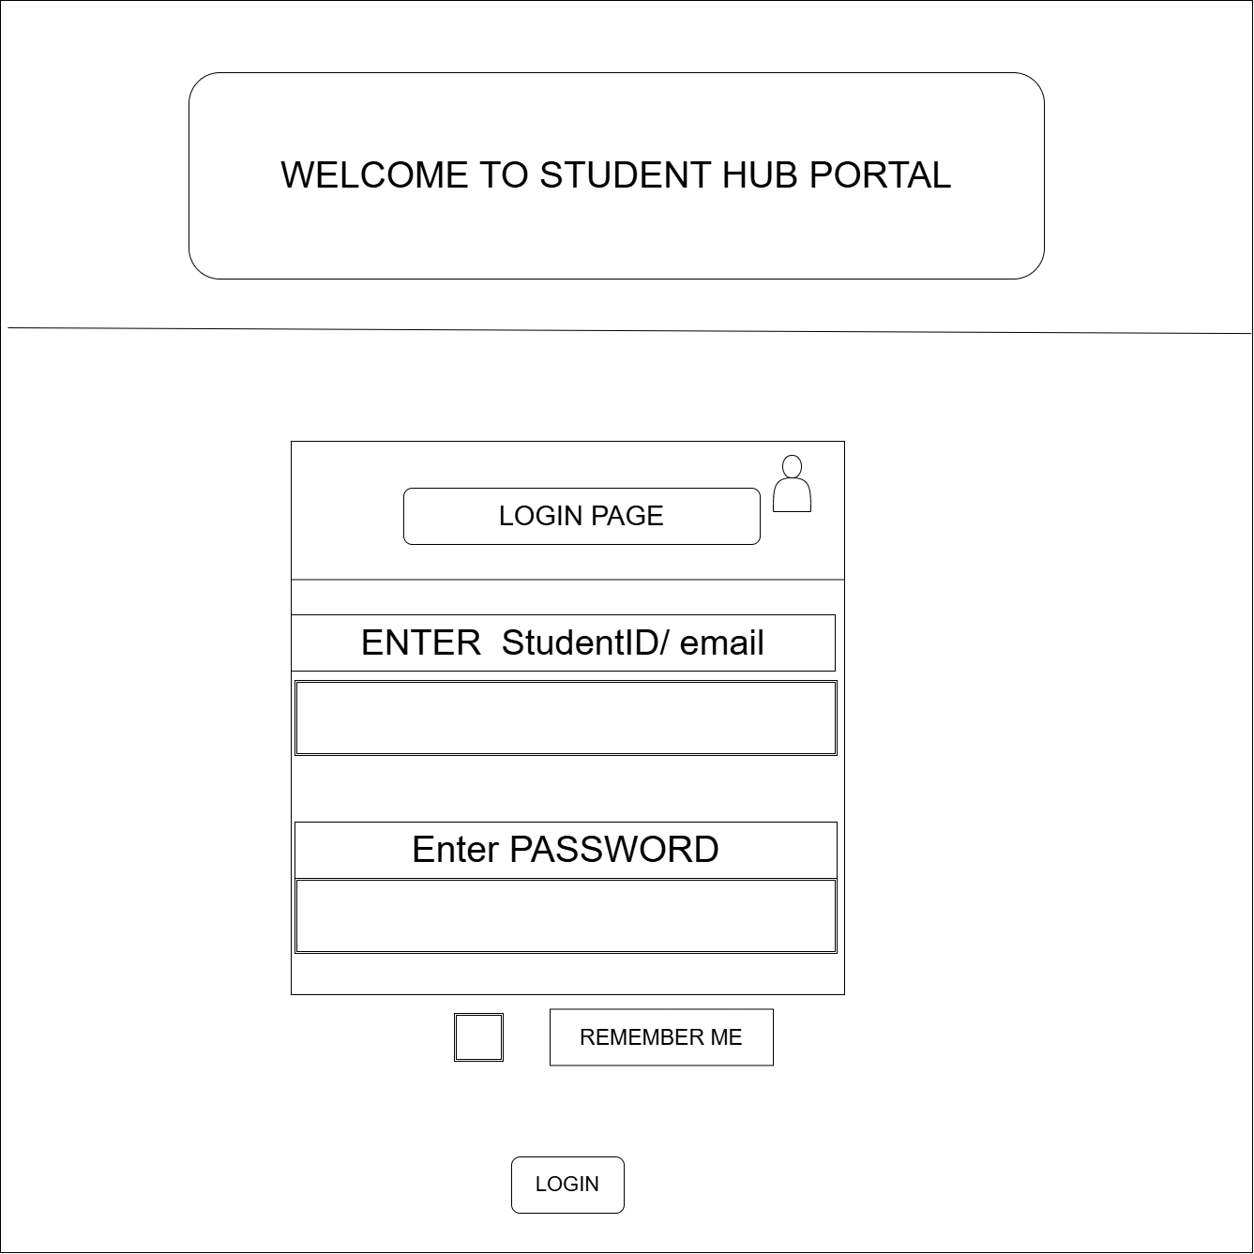

Figure 1.2: Wireframe of Student Dashboard page:
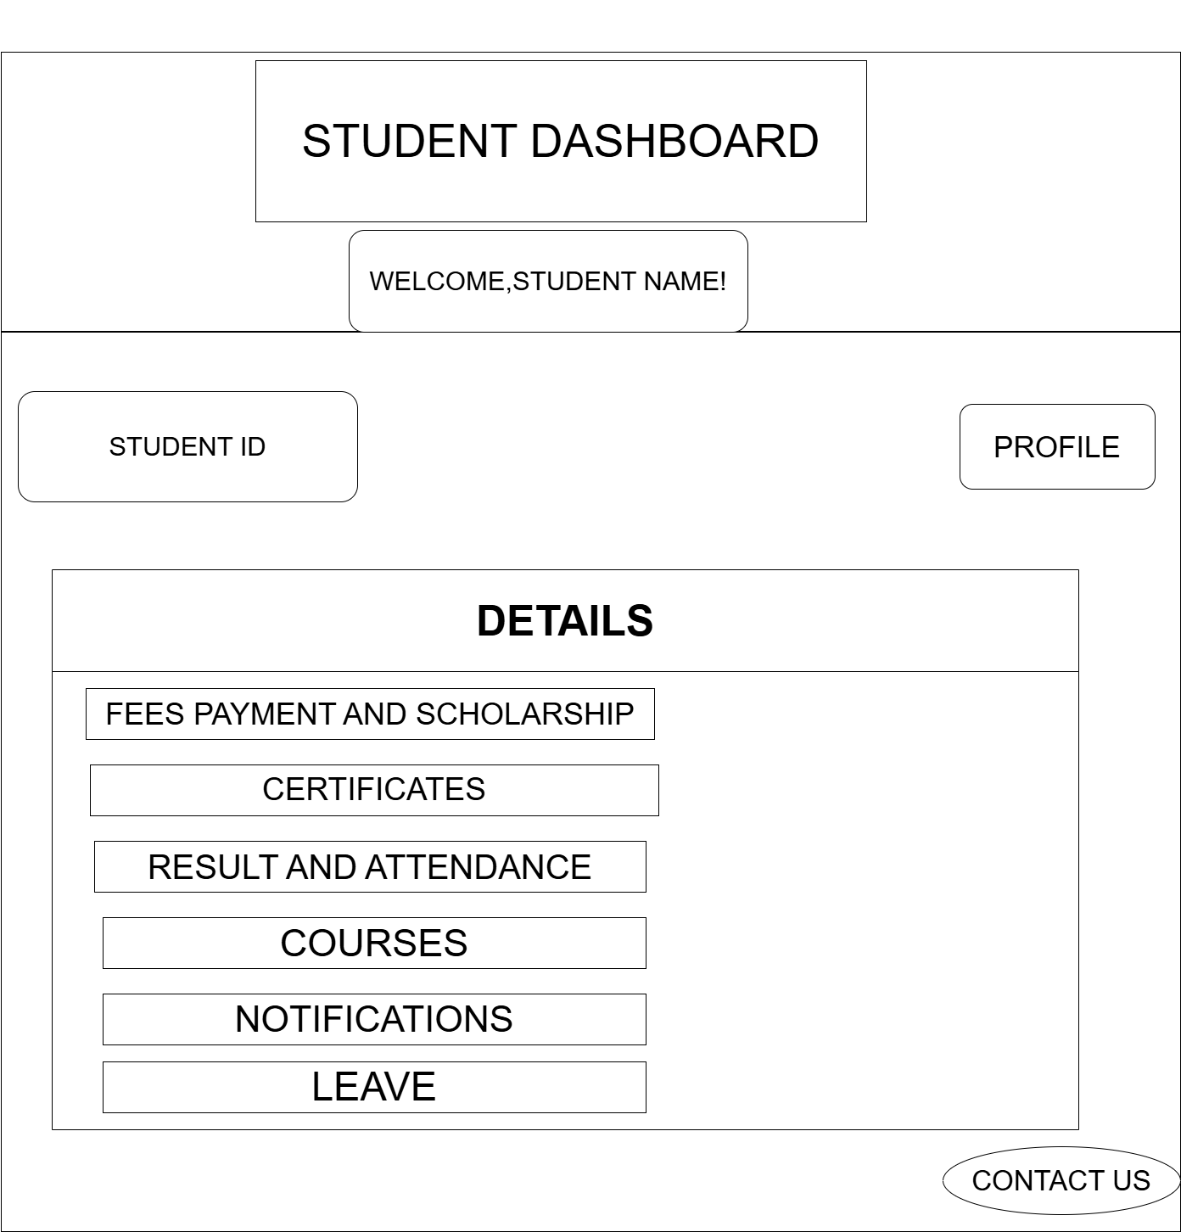

Figure 1.3: Wireframe of fees and scholarship page:

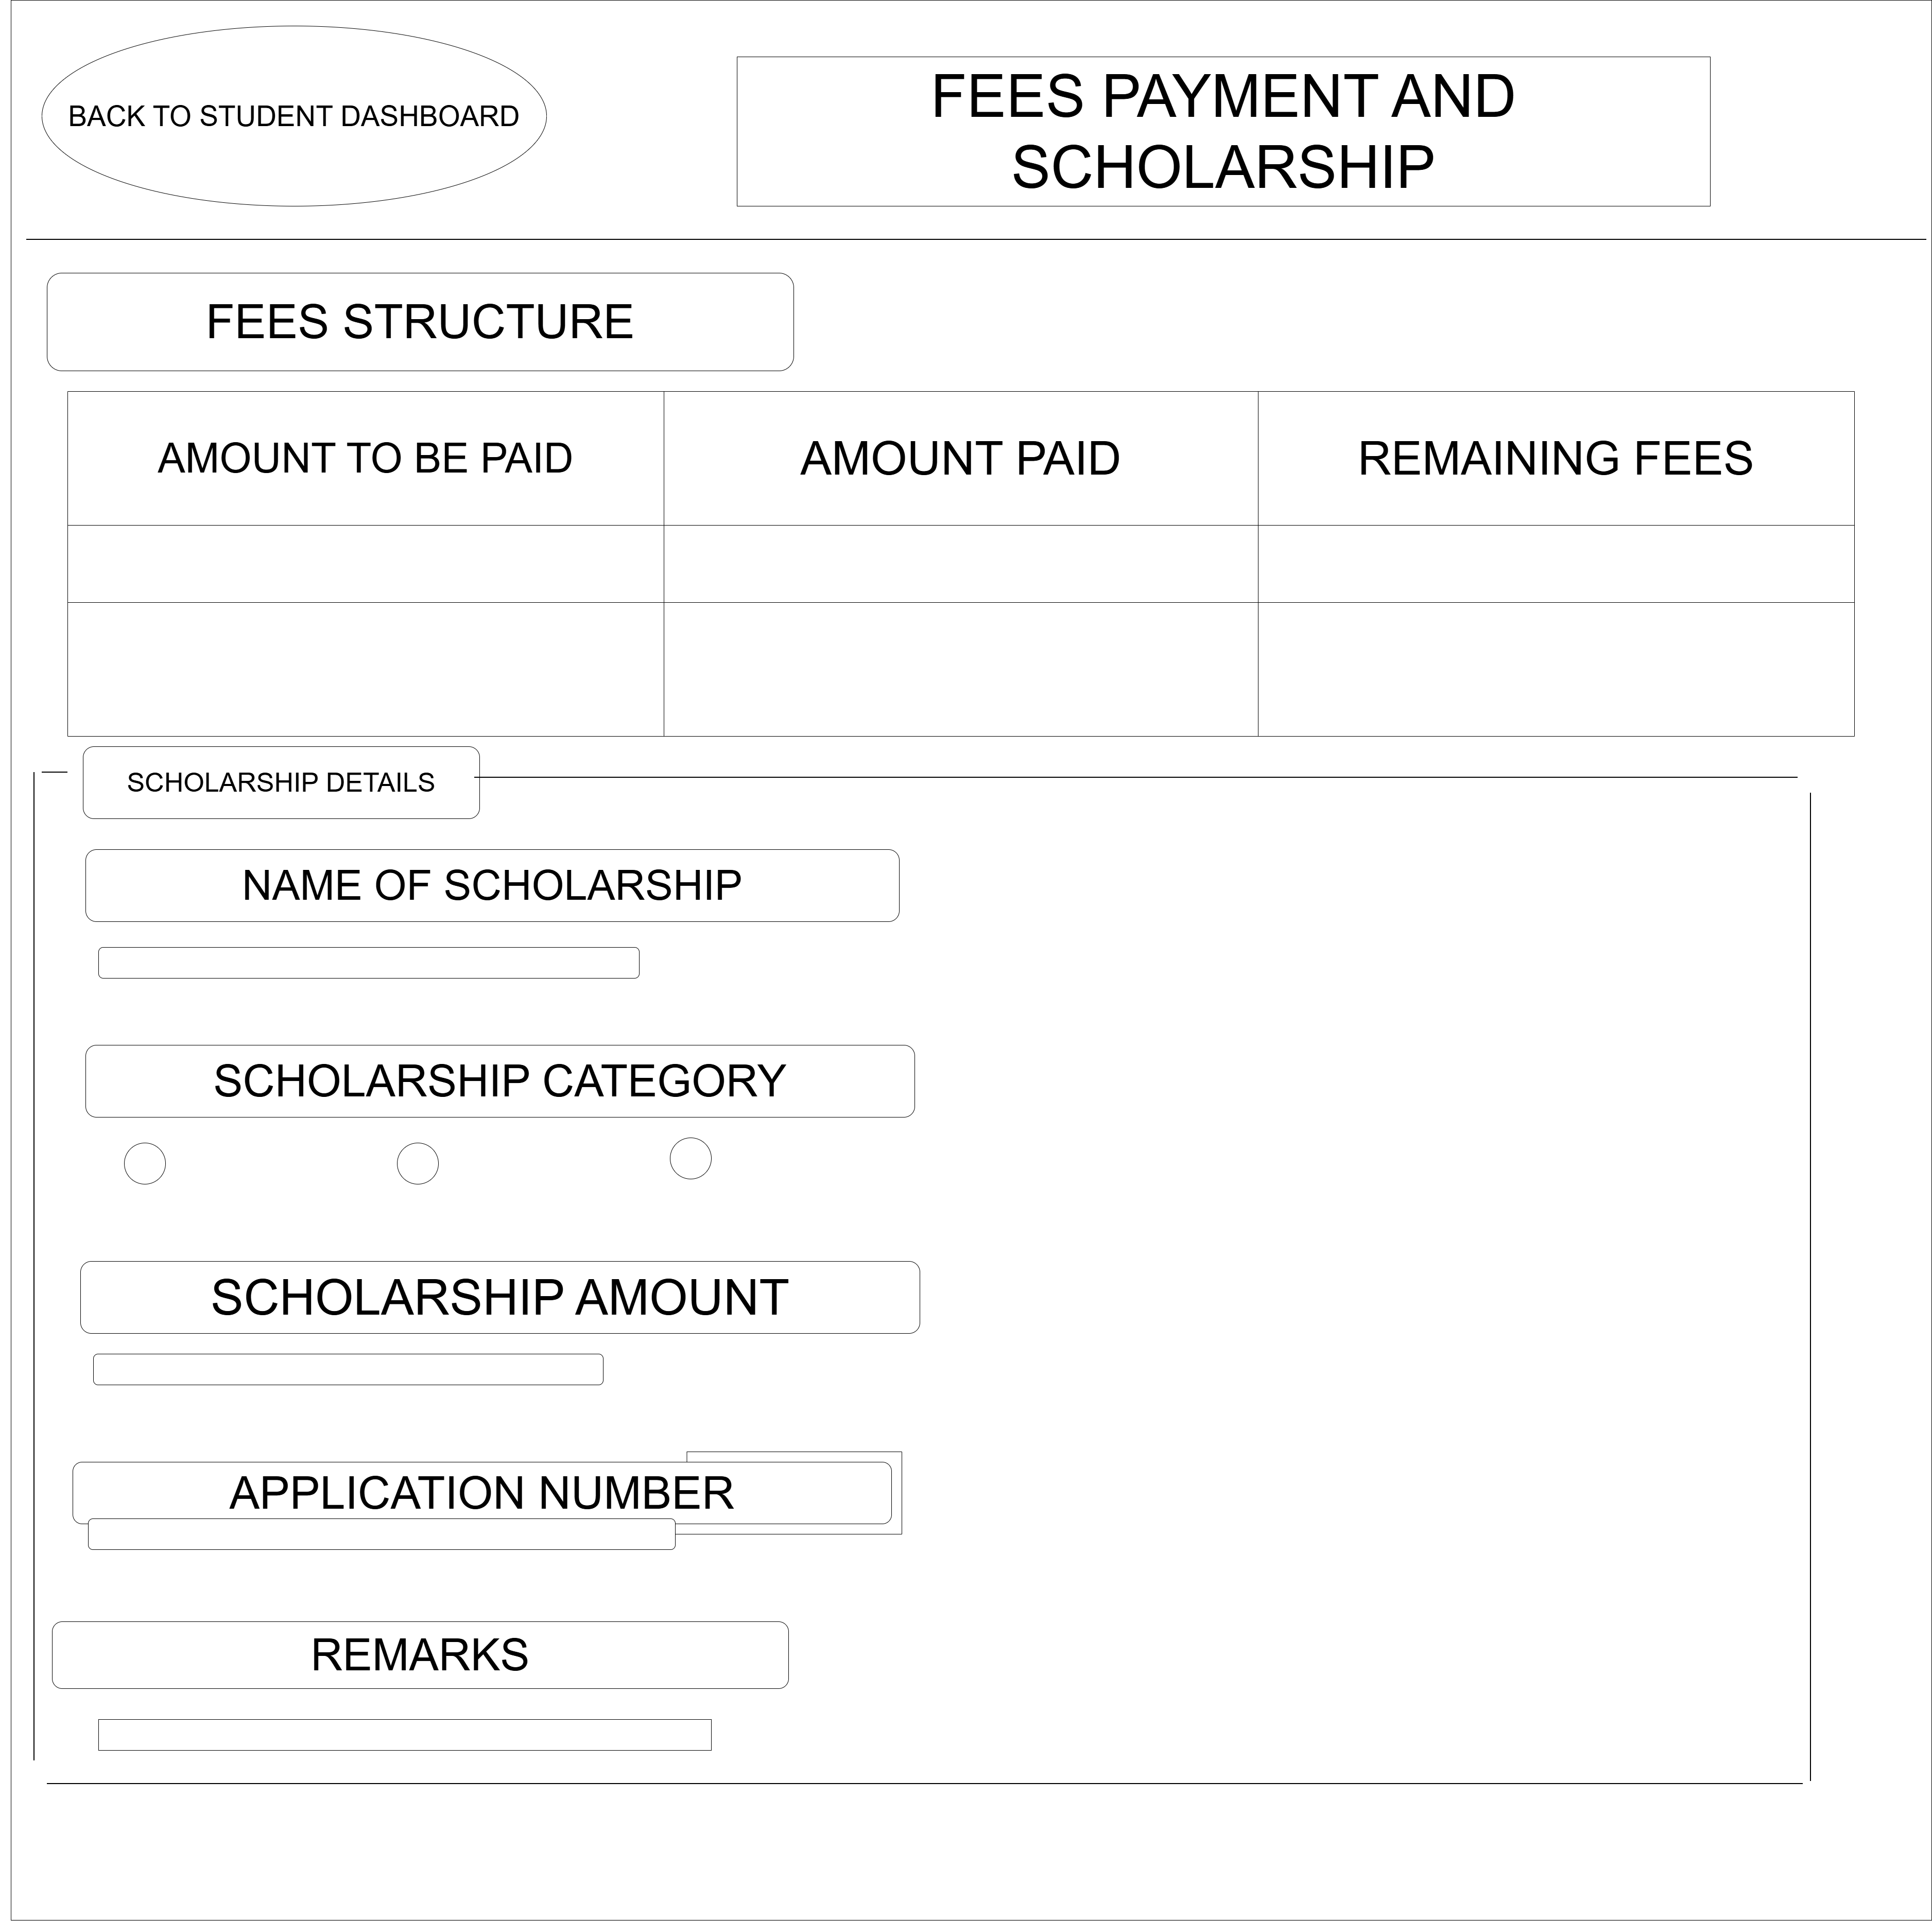

Figure 1.4: Wireframe of certificate page:

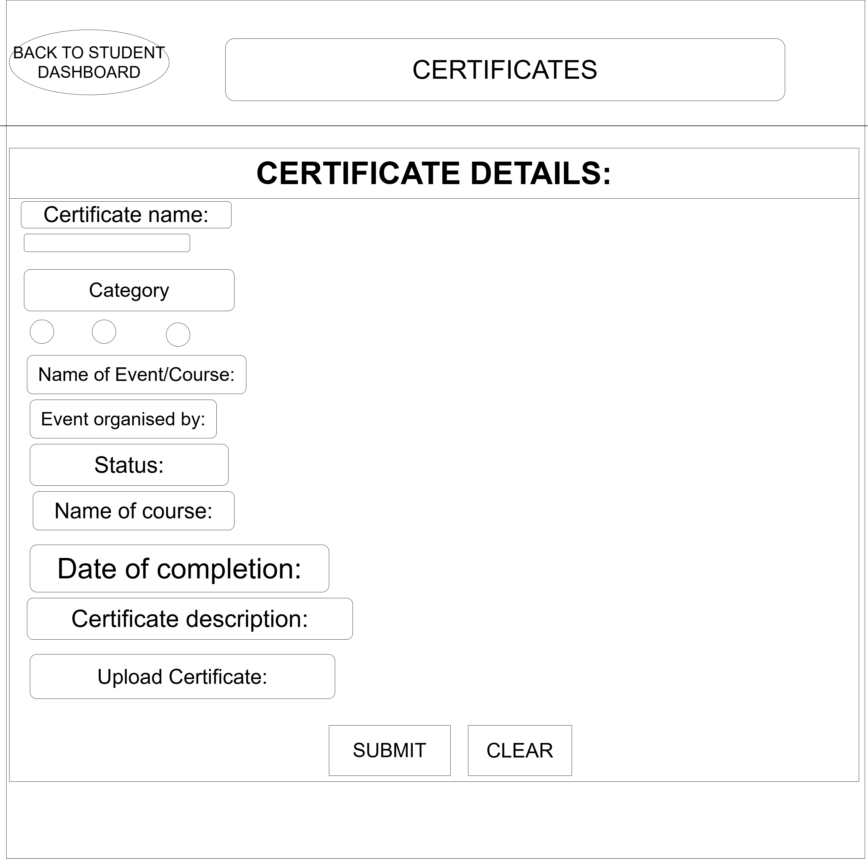

Figure 1.5: Wireframe of result and attendance page:

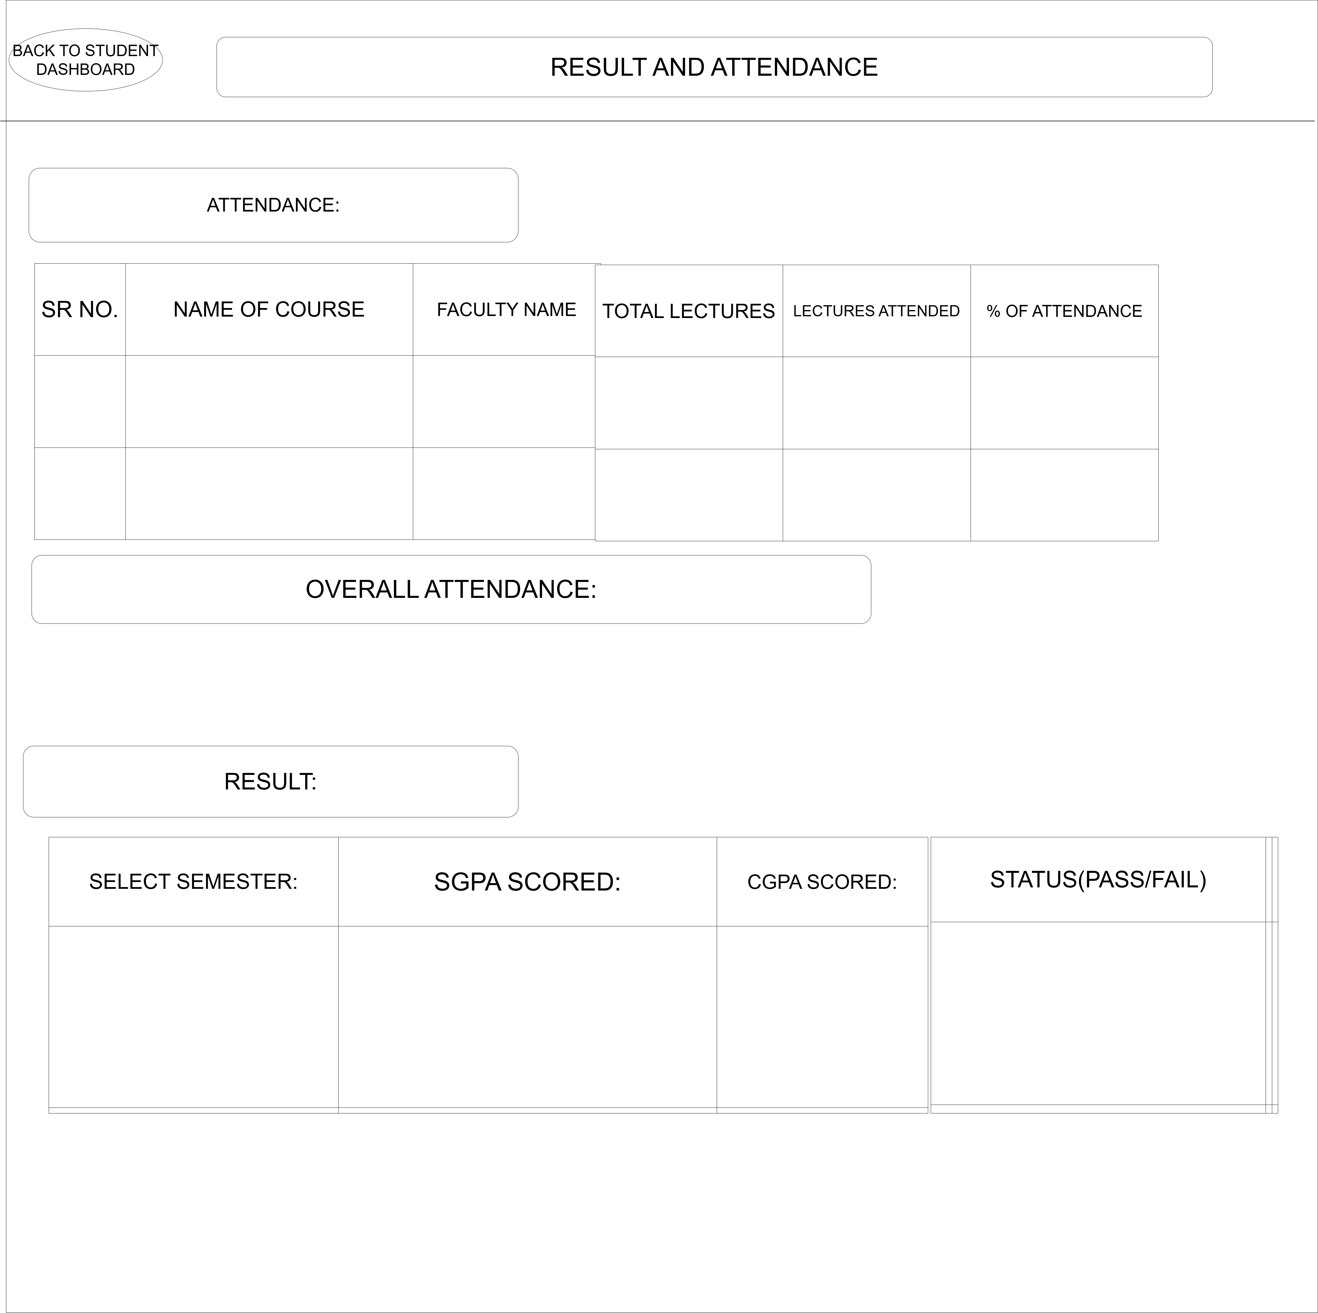

Figure 1.6: Wireframe of courses page:

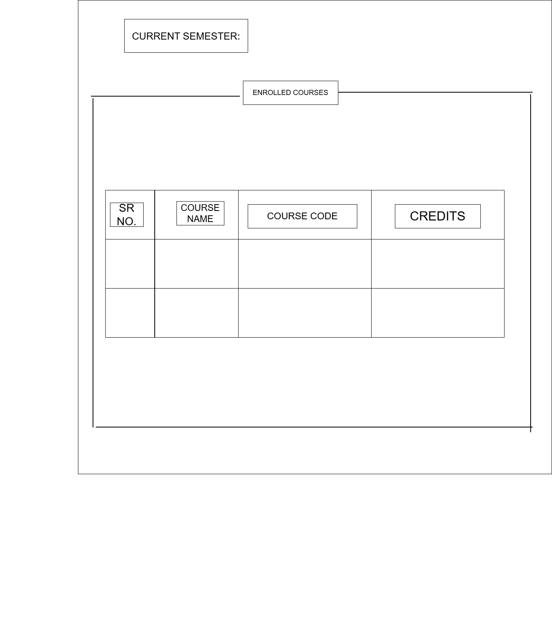

Figure 1.7: Wireframe of notification page:

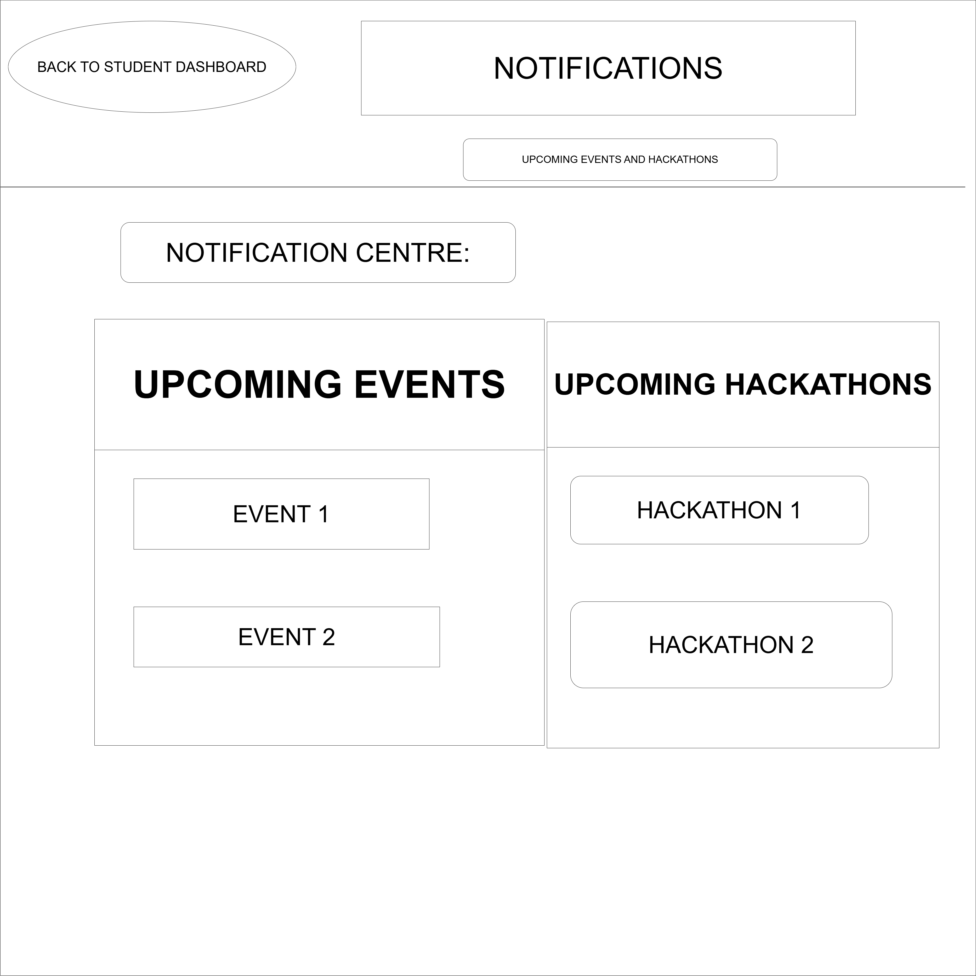

Figure 1.8: Wireframe of leave page:

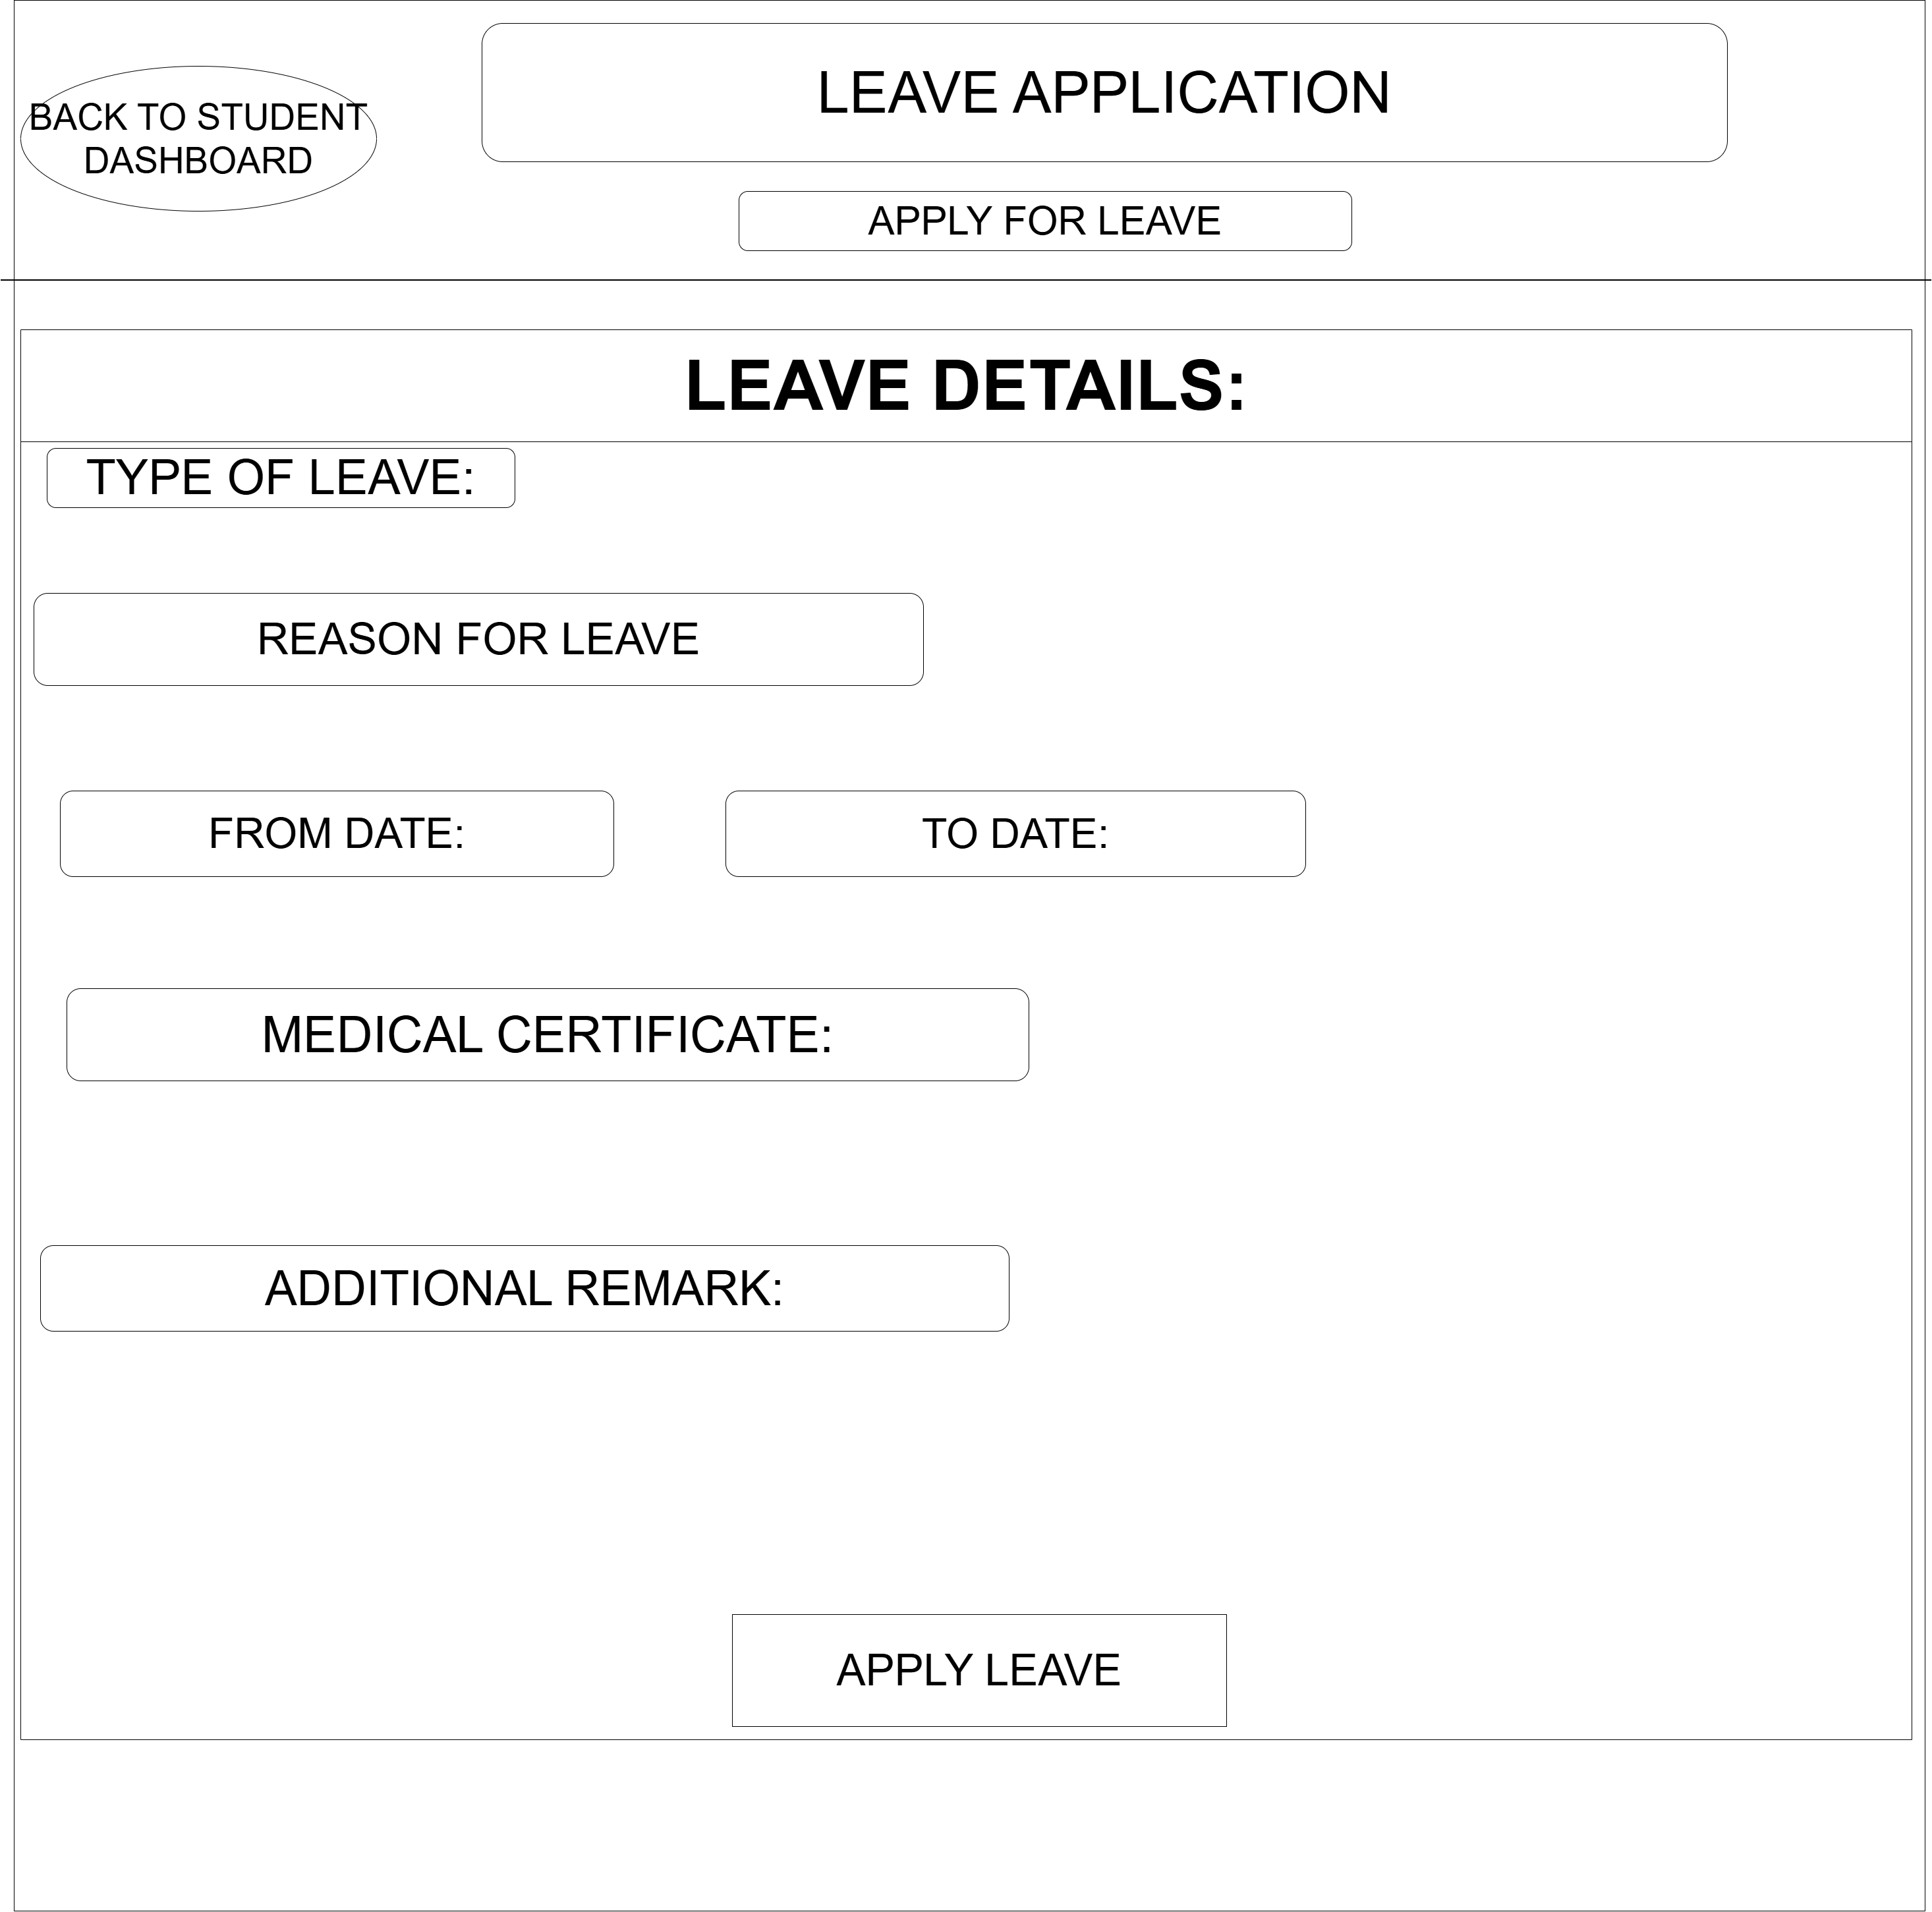

Figure 1.9: Wireframe of profile page:

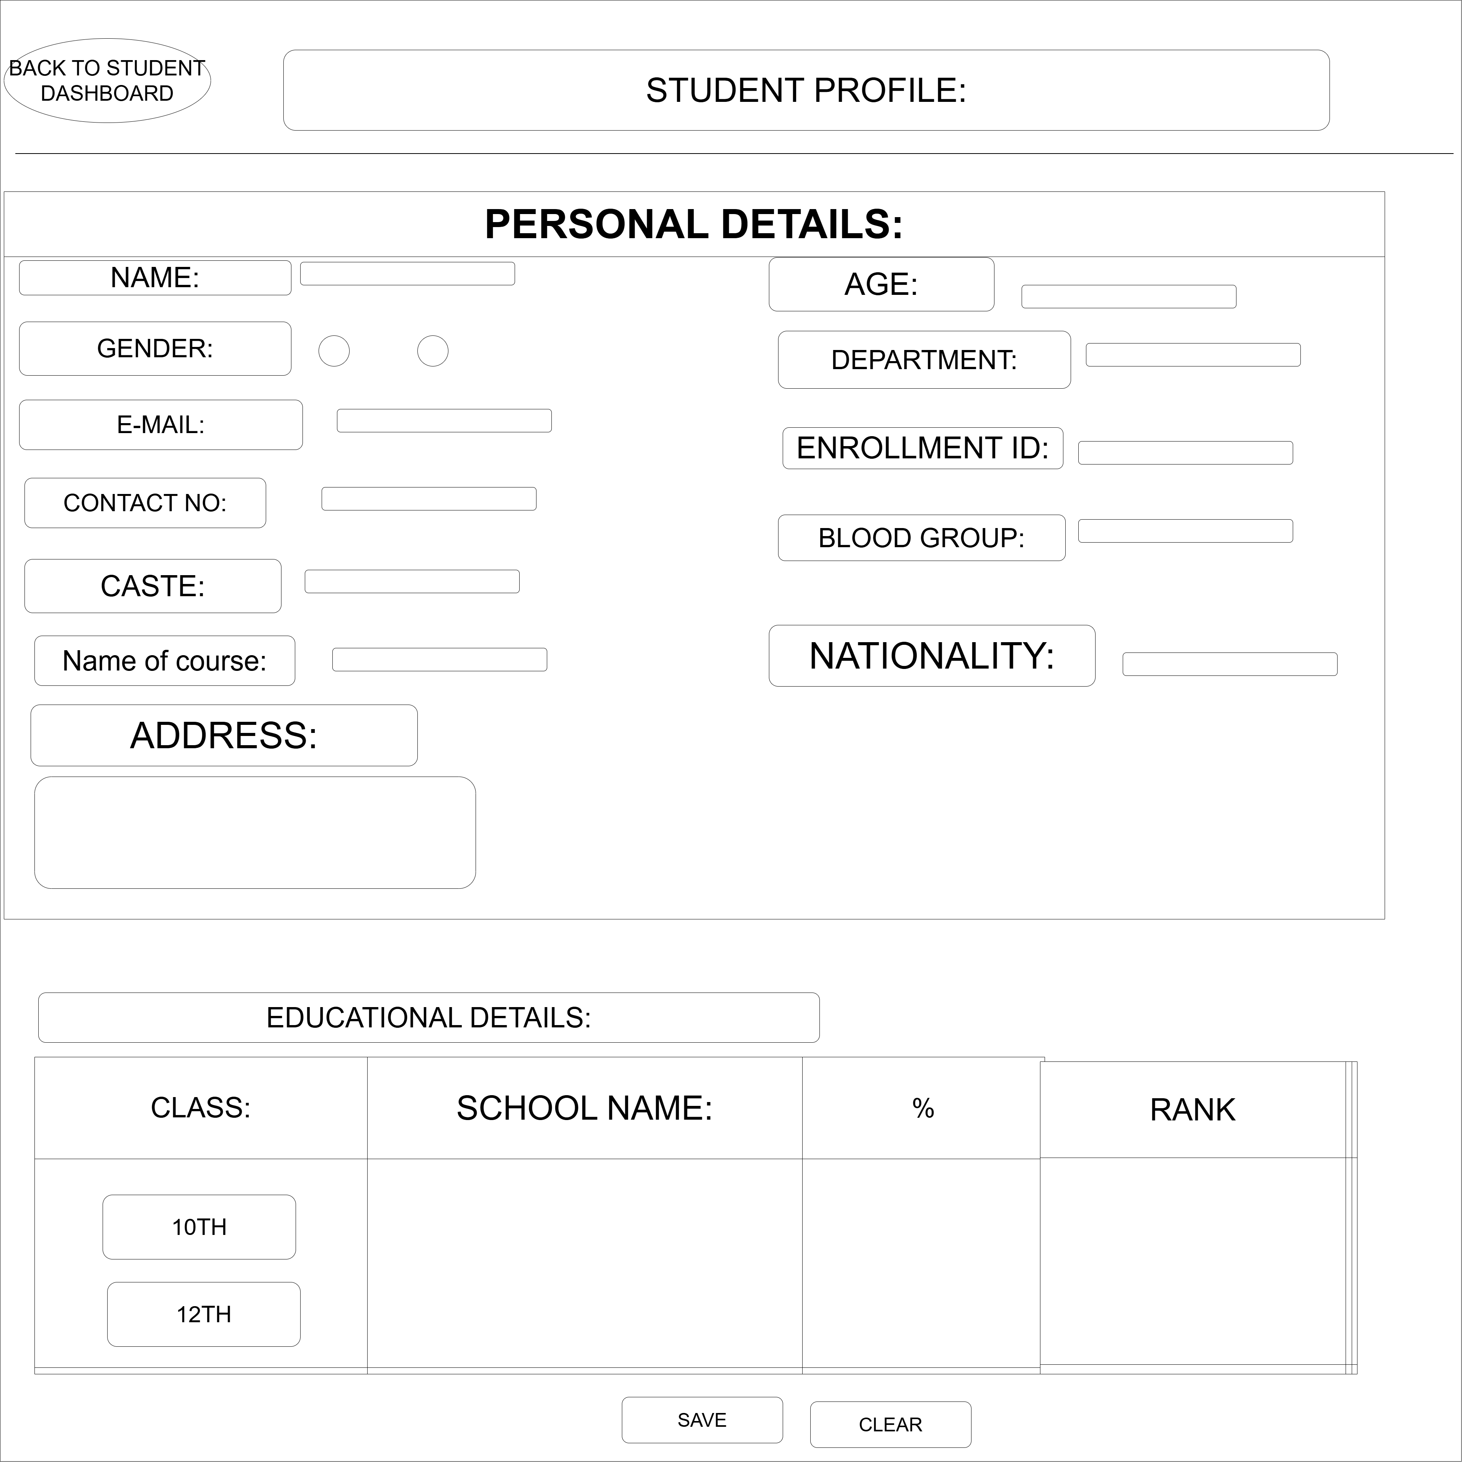

Figure 1.10: Wireframe of contact us page:

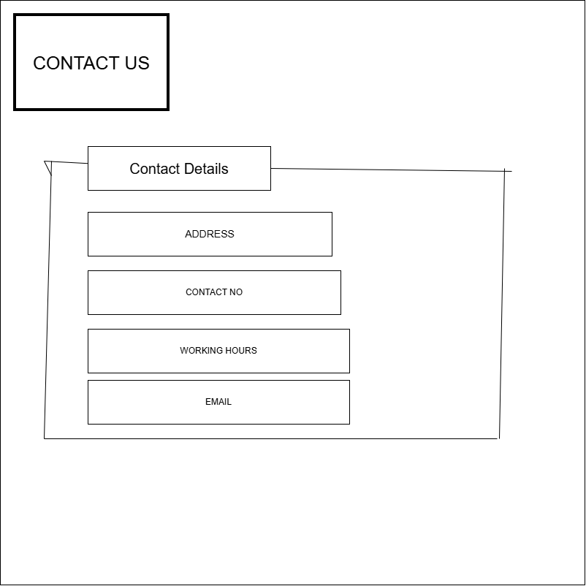

GitHub Repository Link:

https://github.com/shiloni28/WDF.git

Challenges Faced:

- Learning how to create a GitHub repository and upload project files.
- Understanding how to make commits and maintain project versions on GitHub.

Learning Outcomes:

- How to analyze project requirements before starting development.
- How to identify the problem scope, user roles, and project objectives.

Faculty Remarks:

