Practical - 2
Practical Title: Semantic HTML5 Pages with Accessibility-Ready Structure

Problem Definition: Develop static HTML5 skeletons for at least 10 StudentHub pages such as

Home, About, Register, Login, Dashboard, Events, Profile, Contact,

Admin, FAQ, and Feedback. Use semantic tags and accessibility-friendly

structure.

Theory

1. Are semantic tags such as header, nav, main, section, article, aside, and

footer used properly?
Answer. Yes, Semantic HTML5 tags are used to organize the webpage in a meaningful way. Each tag has a specific purpose, which makes the code easier to read, maintain, and understand.
- <header> is used for the top section of the webpage, such as the website title or logo.
- <nav> is used for the navigation menu that contains links to different pages.
- <main> contains the main content of the webpage.
- <section> is used to divide the content into different parts.
- <article> is used for independent content such as news, blogs, or announcements.
- <aside> is used for additional information like sidebars or quick links.
- <footer> is used at the bottom of the page for contact details, copyright information, or useful links

2. Are form labels, headings, image alt text, and navigation links

accessible?
Answer. Yes, Accessibility features are included to make the website easy to use for everyone.
- Every form field has a label that clearly tells users what information to enter.
- Proper headings are used to organize the content in a logical order.
- Every image includes an alt attribute that describes the image for users who cannot see it or use screen readers.
- Navigation links are simple, clearly named, and easy to use so users can move between pages without confusion.

3. Is the page structure consistent across all pages?
Answer. Yes, All webpages follow the same layout and structure to provide a consistent user experience.
Each page includes:
- The same navigation menu.
Keeping the same structure on every page helps users find information quickly and makes the website look organized.

Implementation/ Output/Result

Evidence of Work (Screenshots):
Figure 1.1: Login Page of StudentHub Portal using HTML

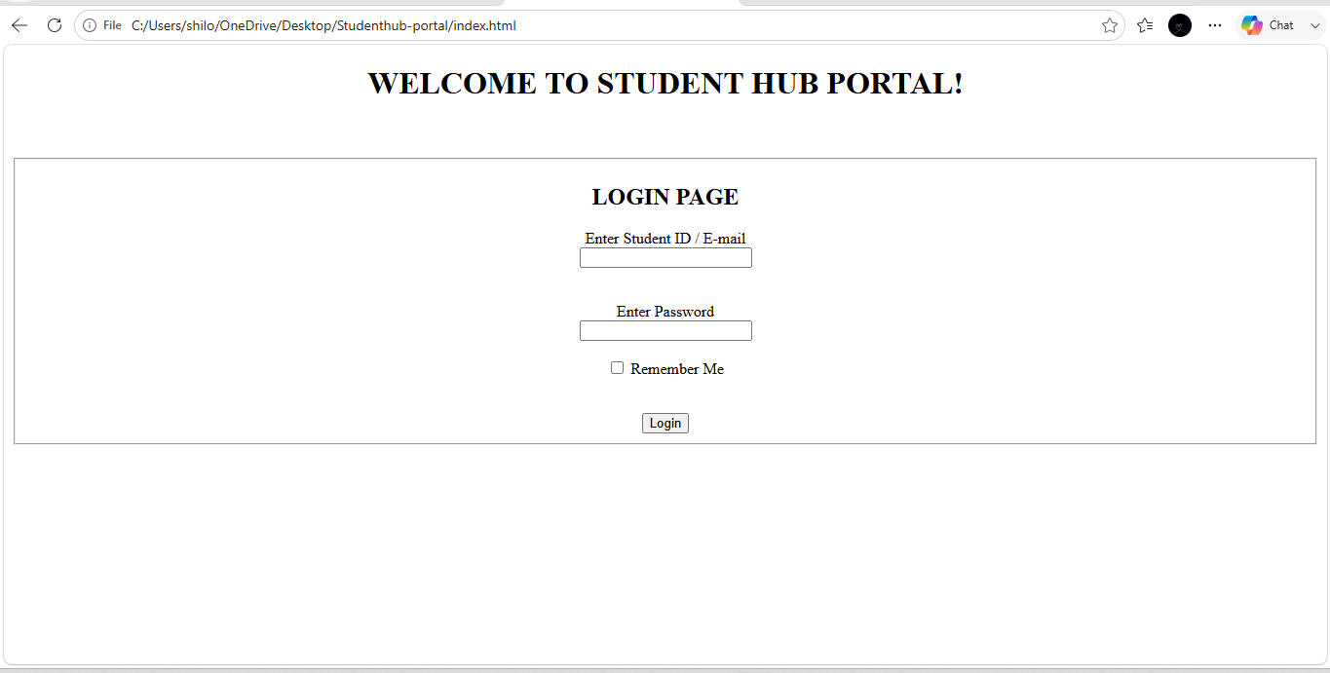

Figure 1.2: Student Dashboard Page of StudentHub Portal using HTML

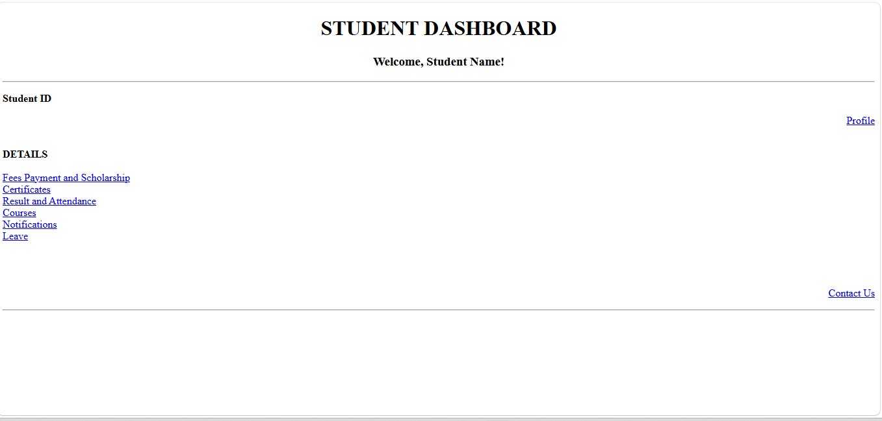

Figure 1.3: Fees payment & Scholarship Page of StudentHub Portal using HTML
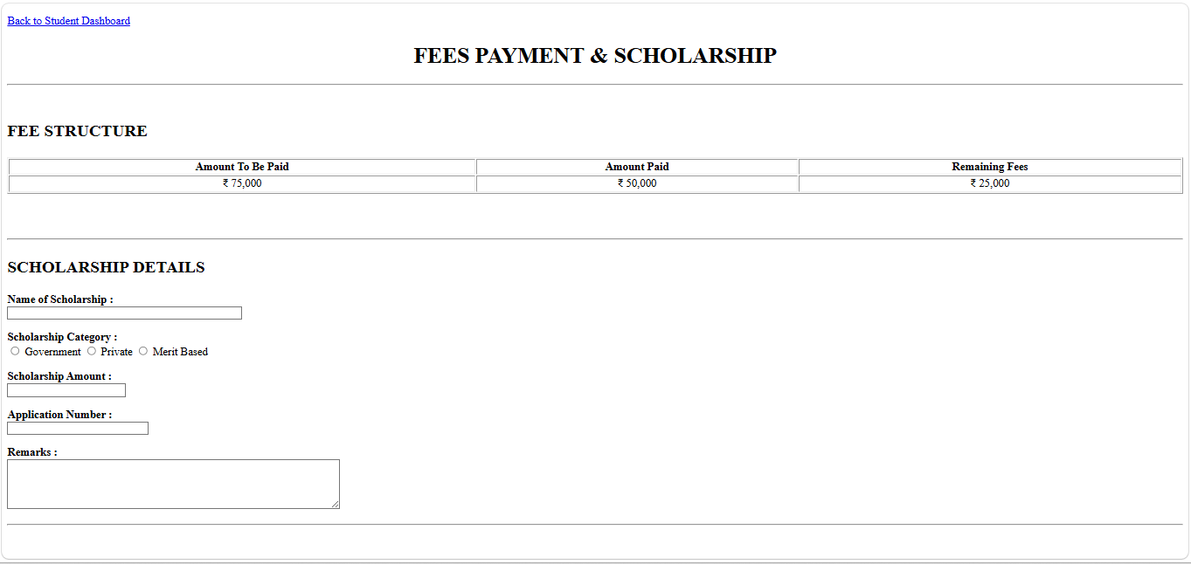

Figure 1.4: Certificates Page of StudentHub Portal using HTML
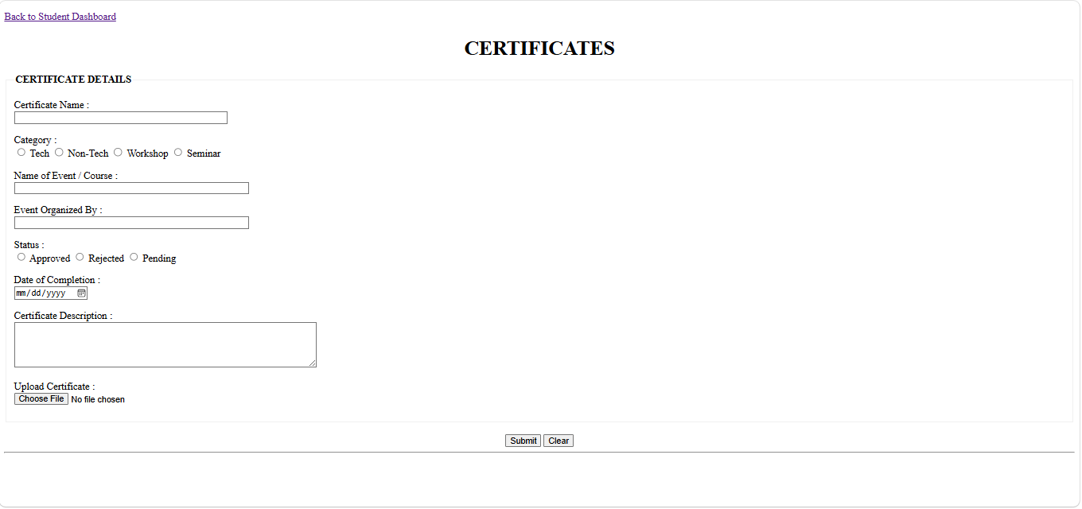

Figure 1.5: Course Page of StudentHub Portal using HTML
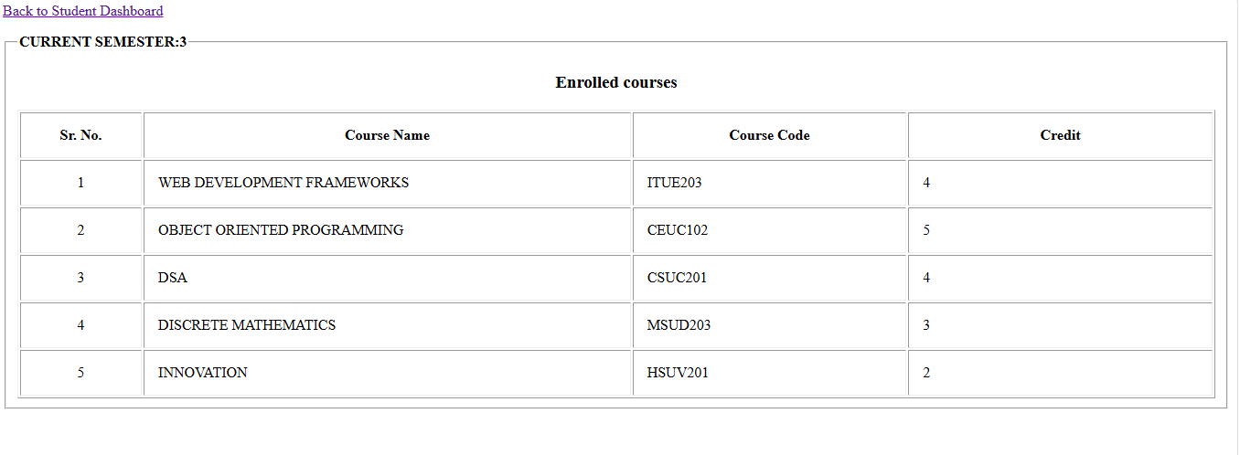

Figure 1.6: Result & Attendance Page of StudentHub Portal using HTML
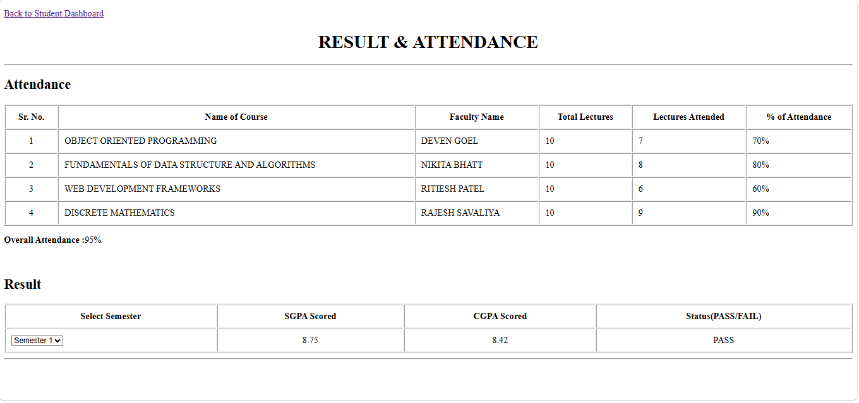

Figure 1.7: Notification Page of StudentHub Portal using HTML
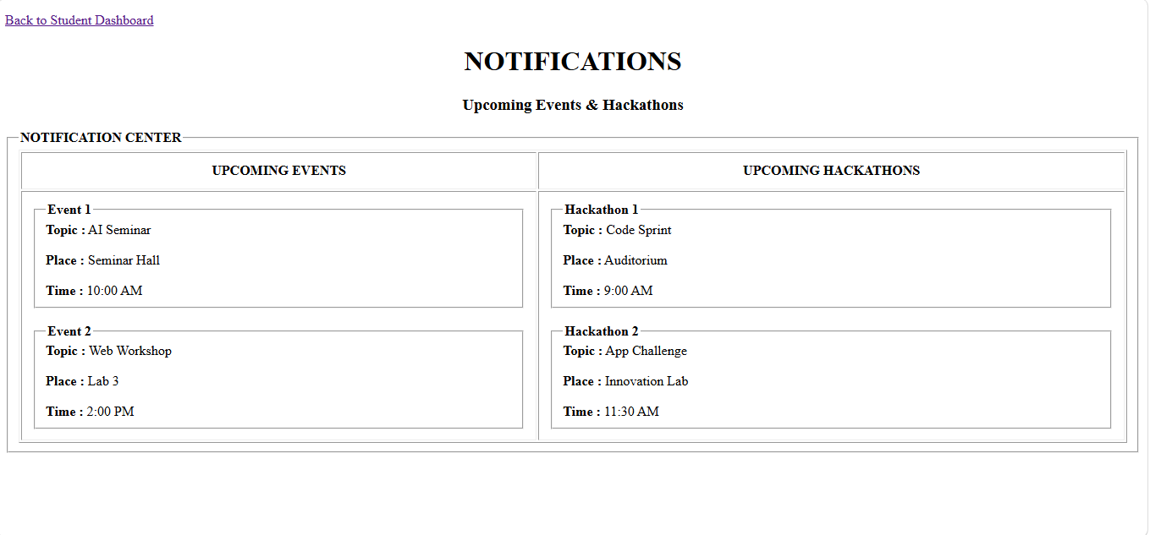

Figure 1.8: Leave Page of StudentHub Portal using HTML

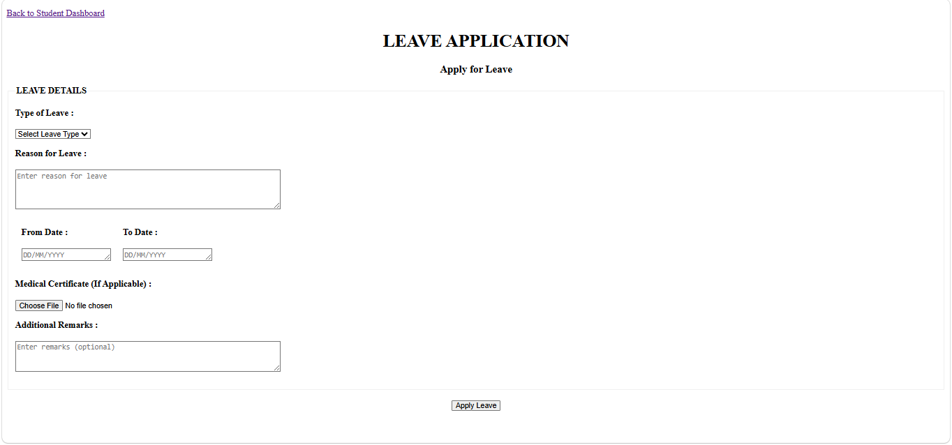

Figure 1.9: Student Profile Page of StudentHub Portal using HTML

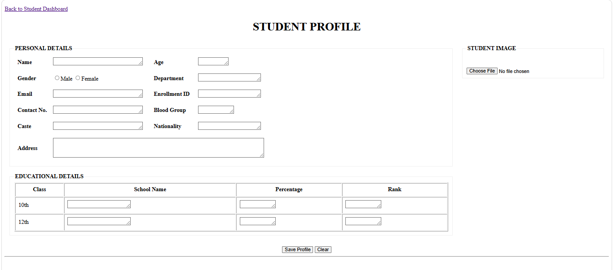

Figure 1.10: Contact Us Page of StudentHub Portal using HTML
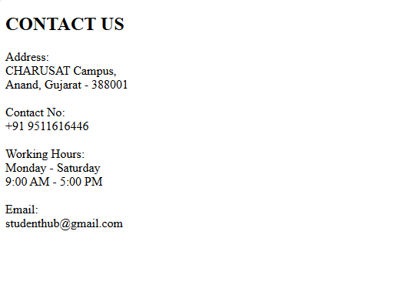

GitHub Repository Link:

https://github.com/shiloni28/WDF.git

Challenges Faced:
- Ensuring the website is easy to navigate for all users.
- Testing all pages to ensure links, forms, and navigation worked correctly without errors.
- To make the feature like profile look alike professional and to add details.
- Ensuring pages are understandable even without CSS styling.

Learning Outcomes:
- How to use semantic HTML5 tags to create a well-structured webpage.
- How to organize webpage content using proper sections and semantic elements.
- How to create multiple webpages with a consistent layout and navigation.
- To know how to do navigation like going first the webpage and then coming back to the dashboard.

Faculty Remarks:

