**Question: Can you overload a method with same return type? Explain your answer with proper logic.**

**Answer: yes, we can overload a method with same return type, but with different number of arguments.**

Method Overloading is a feature that allows a class to have two or more methods having same name, if their argument lists are different. So, it’s nowhere mentioned that return type need to be different in case of overloading.

Following example will explain the concept in detail:

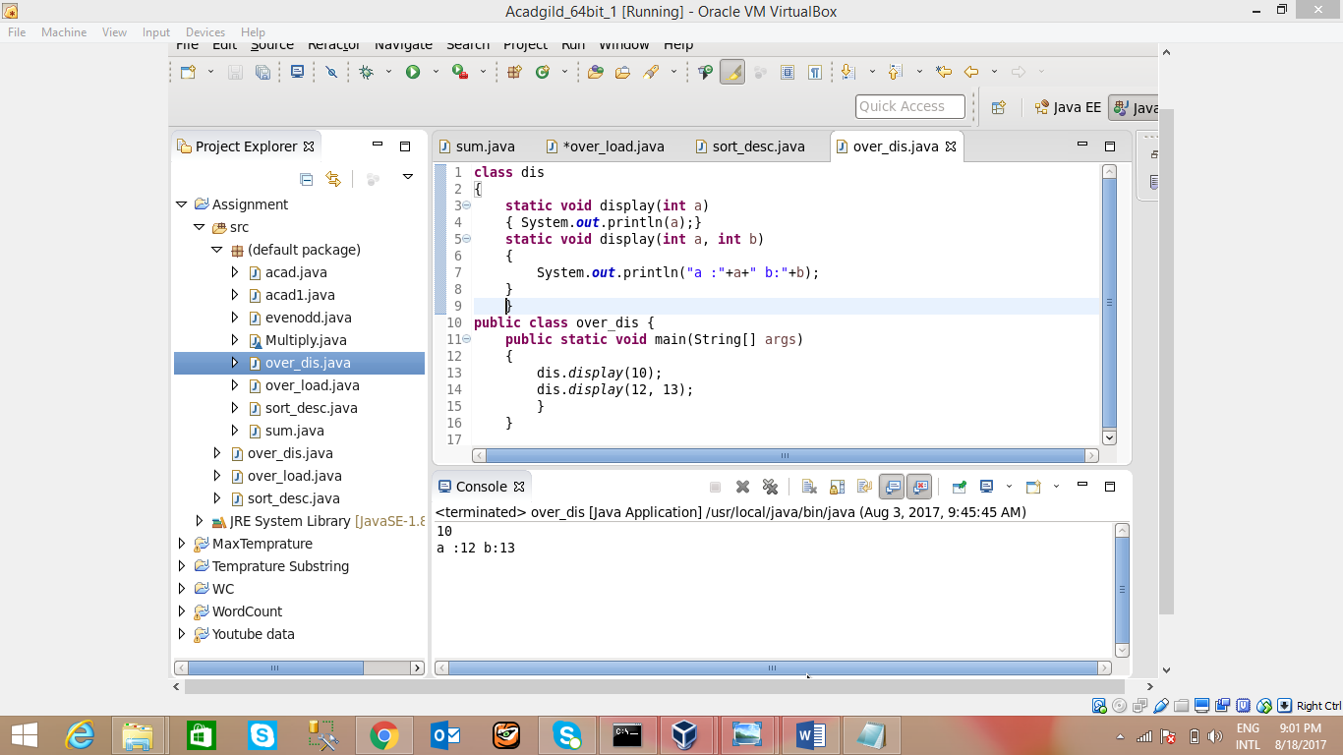

**So, in this example we have 2 methods with same name, same return type and different arguments.**

**Display(int a), will accept 1 argument.**

**Display(inta, int b) will accept 2 arguments.**

**But, return type remain the same.**