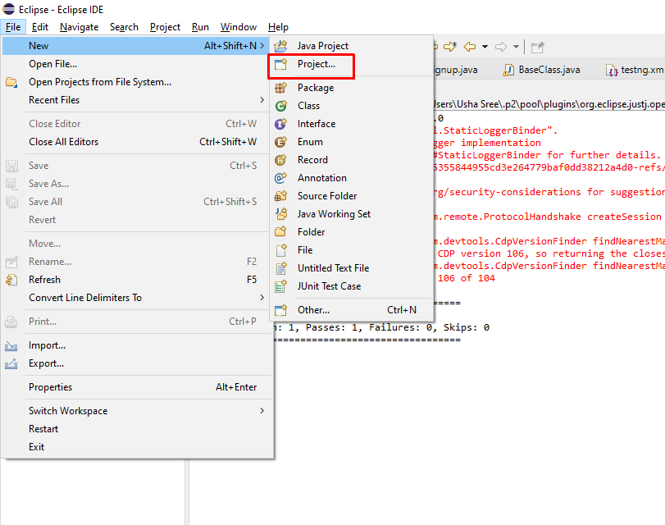

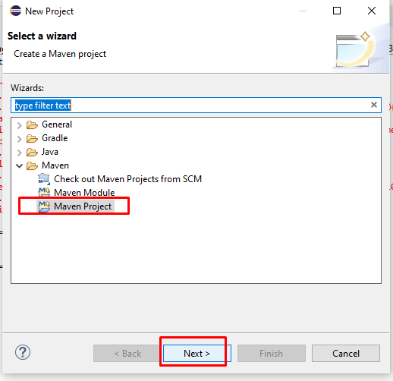

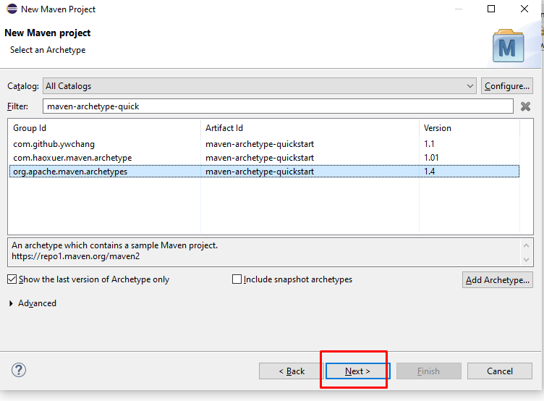

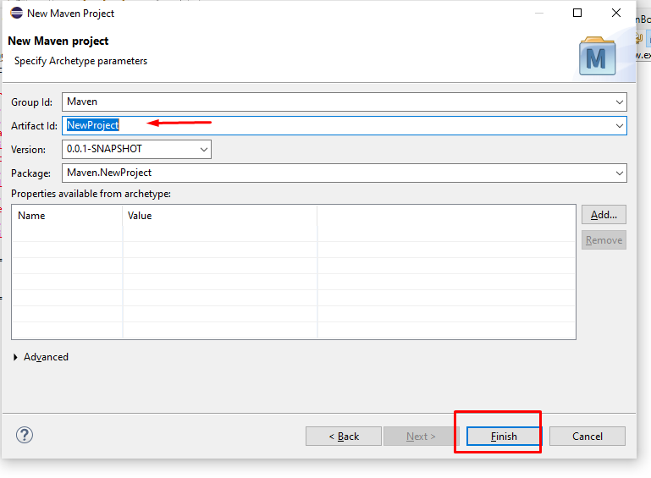

Pom.xml

<dependency>

<groupId>org.seleniumhq.selenium</groupId>

<artifactId>selenium-java</artifactId>

<version>4.4.0</version>

</dependency>

<!-- https://mvnrepository.com/artifact/io.github.bonigarcia/webdrivermanager -->

<dependency>

<groupId>io.github.bonigarcia</groupId>

<artifactId>webdrivermanager</artifactId>

<version>5.3.0</version>

</dependency>

<!-- https://mvnrepository.com/artifact/org.testng/testng -->

<dependency>

<groupId>org.testng</groupId>

<artifactId>testng</artifactId>

<version>7.4.0</version>

<scope>test</scope>

</dependency>