HOSPITAL_MANAGEMENT_SYSTEM(H_M_S)

- Introduction to MySQL: MySQL is an open-source relational database management system (RDBMS) that uses structured query language (SQL) to manage and manipulate data in a database. It is widely used for various applications, from small web applications to large enterprise systems. MySQL's key features include:

  - Scalability: Capable of handling large amounts of data and concurrent connections.

  - Flexibility: Supports various data types and storage engines.

  - Performance: Optimized for speed and efficiency.

  - Reliability: Known for its stability and robustness.

2. Installation of MySQL: MySQL can be installed on various operating systems, including

Windows, macOS, and Linux. Here are the general steps to install MySQL:

Windows:

  - Download the MySQL installer from the official website. https://dev.mysql.com/downloads/installer/

  - Run the installer and follow the on-screen instructions.

  - Choose the installation type (Typical, Complete, or Custom). Recommended Custom.

  - Set a root password for the MySQL server.

- E-R Diagram (ERD)

An Entity-Relationship Diagram (ERD) is a visual representation of the data model that shows the entities, attributes, relationships between entities, and cardinality. ERDs are commonly used in database design to help developers and stakeholders understand the structure and relationships within a database.

Identify Entities

- Start by identifying the main entities in your system. These are the objects or concepts about which you want to store data.

- Each entity should correspond to a table in your database.

Define Attributes

- For each entity, list the attributes (properties or fields) that describe it.

- These attributes will become columns in the corresponding database table.

Identify Relationships

- Determine how entities are related to each other. There are three types of relationships: one-to-one (1:1), one-to-many (1:N), and many-to-many (N:M).

- Represent these relationships using lines connecting the entities.

Let’s see a few examples of relationships:

One to One
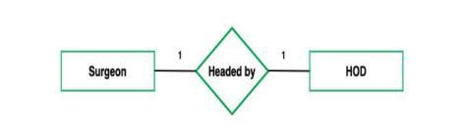

One to Many
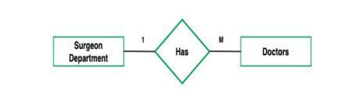

Many to One
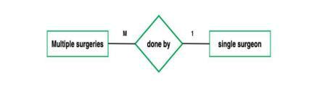

Many to Many
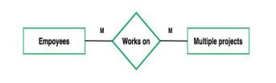

Cardinality Notation

Cardinality represents the number of times an entity of an entity set participates in a relationship set.

Or we can say that the cardinality of a relationship is the number of tuples (rows) in a relationship.

- Use notation (such as Crow's Foot Notation or Chen Notation) to indicate the cardinality of each relationship.

- Cardinality describes how many instances of one entity are related to how many instances of another entity.

- Common notations include:

  - One (1)

  - Zero or one (0..1)

  - Many (N)

  - Zero or many (0..N)

Optional:

Add Attributes and Constraints

- Include additional information in your ERD, such as primary keys, foreign keys, and constraints (e.g., unique constraints).

Create the diagram

- Use specialized diagramming software or tools (e.g., Lucidchart, draw.io, or even pen and paper) to create your ERD.

Refine and Review:

- Review your ERD with stakeholders and team members to ensure it accurately represents the data model and relationships. Make any necessary refinements.

Let’s identify the entities of the Hospital management system

1.admissions

2.appointments

3.billing_invoices

4.departments

5.doctors

6.insurance
7.inventory

8.lab_tests

9.medical_records

10.patients

11.staff

12.suppliers

13.wards_rooms

Now let’s identify the attributes and relationships of each entity for the Hospital Management System.

DATABASES

→HOSPITAL

TABLES

→admissions
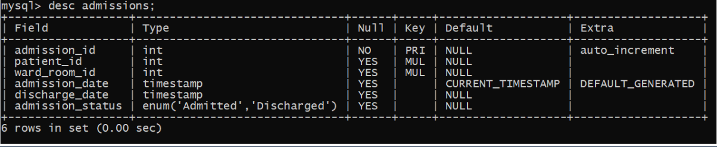

CODE:

CREATE TABLE admissions (

admission_id INT AUTO_INCREMENT PRIMARY KEY,

patient_id INT NOT NULL,

ward_room_id INT NOT NULL,

admission_date TIMESTAMP NOT NULL,

discharge_date TIMESTAMP,

admission_status VARCHAR(50) NOT NULL

);

→appointments

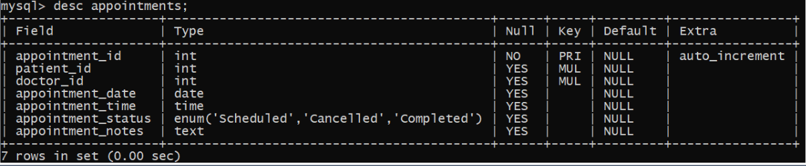

CODE:

CREATE TABLE appointments (

appointment_id INT AUTO_INCREMENT PRIMARY KEY,

patient_id INT NOT NULL,

doctor_id INT NOT NULL,

appointment_date DATETIME NOT NULL,

appointment_status VARCHAR(50) NOT NULL,

appointment_notes TEXT,

CONSTRAINT fk_patient FOREIGN KEY (patient_id) REFERENCES patients(patient_id), CONSTRAINT fk_doctor FOREIGN KEY (doctor_id) REFERENCES doctors(doctor_id)

);

→billing_invoices
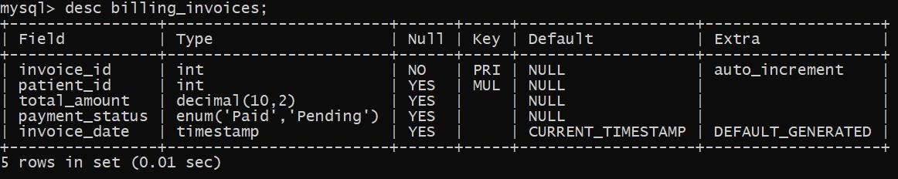

CODE:

CREATE TABLE invoices (

invoice_id INT AUTO_INCREMENT PRIMARY KEY,

patient_id INT,

total_amount DECIMAL(10,2),

payment_status ENUM('Paid','Pending'),

invoice_date TIMESTAMP DEFAULT CURRENT_TIMESTAMP,

CONSTRAINT fk_patient FOREIGN KEY (patient_id) REFERENCES patients(patient_id)

);
→departments
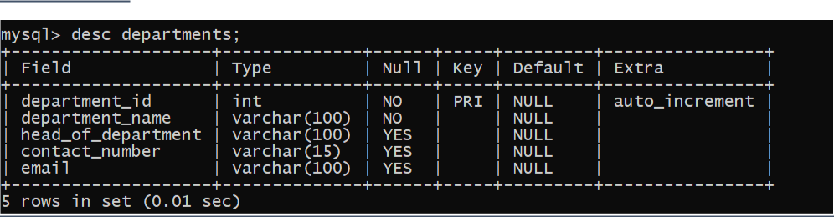

CODE:

CREATE TABLE departments (

department_id INT AUTO_INCREMENT PRIMARY KEY,

department_name VARCHAR(100) NOT NULL,

head_of_department VARCHAR(100),

contact_number VARCHAR(15),

email VARCHAR(100)

);

→doctors
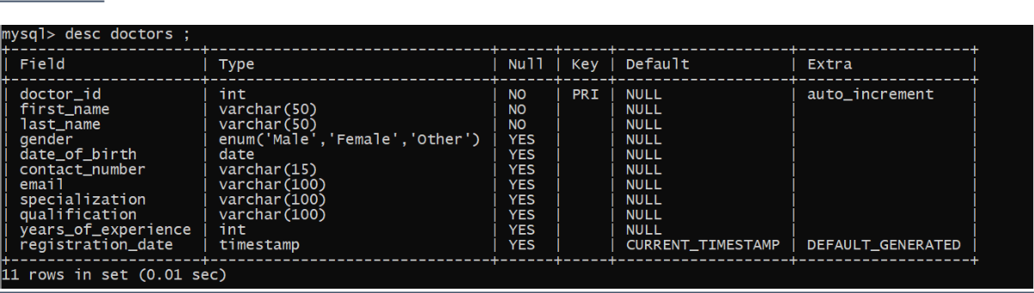

CODE:

CREATE TABLE doctors (

doctor_id INT AUTO_INCREMENT PRIMARY KEY,

first_name VARCHAR(50) NOT NULL,

last_name VARCHAR(50) NOT NULL,

gender ENUM('Male','Female','Other'),

date_of_birth DATE,

contact_number VARCHAR(15),

email VARCHAR(100),

specialization VARCHAR(100),

qualification VARCHAR(100),
years_of_experience INT,

registration_date TIMESTAMP DEFAULT CURRENT_TIMESTAMP

);

→insurance
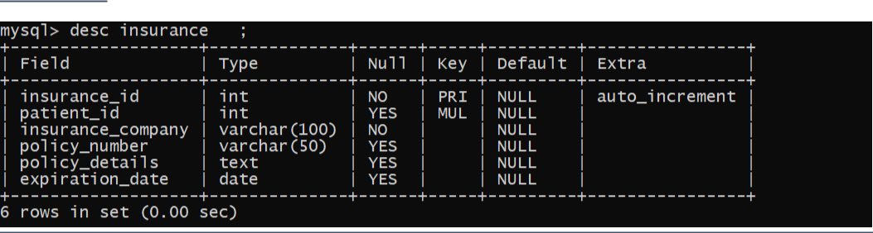

CODE:

CREATE TABLE insurance (

insurance_id INT AUTO_INCREMENT PRIMARY KEY,

patient_id INT,

insurance_company VARCHAR(100) NOT NULL,

policy_number VARCHAR(50),

policy_details TEXT,

expiration_date DATE

);

→inventory
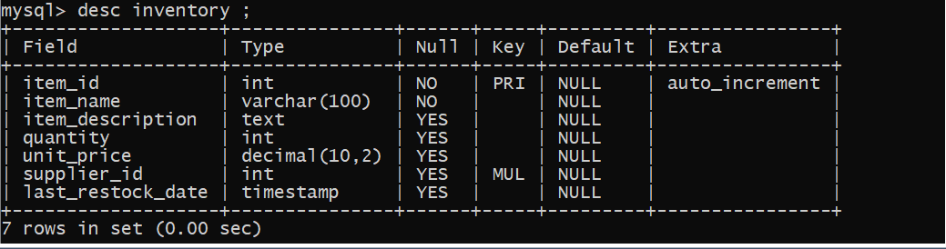

CODE:

CREATE TABLE items (

item_id INT AUTO_INCREMENT PRIMARY KEY,

item_name VARCHAR(100) NOT NULL,

item_description TEXT,

quantity INT,
unit_price DECIMAL(10,2),

supplier_id INT,

last_restock_date TIMESTAMP

);

→lab_tests
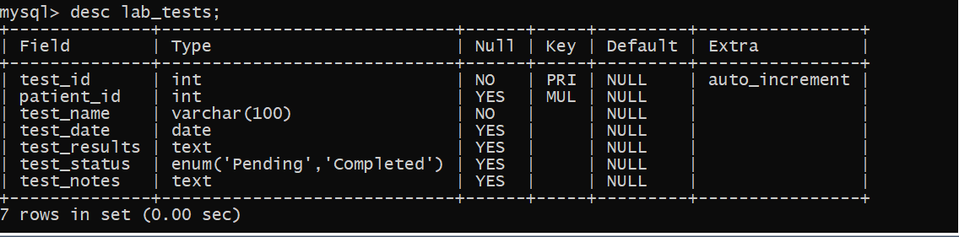

CODE:

CREATE TABLE lab_tests (

test_id INT AUTO_INCREMENT PRIMARY KEY,

patient_id INT,

test_name VARCHAR(100) NOT NULL,

test_date DATE,

test_results TEXT,

test_status ENUM('Pending','Completed'),

test_notes TEXT

);

→medical_records
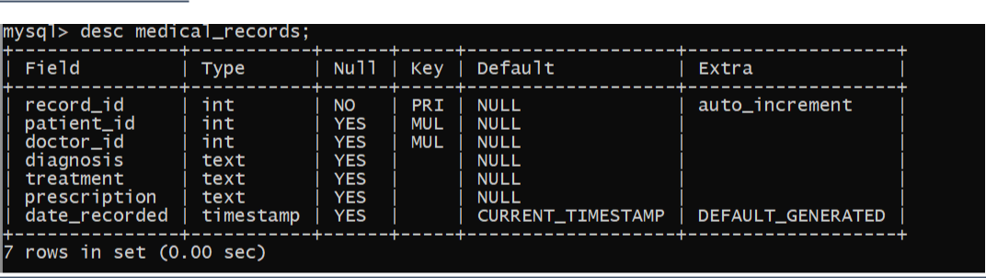

CODE:

CREATE TABLE medical_records (

record_id INT AUTO_INCREMENT PRIMARY KEY,

patient_id INT,
doctor_id INT,

diagnosis TEXT,

treatment TEXT,

prescription TEXT,

date_recorded TIMESTAMP DEFAULT CURRENT_TIMESTAMP

);

→patients
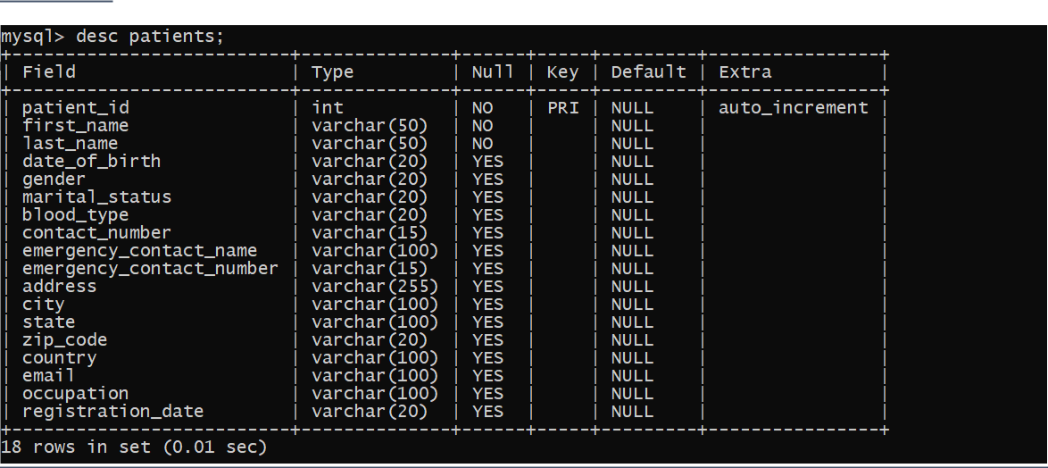

CODE:

CREATE TABLE patients (

patient_id INT AUTO_INCREMENT PRIMARY KEY,

first_name VARCHAR(50) NOT NULL,

last_name VARCHAR(50) NOT NULL,

date_of_birth VARCHAR(20),

gender VARCHAR(20),

marital_status VARCHAR(20),

blood_type VARCHAR(20),

contact_number VARCHAR(15),

emergency_contact_name VARCHAR(100),

emergency_contact_number VARCHAR(15),

address VARCHAR(255),

city VARCHAR(100),

state VARCHAR(100),

zip_code VARCHAR(20),
country VARCHAR(100),

email VARCHAR(100),

occupation VARCHAR(100),

registration_date VARCHAR(20)

);

→staff
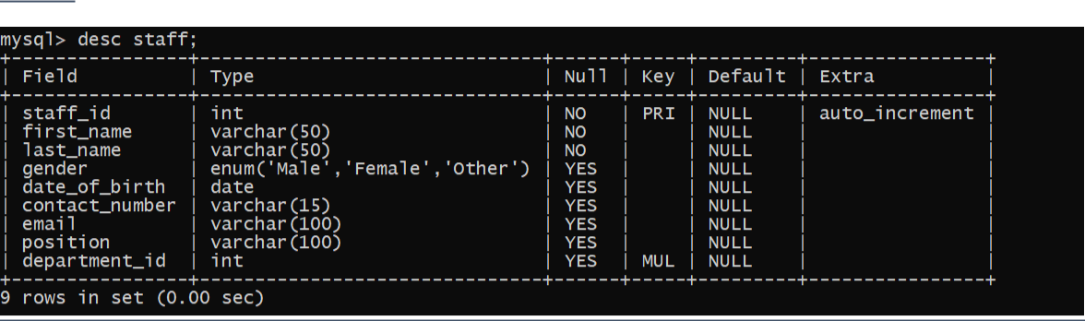

CODE:

CREATE TABLE staff (

staff_id INT AUTO_INCREMENT PRIMARY KEY,

first_name VARCHAR(50) NOT NULL,

last_name VARCHAR(50) NOT NULL,

gender ENUM('Male','Female','Other'),

date_of_birth DATE,

contact_number VARCHAR(15),

email VARCHAR(100),

position VARCHAR(100),

department_id INT,

FOREIGN KEY (department_id) REFERENCES departments(department_id)

);

→suppliers
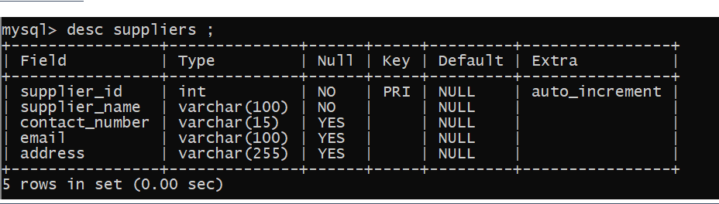
CODE:

CREATE TABLE suppliers (

supplier_id INT AUTO_INCREMENT PRIMARY KEY,

supplier_name VARCHAR(100) NOT NULL,

contact_number VARCHAR(15),

email VARCHAR(100),

address VARCHAR(255)

);

→wards_rooms
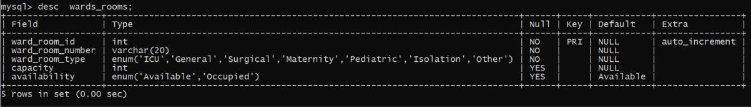

CODE:

CREATE TABLE wards_rooms (

ward_room_id INT AUTO_INCREMENT PRIMARY KEY,

ward_room_number VARCHAR(20) NOT NULL,

ward_room_type ENUM('ICU','General','Surgical','Maternity','Pediatric','Isolation','Other') NOT NULL, capacity INT,

availability ENUM('Available','Occupied') DEFAULT 'Available'

);

4. Creating a Database

Using MySQL server, create a new database for your hospital management system. You can do this with SQL commands or through the graphical interface.

CREATE DATABASE hospital;

5. Using a Database

Before performing any operations on a database, you need to select it using the USE statement:

USE hospital

ERD Diagram
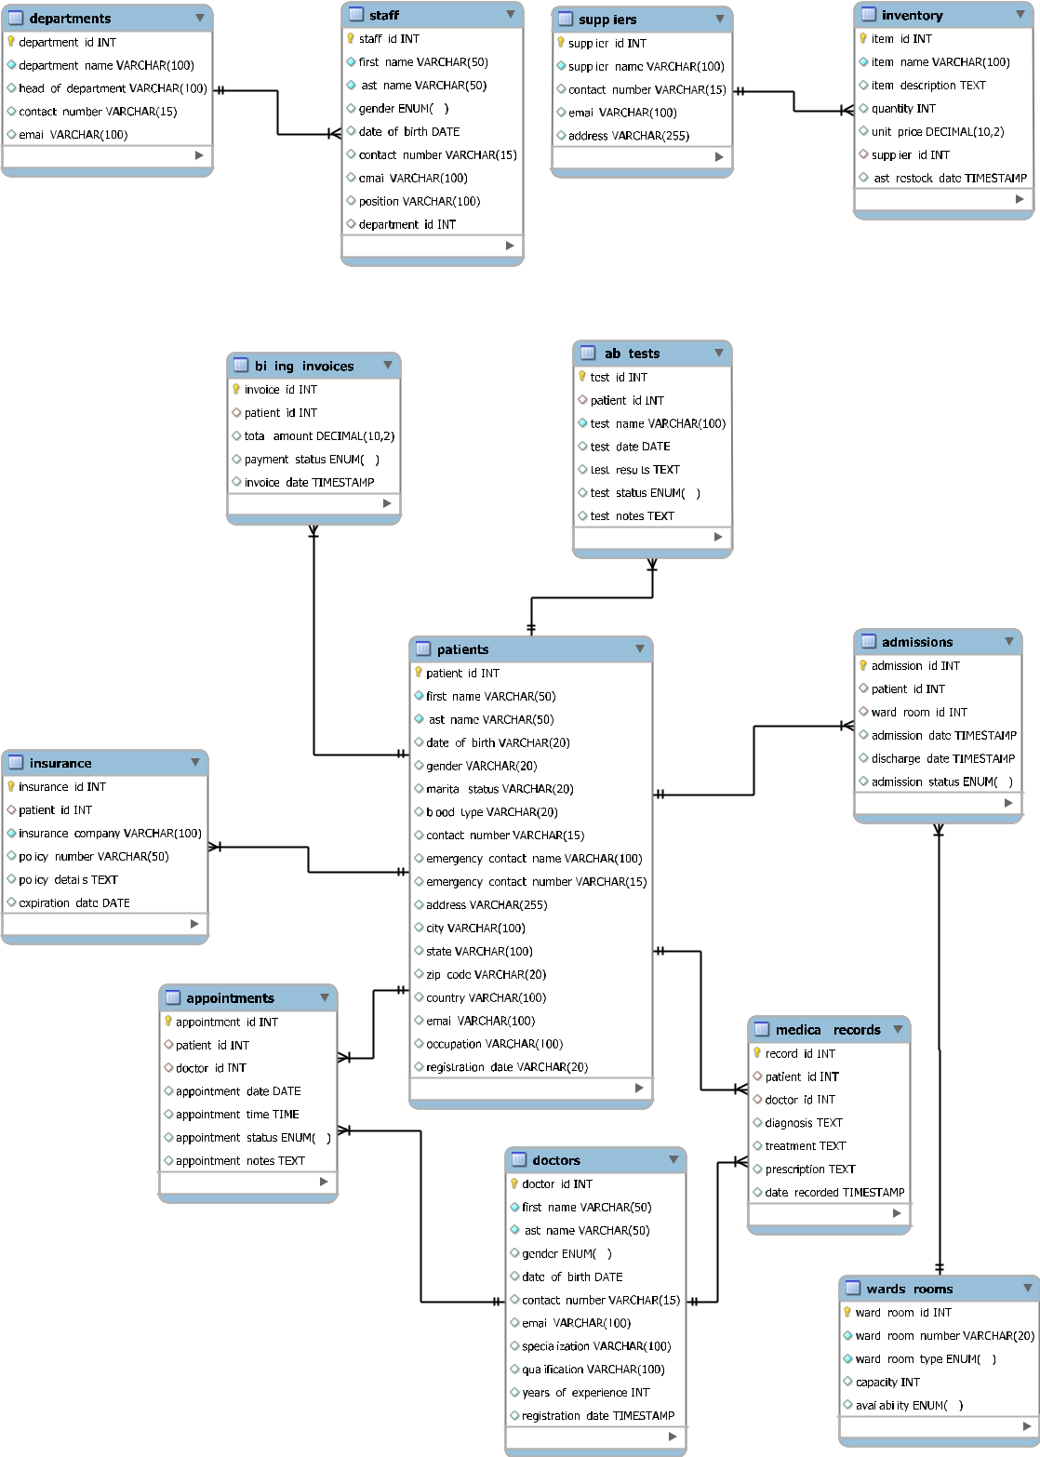

PN: Ideally no data should be deleted from any tables. You can use an additional column to set the status of that record to ‘Active/Inactive’, etc. Or you can use an Archive table to move the unnecessary records out of the main table.

THANK YOU…….

