

**A project Report on**

**AMAZON WEBSITE USING AUTOMATION TOOL SELENIUM WEBDRIVER WITH JAVA.**

**By**

**SHILPA. D**

**Batch- 5533**

**Under the Guidance of,**

**Amruta Deore Kachole**

**(Technical Trainer)**

**EduBridge India Pvt. Ltd.**

**Introduction:**

This project aims to do overall testing like functional testing, GUI testing on Amazon website to check, quality of application using selenium web driver. It helps to improve the quality of website and saves time for manually doing this testing.

In this project our main focus is to test the products. Module and Hotels module. Amazon website is usually seeking to appeal to a broad audience and often has a wealth of information to share with that audience. Finding the best design for your requirements means picking you battles.

**Software Requirements:**

Operating System: Windows 10

Browser: Latest version of Google Chrome

Platform: Eclipse IDE

Automation Tool and Language: Selenium WebDriver, Java

Files: JDK, Selenium Jar files, Common IO file

1. **AMAZON WEBSITE MODULE**

**TC01:** To Launch the browser and Amazon website

**Selenium WebDriver Test Script:**

System.*setProperty*("webdriver.chrome.driver","/Users/ shilpa/Desktop/SWD/chromedriver/ chromedriver");

WebDriver driver=new ChromeDriver();

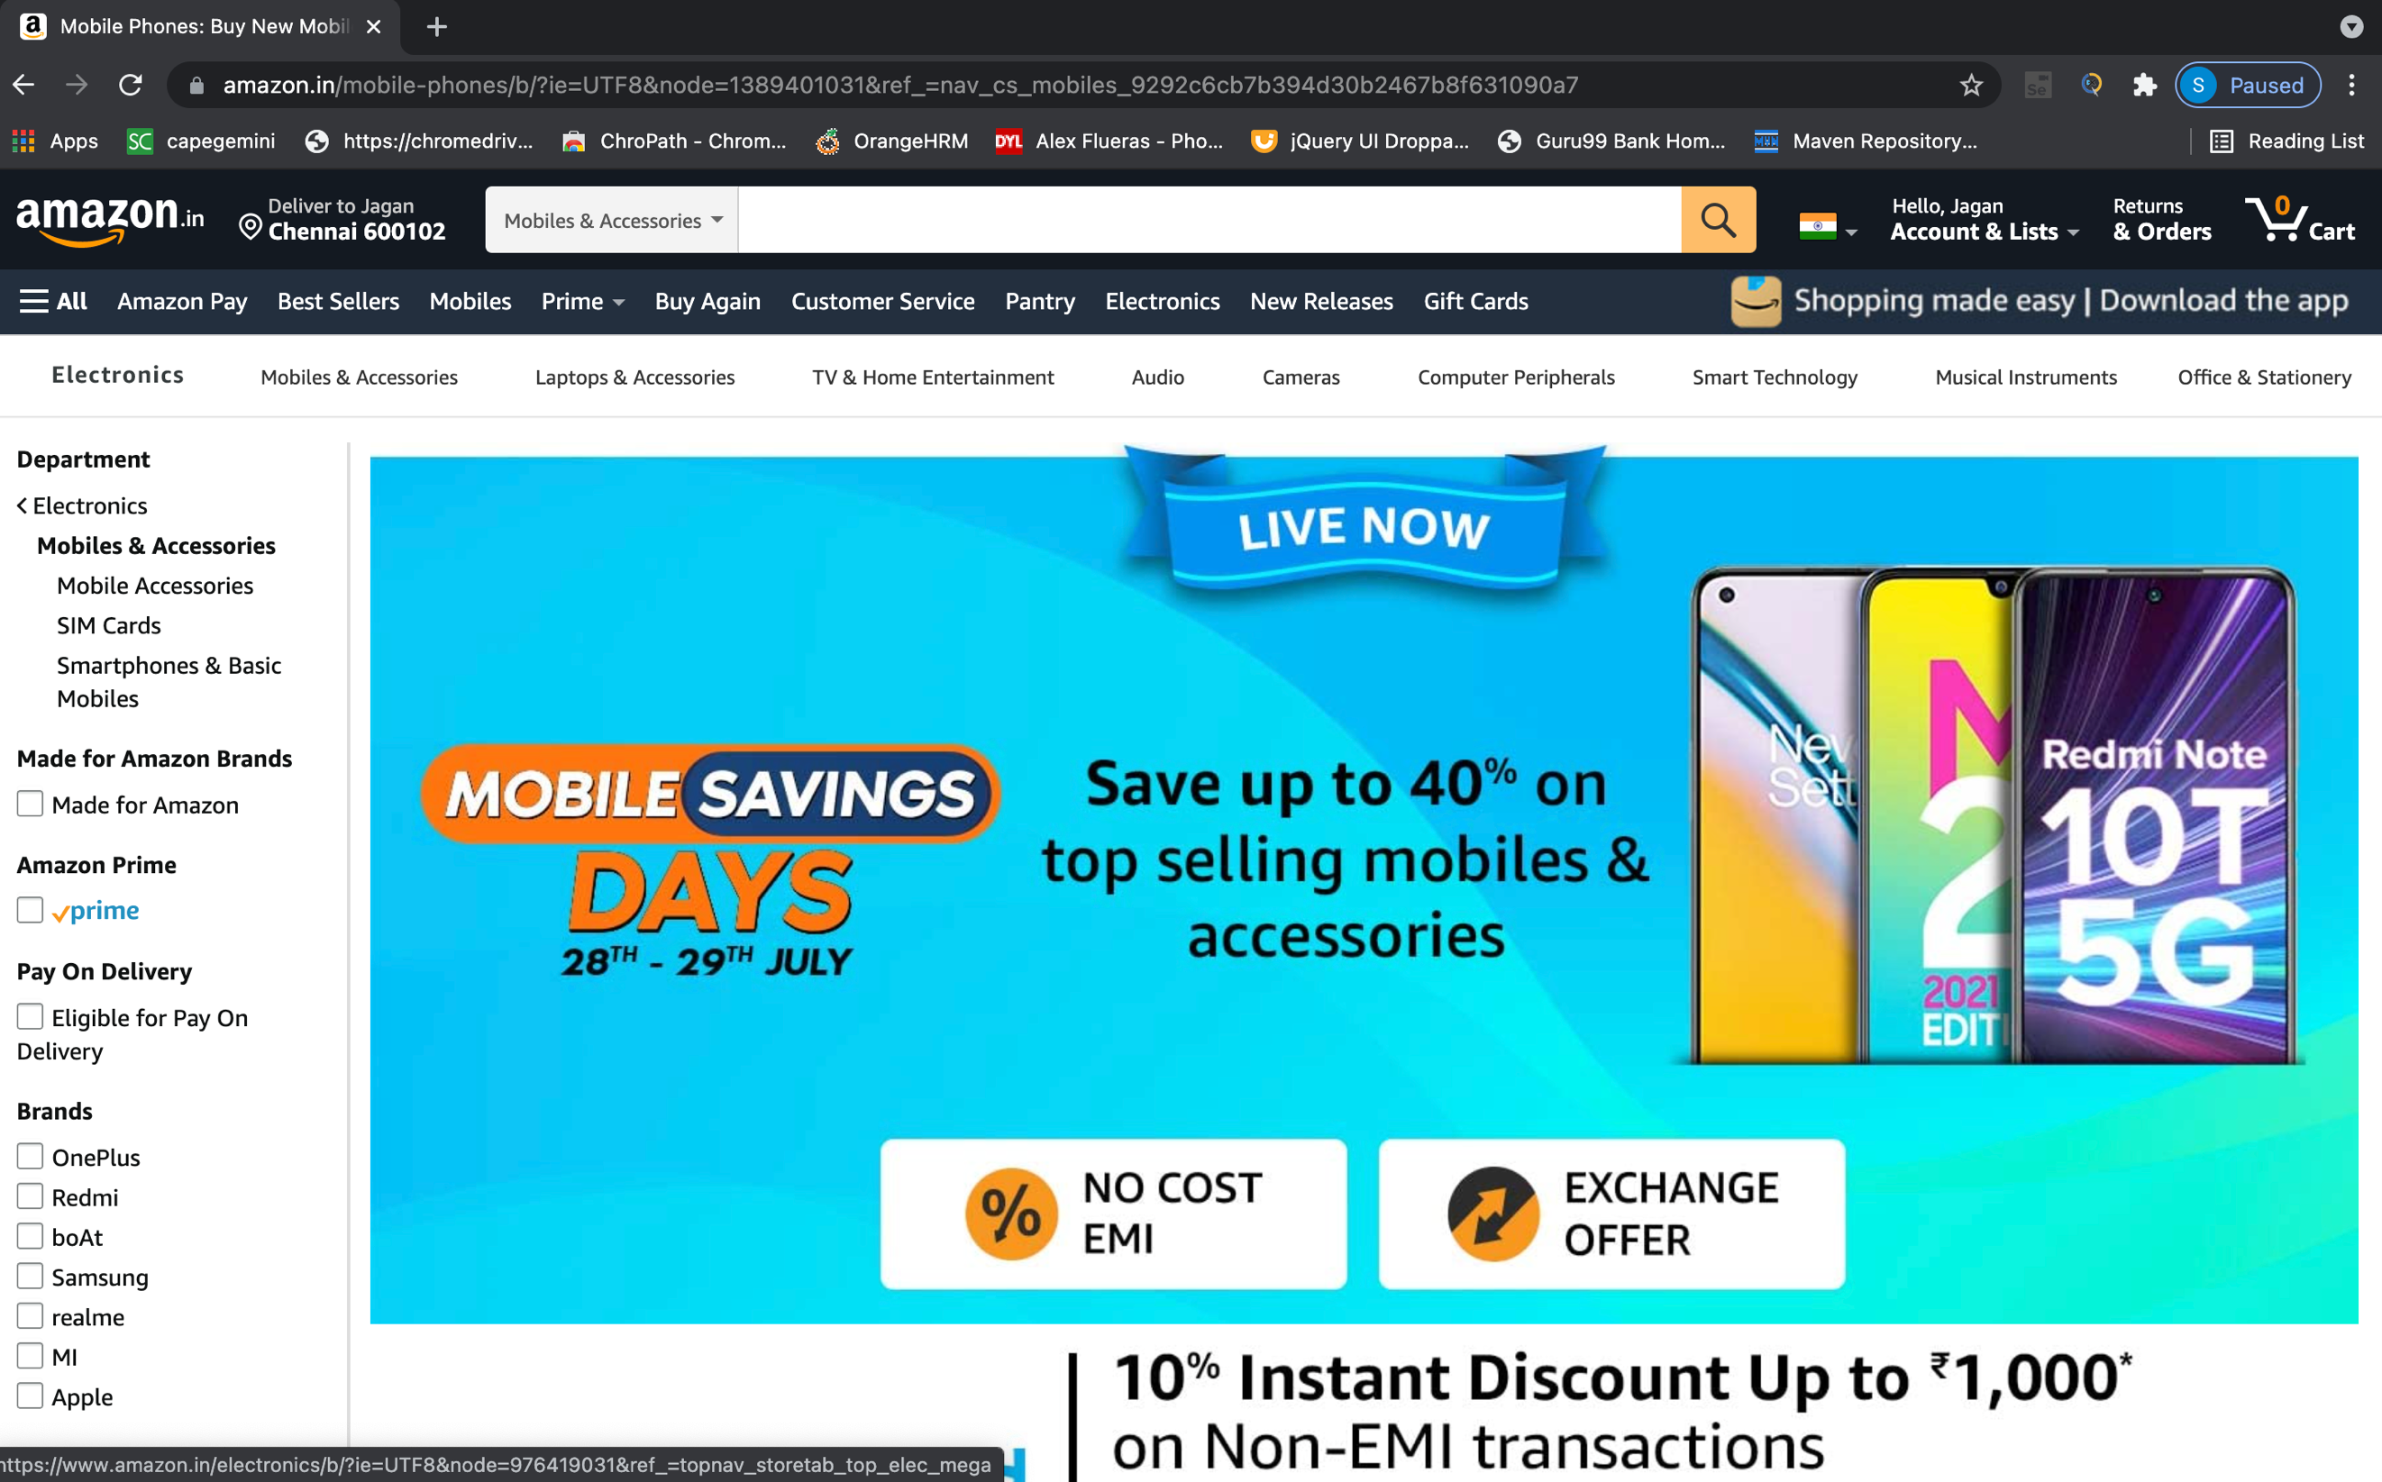

**TC02:** To verify the functionality of login button from Amazon Website

**Selenium WebDriver Test Script:**

driver.findElement(By.*xpath*("//header/div[@id='navbar']/div[@id='nav-flyoutanchor']/div[9]/ div[2]/ a[1]/span [1]" )). click();

**TC03:** To verify the functionality of login page and pass details

**Selenium WebDriver Test Script:**

driver.findElement(By.*xpath*("//input[@id='ap_email']")). sendKeys("7358777236");

driver.findElement(By.*xpath*("//input[@id='continue']")). click();

driver.findElement(By.*xpath*("//input[@id='ap_password']")). sendKeys("shilpa");

driver.findElement(By.*xpath*("//input[@id='signInSubmit']")). click();

**TC04:** To verify and display the Title of the current page.

**Selenium WebDriver Test Script:**

String expectedTitle = "Amazon.in";

String actualTitle = driver.getTitle();

if(actualTitle.contentEquals(expectedTitle))

{

System.***out***.println("Test Passed !")

}

else

{

System.***out***.println("Test Failed !");

}

driver.getTitle();

System.***out***.println("Title of page is:\"+d.get Title()");

**TC05:** To verify the functionality of language button from radio buttons

**Selenium WebDriver Test Script:**

driver.findElement(By.*xpath*("//header/div[@id='navbar']/div[@id='nav-belt']/div[3]/div[1]/a[1] /span[1]/span[2]/span[1]")). click();

driver.findElement(By.*xpath*("//body/div[@id='a-page']/div[ @id =' customer- preferences']/div [1]/div [1]/ form [ 1]/ div[1]/div[1]/div[1]/ div[1]/label[1]/ i[1]")).click();

driver.findElement(By.*xpath*("//body/div[@id='a-page']/div[@id='customer-preferences']/div[1] /div[1]/form[1]/span[2]/span[1]/input[1]")). click();

**TC06:** To verify the functionality of mobiles link text

**Selenium WebDriver Test Script:**

driver.findElement(By.*xpath*("//a[contains(text(),'Mobiles')]")). click();

**TC07:** To verify the functionality of check box in the website

**Selenium WebDriver Test Script:**

driver.findElement(By.*xpath*("//body/div[@id='a-page']/div[2]/div[2]/div[2]/div[1]/div[1]/div [5]/ul[1]/li[1]/span[1]/a[1]/span[1]")). click();

**TC08:** To verify the functionality of mouse over a product

**Selenium WebDriver Test Script:**

driver.findElement(By.*xpath*("//span[contains(text(),'OnePlus Bullets Wireless Z Bass Edition (Bold Blac')]" )). click();

**TC09:** To verify multiple window handling

**Selenium WebDriver Test Script:**

String Mainwindow= driver.getWindowHandle();

Set<String> s1= driver.getWindowHandles();

Iterator<String> i1=s1.iterator();

while(i1.hasNext())

{

String childwindow=i1.next();

if(!Mainwindow.equalsIgnoreCase(childwindow))

{

driver.switchTo().window(childwindow);

}

System.***out***.println("Handling Multiple Window!");

}

**TC10:** To verify the functionality of drop-down button

**Selenium WebDriver Test Script:**

Select quan= new Select(driver.findElement(By.*name*(" quantity")));

quan.selectByValue("2");

**TC11:** To verify check box and add to cart button

**Selenium WebDriver Test Script:**

driver.findElement(By.*xpath*("//input[@id='gift-wrap'] ")).click(); driver.findElement(By.*xpath*("//input[@id='add-to-cart-button']")).click();

**TC12:** To verify the functionality of search bar

**Selenium WebDriver Test Script:**

driver.findElement(By.*xpath*("//input[@id='twotabsearchtextbox']")).sendKeys("Chocolates");

driver.findElement(By.*xpath*("//input[@id='nav-search-submit-button']")).click();

**TC13:** To verify the functionality of scroll down and scroll up

**Selenium WebDriver Test Script:**

JavascriptExecutor js = (JavascriptExecutor)driver;

js.executeScript("window.scrollBy(0,200)");

Thread.*sleep*(3000);

js.executeScript("window.scrollBy(0,-200)");

**TC14:** To verify the functionality of link text of rating

**Selenium WebDriver Test Script:**

driver.findElement(By.*xpath*("//body[1]/div[1]/div[2]/div[1]/div[1]/div[2]/div[1]/div[3]/span[1]/div[1]/span[1]/div[1]/div[1]/div[4]/ul[1]/li[1]/span[1]/a[1]/section[1]/span[1]")).click();

**TC16:** To verify the functionality of logout button

**Selenium WebDriver Test Script:**

driver.findElement(By.*xpath*("//header/div[@id='navbar']/div[@id='nav-belt']/div[3]/div[1] /a[2]/span[1] ")). click();

driver.findElement(By.*xpath*("//span[contains(text(),'Sign Out')]")).click();

**TC17:** To verify the navigation to go back to previous page.

**Selenium WebDriver Test Script:**

driver.navigate().back();

**TC18:** To verify that browser is able to close.

**Selenium WebDriver Test Script:**

driver.close();