**Churn Prediction**

  The logistic regression gives the best model: a better true positive rate for less false positive observations.

Once uploaded, navigate to Sheet 1 as shown in the below figure.

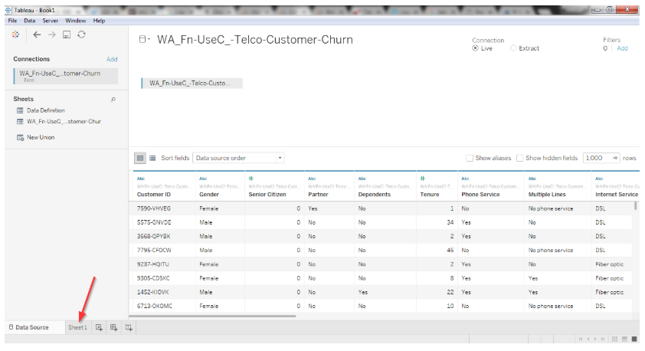

The field "Churn" is a boolean field with "Yes/No" values. We can also transform it into values such as 0/1. The reason I brought up this simple transformation here is to demonstrate the use of **calculated field**option in Tableau. This option helps to create new fields and is useful for cases where we want to do some data transformations, calculations such as aggregations, or if we want to create new data using a formula based on already existing data. Right click and select 'Create Calculated Field' in the Measures tab as shown in the following figure.

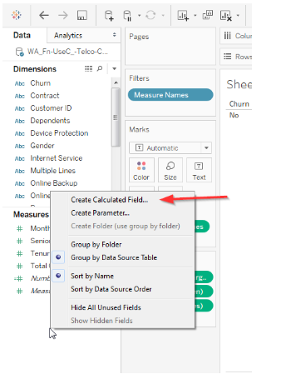

This pops up an editing dialog box. The calculated values are defined by entering a formula into Tableau's formula box. For this exercise, enter the calculated field's name to be "Churn_transformed". Use the below function in the formula section of the dialog box and click OK to create the field:

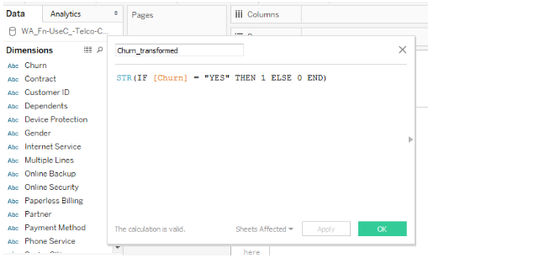

Now, we know how to create a calculated field. Let's move on to create the Churn[predicted] field. This will store the result of the customer churn prediction returned from R. Before we move on creating the field, we first need to connect Tableau to R using the '**Manage External Service Connection**' option, available in the Help section of Tableau as illustrated in the below figure.

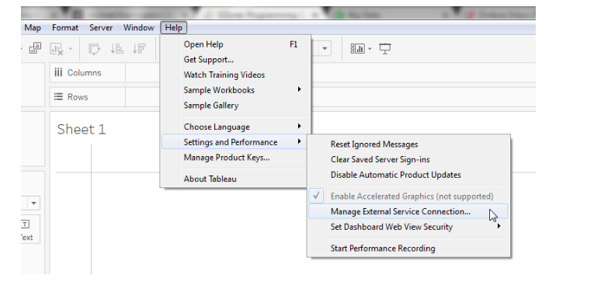

If your R services and Rserve are running at the same place, set the connection's server to localhost. The default port is 6311. You can leave it as is, if the port is not changed. Click OK to connect R and Tableau.

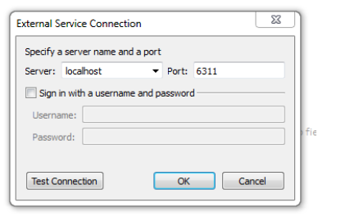

Now, create the **Churn[Predicted]** field in the same manner we created the Churn_transformed field. However, for this exercise, we will be using an R script in the formula section. There are various ways to call an R script from Tableau as discussed below. Mostly they are identified by the type of values they return from R:

* **SCRIPT_INT**returns an integer.
* **SCRIPT_REAL** returns float values.
* **SCRIPT_STR** returns string.
* **SCRIPT_BOOL** returns T|F values.

The below script reads that the first parameter .arg1 for R script references Tableau's field ATTR([Churn_transformed]). The other parameters follow the same pattern.

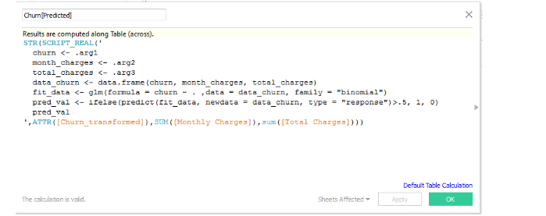

With this, you are now ready to use the predictions from R along with other attributes of your data set. Now with this field, you can do a lot more on Tableau to get great eye-catching visualization and dashboard with your historical and predicted data.

