**Predicting Traffic Accident Severity**

**Applied Data Science Capstone**

Shilpa charaya

github.com/

shilpaabc

Traffic accidents are...

Cause of 1.35 million deaths globally in 2016.

Main cause of death among those aged 15

–

29

years.

Predicted to become the 7th leading cause of death by 2030.

Predicting the accident severity in advance could be used to send the exact required staff

and equipment to the place of the accident, thus saving a significant amount of lives each

year.

Road safety should be a prior interest for governments, local author

ities and private com

-

panies investing in technologies that can help reduce accidents and improve overall

driver safety.

©

AMAN KESHARWANI

© AMAN KESHARWANI © AMAN KESHARWANI



**Data**

All the recorded accidents in France from 2005 to 2016, both years included.

In

itial dataset from the Kaggle,

here

.

Pre

-

selcted features on my GitHub,

here

In total 49 features, 839,985 rows in the Kaggle dataset

Redundant and not relevant features were dropped

29

features pre

-

selected

On the data cleaning missing values and outliers were replaced.

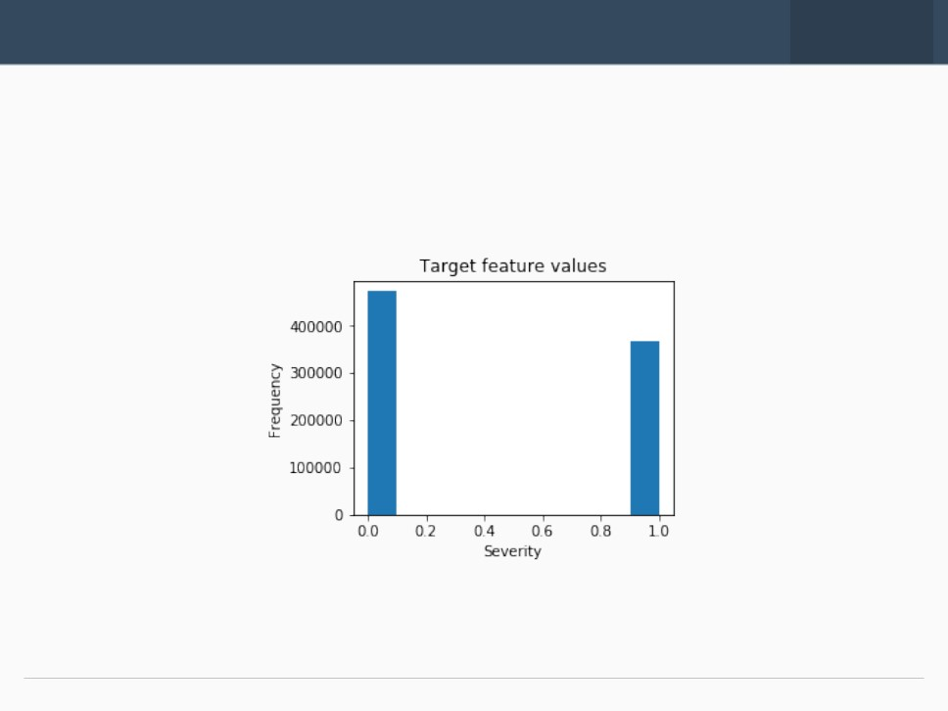

**EDA**

**-**

**Target**

The target feature a binary classifier, describing the accident severity.

0:

low severity.

1:

high severity, from hospitalized wound

ed injuries to death.

It is a balanced labeled dataset with more cases of lower severity.

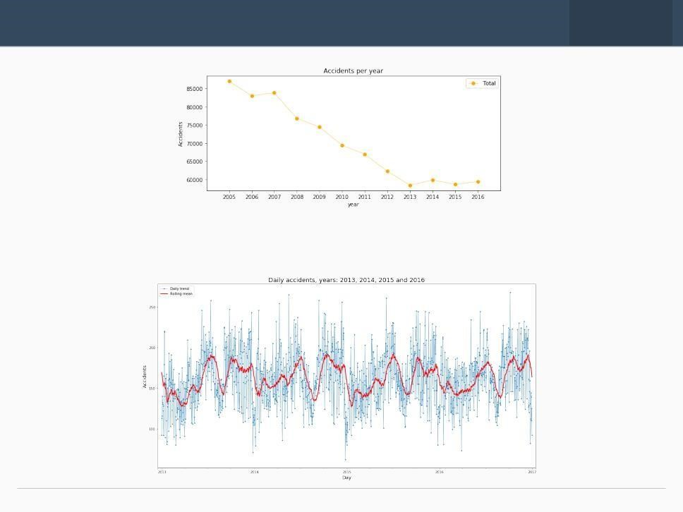

**EDA**

**-**

**Seasonality**

The number of traffic accidents decreased over the years from 2005 to 2013, after

which the trend became stable.

©

AMAN KESHARWANI

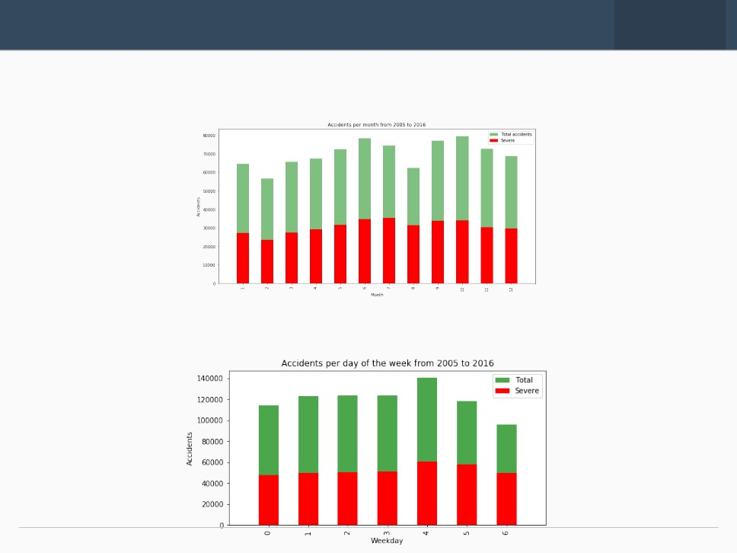

**EDA**

**-**

**Seasonality**

Accidents increase from March to June and then again in September, decreasing a

t

the end of the year.

Steady trend during the

**week**

. More accidents on Friday and less on Sunday

©

AMAN KESHARWANI

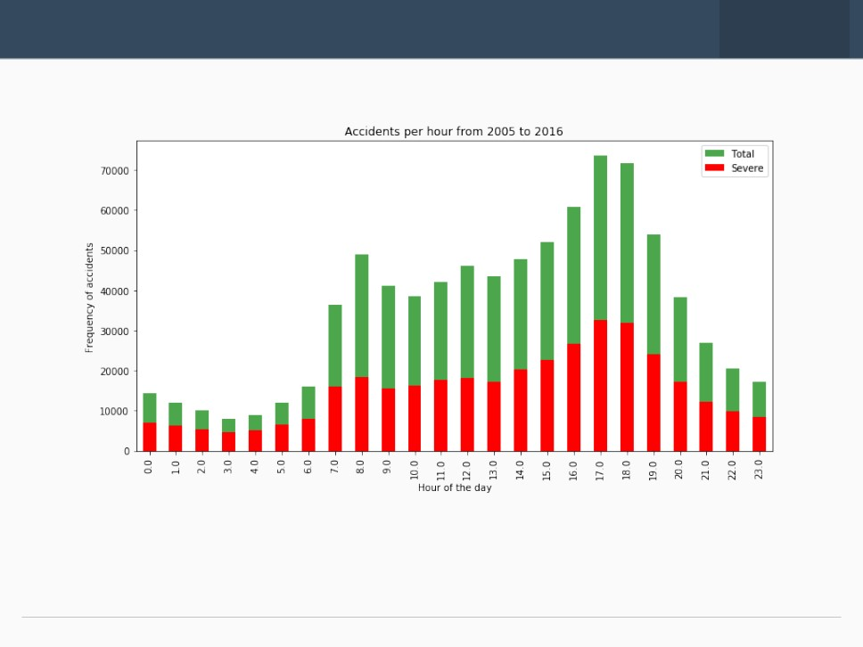

**EDA**

**-**

**Seasonality**

The trend of highly severe accidents is proportional to the global trend.

**Spikes:**

8

am: people go to work

5

-

6

pm: people return home.

©

AMAN KESHARWANI

© AMAN KESHARWANI



**Classification Models**

Random Forest:

10

decision

trees

maximum depth of 12 features

Logistic

Regression

c=0.001

K

-

Nearest Neighbor

K=16

Supervised Vector Machine

Due to computation inefficiency, training size was reduced to 75,000 samples.

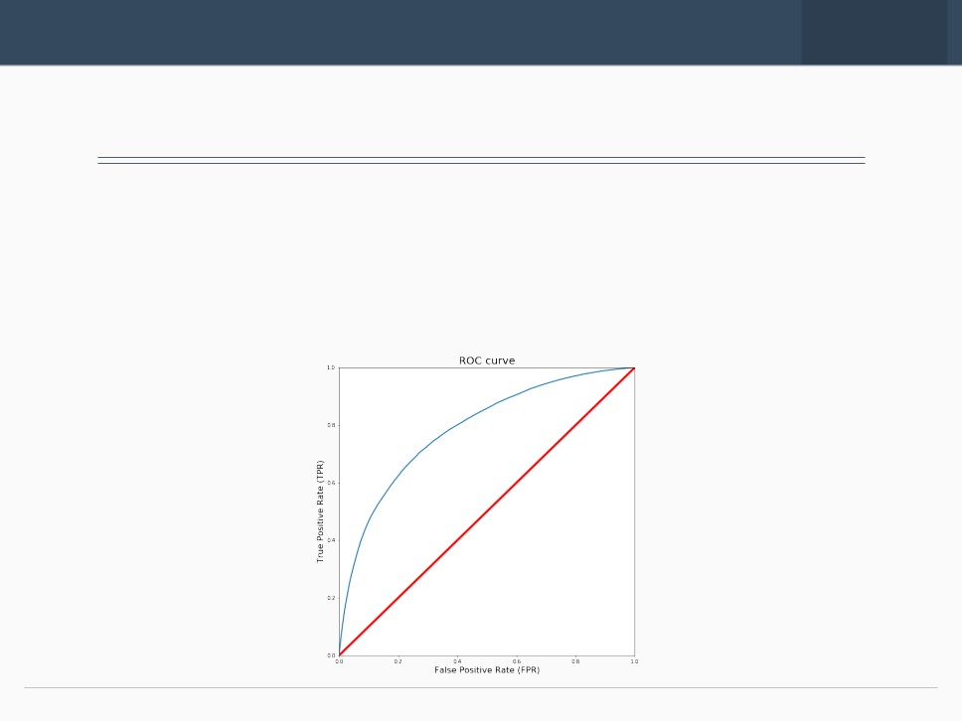

**Results**

This table reports the results of the evaluation of each model.

**Algorithm**

**Jaccard**

**f1**

**-**

**score**

**Precision**

**Recall**

**Time(s)**

**Random Forest**

0.722

0.72

0.724

0.591

6.588

**Logistic Regression**

0.661

0.65

0.667

0.456

6.530

**KNN**

0.664

0.66

0.652

0.506

200.58

**SVM**

0.659

0.65

0.630

0.528

403.92

With no doubt the

*Random*

*Forest*

is the

best model,

in the same

time

as

the

*log.*

*res.*

it

improves the accuracy from 0.66 to 0.72 and the recall from 0.45 to 0.59.

©

AMAN KESHARWANI

© AMAN KESHARWANI



**Conclusion and future projects**

Built useful models to predict the severity of a traffic accident.

Accuracy of the models has room for improvement.

Future projects:

Add features such as vehicle speed and time of uninterrupted traveling.

Prediction of potential accident, critical spots and time.