**Marketects: Delivering Good Enterprise Architecture**

[blog.cutter.com](https://blog.cutter.com/2013/04/09/marketects-delivering-good-enterprise-architecture/)

5-6 minutes

Good architects also need to be good “marketects”: they must be able to sell and promote their cause as well as publicize their achievements, outcomes, and results. But how do they do this? What tips and guidelines from the world of marketing can architects adopt to their advantage?

First of all, what do we mean by “marketecture”? With a cynical hat on, some might argue that marketecture is about selling something that you don’t really need. In a [Dilbert cartoon from 2009](http://dilbert.com/2009-03-02), the Director of Marketecture says that “it is better to seem good than to be good. A misleading benchmark test can accomplish in minutes what years of good engineering can never do.”

In contrast, our aim should be to deliver good enterprise architecture — and to make sure all stakeholders recognize and see that it is good! Here we use the term in this positive sense to describe practical steps that enterprise architects must take in order to properly promote the benefits, outcomes, and achievements delivered by a change to the architecture. Effective communication is key: gain commitment from a diverse range of stakeholders and then keep them on board throughout the evolution and change process of the architecture.

So, in essence, marketecture (sometimes spelled “markitecture”) is a way of presenting the enterprise architecture so that you can promote it in an appealing manner. Typically this view comprises a simplified picture or story that still refers to all key architectural components. It must make sense to both a technical and a nontechnical audience. And it must demonstrate how EA not only supports strategy or requirements but how EA delivers benefits, value, or key outcomes.

**Effective Marketecture Requirements**

Figure 1 describes the four areas that need to be included in an effective marketecture:

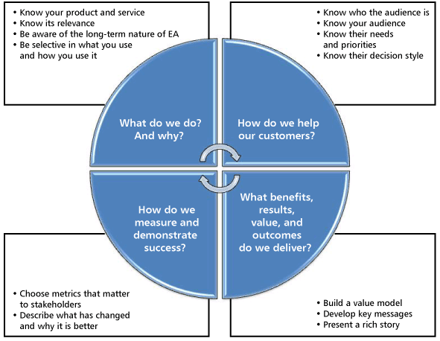

Figure 1 — Marketecture requirements.

1. **We need to say a little bit about what we do, as architects, and why we do it.** But we shouldn’t get too carried away because it can get boring, esoteric, and irrelevant to our audience. Instead, we need to be selective and say enough to distinguish EA from other disciplines. Think as an architect by using relevant architectural techniques, simplified if necessary, to get your ideas across. Above all, a vital and unique characteristic of EA is the ability to synthesize multiple diverse views.
2. **We need to be clear about how we help our customers.** All marketecture must be directed to its needs and priorities. Architects must explicitly show how EA supports decision making and promotes effective investment.
3. **Marketecture must focus on the delivered benefits, results, value, and outcomes.** To do this, we need to build a value model that recognizes the value propositions that matter to our stakeholders.
4. **We need to measure and demonstrate our success.** We need to succinctly describe the changes we have produced, using metrics that prove things are better.

The two most effective ways to sell your cause are to tell great stories and create compelling pictures. For every EA initiative, there should be a minimum of one really good story — something that can become part of the mythology of the enterprise. And for every EA idea, concept, or transformation that you want to marketect, there should be informal one-page overviews to show the essential components and relationships in the architecture. EA diagrams can be far too complicated and abstruse; don’t fall in that trap. A strong, compelling graphic serves as a great vehicle for getting your ideas across.

Whatever you produce to promote and sell your cause, it must achieve the following three objectives:

* Serve to sell architectural ideas and get commitment.
* Must be easy to understand and explain, serving as a starting point for deeper debate.
* Must be an excellent and useful tool for facilitating discussion and analysis among stakeholders during the design, build, review, and operation of the architecture.

**Conclusion**

We need to actively marketect EA because (1) the benefits of architecture are mainly long term; (2) we have created a misconception that EA is optional; and (3) the holistic nature of architecture means that there are a very large number of constantly shifting stakeholders.

Marketecture is really nothing more than good communication with people that matter. Three key points to remember within those communications are:

* **Think like an architect.** Do not use a project or short-term view.
* **Maintain an holistic, big-picture overview.** Balance all views.
* **Create compelling diagrams, stories, and metrics.** Use ones that matter to your audience.