/* Write a Javascript code to check whether number is odd or even

<html>

<head>

<script type="text/javascript">

function even()

{

var no;

no= parseInt(f1.t1.value);

if(no%2==0)

{

alert("No is even");

}

else

{

alert("No is odd");

}

}

</script>

</head>

<body>

<form name="f1">

<h1>to check whether number is odd or even</h1>

Enter number:<input type="text" name="t1"><br>

<input type="button" name="b1" value="check" onClick="even()">

</form>

</body>

</html>

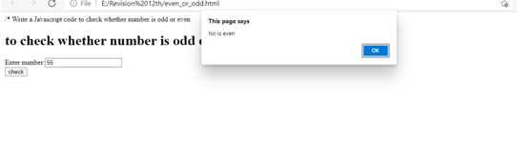

/* Write a Javascript code to check whether number is multiple or divisible by 5 or not

<html>

<head>

<script type="text/javascript">

function cal()

{

var no;

no= parseInt(f1.t1.value);

if(no%5==0)

{

alert("No is divible by 5");

}

else

{

alert("No is not divible by 5");

}

}

</script>

</head>

<body>

<form name="f1">

<h1>to check whether number is multiple or divisible by 5 or not</h1>

Enter number:<input type="text" name="t1"><br>

<input type="button" name="b1" value="check" onClick="cal()">

</form>

</body>

</html>

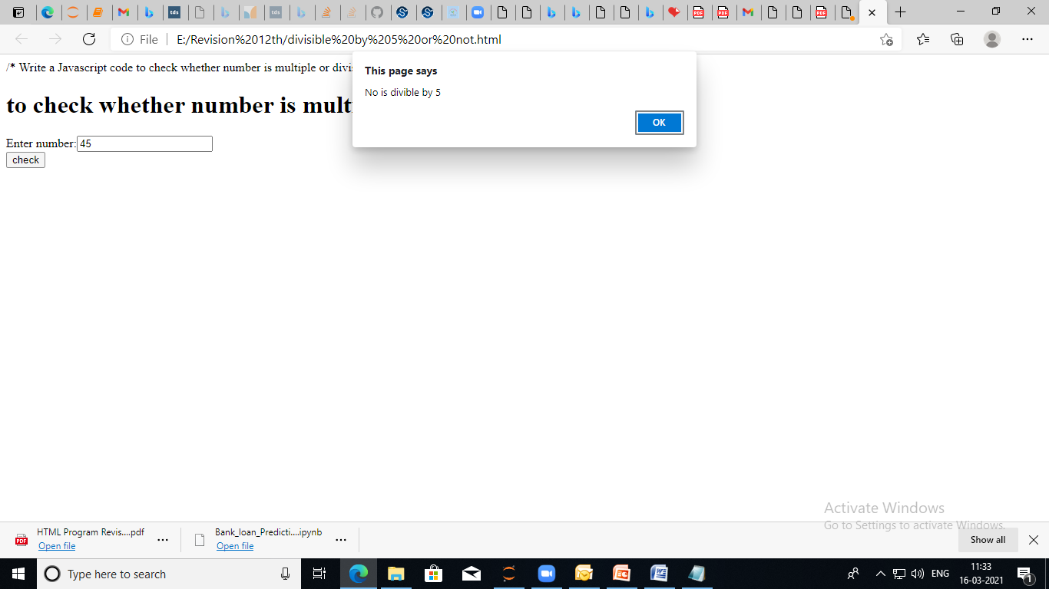

/* Write javascript code to print all even numbers from 100 to 150

<Html>

<head>

<title> Even numbers</title>

<script type="text/javascript">

function even()

{

var i;

document.write("Even numbers from 100 to 150 <br>");

for(i=100;i<=150;i=i+2)

{

document.write(i+"<br>");

}

}

</script>

</head>

<body>

<form>

<h1>print all even numbers from 100 to 150</h1>

<input type="button" value="click here" onClick="even()">

</form>

</body>

</html>

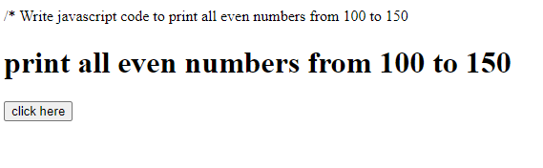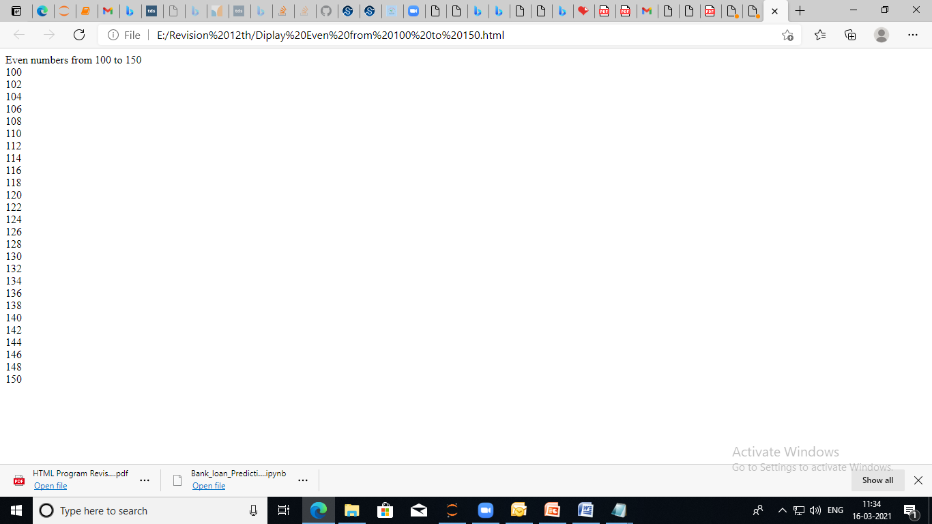

/* Write javascript code to print all odd numbers from 100 to 150

<Html>

<head>

<title> Odd numbers</title>

<script type="text/javascript">

function odd()

{

var i;

document.write("Odd numbers from 100 to 150 <br>");

for(i=101;i<=150;i=i+2)

{

document.write(i+"<br>");

}

}

</script>

</head>

<body>

<form>

<h1>print all odd numbers from 100 to 150</h1>

<input type="button" value="click here" onClick="odd()">

</form>

</body>

</html>

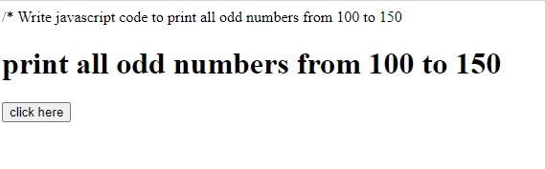

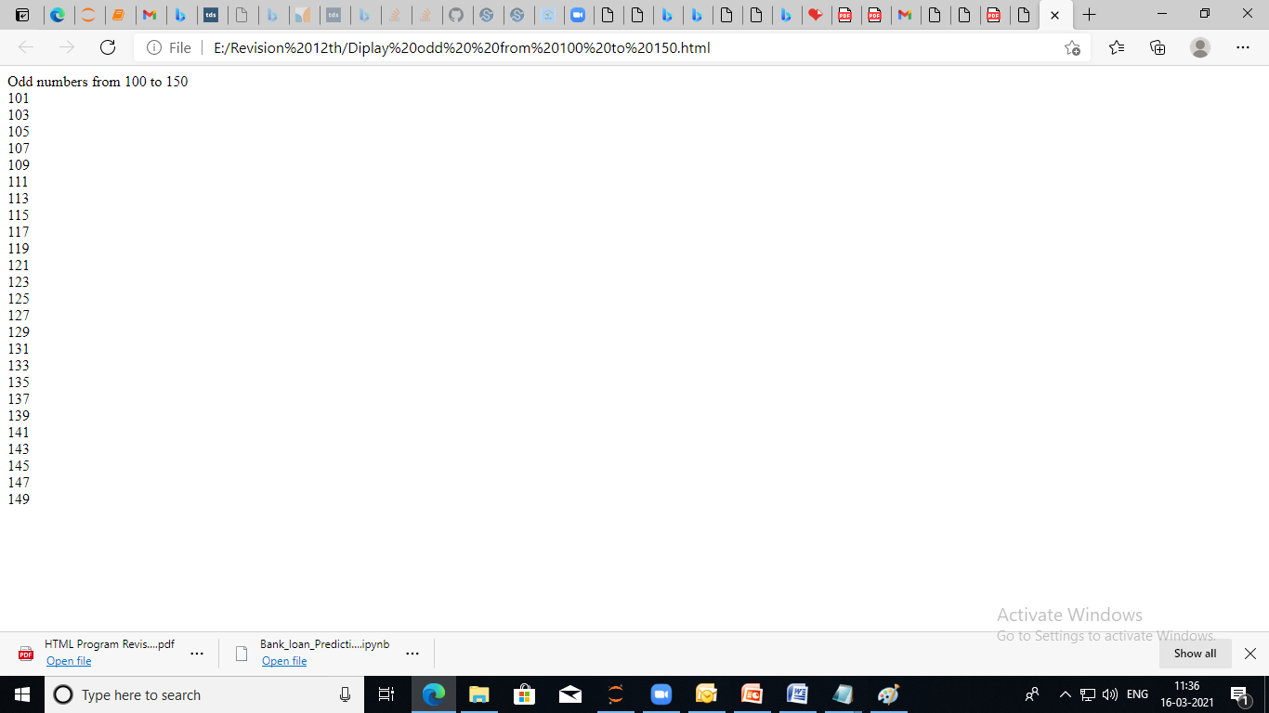

/* write Javascript code to print multiplication table of 3

<html>

<Head><title> Multiplication table of 3</title>

<script type="text/javascript">

function table()

{

var no,i,mul;

no =3;

document.write("Table of 3 is as follows<br>");

for(i=1;i<=10;i++)

{

mul=no*i;

document.write(no+"*"+i+"="+mul+"<br>");

}

}

</script>

</head>

<body>

<Form>

<h1>Multiplication table of 3</h1>

<input type="button" value="click me" onClick="table()">

</form>

</body>

</html>

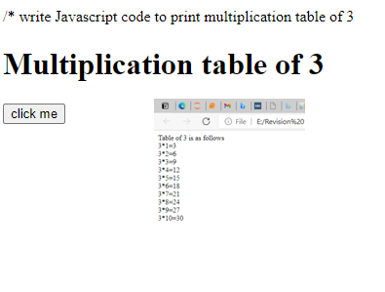

/* Write javascript code to print all first 50 natural numbers

<Html>

<head>

<title> first 50 natural number</title>

<script type="text/javascript">

function natural()

{

var i;

document.write("first 50 natural number <br>");

for(i=1;i<=50;i=i+1)

{

document.write(i+"<br>");

}

}

</script>

</head>

<body>

<form>

<h1>first 50 natural number</h1>

<input type="button" value="click here" onClick="natural()">

</form>

</body>

</html>

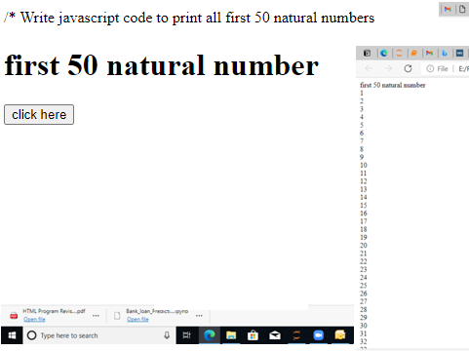

/* Write javascript code to print square of accepted number

<head>

<title> to print square of accepted number</title>

<script type="text/javascript">

function square()

{

var i,square;

i=parseInt(f1.t1.value);

document.write("To print square of accepted number <br>");

square=i*i;

document.write(i+"*"+i+"="+square+"<br>");

}

</script>

</head>

<body>

<form name="f1">

<h1>to print square of accepted number</h1>

Enter number:<input type="text" name="t1"><br>

<input type="button" value="click here" onClick="square()">

</form>

</body>

</html>

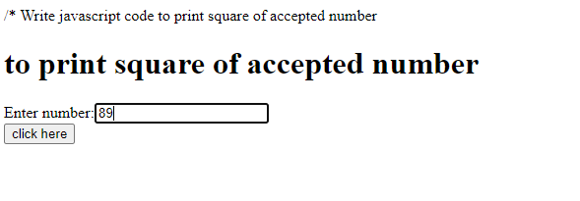

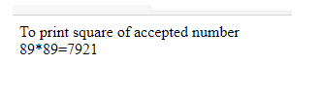

/* find number of vowels in a string in JavaScript*/

<html>

<head>

<title>find number of vowels in a string in JavaScript</title>

<script type="text/javascript">

function Vowels()

{

var str = document.getElementById("t1").value;

var count = 0, total_vowels="";

for (var i = 0; i < str.length; i++)

{

// findVowels

if(str.charAt(i)=="a"||str.charAt(i)=="e"||str.charAt(i)=="i"||str.charAt(i)=="o"||str.charAt(i)=="u"||str.charAt(i)=="A"||str.charAt(i)=="E"||str.charAt(i)=="I"||str.charAt(i)=="O"||str.charAt(i)=="U")

{

count++;

}

}

alert("VOWEL count is="+ count);

}

</script>

</head>

<body>

<form>

<h1>Get Vowels from String</h1>

Enter Text :<input type="text" id="t1" />

<input type="button" value="Get Vowels Count" onclick="Vowels()" />

</form>

</body>

</html>

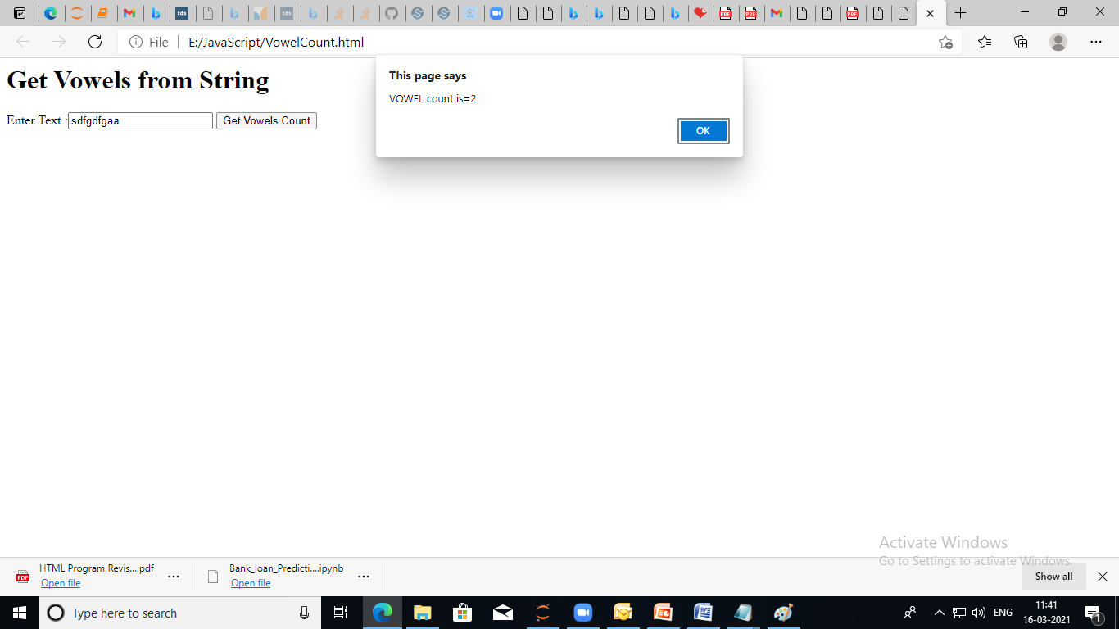

/*1. DISPLAY Addition, MULTIPLICATION, division AND REMAINDER of two numbers, which were ACCEPTED from user.*/

<!doctype html>

<html>

<head><title>Calculator using Javascript</title>

<script type="text/javascript">

var result=0;

function calc()

{

var n1=parseInt(f1.t1.value);

var n2=parseInt(f1.t2.value);

document.write("<br>Accepted Numbers are n1= "+n1+" & n2="+n2);

result=n1+n2;

document.write("<br>Addition is="+result);

result=n1*n2;

document.write("<br>Multiplication is="+result);

result=n1/n2;

document.write("<br>division ans is="+result);

result=n1%n2;

document.write("<br>Reminder is="+result);

}

</script>

</head>

<body>

<form name="f1">

Enter first Number:<input type="text" name="t1"><br><br>

Enter Second Number:<input type="text" name="t2"><br><br>

<input type="button" value="Calculator" onClick="calc()">

</form>

</body>

</html>

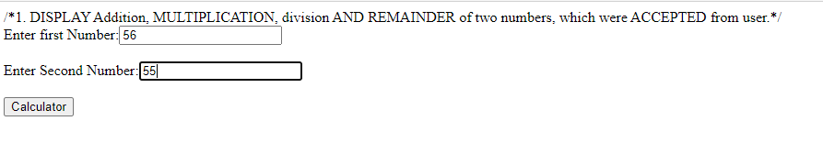

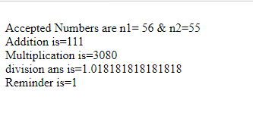

/* find Factorial of given number

<!Doctype html>

<HTML>

<Head><title>Factorial of given number</title>

<script type="text/javascript">

function fact()

{

var i=1,fact=1;

var num=parseInt(f1.t1.value); //To accept value

for(i=1;i<num;i++)

{

fact=fact*i;

}

document.write("factorial of "+num+"="+fact);

}

</script>

</Head>

<body>

<form name="f1">

Enter number:<input type="text" name="t1">

<input type="button" value="find factorial" onClick="fact()">

</form>

</body>

</HTML>

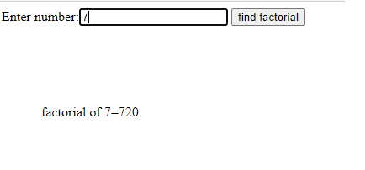

/* Factorial of 5

<!Doctype html>

<HTML>

<Head><title>Factorial of 5 </title>

<script type="text/javascript">

function fact()

{

var i=1,fact=1;

for(i=1;i<=5;i++)

{

fact=fact*i;

}

document.write("factorial of 5="+fact);

}

</script>

</Head>

<body>

<form name="f1">

<input type="button" value="find factorial of 5" onClick="fact()">

</form>

</body>

</HTML>

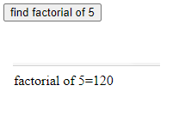

/* write Javascript to swap two numbers

<!doctype html>

<html>

<head><title> Swapping of two numbers</title>

<script type="text/javascript">

function swap()

{

var a,b,tmp;

a=f1.t1.value;

b=f1.t2.value;

document.write("Values before swapping <br> a="+a);

document.write("<br>b="+b);

tmp=a;

a=b;

b=tmp;

document.write("<br>Values after swapping <br> a="+a);

document.write("<br>b="+b);

}

</script>

</head>

<body>

<form name="f1">

Enter a:<input type="text" name="t1"><br>

Enter b:<input type="text" name="t2"><br>

<input type="button" value="swap" onClick="swap()">

</form>

</body>

</html>

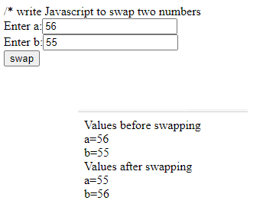

/* wrie code to print multplication of 2 numbers*/

<html>

<head> <title> multplication</title>

<script type="text/javascript">

function mult()

{

var a,b, result;

a=parseInt(f1.t1.value);

b=parseInt(f1.t2.value);

result=a*b;

document.write("Multiplication is="+result);

}

</script>

</head>

<body>

<h1> Muliplication</h1>

<form name="f1">

Enter First number:<input type="text" name="t1"><br>

Enter Second number:<input type="text" name="t2"><br>

<input type="button" value="Multiplication" onClick="mult()">

</form>

</body>

</html>

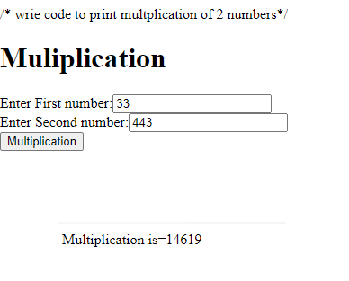

/* Display table of 5 using Javascript

<!doctype html>

<html>

<head><title> Display table of 5</title>

<script type="text/javascript">

function display()

{

var i, num=5, res

document.write("Table of 5");

document.write("<Br>");

for(i=1;i<=10;i++)

{

res=num*i;

document.write(num+"*"+i+"="+res+"<BR>");

}

}

</script>

<body>

<h1> Table of 5</h1>

<form>

<input type="button" value="clickhere" onClick="display()">

</form>

</body>

</html>

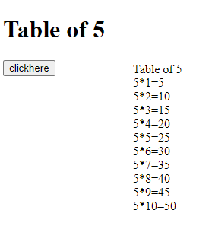

/* Write a Javascript to print perimeter of trapezium.*/

<html>

<head><title>print perimeter of trapezium</title>

<script type="text/javascript">

function perimeter()

{

var n1,n2,n3,n4,p;

n1=parseInt(f1.t1.value);

n2=parseInt(f1.t2.value);

n3=parseInt(f1.t3.value);

n4=parseInt(f1.t4.value);

p=(n1+n2+n3+n4);

document.write("perimeter of trapezium="+ p);

}

</script>

</head>

<body>

<form name="f1">

Enter value of first side :<input type="text" name="t1"><br>

Enter value of Second side:<input type="text" name="t2"><br>

Enter value of third side:<input type="text" name="t3"><br>

Enter value of fourth side:<input type="text" name="t4"><br>

<input type="button" value="Perimeter" onClick="perimeter()">

</form>

</body>

</html>

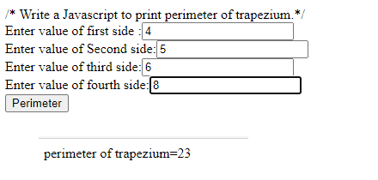

/* write javascript code to print area of triangle (hint 1/2 * base * height)

<html>

<head> <title> area of triangle </title>

<script type="text/javascript">

function Tarea()

{

var base,height, result;

base=parseInt(f1.t1.value);

height=parseInt(f1.t2.value);

result= 1/2*base*height;

document.write("Area of triangle is="+result);

}

</script>

</head>

<body>

<h1>to print area of triangle</h1>

<form name="f1">

Enter First number:<input type="text" name="t1"><br>

Enter Second number:<input type="text" name="t2"><br>

<input type="button" value="calculate" onClick="Tarea()">

</form>

</body>

</html>

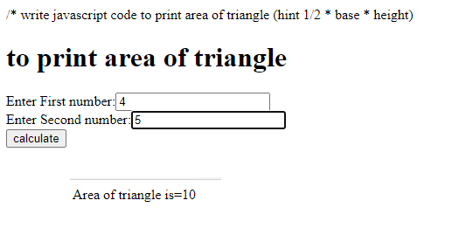

<html>

<head>

<title>find number of vowels in a string in JavaScript</title>

<script type="text/javascript">

function Vowels()

{

var str = document.getElementById("t1").value;

var count = 0, total_vowels="";

for (var i = 0; i < str.length; i++)

{

// findVowels

if(str.charAt(i)=="a"||str.charAt(i)=="e"||str.charAt(i)=="i"||str.charAt(i)=="o"||str.charAt(i)=="u"||str.charAt(i)=="A"||str.charAt(i)=="E"||str.charAt(i)=="I"||str.charAt(i)=="O"||str.charAt(i)=="U")

{

count++;

}

}

alert("VOWEL count is="+ count);

}

</script>

</head>

<body>

<form>

<h1>Get Vowels from String</h1>

Enter Text :<input type="text" id="t1" />

<input type="button" value="Get Vowels Count" onclick="Vowels()" />

</form>

</body>

</html>

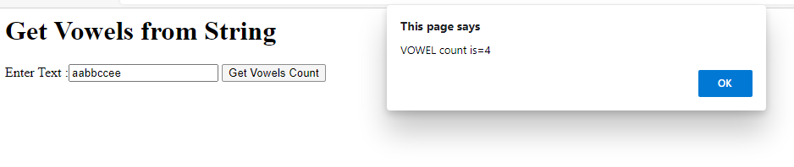

// To accept string and calculate its length

<html>

<head><title> find length of string using onClick event</title>

<script type ="text/Javascript">

var str,len;

function Calculate()

{

var str=f1.t1.value;

len=str.length;

alert(len+" is the Length of string"==+str);

}

</script>

</head>

<body>

<h1>To accept string and calculate its length </h1>

<form name="f1">

Enter string:<input type="text" name="t1">

<br>

<input type="button" value="click here" onClick="Calculate()">

</form>

</body>

</html>

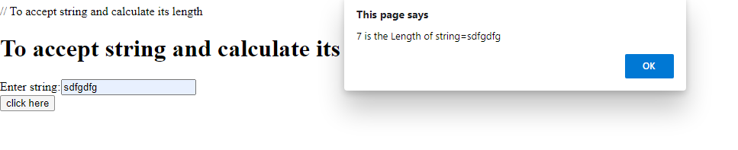

// To accept string and display it into lowercase and uppercase by onClick event

<html>

<head><title> To accept string and display it into lowercase and uppercase by onClick event</title>

<script type ="text/Javascript">

var str,str1,str2;

function convert()

{

var str=f1.t1.value;

str1=str.toLowerCase();

str2=str.toUpperCase();

f1.t2.value=str1;

f1.t3.value=str2

}

</script>

</head>

<body>

<h1>To accept string and display it into lowercase and uppercase by onClick event </h1>

<form name="f1">

Enter string:<input type="text" name="t1"><br>

Uppercase format of string:<input type="text" name="t2"><br>

Lowercase format of string:<input type="text" name="t3"><br>

<input type="button" value="click here" onClick="convert()">

</form>

</body>

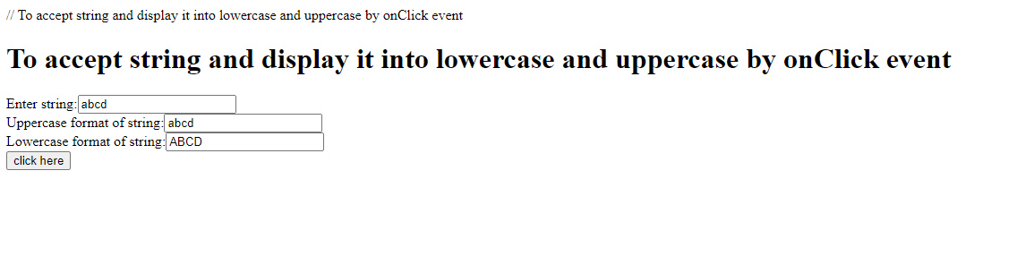

// To check the string length is 4 or greater using onClick event

<html>

<head><title> To check the string length is 4 or greater using onClick event</title>

<script language ="Javascript">

var str,len;

function Calculate()

{

var str=f1.t1.value;

len=str.length;

if(len>=4)

alert(str+" length is 4 or more than 4");

else

alert(str+" length is less than 4");

}

</script>

</head>

<body>

<h1>To check the string length is 4 or greater using onClick event</h1>

<form name="f1">

Enter string:<input type="text" name="t1">

<br>

<input type="button" value="click here" onClick="Calculate()">

</form>

</body>

</html>

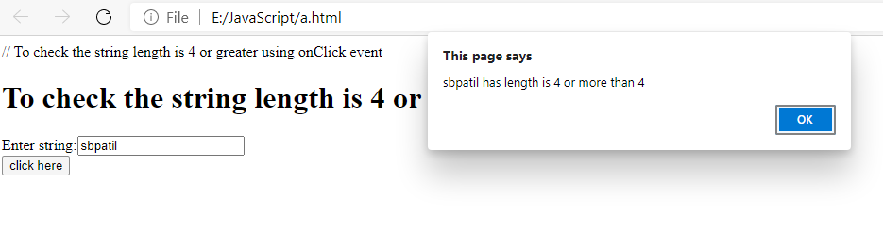

// Accept two numbers and find Larger Number

<html>

<head><title> find larger </title></head>

<body>

<h1> Accept two numbers and find Larger Number </h1>

<script type="text/Javascript">

var a,b;

a=parseInt(prompt("Enter first number"));

b=parseInt(prompt("Enter Second number"));

document.write("Entered numbers are"+a+"and"+b);

if (a>b)

alert(a+"is larger than"+b);

else

alert(b+"is larger than "+a);

</script>

</body>

</html>