**Echo:** echo is a built-in command in the bash and C shells that writes its arguments to standard output.

**#**echo hello

**#**echo hello; echo world

# echo hello $USER

# This is the $SHELL shell

# echo This is the $SHELL shell in computer $HOSTNAME

# echo The userid of $USER is $UID and his homedir is $HOME

**Sleep: The sleep command is used to delay for a specified amount of time.**

#sleep 20 &

**Comment:** Commenting after command

# mkdir test # creating directory

# cd test ## to enter into a directory

# ls # Check if the directory is empty or not

**Man, Info, --help**

$man <command>

$man whois

$man syslog.conf

$man –k syslog.conf [shows list of Man pages containing your searchstring]

**$**info <command>

**Info** command is similar to **man** command, but often more in-depth details about the command.

How to use **info** command ?

Navigate with arrows, pgup, pgdn

Tab moves to next link

Enter follows the selected link

n/p/u goes to next/previous/up-one node

s text searches for text (default:last search)

q quits info

**$<command> --help**

**#**date –help

Difference between Man Info Help

help is a bash command. It uses internal bash structures to store and retrieve information about bash commands.

man is a macro set for the troff (via groff) processor. The output of processing a single file is sent to a pager by the man command by default.

info is a text-only viewer for archives in the info format output of Texinfo.

**vi Editor**

Create a file using ‘touch’ command

**# touch <filename>**

Open an existing file, using vi editor

**# vi <filename>**

"filename" is the name of existing file. If the file is not in your current directory, you must use the full pathname.

**vi Modes :** vi editor has two modes:

1. Command mode
2. Insert mode

**Command mode:** In command mode, the letters of the keyboard perform editing functions (like moving the cursor, deleting text, etc.). To enter command mode, press the escape <Esc> key.

**Insert Mode:** In insert mode, the letters you type form words and sentences. Type i to enter insert mode

**To enter text in a file:**

In order to begin entering text in this empty file, you must change from command mode to insert mode. To do this, press i after you open the file.

**Moving the Cursor:**

To move the cursor to another position, you must be in command mode. If you have just finished typing text, you are still in insert mode. Go back to command mode by pressing <Esc>.

**h** left one space

**j** down one line

**k** up one line

**l** right one space

**Editing:** Editing commands require that you be command mode and are case sensitive.

**yy** – To copy the current line

**nyy** – To copy n number of lines including the current line.

**p** – Pasting the copied lines into the text after the current line.

**x** - To delete a character from a file, move the cursor until it is on the incorrect letter.

**4x** - To remove four characters (the one under the cursor and the next three)

**X** - To delete the character before the cursor.

**dw** - To delete a word and the space following it, move the cursor to the first letter of the word

**3dw** - To delete three words

**dd** - To delete a whole line

The cursor does not have to be at the beginning of the line. Typing dd deletes the entire line containing the cursor and places the cursor at the start of the next line.

**2dd** - To delete two lines

**D** - To delete from the cursor position to the end of the line

**r** - To replace one character with another, Move the cursor to the character to be replaced, type r and type the replacement character. The new character will appear, and you will still be in command mode.

**cw** - To replace one word with another, move to the start of the incorrect word and type cw

The last letter of the word to be replaced will turn into a $. You are now in insert mode and may type the replacement. The new text does not need to be the same length as the original. Press <Esc> to get back to command mode.

**3cw** - To replace three words

**C** - To change text from cursor position to the end of the line, Type the replacement text. Press <Esc>.

**i** - To insert text in a line. Position the cursor where the new text should go. Type i and enter the new text. The text is inserted BEFORE the cursor. Press <Esc> to get back to command mode.

**a** - To add text to the end of a line. Position the cursor on the last letter of the line. Type a and enter the new text. This adds text AFTER the cursor. Press <Esc> to get back to command mode.

**o** - To insert a blank line below the current line, type o (lowercase)

**O** - To insert a blank line above the current line, type O (uppercase)

**J** - To join two lines together. Put the cursor on the first line to be joined. Type J

**3J** - To join three lines together. Put the cursor on the first line to be joined. Type 3J

**u** - To undo your most recent edit, type u

**U** - To undo all the edits on a single line, type U (uppercase)

Undoing all edits on a single line only works as long as the cursor stays on that line. Once you move the cursor off a line, you cannot use U to restore the line.

**Few other shortcuts used in vi editor:**

**w** forward word by word

**b** backward word by word

**$** to end of line

**0** **(zero)**  to beginning of line

**H** to top line of screen

**M** to middle line of screen

**L** to last line of screen

**G** to last line of file

**1G** to first line of file

**Control + f** scroll forward one screen

**Control + b** scroll backward one screen

**Control + d** scroll down one-half screen

**Control + u** scroll up one-half screen

**/ (slash):** To search for text, while in command mode. Type / (slash). Enter the text to search for. Press enter. The cursor moves to the first occurrence of that text.

To repeat the search in a forward direction, type **n**

To repeat the search in a backward direction, type **N**

**Saving and closing files:**

**:w** - To save the edits you have made, but leave vi running and your file open. Press <Esc>. Type :w

Press enter.

**:wq** – To save the edits you made and want to leave the file. Press <Esc>. Type :wq

Press enter

**:q!** - To quit vi, and discard any changes your have made since last saving. Press <Esc>. Type :q!

Press enter.

**File system View**

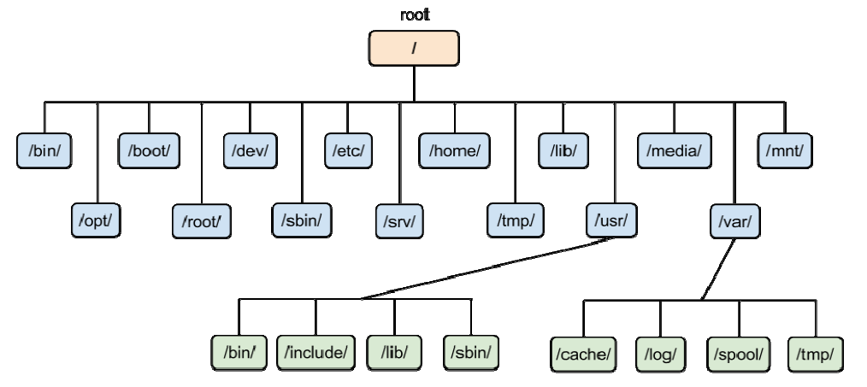

**Basic Commands**

[ To create file]

# touch <file>

[copy file]

cp <source> <destination>

[move file]

mv <source> <destination>

[change directory]

cd </directory>

[making directory]

mkdir <dir name>

**Adding/Deleting a user**

[To create user]

# Useradd raj

#passwd raj

Password:

Re-type password:

[to list user account]

#cat /etc/passwd

[to lists user password]

# /etc/shadow

[to list last 10 created user accounts]

# Tail –1 /etc/passwd

[to list the details of the home directory of a user]

# ls –ld /home/raj

[to remove the useraccount along with all the data]

# userdel –r <rajkumar>

# tail -1 /etc/passwd

[to create a user account with shortname of user]

# useradd –c ‘hari om’ hari

# tail -1 /etc/passwd

# tail -1 /etc/shadow

[to modify a user account with short name changes in user]

#usermod –c ‘om hari’ hari

# tail -1 /etc/passwd

# tail -1 /etc/shadow

[locking a useraccount]

# passwd –l raj

# tail -1 /etc/shadow

[still you can login to raj through root]

# su – raj

[unlocking a user account]

# passwd –u raj

# openssl passwd ram123 [ to generate a encrypted password ]

[create a user]

# useradd sairam

[ Modifying user account with encrypted password]

# usermod –p <copy encrypted password> sairam

[ gives info about who logged on to system ]

# whoami

[ you can see which of the who list is yourself ]

# who am i

[ list of user accounts logged in ]

# who

**Adding/Deleting a group**

[Adding a group]

# groupadd cricket

[checking the added group]

# tail -1 /etc/group

[create two users]

# useradd sachin

# useradd sehwag

[check the users group]

#groups sachin

#groups sehwag

[check the users grop]

# usermod -g cricket sachin

# usermod –g cricket sehwag

# tail -1 /etc/group

[changing the groupname]

# groupmod –n hockey cricket

# tail -1 /etc/group

[ shows list of groups of the logged in user]

# groups

[ displays uid, gid and group info about your logged account ]

# id

[ displays uid, gid and group info about a particular user ]

# id <username>

# grep –i pass /etc/login.defs [ displays password aging and length settings, numerical limits of user id’s and group id’s and whether or not a home directory should be created by default ]

[ logging as root to user account ‘raj’ without providing password ]

# su raj

[ logging from useraccount to root ]

# su – (or) # su

[ list the settings for a user ]

# chage –l raj

[ list the login shells ]

# chsh –l

[ changing the shell for currently logged in user ]

# chsh –s /bin/ksh

[ Adding permissions of group ‘hockey’ to useraccount ‘raj’ ]

# gpasswd –a raj hockey

[ Adding user sriram to hockey group ]

# gpasswd –a sriram hockey # id sriram

# tail -1 /etc/group

[ removing user sriram from hockey group ]

# gpasswd –d sriram hockey

[checking whether group has password or not]

# tail -1 /etc/gshadow

[Assigning a password to hockey group]

# gpasswd hockey

Password:

Retype password:

[checking whether group has password or not]

# tail –l /etc/gshadow

**File permissions**

[create a file ‘raj’]

# touch raj

[check the details of file ‘raj’]

# ls –l raj

[ adding execute permissions to user ]

# chmod u+x raj

# ls –l raj

# chmod g-r file1 [ removes read permission to ‘group’ ]

# ls –l raj

# chmod o-r file1 [ remove read permissions to ‘others’ ]

# ls –l raj

[Adding wrtite permissions to all of them ]

# chmod a+ w raj (or) chmod +w raj

# ls –l raj

[ Adding read, write permissions to user ]

# chmod u=rw raj

# ls –l

[ adding permissions as per requirement ]

# chmod u=rw,g=rw,o=r file1

# ls –l

[ adding permissions as per requirement ]

# chmod u=rwx,ug+rw,o=r file1

# ls –l

**Octal permissions**

# chmod 777 raj

# ls –l raj

# chmod 664 raj

# ls –l raj

# chmod 750 raj

# ls –l