# Graphical Analysis of Assessment Responses

## 1. Distribution of Neurotypical and ASD Children

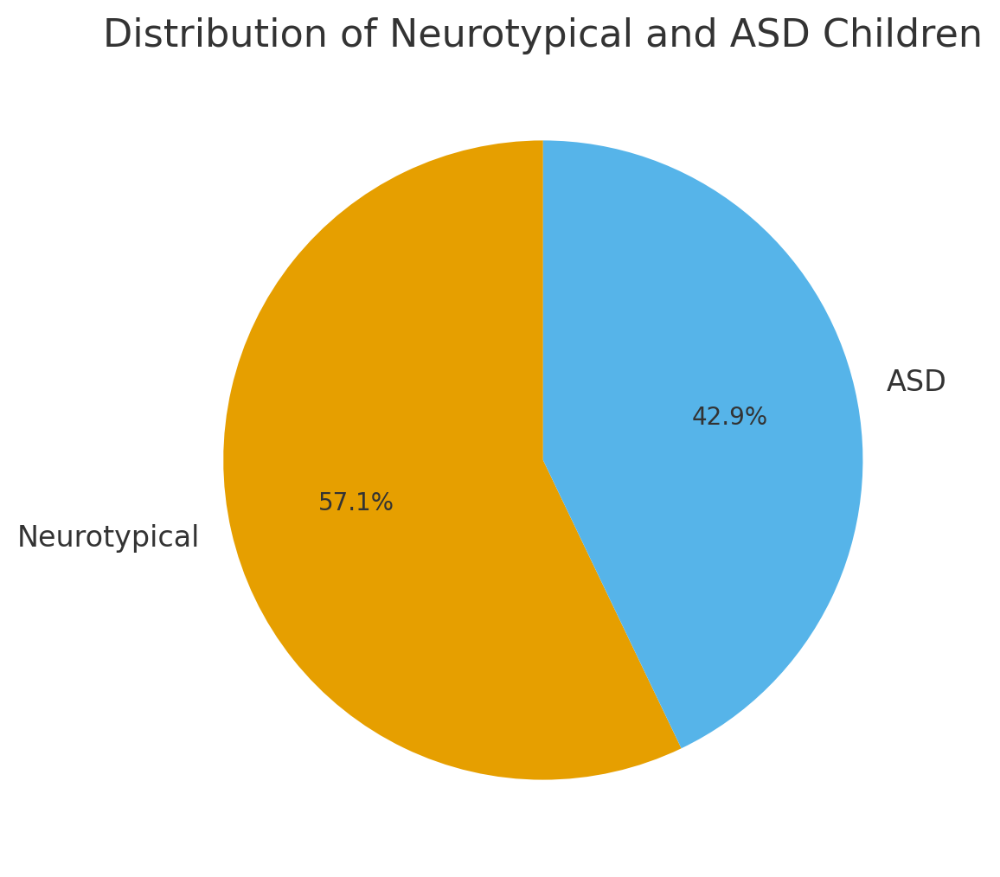

This chart shows the proportion of Neurotypical and ASD children who participated in the assessment.

## 2. Overall Yes vs No Responses

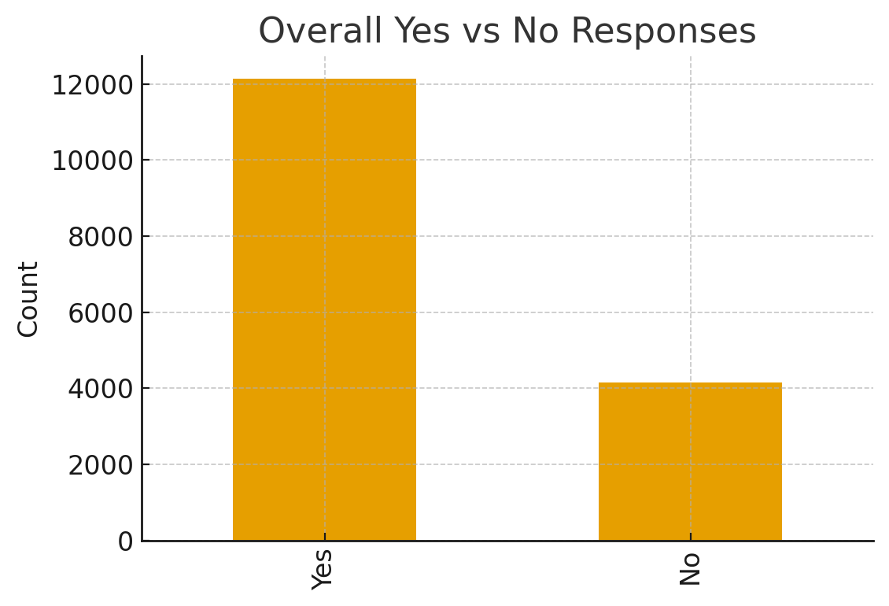

This chart provides a summary of the total 'Yes' and 'No' responses across all questions.

## 3. Yes/No Response Distribution per Question

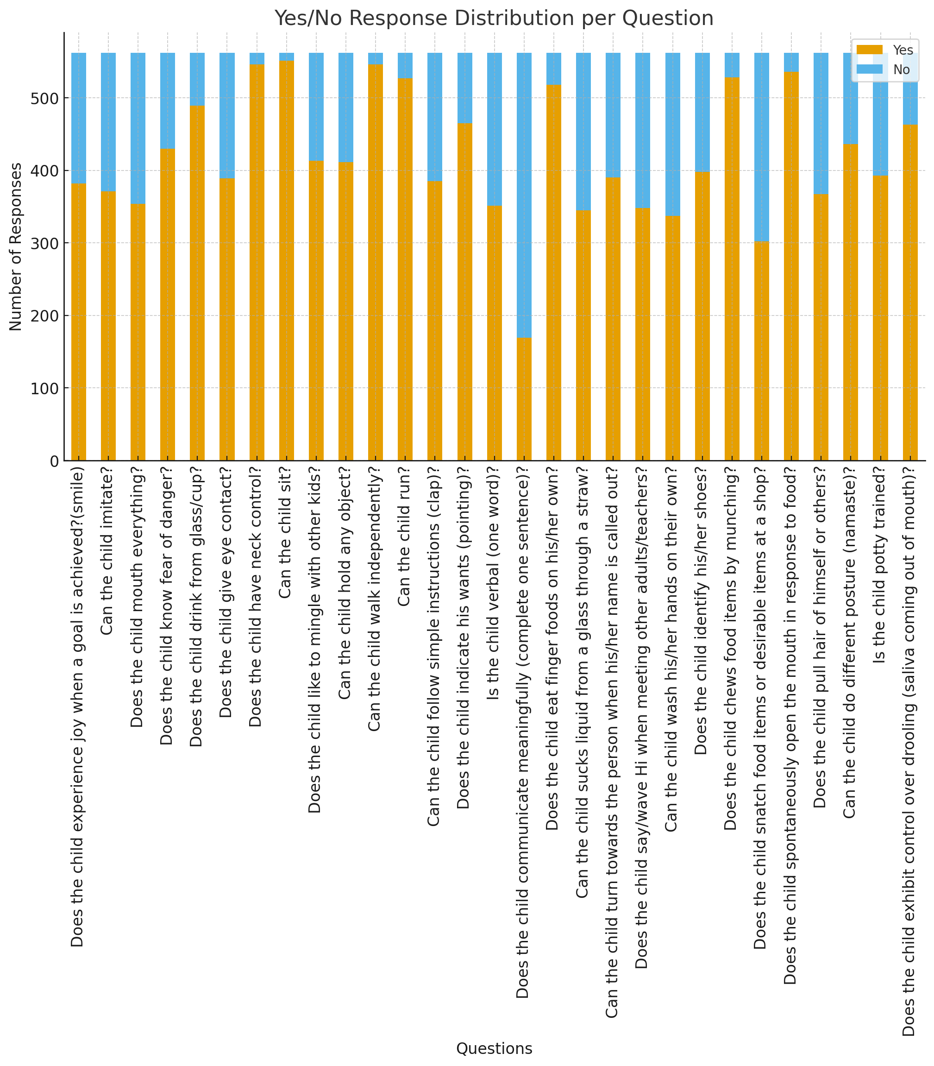

This stacked bar chart represents the number of 'Yes' and 'No' responses for each question in the assessment.