**Software Testing Project**

**Name**: **Shilpa Shinde**

**ID:**10566

**USECASE DIAGRAM:**

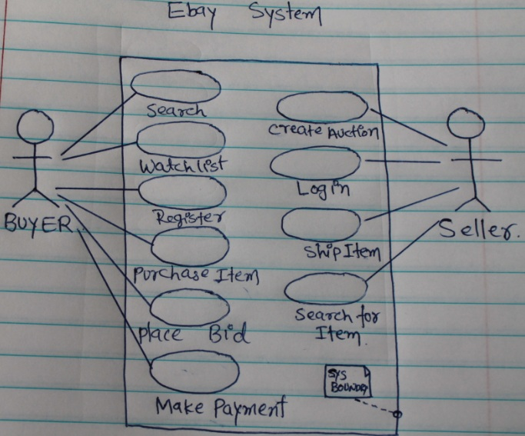

**Testcase1-A: : Verify the Sign in and signout page with valid username and password.**

Go to Link sign in page on ebay.com.Enter the valid username and password. Homepage should display entered username. When click the sign-out button It displayed the message “You have signout”.

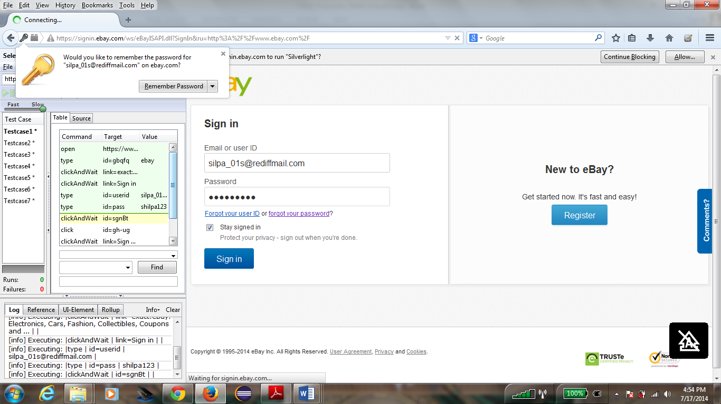

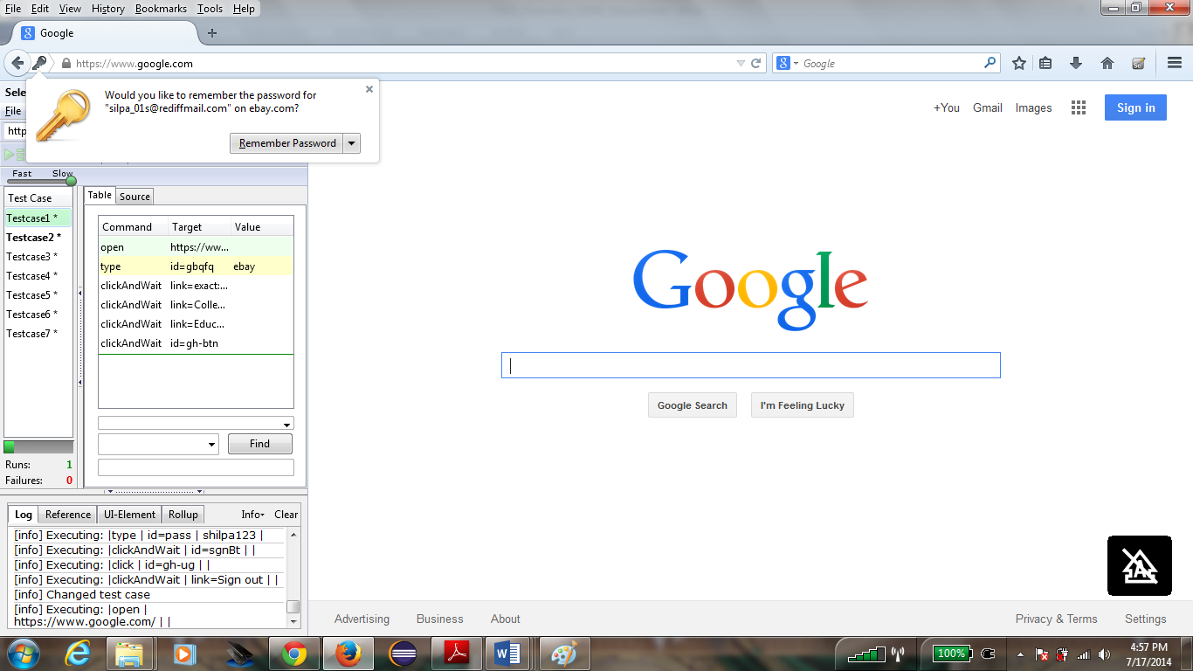

**Testcase2 : Verify the sub category is working.**

Go to ebay.com. Go to Link Shop by Category which contain subcategory. Click on the Toys & Hobbies category.Click on Collector & hobbyist toys. Click on search button. It should display all things under that category.

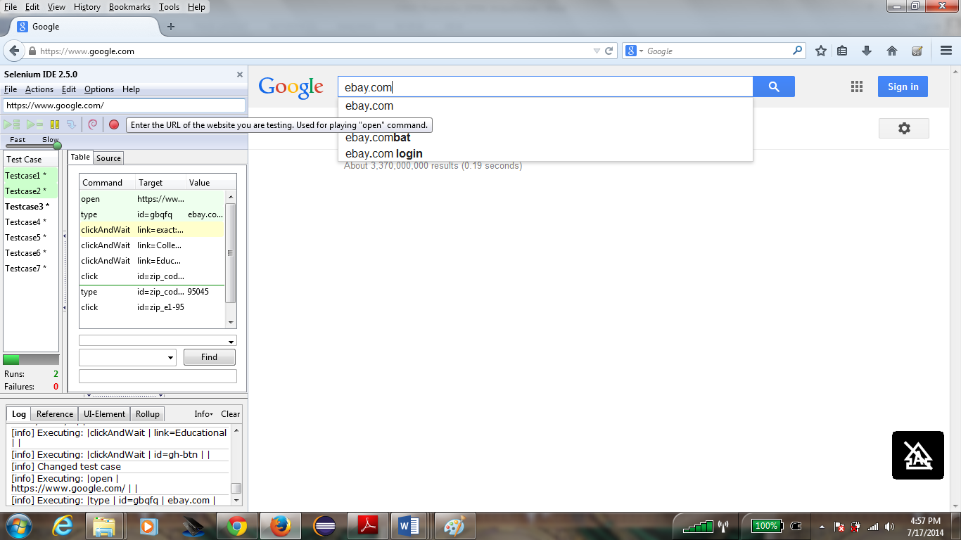

**Testcase3** : **Verify the zip code button function**

Go to ebay.com. Go to Link Shop by Category which contain subcategory. Click on the Toys & Hobbies category. Click on Collector & hobbyist toys. Click on go button after entering zip code in textbox.

It should display the item which can ship to particular zipcode.

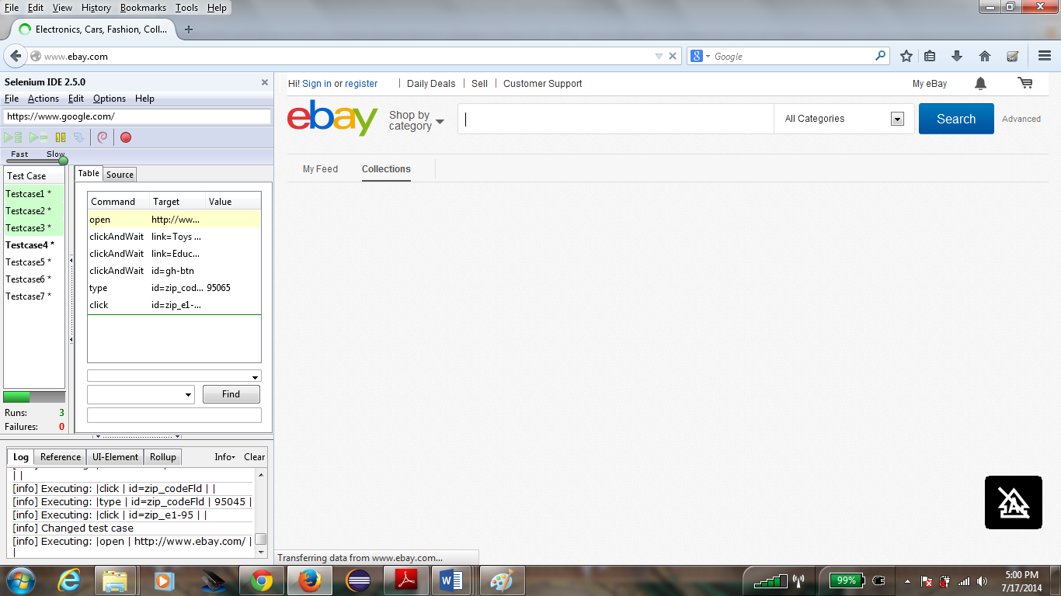

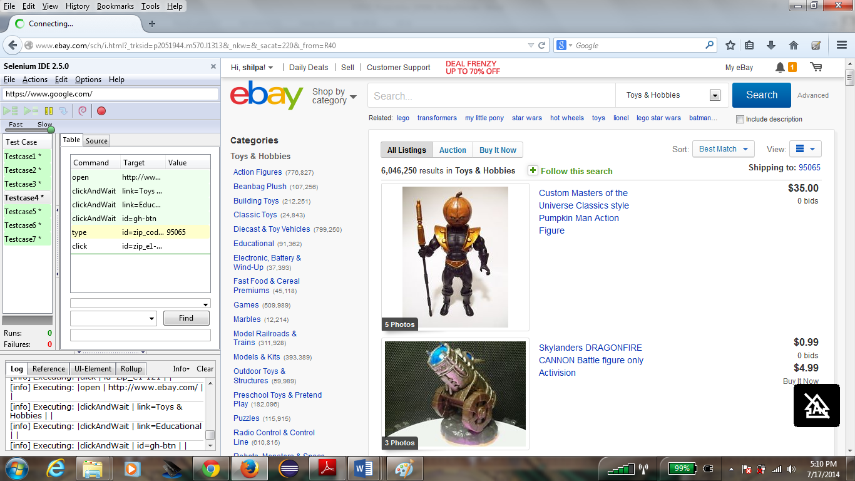

**Testcase4** : **Verify the add to cart function**

Go to ebay.com. Go to Link Shop by Category which contain subcategory. Go to Collector & hobbyist toys . Under the category select one category. enter the 1 in quantity field .It should display the message. Click on Add to cart.

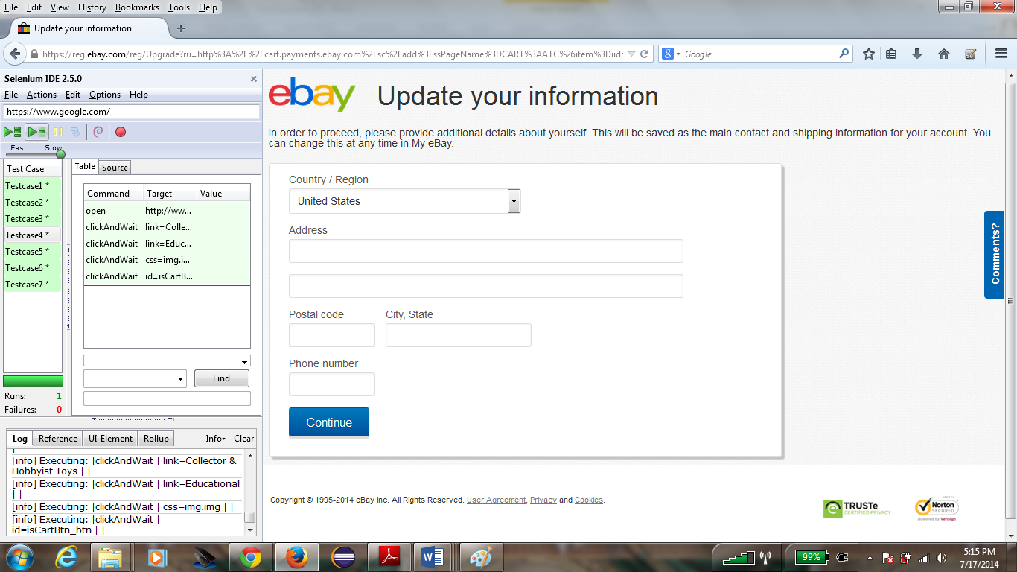

**Testcase5** : **Verify the buy the item.**

Go to ebay.com. Go to Link Shop by Category which contain subcategory. Go to Collector & hobbyist toys . Under the category select one category. enter the 1 in quantity field .It should display the message. Click on Add to cart.

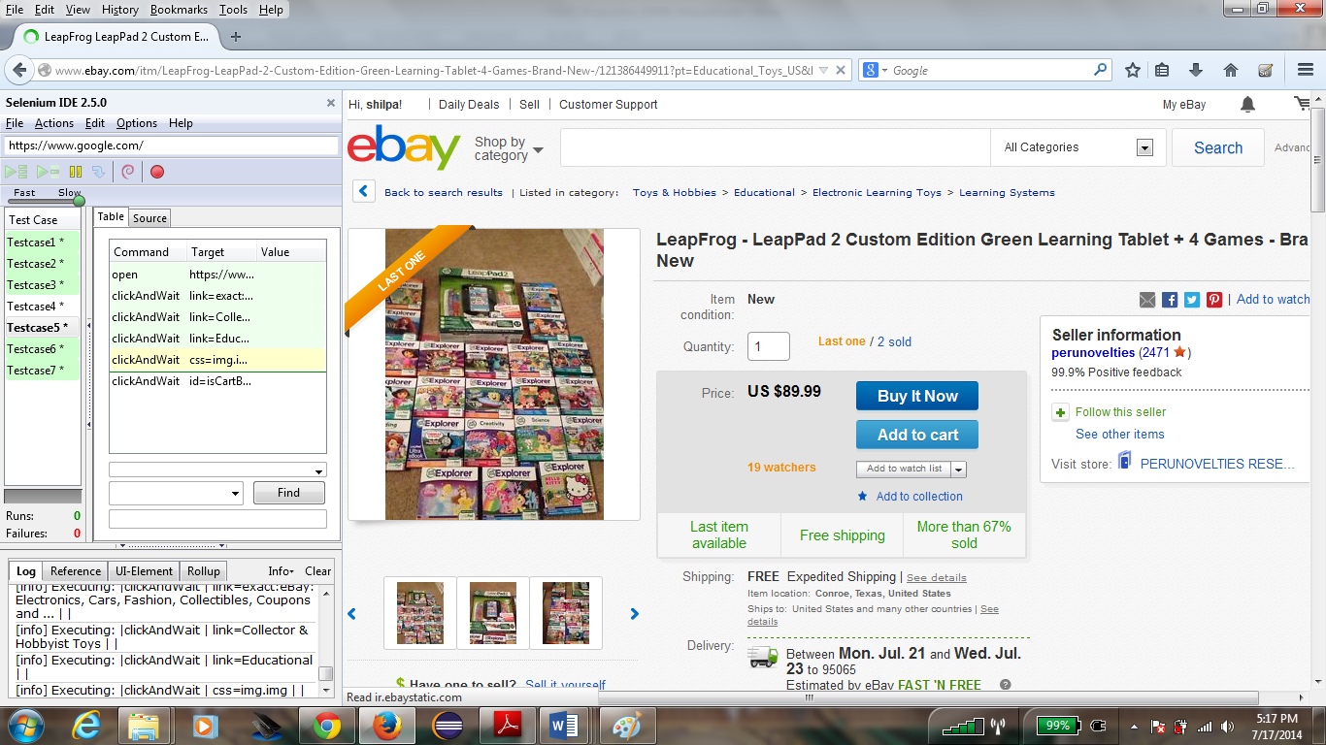

**Testcase6 : Verify brand function under subcategory.**

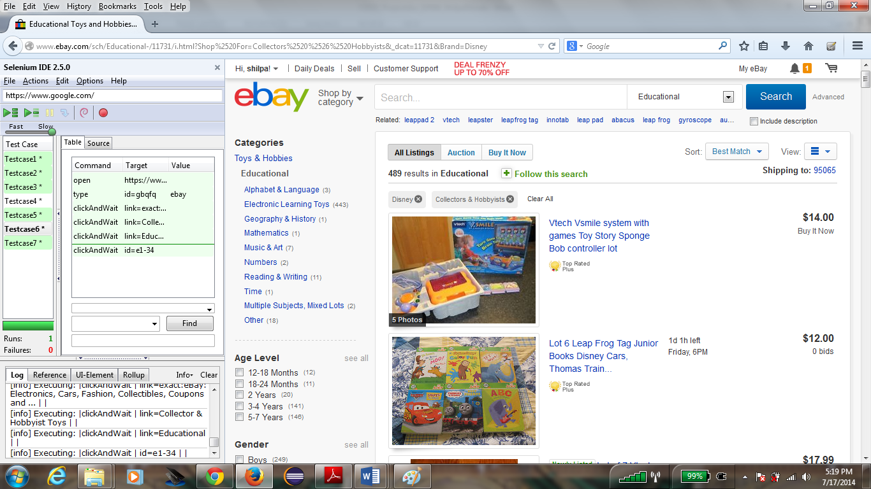

**Testcase7** : **Verify watch list on my eBay account**

