**Treemap**

1. In the following example, you see Superstore data displaying the number of products sold per *Sub-Category*. Each *Sub-Category* is represented by a proportionate rectangle with size and colour reflecting the number of items purchased. A larger box and a darker colour indicate a higher number of items purchased within the *Sub-Category*.

Number of Product sold per sub category:

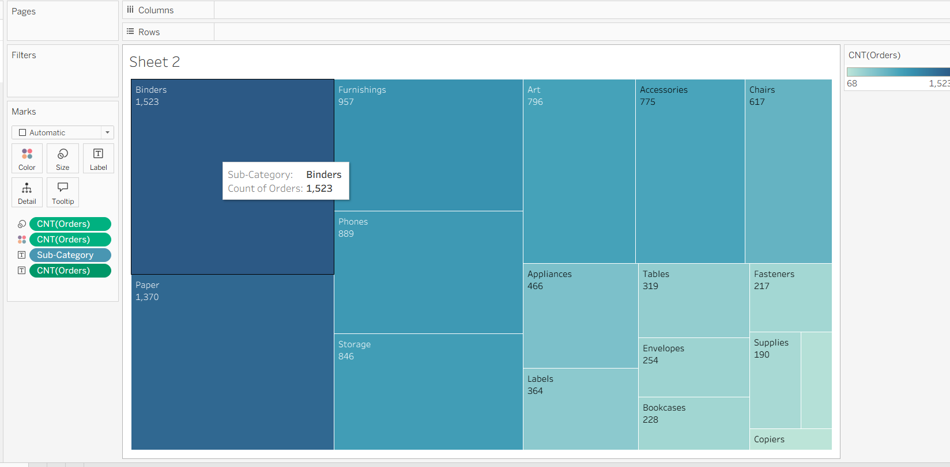

1. I wanted to compare one measure and two dimensions — *Sales*, *Region*, and *Sub-Category*. Below treemap is showing that comparison details:

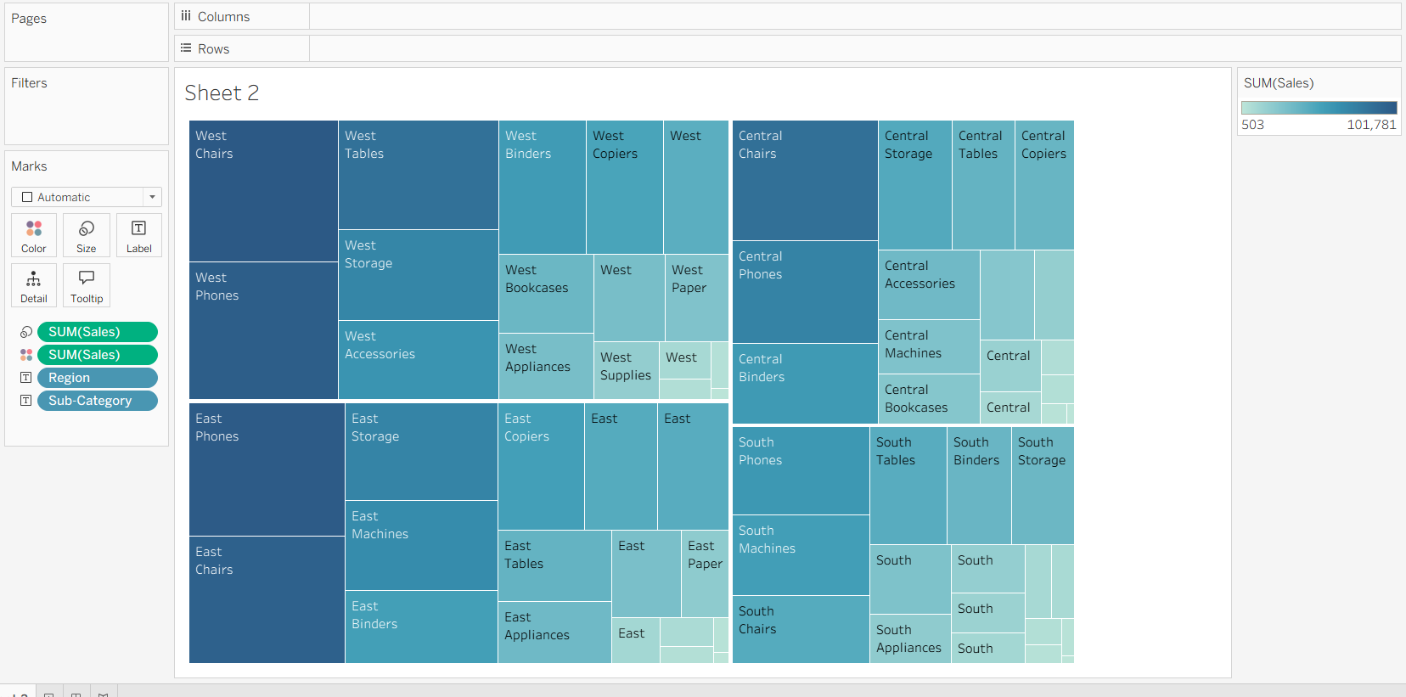

Above treemap shows the sub-categories with the most sales for each region, but what are the actual sales? To answer this, I added some more information to help the audience see what the size of the rectangles represents.

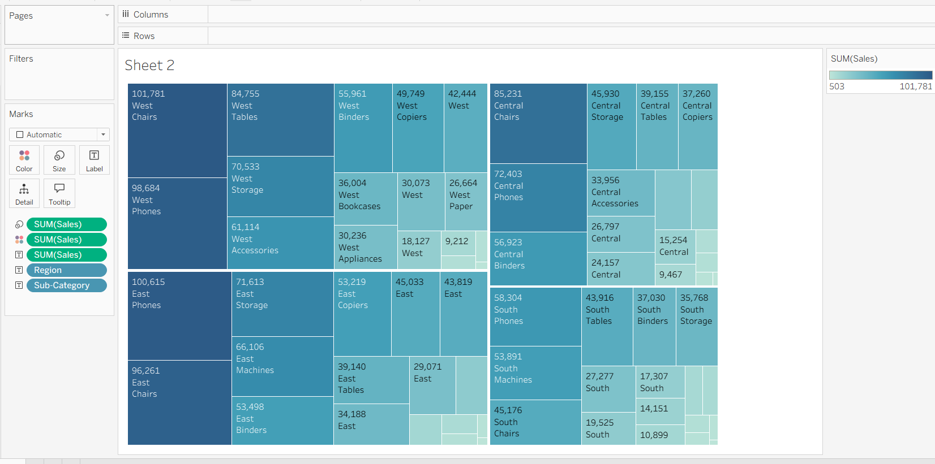

**Bubble charts**

1. My manager wants a visualization that compares the quantity of products sold for each category to include in a sales presentation. I suggest a bubble chart as an option that is visually interesting and easy to convey information at a glance for the audience.

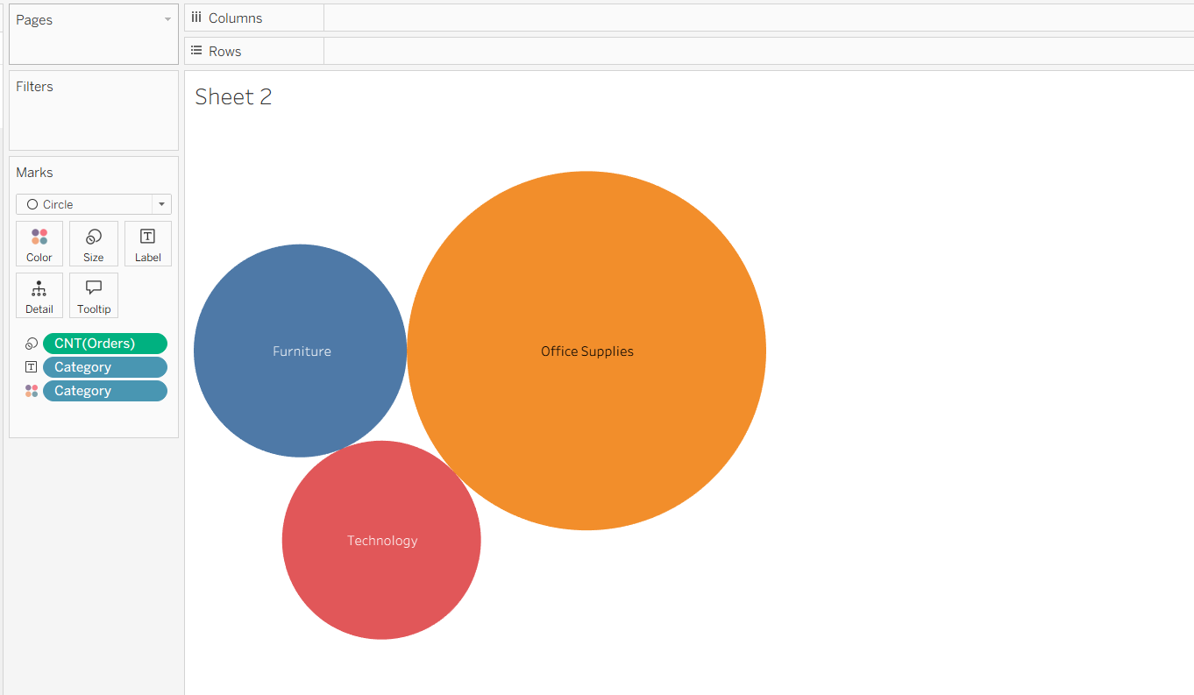

Now to add more information I added the quantity in the bubble chart

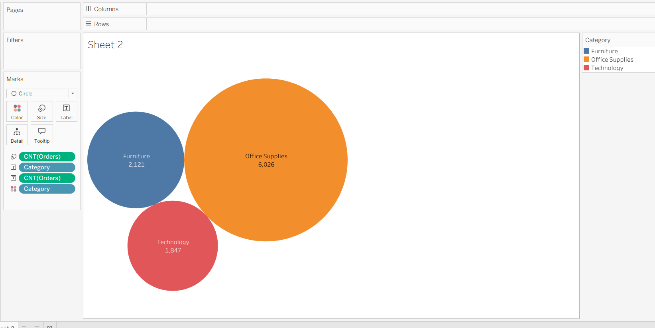

now my manager has a visually interesting data visualization to add to their presentation! They are pleased with the bubble chart because it provides some variety and interest to their presentation.