Task 3: Basic Firewall Configuration with UFW

Step 1: Install UFW
Open a terminal and run the following command to install UFW:



Step 2: Configure the Firewall
Allow SSH Traffic: This is important to ensure you can connect to your server via SSH.



Deny HTTP Traffic: To deny HTTP traffic (port 80), you can use the following command:

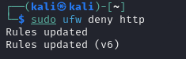

Step 3: Enable UFW
After configuring the rules, enable UFW with the following command:

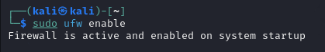

Step 4: Check Firewall Status
To check the status of UFW and see the rules that are currently in place, run:

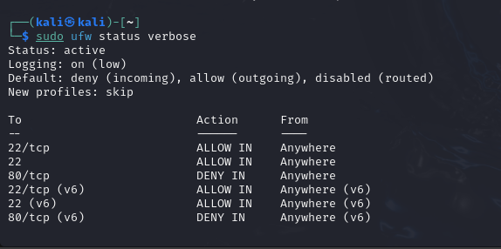

In conclusion, UFW (Uncomplicated Firewall) is a powerful and user-friendly tool for managing firewall rules on Linux systems. By following the steps outlined in this guide, you have successfully installed UFW, configured it to allow SSH traffic while denying HTTP traffic, and verified the status of your firewall.

