# GIT Versioning

1. **Clone:**

git clone [https://shilpi.shilpi@innersource.soprasteria.com/EUIPO/Back-Office/pub.git/](https://shilpi.shilpi@innersource.soprasteria.com/EUIPO/Back-Office/IPTOOL/backend.git) --branch production

https://shilpi.shilpi@soprasteria.com/gitlab.wub-dev.de/des/des.git

* 1. shilpi.shilpi : This is my userId of innersource
  2. Will ask for password : This is your innersource password. If not set please reset in innersource as per below screen shot

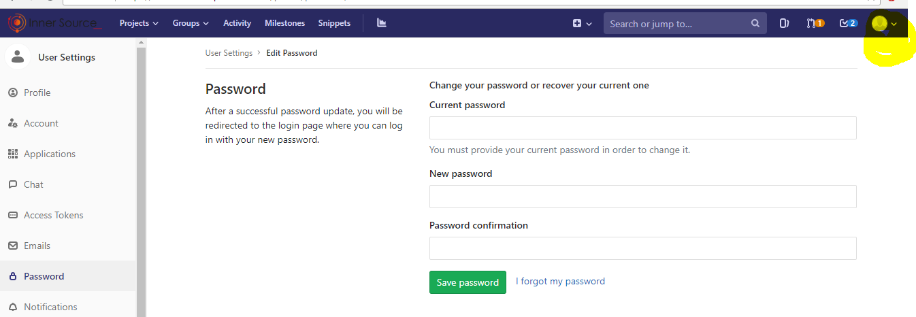

1. Move to the coned directory:

cd /home/sopra/workspace/microservice-international-master/microservice-international

1. Below steps to be followed in case “development” is not present on innersource:
   1. git checkout -b development
   2. git push

--(Everything up-to-date)

* 1. git push --set-upstream origin development

1. If “development” branch is present perform below steps:
   1. git checkout development
2. git branch

* development

master

1. Create the feature branch based on your task. Every task or Jira Ticket should have a separate task to be created and pushed.
   1. [sopra@VM-CENTOS6 microservice-international]$ git checkout -b featureBranchXXX-MI

Switched to a new branch 'featureBranchXXX-MI'

[sopra@VM-CENTOS6 microservice-international]$ git branch

development

* featureBranchXXX-MI

master

1. Do your changes on this branch.
2. git add .
3. git commit
4. git push --set-upstream origin featureBranchXXX-MI
5. Create Merge Request in GIT-innersource. Please Find below SS:

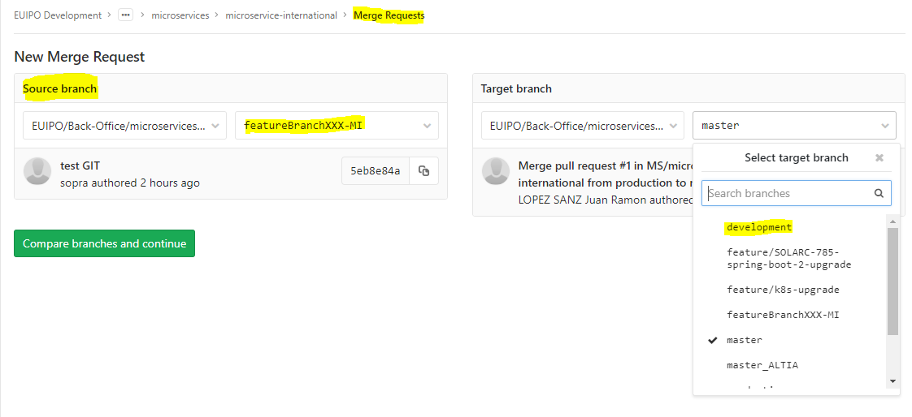

git checkout exparteEntityIA

git pull origin exparteEntityIA

git checkout -b <<NEWfeatureBranchXXX->>

consul agent -config-dir /etc/consul -bind=127.0.0.1